
About the Annual Report
The Queensland Independent Remuneration Tribunal is required under the Queensland Independent Remuneration Act 2013 (the Act) to prepare and give to the Clerk of the Parliament a written report about the operations of the Tribunal during each financial year.
The Annual Report provides information on the Tribunal, the Tribunal’s key achievements during 2013-2014, its priorities for 2014-2015 and a summary of the Tribunal’s financial operations.
The Annual Report can be accessed online at www.remunerationtribunal.qld.gov.au/
ISSN: 2203-9341
© State of Queensland (Queensland Independent Remuneration Tribunal) 2014.
With the exception of any material protected by a trade mark, third party copyright material and where otherwise noted, all material in this report is licensed under a Creative Commons Attribution (CC BY) 3.0 Australia licence, available at http://creativecommons.org/licences/by/3.0/au/deed.en. In essence, content from this report may be adapted and copied for use if attributed to the State of Queensland (Queensland Independent Remuneration Tribunal).
Further information is available at www.remunerationtribunal.qld.gov.au/tools/copyright.aspx.

Contact us
Web: www.remunerationtribunal.qld.gov.au
Email: remunerationtribunal@qirt.qld.gov.au
Post: The Secretariat
Queensland Independent Remuneration Tribunal
PO Box 15185
CITY EAST QLD 4002

Letter of compliance

21 August 2014

Mr Neil Laurie
Clerk of the Parliament
Cnr of George and Alice Streets
BRISBANE QLD 4000

Dear Mr Laurie

I am pleased to present the Annual Report 2013-2014 for the Queensland Independent Remuneration Tribunal.

This is the first report issued under section 26 of the Queensland Independent Remuneration Tribunal Act 2013 and complies with the provisions of that section.

Yours sincerely

Professor Tim Brailsford
Chair
Table of Contents
Message from the Chair 1
1 - About the Queensland Independent Remuneration Tribunal 2
1.1 Establishment 2
1.2 Members 3
1.3 Remuneration of Tribunal members 4
1.4 Roles and functions of the Tribunal 4
1.5 Secretariat support 5
2 – Communication strategy 6
2.1 Communication strategy 6
2.2 Public consultation process 7
3 - Key activities 2013-2014 8
3.1 Tribunal Determinations 2013-2014 8
3.2 Determination 1/2013…………………………………………………………………………. 8
3.3 Determination 2/2013 11
3.4 Determination 3/2014 11
3.5 Determination 4/2014 11
3.6 Tribunal meetings 11
4 - Priorities for 2014-2015 12
5 - Financial statement 13

Message from the Chair
The first year of the newly established Queensland Independent Remuneration Tribunal was a busy period. The Tribunal was established on 16 July 2013 and held its first meeting on 18 July 2013.
The first few months of the Tribunal’s operation were spent in start-up mode while simultaneously working toward the first Determination which was due by 15 October 2013. Despite the short lead-time and the inevitable teething issues in the preliminary stages, Determination 1/2013 was released on schedule. Three further Determinations followed during the first twelve months.
Taken together, these four Determinations contain the foundations for building a new remuneration structure for Members of the Queensland Parliament. A key part of the Tribunal’s work focussed on simplifying the system, making it more accountable and transparent, and working from the principle of equity.
In short, the Tribunal’s work involved establishing a new base salary; introducing a simplified and more transparent schedule of additional salaries for office bearers that reflects comparative work values; replacing a complex system of a myriad of allowances with just three allowance categories that reflect travel requirements, electorate responsibilities and information and communication needs. Further, during the year the Tribunal introduced an acquittal system for allowance expenditures consistent with improved accountability and transparency.
The Tribunal recognises its requirement for independence, and the associated attributes of impartiality and integrity. It has established some protocols in relation to consultation with a range of stakeholders. Part of this consultation occurred through a public submissions process that attracted over 2,500 responses.
The Tribunal has already established a work plan for next year which involves consideration of entitlements to former members, a review of the new allowances system and a review of the base salary level.
I offer thanks and acknowledge my fellow Tribunal members. We have undertaken a significant body of work in our first year of existence and I appreciate your support, hard work and diligence. We have had to overcome some significant challenges posed by an ambitious work plan but we have delivered major policy reform on time.
The achievements of the Tribunal would not have been possible without the strong assistance and support of the Clerk of the Parliament and his staff, the Secretariat to the Tribunal comprising Mr Tim Herbert, Mrs Alexandra Brouwer and for the first Determination Ms Kellie Moule, and the resourcing provided by the Director-General of the Department of the Premier and Cabinet.

Professor Tim Brailsford
Chair

21 August 2014
1 - About the Queensland Independent Remuneration Tribunal

1.1 Establishment
The Queensland Independent Remuneration Tribunal (the Tribunal) was administratively established as an independent entity on 16 July 2013 to review and decide the remuneration in connection with Members and former Members of the Queensland Parliament. On 9 August 2013, the Tribunal was established as an independent statutory authority under Queensland Independent Remuneration Tribunal Act 2013 (the Act).
The Tribunal was established following the Premier, the Honourable Campbell Newman MP’s announcement of a five point plan to reform the Queensland Parliament’s entitlements system. Pursuant to the Premier’s announcement, the Act:
- broke the legislative nexus between the salaries of Queensland and Commonwealth MPs (formerly the base salary of a Queensland MP was legislatively linked to the base salary of a Commonwealth MP)
- established the Tribunal under legislation
- provided that the determinations of the Tribunal are independent, binding and not subject to change by MPs
- legislated to rescind a 41.9 per cent pay rise that occurred prior to the Tribunal’s establishment
- provided that the Tribunal must ensure that any allowances reflect the amount of reasonable expenses incurred by an MP in servicing their electorate and that allowances are not a substitute for other remuneration, i.e. salary.

1.2 Members
Under the Act, the Tribunal consists of three persons appointed by the Governor in Council. The inaugural Tribunal chair and members were appointed by the Governor in Council from 15 August 2013 for a term ending on 15 July 2016. Professor Tim Brailsford was appointed as Chair and David Harrison and Joanne Jessop were appointed as members.
Biographies of the members are provided below.

Professor Tim Brailsford

Professor Brailsford is the Vice Chancellor and President of Bond University. Professor Brailsford’s previous positions include Executive Dean at the University of Queensland, Dean at the Australian National University in Canberra, and other senior academic positions at the University of Melbourne and Monash University. Professor Brailsford’s area of expertise is finance and investments. He holds a PhD, Masters and Honours degrees and is a Fellow of the Financial Services Institute of Australasia, Fellow of the Australian Institute of Management and Fellow of CPA Australia. He was appointed as the inaugural Frank Finn Professor of Finance at the University of Queensland.

David Harrison

Mr Harrison is an experienced non-executive company director, having served on a variety of private and public sector boards since 1987, as well as having more than 30 years’ experience in industrial relations. He is currently the Chairman of QMI Solutions Limited (since December 2004).
Mr Harrison has filled many directorships and chairman roles over the years, including the Workers’ Compensation Regulatory Authority – QCOMP (2012 to 2014), Australia TradeCoast Limited (2005 to 2012), Ferny Grove Bowls Sports and Community Club Inc. (2008 to 2013), Port of Brisbane Corporation (1999 to 2010), QIC Limited (1998 to 2011), Brisbane Airport Corporation (2005 to 2012), Sunsuper Pty Ltd (1994 to 2005), Queensland Theatre Company (2001 to 2004) and Sugar Manufacturers of Australia Retirement Trust Pty Ltd (1987 to 1994). His industrial relations experience includes nine years as Queensland Secretary of the Australian Manufacturing Workers’ Union and 10 years as Honorary President of the Queensland Council of Unions. In 2003, he was awarded the Centenary Medal for distinguished services to industrial relations and he is a Fellow of the Australian Institute of Company Directors.


Joanne Jessop
Ms Jessop has served as Chief Executive Officer of Multicap since 2006 and is vice-chair of the Queensland National Disability Services committee. Ms Jessop has extensive international experience in senior management roles in the healthcare and human services sectors and holds an MBA from the University of Queensland. She is a graduate of the Australian Institute of Company Directors, a Fellow of the Australian Institute of Management, and a Director of CheckUp Australia.

1.3 Remuneration of Tribunal members
In establishing the Tribunal the remuneration of Tribunal members was assessed as category A1 in accordance with the Remuneration of Part-Time Chairs and Members of Government Boards, Committees and Statutory Authorities. These same remuneration categories apply to the majority of Queensland Government bodies.
Tribunal members are appointed on a part-time basis and are paid the remuneration and allowances decided by the Governor in Council being $425 per half day meeting for the Chair and $346 per half day meeting for members. The Chair and members are also entitled to receive payment for special assignments.

1.4 Roles and functions of the Tribunal
The Tribunal’s functions are to review remuneration in connection with MPs and former MPs of the Queensland Legislative Assembly and make binding decisions, known as ‘determinations’ about this remuneration.
For the purposes of the Act, ‘remuneration’ refers to salary, allowances or entitlements in connection with an MP or former MP (including associated recipients such as spouses).
In making a determination, the Tribunal may enquire into and inform itself of anything in the way it considers appropriate, for instance, it may seek and receive written or oral statements and is not bound by the rules of evidence. The Tribunal must have regard to effective and efficient processes in carrying out its functions.
Under the Act, the Tribunal must:
- consult with and consider the views of the Clerk of the Queensland Parliament (the Clerk)
- ensure any allowances paid to an MP reflect the amount of reasonable expenses incurred by an MP in servicing their electorate i.e. expenses to assist constituents
- ensure these allowances are not a substitute for other remuneration
- ensure accommodation, services or other entitlements mentioned in section 55 of the Act are not taken into account.
The Tribunal may consider the following principles:
- the value to the community of an MP carrying out their role, functions and responsibilities
- the importance of an MP being appropriately remunerated for carrying out their role, functions and responsibilities
- relevant laws that apply to MPs
- any other matter the Tribunal considers appropriate (e.g. the size of an MP’s electorate).
In performing its functions, the Tribunal must also act independently, impartially and fairly. When reviewing the various components of MP’s remuneration the Tribunal has been impartial, independent and fair to all sides of politics and taken into account the views of the community on these matters.
To preserve the Tribunal’s independence, it is not subject to direction from a Minister and its decisions are legally binding and cannot be appealed.
To ensure the Tribunal operates in a transparent manner, it must include written reasons for its determinations, provide a copy of the determination and reasons to the Clerk for tabling in Parliament and make the determination and reasons publicly available.

Section 55 of the Act provides that the Act (and therefore any Tribunal determination) does not prevent a person from receiving the following:
- accommodation and services provided by the Parliamentary Service at Parliament House
- accommodation and services provided in electorate offices, such as offices, staff, IT infrastructure and other major office equipment
- entitlements a minister or assistant minister receives to perform that role under the Queensland Ministerial Handbook (www.premiers.qld.gov.au/publications/categories/policies-and-codes/handbooks/ministerial-handbook.aspx)
- entitlements the Leader of the Opposition receives to perform that role under the Queensland Opposition Handbook (www.premiers.qld.gov.au/publications/categories/policies-and-codes/opposition-handbook.aspx)
- entitlements the Speaker of the Legislative Assembly receives under the Guidelines for the Financial Management of the Office of the Speaker (www.parliament.qld.gov.au/members/entitlements).

1.5 Secretariat support
In accordance with the Act the Tribunal receives assistance from the Chief Executive of the Department that administers the Act.
Given the significant work involved in setting up the Tribunal and commencing the review of the remuneration of MPs, the Secretariat initially consisted of two full-time officers from the Department of the Premier and Cabinet and a part-time officer seconded from the Parliamentary Service. Once this initial establishment period and first phase of work was completed, and Determination 1/2013 released, the Secretariat was reduced to two part-time officers.
The Secretariat has assisted the Tribunal in preparing meeting documents, drafting meeting minutes, completing action items, drafting research materials, compilation of submissions and drafting determinations and other reports as advised by Tribunal members. The Secretariat has also coordinated support for the Tribunal in relation to the website, design, communications, printing and other resourcing needs.
2 - Communication strategy

2.1 Communication strategy
Following its establishment, the Tribunal developed a communication strategy seeking to build awareness and raise understanding of the issues associated with the remuneration in connection with MPs and former MPs, inform Queenslanders of the Tribunal’s reviews of the remuneration system and facilitate easy participation in the review process by key stakeholders and members of the public.
A key element of the communication strategy was the development of a user friendly, informative website providing information about the Tribunal, its members and its work. The first news item released by the Tribunal on the website was published on 19 July 2013, three days after the Tribunal members were appointed, demonstrating the Tribunal’s commitment to keeping the public informed.
The website has been a key tool in engaging with the public by advising them of the public submission periods, the release of determinations and other work of the Tribunal.
Members of the public are also able to subscribe to media alerts. Media alerts are sent directly to the subscribers email address and also bring the subscribers attention to calls for public submissions, the release of determinations and other work of the Tribunal.
The website provides a cost effective and efficient method of engaging with the public in accordance with the Tribunal’s obligation to have regard to effective and efficient processes in carrying out its functions.
The website can be accessed by following this link: www.remunerationtribunal.qld.gov.au
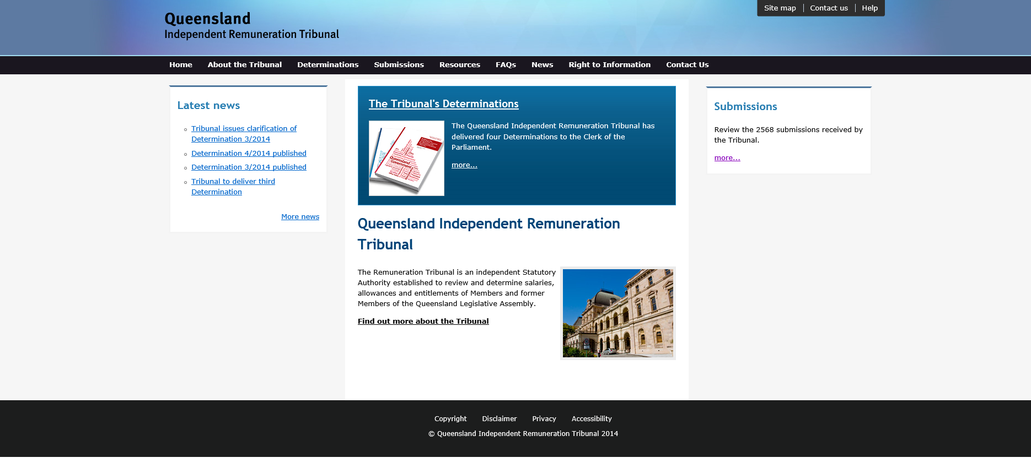

2.2 Public consultation process
The Tribunal called for public submissions to be submitted via post, email or the Tribunal’s website from 23 August 2013 until 10 September 2013. These dates allowed the widest possible time frame for submissions to be made while enabling the Tribunal to meet its legislative deadline of 15 October 2013 for its first determination. A grace period was applied beyond 10 September to allow late submissions to be received and considered.
The Tribunal used a number of methods to notify the MPs, former MPs and the general public of the consultation and submission process:
- A notice was posted on the Tribunal’s website www.remunerationtribunal.qld.gov.au and on Queensland parliament’s website www.parliament.qld.gov.au.
- On Saturday 24 August 2013 the Courier-Mail and the Weekend Australian contained an advertisement calling for submissions.
- A media alert was issued to media subscribers.
- The Tribunal wrote to current and former MPs inviting them to make written submissions.
- The Chair of the Tribunal was interviewed by a number of media outlets. This resulted in articles about the public submission process being included in the Courier-Mail, the Herald Sun and an interview with the Chair being broadcast via radio on ABC.
- In calling for public submissions the Tribunal released a discussion paper to provide guidance for those wishing to make a submission. A copy of the discussion paper was published on the Tribunal’s website www.remunerationtribunal.qld.gov.au following the link to “Resources”.
The intent of the discussion paper was to provide a clear, easily understandable statement of what the Tribunal’s role is in reviewing MP remuneration and canvassing some of the key issues. In addition to seeking general views from Queenslanders on the issue of MP remuneration, the Tribunal also posed the following specific questions:
- In considering the role of a Queensland MP do you believe an appropriate remuneration structure is a combination of direct salary (including superannuation) and some expense allowances associated with performing the role of an MP? Please explain your answer.
- If you believe there should be expense allowances, what sort of expenses should be allowed for? Please give examples.
- How do you think the Tribunal should ensure that allowances are only used to meet the reasonable expenses of an MP and are not regarded as a substitute for salary?
- What factors and benchmarks do you consider relevant in determining the reasonable direct salary (excluding expense allowances) that reflects the value to the community of an MP carrying out their role, functions and responsibilities?
- Is there anything else about MP remuneration that you think is important for the Tribunal to take into consideration?
The notification process resulted in 2,568 submissions. The submissions were de-identified and are available at www.remunerationtribunal.qld.gov.au/submissions.aspx.
Submissions received have been considered by the Tribunal in reviewing and determining the base salary of an MP, the additional salaries of office holders and in reforming the allowances system and will be considered in future reviews.
The Tribunal has also undertaken targeted consultation with the Clerk of the Parliament on a number of occasions during its reviews as well as other key stakeholders such as representatives from QSuper, the Committee of the Legislative Assembly, various MPs including minor parties and Independents, and other office holders.
3 - Key activities 2013-2014

3.1 Tribunal Determinations 2013-2014
The Tribunal decided to prioritise its work in reviewing the remuneration in connection with current and former MPs in order to issue its first determination by 15 October 2013. The Tribunal divided its work plan into three main determinations each forming part of the ‘Building a New Remuneration Structure for Members of the Queensland Parliament’ series.

3.2 Determination 1/2013
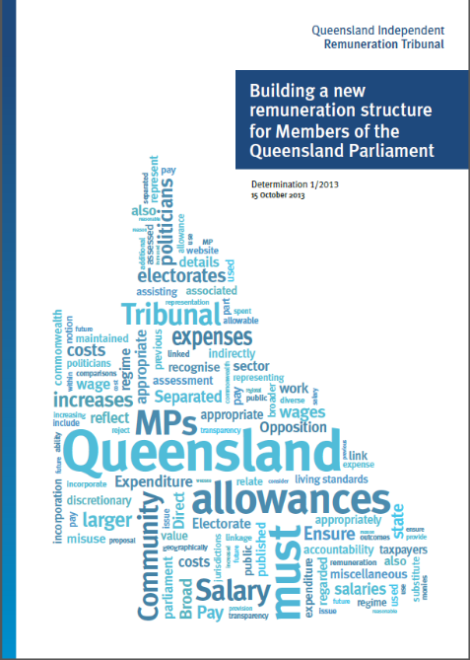
Determination 1/2013 is available at www.remunerationtribunal.qld.gov.au/determinations.aspx.
Under the Act, Determination 1/2013 was required to be handed down by 15 October 2013, just three months after the Tribunal’s establishment.
The importance of deciding the base salary of MPs flowed from the increase and subsequent repeal of a 41.9 per cent pay rise which received significant media coverage and highlighted the matter of the base salary to the broader public.
The allowances system also required consideration in light of the legislative requirement that allowances to MPs not be regarded as a substitute for other remuneration.
On 15 October 2013 the Tribunal handed down Determination 1/2013. This Determination dealt with two primary issues. Firstly, Determination 1/2013 established the level of the base salary of an MP.
Determination 1/2013 outlines that:
In relation to determination of the base salary of an MP, the Tribunal has holistically examined the role, functions and responsibilities of a Queensland MP taking into account, among other things, submissions received during the consultation process. References made in submissions to examining the role and work value of an MP have also been considered.
The Tribunal has undertaken a detailed comparison between historical changes in the base salary and various benchmarks. These benchmarks include general wage increases, the salary of other occupations, salary levels in the public sector and base salaries of MPs in other jurisdictions.
This analysis shows that the average annual increase in base salary has been 6.67% over the past 50 years. More recently from 1988 to 2007, the average annual change in base salary has been 5.23%. There has been no increase in base salary since August 2011.
In recent years the cumulative growth in the base salary has been lower than the cumulative growth in average weekly earnings. For instance, $1,000 in 2005–06 at the average annual growth in average weekly earnings would have a compounded value of $1,438 in 2012–13. In contrast the equivalent amount at the average annual growth rate in base salary would have a compounded value of $1,239.

The Tribunal has undertaken a comparison of the salary of an MP to other selected occupations including Teacher (base), Registered Nurse, Police Constable (first year), District Court Judge and the Auditor-General. The relativity of base salary has generally trended downward against these other professions.
The Tribunal has also undertaken a comparison of the growth over the last decade in base salary to various salary indices relating to the Queensland public service. The growth in base salary has been marginally less than the growth in salaries of the executive public service and less than the growth in salaries of the core public service. However the growth in the average public service salary exceeded the growth in MP base salary.
The Tribunal has further compared the base salary of a Queensland MP to those of other MPs in selected international jurisdictions and Australian jurisdictions. In terms of Australian state jurisdictions, the analysis reveals that over the past 10 years, the relativity of the base salary in Queensland has fallen behind that of the average of the other states. Presently, the base salary of a Queensland MP is lower (at 96.9%) than the average base salary of the other states. In dollar terms, this difference translates to $4,342. The difference becomes larger in the comparison with NSW, Victoria and Western Australia, with the base salary in Queensland now falling to 94.4% of the average base salary of these states. In dollar terms this difference translates to $8,138.
The Tribunal considers that the closest comparator is the base salaries paid to MPs in other states noting also that many of these salaries are set by independent tribunals within these jurisdictions which would have most likely carefully considered many of the factors that the Queensland Tribunal has had to consider.
The Tribunal concludes that an increase in MP base salary is justified. The Tribunal has concluded that no single benchmark is appropriate but rather a holistic approach is required that considers a range of benchmarks. In reaching its decision the Tribunal constructed a series of averages and determines that the base salary, as at 1 July 2013, be set at $144,485. The new salary level represents a total increase of 5.35% since August 2011.
In relation to the base salary increase for 2013–14 the Tribunal considered a range of factors and economic indicators. Using these benchmarks an average series has been developed for the period 1 July 2013 to 30 June 2014. The applicable rate for this 12 month period is 3.02%. The Tribunal will therefore apply an increase of 3.02% to the base salary from 1 July 2013.
The net effect of the Tribunal’s Determination of the base salary and percentage increase for 2013–14 results in a total base salary of $148,848 applicable from 1 July 2013.
Secondly, Determination 1/2013 contained significant reforms to the allowances and entitlements system to make the system more streamlined, accountable and transparent as follows:
Following an examination of the allowances and entitlements currently provided to MPs, as detailed in the Members’ Entitlements Handbook and Members’ Office Support Handbook, it is evident that the current system has a number of issues. It does not reflect modern society or advances in transport, technology and communication. It also lacks a comprehensive and transparent acquittal process.
The Tribunal notes that there is limited accountability and transparency in the current system, particularly in relation to the Members (Electorate) and Miscellaneous Allowances, and that this matter was raised by the majority of public submissions. In developing the new allowance system the Tribunal has endeavoured to increase the accountability and transparency of allowances and entitlements for MPs while at the same time enabling them flexibility to meet the diverse needs of their electorates.
The method by which entitlements and allowances are currently calculated also does not sufficiently take into account individual circumstances of an electorate or the role of an MP. For instance, a number of allowances are adjusted according to variations in the Consumer Price Index (CPI) rather than reflecting the changing needs of individual electorates and their constituents.
The Tribunal has determined a major overhaul to the allowances system. The new system, developed in close consultation with the Clerk of the Parliament and taking into account suggestions received from the public consultation, will provide a contemporary, transparent and accountable framework for MP allowances and entitlements.
Given the magnitude of the changes, some time is required to allow the administrative processes to be developed that will support the new system. The Tribunal has therefore set the remainder of 2013 as the period of transition with the new allowances system to be effective from 1 January 2014.
There will be three new categories of allowances and entitlements each with acquittal and reporting requirements. On 1 January 2014 the new system with three new categories of allowances for Queensland MP’s will be established. The three categories are:
- Electorate Allowance (e.g. expenditure incurred in supporting their electorate and its constituents)
- Information and Communication Allowance (e.g. expenditure incurred in obtaining and disseminating constituency and legislative information)
- General Travel Entitlement (e.g. expenditure incurred in travelling to conduct electorate and parliamentary business—excluding political party business as currently defined in the Entitlements Handbook—including:
  - Motor Vehicle Allowance
  - General Travel Allocation
  - Commercial Air Travel or Warrant Allocation.
The Tribunal’s review of the system has identified a large number of current allowances and entitlements that will be abolished noting that many of these are incorporated into the new categories of allowances and entitlements referred to above.
The Tribunal is also establishing new acquittal and reporting requirements for these allowances. These requirements are detailed in the Determination. The new system provides for a higher level of accountability as it requires acquittal and reporting for all items (apart from items below a materiality threshold) across all categories of allowances. This change will require MPs to undertake a greater level of record keeping but no more onerous than that required by the Australian Taxation Office for deductible expense claims or that required by many employers. As the new system will be introduced from 1 January 2014, MPs will be required to implement new record keeping systems from that date.

3.3 Determination 2/2013
On 14 November 2013 the Tribunal handed down Determination 2/2013 which set new rates for the Daily Travel Allowance and addressed minor and technical issues that had arisen during the implementation of Determination 1/2013. This Determination is available at www.remunerationtribunal.qld.gov.au/determinations.aspx.

3.4 Determination 3/2014
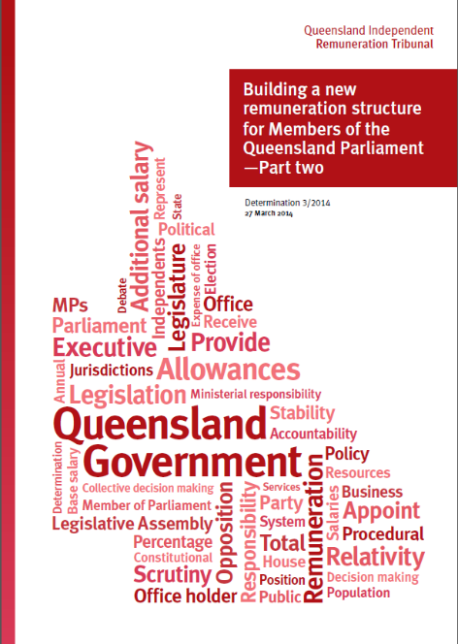
Determination 3/2014 was issued on 27 March 2014 and sets the additional salary levels for office holders of the Queensland Parliament (i.e. Premier, Ministers, and the Leader of the Opposition etc) as follows:
After detailed consideration of the role and responsibilities of the Premier, and a comparison against a range of benchmarks, the Tribunal has determined that the additional salary of the Premier be set at $230,312. This amount subsumes the Expense of Office Allowance, and includes a 3.02% increase for the current 2013-14 year, which is the same annual percentage increase that was applied to the base salary of an MP in Determination 1/2013.
Additional allowances associated with office holders will be abolished thereby providing greater transparency and consistency with the principle that allowances are not to be regarded as de-facto salary…
The Tribunal has also considered the roles and responsibilities of each office, where each office sits relative to the Premier in other jurisdictions and has undertaken targeted consultation with key stakeholders to determine where the additional salary of each office should sit relative to the additional salary of the Premier.
The Tribunal determined that the additional salary of each office holder would sit in one of ten bands relative to the additional salary of the Premier. Changes were back-dated to take effect as at 1 July 2013 for consistency with Determination 1/2013 and noting that there had been no increase in additional salaries since 1 August 2011.
This Determination also abolished the Expense of Office Allowance and Opposition Spokespersons’ Allowances effective 30 June 2014.

3.5 Determination 4/2014
On 27 March 2014 the Tribunal issued Determination 4/2014 that made minor amendments to the definition of Parliamentary Business. The Determination is available at www.remunerationtribunal.qld.gov.au/determinations.aspx.

3.6 Tribunal meetings
The Tribunal held meetings on 26 occasions from 18 July 2013 to 30 June 2014. Meetings were generally held in Brisbane at either the Executive Building, 100 George Street or Parliament House. The majority of meetings were held in person however technology was used on occasion to enable members to remotely attend Tribunal meetings as necessary. Tribunal members communicated via e-mail outside formal meetings to draft and finalise documentation. Minutes were produced for each meeting in accordance with the Act.
4 - Priorities for 2014-2015
The Tribunal’s priorities for 2014-2015 include an initial review of the new remuneration system for MPs including a review of the recently implemented allowances system.
The Tribunal will also review the 2014-2015 base salary rate for MPs.
A further matter that will be considered over the next year is to review the entitlements and allowances provided to former MPs of the Queensland Parliament.
5 - Financial statement
The Financial statement for the Queensland Independent Remuneration Tribunal (the Tribunal) has been prepared on an accrual basis in accordance with the prescribed requirements. The Department of the Premier and Cabinet provides Secretariat support to the Tribunal. The revenues and expenses recognised for the Tribunal do not include allocations for in-kind corporate support and executive management services which are provided by the Department of the Premier and Cabinet.
Financial Statement for period 16 July 2013 to 30 June 2014¹
 | NOTE | 2013-2014
Revenue from ordinary activities |  | $
Departmental Services revenue |  | 156,987
Total revenue from ordinary activities |  | 156,987
Expenses from ordinary activities
Establishment costs
Staff salaries and wages and related costs |  | 76,735
Salary-related taxes |  | 2,660
Superannuation |  | 5,545
Total establishment costs | 2 | 84,940
Tribunal Member Fees and related costs | 3 | 52,164
Supplies and services
Consultancy and Contractors |  | 2,820
Consumables |  | 1,181
Parking |  | 39
Travel costs |  | 215
Telecommunications costs |  | 1,008
Printing and communication costs |  | 11,389
Legal costs |  | 3,231
Total supplies and services |  | 19,883
Total expenses from ordinary activities |  | 156,987
Net Operating Result |  | -

Notes to and forming part of the financial statement:
- The reporting period for the financial statement is 16 July 2013 to 30 June 2014. No comparative data exist for the Tribunal as it is in its first year of operation. This financial statement and associated notes have not been audited. Full audited statements will be included in the Department of the Premier and Cabinet 2013-2014 Annual Report.
- Total expenses for the period ended 30 June 2014 include establishment costs associated with the initial set up of the Tribunal. These establishment costs are non-recurrent.
- The table below provides total remuneration received by members of the Tribunal for the period 16 July 2013 to 30 June 2014. This table is less than the amount disclosed in the financial statement as Tribunal Member Fees and related costs due to the inclusion of accruals in the financial statement figure of $52,164.

Tribunal Remuneration
Member |  |  | Post | Total
 |  | Short Term | Employment | Remuneration
BRAILSFORD, Timothy J |  | $ 16,770 | $ 1,551 | $ 18,321
HARRISON, David H |  | $ 14,581 | $ 1,349 | $ 15,930
JESSOP, Joanne B |  | $ 14,313 | $ 1,324 | $ 15,637
 |  | $ 45,664 | $ 4,224 | $ 49,888

