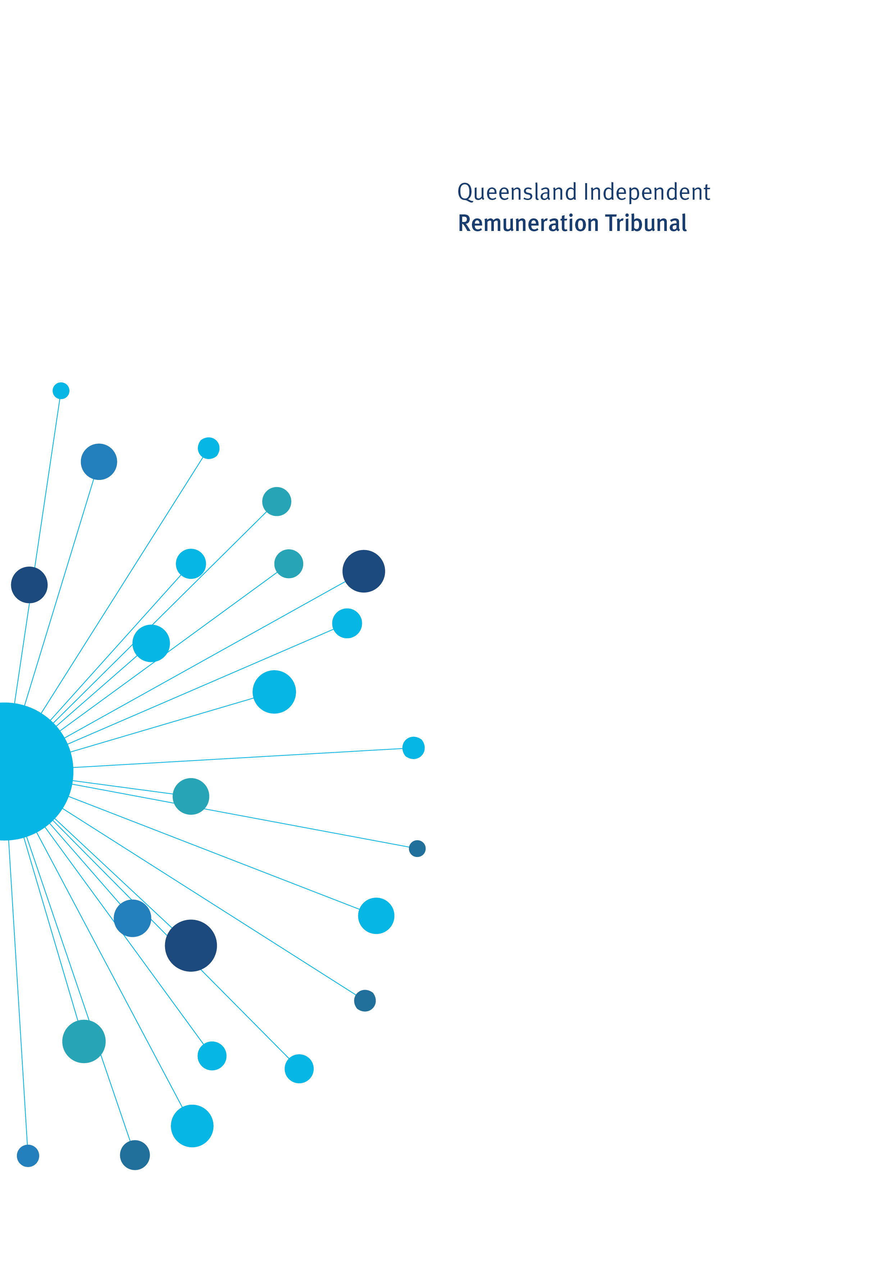

Determination 30/2024

19 February 2024

Remuneration Determination

2022-23 Review of Allowances

Determination 30/2024

Background and Reasons
  - Tribunal roles and responsibilities
The Queensland Independent Remuneration Tribunal Act 2013 (the Act) provides for the Queensland Independent Remuneration Tribunal (the Tribunal) to:
- review and determine remuneration (annual and additional salaries, allowances and entitlements) in connection with members and former members of the Queensland Legislative Assembly (Remuneration Determination); and
- review and determine entitlements of cross bench members to additional staff members (Additional Staff Member Determination).
For a Remuneration Determination, the Tribunal may have regard to the value to the community of a Member of the Legislative Assembly (member) carrying out their role, functions and responsibilities and the importance of a member being appropriately remunerated for carrying out their role. The Tribunal may also consider relevant laws and any other matters the Tribunal considers appropriate including, for example, the size of an electorate (section 29 of the Act). Before making a Determination, the Tribunal must consult with and consider the views of the Clerk of the Parliament (the Clerk).
The Tribunal must ensure any allowances paid to a member reflect the reasonable expenses incurred by a member in servicing their electorate and ensure these allowances are not a substitute for other remuneration and that accommodation services or other entitlements mentioned in section 59D of the Act (such as electorate offices, staffing support and major items of office equipment) are not taken into account (section 30 of the Act).
  - Submissions and consultation
  - The Tribunal received submissions from the Clerk, the Committee of the Legislative Assembly (the CLA) and related correspondence from individual members. All submissions have been considered in making Determination 30/2024.
  - Electorate and Communication Allowance (ECA)
The ECA is provided to cover a range of expenditure associated with:
- providing constituent assistance and service for the electorate
- obtaining and disseminating information to constituents that is relevant to fulfilling a member’s parliamentary and constituency responsibilities
- meeting incidental costs relating to the operation of a member’s electorate office.
The ECA may not be used to meet expenditure for:
- private or commercial purposes or to purchase goods and services where the member, or a connect party, is the provider of the goods and services
- political party activity; or
- electioneering/campaigning purposes.
Electorates are grouped into four bands based on the following formula which recognises the impact of both number of enrolled electors and land area of the electorate on the usage of the ECA:
Band = (60 cents per person registered on the electoral roll) + (1.5 cents per square kilometre of electorate area (land only)).
The bands of the ECA were adjusted in Determination 28/2023 to recognise the increases in registered voters across electorates and to continue to maintain the differentiation between the bands on both electoral roll figures and the geographical size.
Table 1: Quantum of ECA per ECA band
Band | Quantum of ECA for each Band
1 | $93,400
2 | $95,200
3 | $97,700
4 | $100,200
Members representing an electoral district of 100,000km² or more can elect to be provided with an additional electorate office. If the member has a second electorate office, they receive an additional $1,500 per annum to supplement the ECA to assist with electorate office cleaning costs.
In Determination 26/2022 the Tribunal established a ‘high enrolment supplement’. Members are eligible for the high enrolment supplement if:
- the electorate is in ECA Band 4; and
- the number of electors is 25% or more above the quota, over a period of six consecutive months, determined in accordance with the ECQ monthly enrolment data.
In Determination 27/2022 the amount of the high enrolment supplement was set at $5,000 per financial year. Currently only the Member for Coomera is eligible for the high enrolment supplement.
The ECA is divided into seven categories of expenditure for acquittal and reporting purposes:
- support for constituents and organisations
- hosting costs
- production, publication and distribution services
- telecommunications and data costs
- minor equipment
- office expenses
- other
Expenditure over 100% of the ECA is not publicly reported and is met personally by the member and cannot be offset against future reporting period allowances.

  - General Travel Entitlement (GTE)
The GTE consists of three components:
- the Motor Vehicle Allowance - covers expenditure incurred in acquiring and maintaining a member’s vehicle.
- the General Travel Allocation - covers a range of travel expenses incurred by members (and in limited cases, their spouses and staff) when required to travel for the primary purpose of conducting Parliamentary Business (incorporates air and ground travel and overnight expenses).
- Air Warrant (Alternate) travel - facilitates travel from certain regional electorates to/from Brisbane to conduct Parliamentary Business.
The Parliamentary Business Overnight Rate (Brisbane) (PBOR) can also be claimed (outside of the GTA) by members representing certain electorates for overnight stays in Brisbane where the member is travelling for the primary purpose of conducting Parliamentary Business in Brisbane city.
  - Motor Vehicle Allowance (MVA)
The MVA is provided to cover expenditure incurred in acquiring and maintaining a member’s vehicle. It is paid to members in advance on a quarterly basis and there is no carry over to the following year. A motor vehicle purchased or leased with the assistance of this allowance is the property of the member.
The MVA bands, amounts and electorate sizes are detailed in table 2.
Table 2: Motor Vehicle Allowance
Band | MVA amount | Electorate km2
Band 1 | $27,778 | 0-1000
Band 2 | $34,850 | 1001-10,000
Band 3 | $45,715 | 10,001 and over
In accordance with Determination 2/2013, the MVA is not subject to acquittal, reporting or audit requirements. The allowance is subject to PAYG income tax and members are required to comply with Australian Taxation Office (ATO) requirements as they relate to motor vehicle allowances.
  - General Travel Allocation (GTA)
The GTA is the primary travel entitlement available to all members. It covers a range of travel expenses incurred by members (and in limited cases their spouses/staff) when the member is required to travel to conduct ‘Parliamentary Business’.
Types of expenditure that may be claimed include air travel, ground travel and overnight expenses (Daily Travel Allowance). The GTA is an allocation held by the Parliamentary Service and claimed by members.

There are four bands of the GTA based on the land area of each electorate. The current bands, amounts and ranges are listed in table 3.
Table 3: General Travel Allocation Bands
Band | Amount | Range km2
1 | $18,360 | 0 – 4,499
2 | $30,040 | 4,500 - 49,999
3 | $40,000 | 50,000 – 99,999
4 | $79,700 | 100,000 and over
The Daily Travel Allowance (DTA) is claimable from the GTA for overnight stays and the current rates are:
- $416 per day for State and Territory capital cities within Australia, as well as Wellington in New Zealand and Port Moresby in Papua New Guinea
- $330 per day for all other destinations.
  - Discussion
On 26 September 2023, the Clerk tabled in the Legislative Assembly:
- the Annual Report of Electorate and Communication Allowance Expenditure by Members of the Legislative Assembly 1 July 2022 – 30 June 2023
- the Annual Report of the General Travel Allocation Expenditure by Members of the Legislative Assembly 1 July 2022 to 30 June 2023 (GTA report) and
- the Annual Report of Air Warrant and Alternate Travel Expenditure by Members of the Legislative Assembly 1 July 2022 to 30 June 2023 (Air Warrant report).
The Tribunal considered:
- a range of economic indices including the Consumer Price Index for Brisbane, Wage Price Index (public and private sectors), Queensland economic growth, inflation outlook, economic forecasts and projections;
- previous decisions of the Tribunal relating to the quantum of allowances and uses; and
- any increases or decisions regarding allowances for members in other jurisdictions.
  - Electorate and Communication Allowance
The Tribunal has reviewed members’ expenditure of the ECA for 2022 - 23 and makes the following observations:
- ninety-two members expended over 80% of their ECA with an average acquittal amount of 96% of allocated ECA in 2022-23;
- distribution of expenditure across the seven categories of ECA has remained relatively consistent with previous years; and
- consistent with previous financial years, Production, Publication and Distribution Services constituted the primary category of expenditure followed by Support for Constituents and Organisations.

The Tribunal is cognisant that the ECA is not a form of salary and is provided to members for serving their electorates and supporting constituents. Further the Tribunal notes that the band adjustment made in Determination 28/2023 was based on increases in the number of enrolled electors and did not take into account other economic factors or expenditure data.
The Tribunal has decided to increase all bands of the ECA and the High Enrolment Supplement by 4.0% with effect from 1 July 2023.
The Tribunal also decided that the High Enrolment Supplement should be increased by 4.0% with effect from 1 July 2023.
  - General Travel Entitlement
  - Motor Vehicle Allowance
In considering the MVA the Tribunal also considered the RACQ’s Annual Private Vehicle Expenses Report and fuel cost reports on the cost of owning and operating vehicles for private purposes over the last five years. The Tribunal noted increased costs for fuel, registration and insurance, tyres and battery, and service and repairs. The Tribunal also noted the differing increases across car types including electric vehicles.
The Tribunal decided to increase all bands of the MVA by 3.0% with effect from 1 January 2024.
  - General Travel Allocation
The Tribunal has reviewed the GTA report and the Air Warrant report. The Tribunal makes the following observations about members’ claims from the GTA for 2022 – 23:
- total GTA claimed for 2022-23 by all members is significantly higher than the previous three financial years which were impacted by the COVID-19 pandemic, and is higher than pre-COVID GTA claims in 2018-19;
- categories of GTA claims in 2022-23 are consistent with GTA claims made in 2018-19 prior to the COVID-19 pandemic, with the exception of the DTA where the total amount claimed was significantly higher in 2022-23; and
- airfares and the DTA continue to be the primary categories of GTA claimed by members.
In considering the GTA, the tribunal also noted the annual growth in national domestic travel and accommodation prices in 2022-23.
The Tribunal has decided to increase all bands of the GTA by 4.0% with effect from 1 January 2024.
  - Opposition Spokespersons
In their submissions, the Clerk and the CLA raised that Opposition Spokespersons and Leaders of Minor Parties are called upon to undertake official travel more frequently than the majority of other backbench members and there is no recognition in the current framework for this additional travel.
Noting claims made by Opposition Spokespersons and Leaders of Minor Parties from the GTA in 2022-23, the Tribunal confirms its position expressed in Determination 21/2020 that there should be some provision made for Opposition Spokesperson travel. The Tribunal resolved to write again to the Premier requesting consideration be given to amending the Queensland Opposition Handbook and adjusting the Opposition Budget.
  - Severance arrangements
In their submission to the Tribunal the CLA request that the Tribunal consider the severance arrangements available for Members. The Tribunal noted the CLA’s view that the function of the resettlement allowance is to assist a member transition from life in parliament to life out of parliament and should apply to all members.
The entitlements payable to former Members including severance arrangements were considered by the Tribunal in Determination 5/2014. The existing severance arrangements are:
- Resettlement Allowance for member elected or returned to parliament at, or since, the September 2006 election and before 1 October 2014; and
- Transition Allowance for members elected on or after 1 October 2014.
The Tribunal has reviewed the severance arrangements as outlined in Determination 26/2022. The Tribunal remains of the view that the current arrangements will remain unchanged.

Determination 30/2024
Any inconsistencies between earlier Tribunal Determinations and Determination 30/2024 are resolved in favour of Determination 30/2024. Matters in earlier Determinations not addressed in this Determination are confirmed by the Tribunal and not amended.
  - Electorate and Communication Allowance
- The Tribunal determines that all bands of the Electorate and Communication Allowance are increased by 4.0% with effect from 1 July 2023.
- The Tribunal determines that the High Enrolment Supplement is increased by 4.0% with effect from 1 July 2023.
  - Motor Vehicle Allowance
- The Tribunal determines that all bands of the Motor Vehicle Allowance are increased by 3.0% with effect from 1 January 2024.
  - General Travel Allocation
- The Tribunal determines that all bands of the General Travel Allocation are increased by 4.0% with effect from 1 January 2024.

Date of Determination: 19 February 2024

_______________________ ___________________ ___________________
Keitha Dunstan Jim Varghese Patrick Weller
Chairperson Member Member

Determination 16/2017.
During the 2022-23 financial year, the Member for Coomera was paid the high enrolment supplement of $1250 for 1 July 2022 – 31 December 2022 and $2500 for 1 January 2023 - 30 June 2023.
Definition of Parliamentary Business includes Parliamentary Committee business and is provided at p.23 of the Remuneration Handbook available at Members' and Former Members' Entitlements | Queensland Parliament (https://www.parliament.qld.gov.au/Members/Members-and-Former-Members-Entitlements).
https://www.racq.com.au/-/media/project/racqgroup/racq/pdf/articles/news/2023/9/2023-running-costs-racq-final.pdf?rev=61307c2d5e6a42888451ffb5abe101a4&hash=D3C38144A4D84E86C603FF76861ED4AF
RACQ Fair Fuel Price - Fuel Prices - RACQ - RACQ

