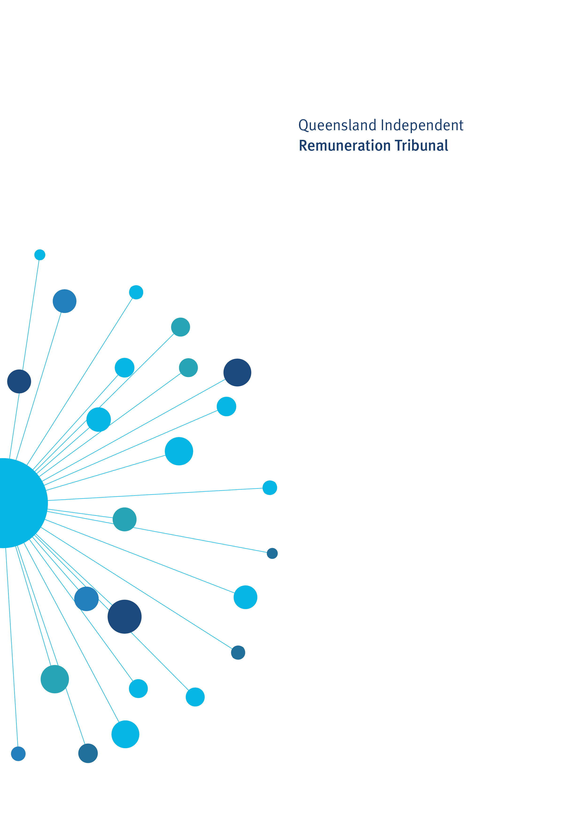

Remuneration Determination

Review of Base and Additional Salary Levels of Members of the Queensland Legislative Assembly 2021

Determination 25/2021

31 May 2021

Determination 25/2021

Background and Reasons

Tribunal roles and responsibilities
The Queensland Independent Remuneration Tribunal Act 2013 (the Act) provides for the Queensland Independent Remuneration Tribunal (the Tribunal) to:
- review and determine remuneration (base and additional salaries, allowances and entitlements) in connection with members and former members of the Queensland Legislative Assembly (Remuneration Determination), and
- review and determine entitlements of cross bench members to additional staff members.
For a Remuneration Determination, the Tribunal may have regard to the value to the community of a member carrying out their role, functions and responsibilities and the importance of a member being appropriately remunerated for carrying out their role. The Tribunal may also consider relevant laws and any other matters the Tribunal considers appropriate including, for example, the size of an electorate (section 29 of the Act). Before making a Determination, the Tribunal must consult with and consider the views of the Clerk of the Parliament (the Clerk).
The Tribunal is required to make a Remuneration Determination on base and additional salary within 90 days after a public service salary decision is made. The determination is capped at the rate of increase to the salary or wage of a departmental employee under the public service salary decision and must take effect on the same day the increases take effect for the public service employee under the public service salary decision (section 31A of the Act).

Base and Additional Salary for Members
Members are entitled to an annual base salary (section 41 of the Act) and an annual additional salary for holding an ‘office’ (section 42 of the Act). A member who holds an office is entitled to one additional salary on top of their annual base salary. Additional salary rates for various officeholders are grouped into bands with reference to the additional salary rate of the Premier.
The current base and additional salary rates are provided below and are effective on and from 1 September 2017:
Member/Office Holder | Annual base salary ($) | Annual Additional Salary ($) | Relativity to Premier’s additional salary | Annual Aggregate Salary ($)
Band 1  Premier | $159,122 | $240,833 | 100% | $399,955
Band 2  Deputy Premier | $159,122 | $192,666 | 80% | $351,788
Band 3  Minister and Leader of the House | $159,122 | $174,604 | 72.5% | $333,726
Band 4  - Minister  - Leader of the Opposition | $159,122 | $168,583 | 70% | $327,705
Band 5  - Speaker  - Assistant Minister and Leader of the House | $159,122 | $144,500 | 60% | $303,622
Band 6  Leader of the House | $159,122 | $120,417 | 50% | $279,539
Band 7  Deputy Leader of the Opposition | $159,122 | $96,333 | 40% | $255,455
Band 8  - Deputy Speaker  - Assistant Minister  - Manager of Opposition Business  - Chief Government Whip | $159,122 | $84,292 | 35% | $243,414
Band 9  - Opposition Spokesperson  - Leader of a Recognised Political Party  - Chairperson of a Committee (including a select committee) | $159,122 | $60,208 | 25% | $219,330
Band 10  - Senior Government Whip  - Opposition Whip | $159,122 | $36,125 | 15% | $195.247
Band 11  - Government Deputy Whip  - Deputy Opposition Whip | $159,122 | $30,104 | 12.5% | $189,226
Band 12  Member of a Committee (including a select committee) | $159,122 | $24,083 | 10% | $183,205
A summary of the salary increases for members and office holders in Queensland in accordance with determinations of the Tribunal since its establishment in 2013 is below:
Date | Base Salary increase | Additional salary increase
1 July 2013 | 3.02% | 3.02%
1 September 2015 | 2.25% | 1.5%
1 September 2016 | 2.25% | 1.5%
1 September 2017 | 2.25% | 1.5%
1 September 2019 | 0.00% | 0.00%
1 September 2020 | 0.00% | 0.00%

  - Background to the current determination

On 1 March 2021, the Queensland Industrial Relations Commission (QIRC) made Wages Determination: Certification of Salary Schedules (Wages Determination) which varied the State Government Entities Certified Agreement 2019 (the 2019 Certified Agreement) to:
- set the salary rate for public service employees under the core agreement at 1 September 2020 as the award rate current at that time (this will be the rate upon which annual increases will be made);
- align the salary increase dates for public service employees with the dates prescribed in the Industrial Relations Act 2016 which was amended in 2020, that is:
- 2.5% wage increase from 1 September 2019
- 2.5% wage increase from 1 September 2021
- 2.5% wage increase from 1 March 2022
- 2.5% wage increase from 1 September 2022.’
The Tribunal has decided that the Wages Determination is a ‘public service salary decision’ for the purposes of section 31A of the Act, triggering the requirement for the Tribunal to make a salary Remuneration Determination within 90 days of 1 March 2021.
Determination 25/2021 will supersede and replace Determination 21/2020 which set the base and additional salary levels of members in accordance with the 2019 Certified Agreement (prior to revision) at a 0% increase for:
- 1 September 2019
- 1 September 2020
- 1 September 2021
- 1 September 2022.

  - Public Service Salary considerations

The Tribunal noted the decisions of the QIRC in the Wages Determination State Wage Case 2020 (State Wage Case) delivered on 26 August 2020 and the Fair Work Commission (FWC) in its Annual Wage Review 2019-20 Decision (FWC Annual Wage Review).
The State Wage Case decision increased the wages or salaries for full time adult employees in all awards by 1.75% from 1 September 2020. This increase was in addition to State Wage Case decisions that increased wages rates by 3.5% and 3% in September 2018 and 2019 respectively. In reaching its 2020 decision the QIRC considered the impact of the COVID-19 pandemic and the unprecedented social and economic consequences of the pandemic on employment and inflation levels.
The FWC Annual Wage Review increased minimum wages by 1.75%, noting that the review was occurring during a global pandemic and that the resulting changes to how work and society is conducted have resulted in ‘substantial economic consequences’. The FWC also noted that unemployment and underemployment have increased and wages growth has declined. In deciding to provide an increase the FWC noted that granting no increase would have reduced the living standards of low-paid award-reliant employees and impact gender pay equity.
  - Economic considerations

While the economic forecast and outlook continue to remain uncertain as a result of the COVID-19 pandemic, it appears that the economy is rebounding, and the outlook is more positive than at the height of the pandemic in 2020 when the salary levels of members were last considered by the Tribunal.
In making its salary determination, the Tribunal further considered the latest available economic indices including the Consumer Price Index, the Wage Price Index (public and private sectors), the unemployment rate, jobs growth figures and the Queensland Government indexation rates for fees and charges and community funding/grants.
The Tribunal also noted the most recent economic commentary by Mr Philip Lowe, Governor, Reserve Bank of Australia in his statement on 4 May 2021 Monetary Policy Decision.9 Mr Lowe noted that the economic recovery in Australia has been stronger than expected and is forecast to continue. The recovery is especially evident in the growth in employment and the fall in the unemployment rate. Despite the strong recovery, Consumer Price Index data confirmed that inflation pressures remain subdued in most parts of the Australian economy with a pick up in inflation and wages growth expected to be gradual and modest.
The Tribunal has also considered the following indices and their annual changes from 2001-2020:
- the base salary of members
- Average Weekly Earnings in the public and private sectors
- the Queensland core public service (covered by the 2019 Certified Agreement)
- the Queensland Senior Executive Service.

Annual changes in member base salary and other salary indices 2001–202010

Year | MP Base Salary | Average Weekly Earnings, Public Sector | Average Weekly Earnings, Private and Public Sector | Consumer Price Index (CPI) | Qld Core Public Service | Senior Executive Service (SES)
2000-01 | 3.93% | 6.97% | 6.70% | 6.15% |  | 3.14%
2001-02 | 3.37% | 4.18% | 3.79% | 3.03% |  | 3.13%
2002-03 | 4.03% | 3.19% | 5.22% | 2.68% |  | 3.97%
2003-04 | 3.92% | 4.44% | 4.95% | 3.13% | 3.80% | 3.96%
2004-05 | 4.12% | 4.61% | 7.41% | 2.53% | 3.80% | 0.00%
2005-06 | 7.05% | 5.42% | 2.25% | 4.19% | 4.00% | 3.95%
2006-07 | 6.85% | 4.54% | 5.65% | 2.60% | 4.00% | 8.16%
2007-08 | 0.00% | 3.99% | 5.57% | 5.07% | 4.00% | 4.00%
2008-09 | 0.00% | 4.96% | 6.16% | 1.98% | 4.50% | 2.50%
2009-10 | 3.14% | 5.17% | 6.05% | 3.23% | 4.00% | 2.50%
2010-11 | 2.50% | 5.12% | 4.23% | 3.86% | 4.00% | 2.50%
2011-12 | 2.50% | 4.15% | 3.77% | 0.90% | 0.00% | 2.20%
2012-13 | 5.35% | 3.80% | 7.65% | 1.99% | 0.00% | 2.20%
2013-14 | 3.02% | 2.43% | 1.07% | 3.22% | 2.20% | 2.20%
2014-15 | 0.00% | 1.56% | 0.15% | 1.51% | 2.20% | 2.20%
2015-16 | 2.25% | 3.54% | 1.35% | 1.49% | 2.50% | 2.50%
2016-17 | 2.25% | 2.82% | 2.45% | 1.83% | 2.50% | 2.50%
2017-18 | 2.25% | 3.69% | 3.06% | 1.71% | 2.50% | 2.50%
2018-19 | 0.00% | 4.15% | 2.29% | 1.68% | 0.00% | 0.00%
2019-20 | 0.00% | 2.22% | 4.32% | -1.05% | 2.50% | 0.00%
5-year ave to 2019-20 | 1.34% | 3.28% | 2.69% | 1.13% | 2.00% | 1.49%
10-year ave to 2019-20 | 2.00% | 3.34% | 3.01% | 1.71% | 1.83% | 1.88%

 | MP Base Salary | Average Weekly Earnings, Public Sector | Average Weekly Earnings, Private and Public Sector | CPI | Qld Core Public Service | SES
$1,000 indexed since 2004-05 to 2019-20 | $1,497 | $1,839 | $1,856 | $1,436 | $1,522 | $1,479

Data | Source
MP Base Salary | MP Base Salary increase from 1 July in financial year
Average Weekly Earnings, Public Sector | ABS 6302.0 - Average Weekly Ordinary Time Earnings - Qld ; Persons ; Full Time ; Adult ; Public Sector
Average Weekly Earnings, Private and Public Sector | ABS 6302.0 - Average Weekly Ordinary Time Earnings - Qld ; Persons ; Full Time ; Adult ; Total (Public and Private Sector)
CPI | ABS 6401.0 - Consumer Price Index - All groups CPI; Brisbane
QLD Core Public Service | Wage increases of 'core' government departments and agencies, State Government Entities Certified Agreement (2003, 2006, 2009, 2013,2015, 2019)
SES Remuneration | Based on SES Remuneration Scale provided by the Public Service Commission

  - Jurisdictional considerations

In 2020 there were no salary increases provided to members in other jurisdictions.
Since 2013 when the base salary of Queensland members was set by the Tribunal, the base salary levels have fallen below the levels of comparable jurisdictions. See table below.
Jurisdiction | Base Salary 2013 | Base Salary 2020 | Total % change | Average annual % change
Queensland | 144,485 | 159,122 | 10.1 | 1.4
New South Wales | 146,251 | 169,192 | 15.7 | 2.1
South Australia | 153,130 | 169,250 | 10.5 | 1.4
Western Australia | 148,638 | 156,536 | 5.3 | 0.7
Northern Territory | 143,122 | 162,696 | 13.7 | 1.8
Victoria | 140,973 | 182,413 | 29.4 | 3.8
Australian Capital Territory | 125,259 | 168,492 | 34.5 | 4.3
Tasmania | 118,466 | 140,184 | 18.3 | 2.4
In 2014 the Tribunal set the additional salaries of Queensland office holders relative to the additional salary of the Premier. The additional salary levels of Queensland office holders have also declined relative to other jurisdictions. A comparison of the salary of the Queensland Premier compared with the Premier/Chief Minister in other jurisdictions is below.
Jurisdiction | Base and Additional Salary 2014 | Base and Additional Salary 2020 | Total % change | Average annual % change
Queensland | 379,160 | 399,955 | 5.5 | 0.9
New South Wales | 350,628 | 407,980 | 16.4 | 2.6
South Australia | 306,260 | 338,500 | 10.5 | 1.7
Western Australia | 344,840 | 355,681 | 3.1 | 0.5
Northern Territory | 272,000 | 325,392 | 19.6 | 3.0
Victoria | 341,155 | 441,439 | 29.4 | 4.4
Australian Capital Territory | 263,044 | 353,833 | 34.5 | 5.1
Tasmania | 268,918 | 301,396 | 12.1 | 1.9

Discussion
In reaching their decision, the Tribunal considered the following:
- the decisions of the QIRC and FWC and the bases upon which those decisions were made
- the changing and evolving economic environment arising from the COVID-19 pandemic since the Tribunal last considered the salary levels of members in 2020
- the current base and additional salary levels of members in Queensland and that members have not had a salary increase since 1 September 2017
- salary increases provided to members in other jurisdictions and that the salary levels of Queensland members has fallen behind comparable jurisdictions
- community expectations and the value to the community of a member performing their role, functions and responsibilities.
The Tribunal has decided that:
- the relativity between base and additional salary levels should be retained, that is, any increase applying to the base salary level will also apply to additional salary levels
- since the Tribunal considered salary levels in 2020, the economic and social circumstances have stabilised to the extent that a salary increase is now justified for members
- the base and additional salary rates for members will be increased as follows:
- 0% increase with effect on and from 1 September 2019
- 2.00% increase with effect on and from 1 September 2021
- 2.25% increase with effect on and from 1 March 2022
- 2.5% increase with effect on and from 1 September 2022.

Determination 25/2021
Any inconsistencies between earlier Tribunal Determinations and Determination 25/2021 are resolved in favour of Determination 25/2021. Matters in earlier Determinations not addressed in this Determination are confirmed by the Tribunal and not amended.
  - Salary
- The Tribunal determines that the following increases will apply to the annual base and additional salary rates of Members of the Legislative Assembly:
- 0% increase with effect on and from 1 September 2019
- 2.00% increase with effect on and from 1 September 2021
- 2.25% increase with effect on and from 1 March 2022
- 2.5% increase with effect on and from 1 September 2022.

Date of Determination: 31 May 2021
Effective Date: Various

_______________________ __________________ ___________________
Mr Walter Tutt Ms Jill Lang AM Emeritus Professor
Chairperson Member Patrick Weller AO, FASSA
Member

Queensland Industrial Relations Commission (QIRC): Matter No. CB/2020/78, Wages Determination, Certification of Salary Schedules, available at: https://www.qirc.qld.gov.au/sites/default/files/2020_cb78.pdf?v=1616657230
QIRC: Matter No. CB/2020/78, Wages Determination, Reprint of Certified Agreement, available at: https://www.qirc.qld.gov.au/sites/default/files/2020_cb78_reprint.pdf?v=1616728595 page 7.
QIRC, Declaration of General Ruling (State Wage Case 2020) [2020] QIRC 132, https://www.qirc.qld.gov.au/sites/default/files/2020_b40_b41_b43_declaration_260820.pdf?v=1598489336
Fair Work Commission (FWC), Summary of Decision, Annual Wage Review 2019-20, C2020/1, [2020] FWCFB3501, https://www.fwc.gov.au/documents/wage-reviews/2019-20/decisions/2020fwcfb3501.pdf
QIRC, Declaration of General Ruling (State Wage Case 2020) [2020] QIRC 132, https://www.qirc.qld.gov.au/sites/default/files/2020_b40_b41_b43_declaration_260820.pdf?v=1598489336
FWC, Summary of Decision, Annual Wage Review 2019-20, C2020/1, [2020] FWCFB3501, https://www.fwc.gov.au/documents/wage-reviews/2019-20/decisions/2020fwcfb3501.pdf, paragraph 2.
Ibid, paragraph 14.
Ibid, paragraphs 28, 29 and 31.
9 Media Release, Statement by Philip Lowe, Governor: Monetary Policy Decision, number 2021-06, 4 May 2021, https://www.rba.gov.au/media-releases/2021/mr-21-06.html
10 Data provided by the Queensland Government’s Statistician’s Office.
See Determination 1/2013.
See Determination 3/2014
New South Wales and Victoria provide an ‘Expense of Office Allowance’ (or equivalent) to office holders. The Expense of Office Allowance has been included in the total base and additional salary rates included above.

