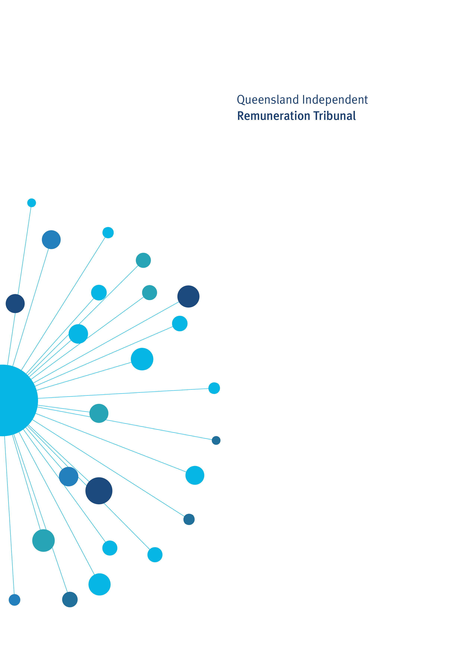

Remuneration Determination

Electorate and Communication Allowance Band Adjustment 2021

Determination 24/2021

10 May 2021

Determination 24/2021

Background and Reasons

Tribunal roles and responsibilities
The Queensland Independent Remuneration Tribunal Act 2013 (the Act) provides for the Queensland Independent Remuneration Tribunal (the Tribunal) to:
- review and determine remuneration (annual and additional salaries, allowances and entitlements) in connection with members and former members of the Queensland Legislative Assembly (Remuneration Determination), and
- review and determine entitlements of cross bench members to additional staff members (Additional Staff Member Determination).
For a Remuneration Determination the Tribunal may have regard to the value to the community of a member carrying out their role, functions and responsibilities and the importance of a member being appropriately remunerated for carrying out their role. The Tribunal may also consider relevant laws and any other matters the Tribunal considers appropriate including, for example, the size of an electorate (section 29 of the Act). Before making a Determination, the Tribunal must consult with and consider the views of the Clerk of the Parliament (the Clerk).
The Tribunal must ensure any allowances paid to a member reflect the amount of reasonable expenses incurred by a member in servicing their electorate; ensure these allowances are not a substitute for other remuneration; and ensure accommodation services or other entitlements provided for in section 55 of the Act are not taken into account, such as electorate offices, staffing support and major items of office equipment (section 30 of the Act).

Electorate and Communication Allowance
Electorate and Communication Allowance
The Electorate and Communication Allowance (ECA) is provided to cover a range of expenditure associated with:
- providing constituent assistance and service for the electorate
- obtaining and disseminating information to constituents that is relevant to fulfilling parliamentary and constituency responsibilities
- meeting incidental costs relating to the operation of a member’s electorate office.

The ECA may not be used to meet expenditure for:
- private or commercial purposes or to purchase goods and services where the member, or a connected party is the provider of the goods and services
- political party activity
- electioneering and campaigning purposes.

ECA bands and electoral roll data
Electorates are grouped into four bands based on a formula of (60c per person registered on the electoral roll) + (1.5c per square kilometre of electorate) in recognition of the impact of population and area on usage of the ECA. The current bands are:

Band | Quantum of ECA for each band
1 | $89,200
2 | $90,900
3 | $93,400
4 | $95,200

Previously, the Tribunal has committed to reviewing electoral roll data and making any necessary adjustments to the allocation of electorates to bands. Review of electoral roll data as at 29 January 2021 reveals that there has been an upward trend in voter registrations. An additional 67,760 voters have been added to the State electoral roll since electoral roll data was previously considered by the Tribunal as at 30 June 2020. This increase in voter registration may be attributed to the 2020 State General Election held on 31 October 2020.
Applying the new electoral roll figures to the ECA formula and ensuring that members of certain electorates are not disadvantaged would result in 36 electorates moving up ECA bands as follows:
Band | Quantum of ECA | No. of electorates at 30 June 2020 | No. of electorates at 29 January 2021
1 | $89,200 | 22 | 8
2 | $90,900 | 28 | 33
3 | $93,400 | 31 | 28
4 | $95,200 | 12 | 24
Accordingly, with effect from 1 January 2021 the ECA bands will be set as follows:
Band | Amount | Electorates in each Band
1 | $89,200 | Gaven, Gladstone, Ipswich, Mundingburra, Oodgeroo, Stretton, Toohey, Waterford
2 | $90,900 | Algester, Bonney, Broadwater, Bundaberg, Burleigh, Burnett, Capalaba, Chatsworth, Currumbin, Ferny Grove, Glass House, Hinchinbrook, Inala, Ipswich West, Lockyer, Mansfield, Maroochydore, Mermaid Beach, Miller, Mirani, Moggill, Mount Ommaney, Mulgrave, Nicklin, Rockhampton, Southport, Springwood, Surfers Paradise, Theodore, Thuringowa, Townsville, Whitsunday
3 | $93,400 | Aspley, Bancroft, Barron River, Buderim, Burdekin, Callide, Cairns, Condamine, Cooper, Everton, Greenslopes, Kawana, Keppel, Kurwongbah, Logan, Lytton, Macalister, Morayfield, Nanango, Noosa, Nudgee, Pine Rivers, Redlands, Sandgate, Scenic Rim, Southern Downs, Toowoomba North, Toowoomba South, Woodridge
4 | $95,200 | Bulimba, Bundamba, Caloundra, Clayfield, Cook, Coomera, Gregory, Gympie, Hervey Bay, Hill, Jordan, Mackay, Maiwar, Maryborough, McConnel, Mudgeeraba, Murrumba, Ninderry, Pumicestone, Redcliffe, South Brisbane, Stafford, Traeger, Warrego
The current acquittal and reporting requirements for the ECA are maintained.
Quantum of ECA bands
The Tribunal takes an evidence-based approach to assessing the quantum of each band of the ECA. Accordingly, the Tribunal will consider the quantum of the ECA bands as part of its annual allowances review which will be undertaken after mid-year when data is available from the Clerk of the Parliament to assess the appropriateness of the allowances.

Determination 24/2021
Any inconsistencies between earlier Tribunal Determinations and Determination 24/2021 are resolved in favour of Determination 24/2021. Matters in earlier Determinations not addressed in this Determination are confirmed by the Tribunal and not amended.
Electorate and Communication Allowance
- The Tribunal determines that electorates will be allocated to the following Electorate and Communication Allowance bands with effect from 1 January 2021:
Band | Amount | Electorates in each Band
1 | $89,200 | Gaven, Gladstone, Ipswich, Mundingburra, Oodgeroo, Stretton, Toohey, Waterford
2 | $90,900 | Algester, Bonney, Broadwater, Bundaberg, Burleigh, Burnett, Capalaba, Chatsworth, Currumbin, Ferny Grove, Glass House, Hinchinbrook, Inala, Ipswich West, Lockyer, Mansfield, Maroochydore, Mermaid Beach, Miller, Mirani, Moggill, Mount Ommaney, Mulgrave, Nicklin, Rockhampton, Southport, Springwood, Surfers Paradise, Theodore, Thuringowa, Townsville, Whitsunday
3 | $93,400 | Aspley, Bancroft, Barron River, Buderim, Burdekin, Callide, Cairns, Condamine, Cooper, Everton, Greenslopes, Kawana, Keppel, Kurwongbah, Logan, Lytton, Macalister, Morayfield, Nanango, Noosa, Nudgee, Pine Rivers, Redlands, Sandgate, Scenic Rim, Southern Downs, Toowoomba North, Toowoomba South, Woodridge
4 | $95,200 | Bulimba, Bundamba, Caloundra, Clayfield, Cook, Coomera, Gregory, Gympie, Hervey Bay, Hill, Jordan, Mackay, Maiwar, Maryborough, McConnel, Mudgeeraba, Murrumba, Ninderry, Pumicestone, Redcliffe, South Brisbane, Stafford, Traeger, Warrego

Date of Determination: 10 May 2021
Effective Date: 1 January 2021

_______________________ __________________ ___________________
Mr Walter Tutt Ms Jill Lang AM Emeritus Professor
Chairperson Member Patrick Weller AO, FASSA
Member

1 a) Determination 18/2018 provided that given the geographic challenges identified for Callide, Burdekin and Southern Downs, these electorates are in band 4, despite the formula. b) Electoral districts greater than 100,000sq km, which are provided with a second electorate office receive an additional $1500 per annum to supplement the ECA and address electorate office cleaning costs.
See footnote 1.

