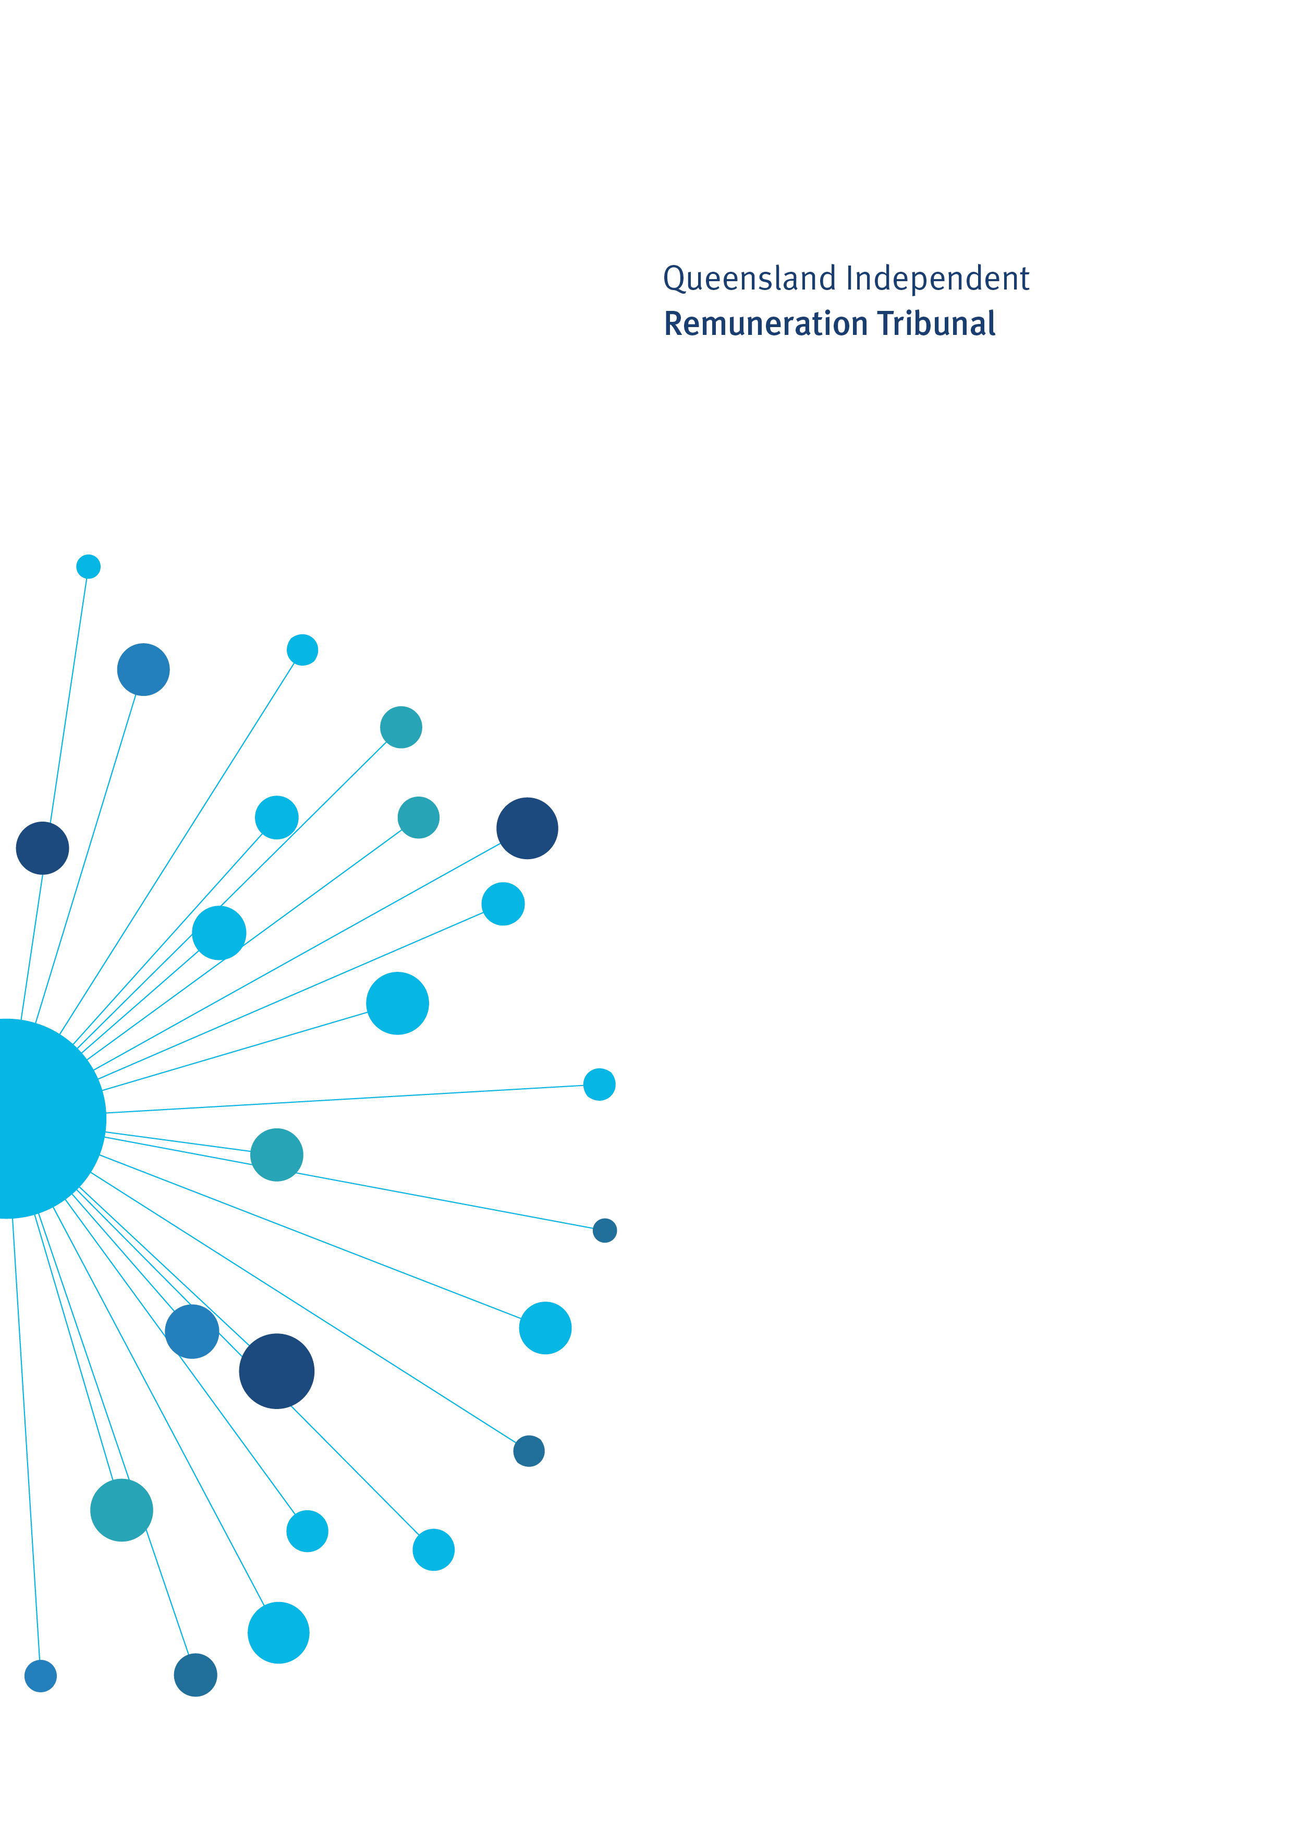

Determination 22/2020

23 October 2020

Remuneration Determination

Minor amendment to Determination 20/2020

Determination 22/2020

Background and Reasons
  - Tribunal roles and responsibilities
The Queensland Independent Remuneration Tribunal Act 2013 (Act) provides for the Queensland Independent Remuneration Tribunal (Tribunal) to review and determine remuneration (annual and additional salaries, allowances and entitlements) in connection with members and former members of the Queensland Legislative Assembly (section 7).
  - Background
On 21 April 2020, the Tribunal considered the impact of COVID-19 on expenditure of the Electorate and Communication Allowance (ECA) by members and made Determination 20/2020 enabling members to retain up to 40 per cent of the total ECA paid for the 2019−20 financial year (excluding any reductions or carry-overs from previous years) that is unexpended at 30 June 2020. This unexpended allowance was to be carried over for use by members in the period 1 July to 30 October 2020.
Under usual ECA carry-over provisions, ‘up to 10 per cent of the total allowance paid for each financial year (excluding any reductions or carry-overs from previous years) that is unexpended at 30 June is able to be retained by the member and carried over for use in the next financial year.’

Determination 20/2020 was intended to ensure that any additional carry-over beyond that applicable in a normal year was used and acquitted prior to the 2020 State general election rather than over the full financial year. However, the literal interpretation of Determination 20/2020 requires that the entire ECA carry-over must be acquitted by 30 October. This is inconsistent with the Tribunal’s intention regarding the additional carry-over provision.

It is the Tribunal’s intention that Members retain up to 40 per cent of the total ECA paid for the 2019-20 financial year (excluding any reductions or carry-overs from previous years) that is unexpended at 30 June 2020. Any amount of unexpended ECA in excess of the standard 10 per cent annual carry-over provision must be used and acquitted in the period 1 July to 30 October 2020. Unexpended ECA within the standard 10 per cent annual carry-over provision must be acquitted by 30 June 2021.

Determination 22/2020
Any inconsistencies between earlier Tribunal Determinations and Determination 22/2020 are resolved in favour of Determination 22/2020. Matters in earlier Determinations not addressed in this Determination are confirmed by the Tribunal and not amended.
  - Electorate and Communication Allowance
- Members may retain up to 40 per cent of the total Electorate and Communication Allowance (ECA) paid for the 2019-20 financial year (excluding any reductions or carry-overs from previous years) that is unexpended at 30 June 2020. Any amount of unexpended ECA in excess of the standard 10 per cent annual carry-over provision must be used and acquitted in the period 1 July to 30 October 2020. Unexpended ECA within the standard 10 per cent annual carry-over provision must be acquitted by 30 June 2021.

Date of Determination: 23 October 2020
Effective Date: 21 April 2020

_______________________ ___________________ ___________________
Mr Walter Tutt Ms Jill Lang Professor Patrick Weller
Chairperson Member Member

