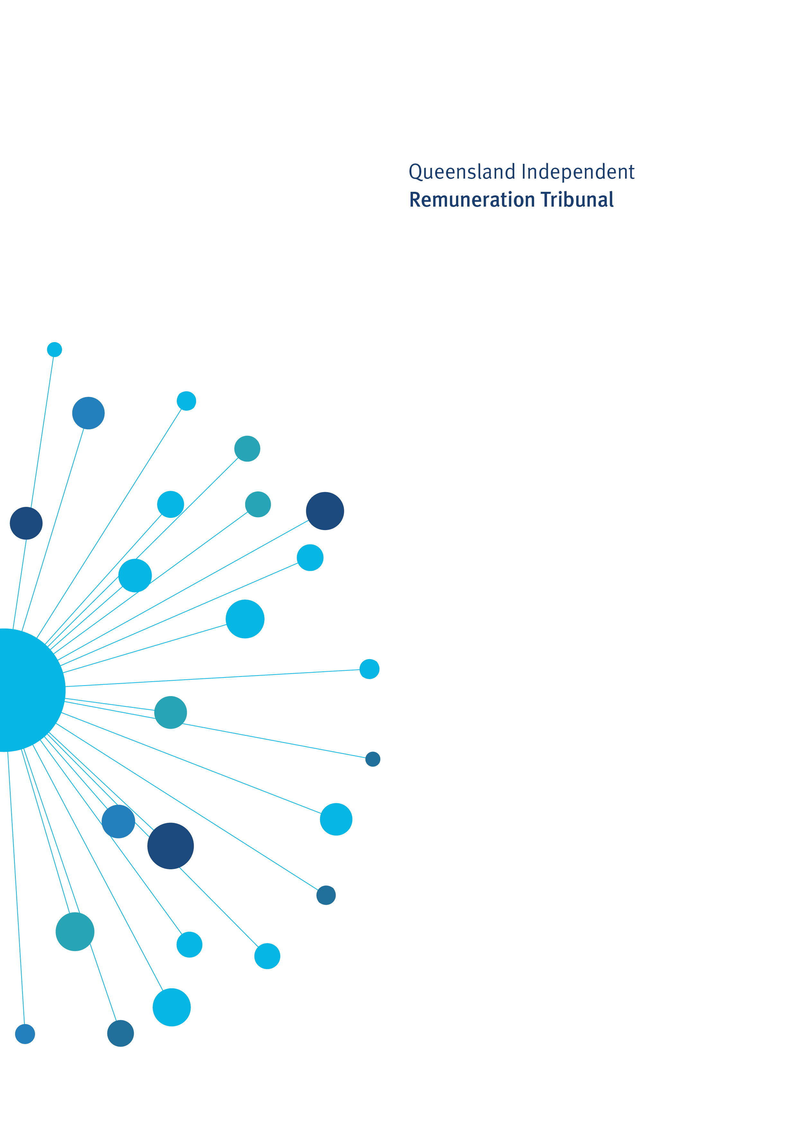

Determination 17/2018

19 June 2018

Minor amendments to the Allowances System 2018

Determination 17/2018

Background and Reasons
  - Tribunal roles and responsibilities
The Queensland Independent Remuneration Tribunal Act 2013 (Act) provides for the Queensland Independent Remuneration Tribunal (Tribunal) to review and determine remuneration (annual and additional salaries, allowances and entitlements) in connection with members and former members of the Queensland Legislative Assembly (section 7).
Under the Act, the Tribunal may have regard to the value to the community of a member carrying out their role, functions and responsibilities and the importance of a member being appropriately remunerated for carrying out their role. The Tribunal may also consider relevant laws and any other matters the Tribunal considers appropriate including, for example, the size of an electorate (section 29).
Before making a Determination, the Tribunal must consult with and consider the views of the Clerk of the Queensland Parliament (the Clerk). In making a Determination, the Tribunal must ensure any allowances paid to a member reflect the amount of reasonable expenses incurred by a member in servicing their electorate; ensure these allowances are not a substitute for other remuneration; and ensure accommodation services or other entitlements provided for in section 55 of the Act are not taken into account - for example, electorate offices, staffing support and major items of office equipment (section 30).
  - Background
On 25 November 2017 the Tribunal handed down Determination 16/2017. This Determination provided a comprehensive review of the allowances system and made consequential amendments to the system following changes to electorate boundaries as determined by the 2017 Queensland Redistribution Commission (QRC).
In Determination 16/2017 the Tribunal committed to continuing to consider allowance related issues and to monitor the use and acquittal of allowances and allocations to ensure their adequacy.
This Determination outlines the results of a six-month assessment of the quantum of the allowances system, having regard to the QRC’s Determination. It adjusts the Electorate and Communication Allowance (ECA) bands and Motor Vehicle Allowance (MVA) bands to reflect updated electoral roll data that became available after the Tribunal’s 2018 review was concluded.

  - Electorate and Communication Allowance
The ECA is provided to cover a range of expenditure associated with:
- providing constituent assistance and service for the electorate
- obtaining and disseminating information to constituents that is relevant to fulfilling parliamentary and constituency responsibilities, and
- meeting incidental costs relating to the operation of a member’s electorate office.
The ECA may not be used to meet expenditure for:
- private or commercial purposes or to purchase goods and services where the member, or a connected party is the provider of the goods and services
- political party activity, or
- electioneering and campaigning purposes.
Determination 16/2017 reconfirmed the importance of both electorate area and population in determining an appropriate ECA and used the formula of 60c for each registered voter on the electoral roll plus 1.5c for each square kilometre of area in the electorate. The ECA provided for in Determination 16/2017 resulted in the following bands:
Band | No. of electorates in band | Quantum of allowance
Band 1 | 45 | $67,800
Band 2 | 21 | $70,400
Band 3 | 25 | $72,000
Band 4 | 2 | $74,500

The Tribunal relied on the published data available from the QRC in determining the number of voters on the electoral roll and size (km²) of each electorate. This data was current as at 29 August 2016.
The same-sex marriage ballot and the November 2017 Queensland State Election, saw approximately 145,000 additional enrolments to the Queensland electoral roll. On 14 June 2018, the Attorney-General and Minister for Justice tabled the Statistical Return, 2017 State General Election including Close of Roll data (page 21) for each electorate, as at
25 November 2017 (polling day). There has been an increase of more than 10% in the electoral roll of six electoral districts and between 5% and 10% in a further twenty-five electorates. The population increases have resulted in an upward shift in electorates across the ECA bands as follows:
Band | No. of electorates in band | Quantum of allowance
Band 1 | 10 | $67,800
Band 2 | 36 | $70,400
Band 3 | 26 | $72,000
Band 4 | 21 | $74,500
In accordance with its legislative requirement to ensure allowances paid to members reflect the reasonable expenses incurred by a member in servicing their electorate, the Tribunal has decided to re-allocate ECA bands based on the Electoral Commission Queensland (ECQ) close of roll data, with effect from 25 November 2017, as outlined in the following table:
Electorate and Communication Allowance Bands
Band 1 – ECA of $67,800
Bonney  Gaven  Gladstone | Ipswich  Logan  Nicklin | Oodgeroo  Theodore | Waterford  Whitsunday
Band 2 – ECA of $70,400
Algester  Bancroft  Broadwater  Buderim  Bundaberg  Bundamba  Burleigh  Burnett  Caloundra | Chatsworth  Currumbin  Glasshouse Hinchinbrook  Inala  Ipswich West  Jordan  Kawana  Kurwongbah | Lockyer  Macalister  Mansfield  Maroochydore  Mermaid Beach  Miller  Mirani  Moggill  Morayfield | Mulgrave  Mundingburra  Redlands  South Brisbane  Southport  Stretton  Surfers Paradise  Toohey  Townsville
Band 3 – ECA of $72,000
Barron River  Burdekin  Cairns  Callide  Capalaba  Ferny Grove  Greenslopes | Gregory  Keppel  Lytton  Maryborough  McConnell  Mount Ommaney  Mudgeeraba | Ninderry  Noosa  Nudgee  Pumicestone  Rockhampton  Sandgate | Scenic Rim  Southern Downs  Springwood  Thuringowa  Toowoomba North  Woodridge
Band 4 – ECA of $74,500
Aspley  Bulimba  Clayfield  Condamine  Cook  Coomera | Cooper  Everton  Gympie  Hervey Bay  Hill | Mackay  Maiwar  Murrumba  Nanango  Pine Rivers | Redcliffe  Stafford  Toowoomba South  Traeger  Warrego

  - Notes regarding data used in the ECA formula:
- Electoral District area data has been provided by the ECQ based on the new electorate boundaries determined by the QRC in its Determination of Queensland’s Legislative Assembly Electoral Districts.
- Electoral roll data is taken from the Statistical Return, 2017 State General Election, Close of Roll Figures and Deviation from Average Enrolment 2017, State General Election held on
25 November 2017, page 21, tabled on 14 June 2018.
  - Motor Vehicle Allowance
A MVA is provided to cover expenditure incurred in acquiring and maintaining a member’s vehicle.
Determination 16/2017 provided for four bands of MVA as follows:
Band | Size of electorate (km²) | No. of electorates in band | Quantum of allowance
Band 1 | 0 – 1,000 | 71 | $25,500
Band 2 | 1,001 – 10,000 | 12 | $32,000
Band 3 | 10,001 – 99,999 | 6 | $37,000
Band 4 | 100,000 and over | 4 | $42,000

The Tribunal has noted concerns raised by members in Band 3 regarding the quantum of their MVA given the significant distances, travel times and diverse locations of key communities within their respective electorates under the new electorate boundaries determined by the QRC. It is appreciated that members in this band saw a reduction in the quantum of their MVA following Determination 16/2017. The electorates currently in Band 3 are as follows:
Band 3 – 10,001km² to 99,999km²- $37,000 per annum
Burdekin | 78,681
Callide | 74,199
Hill | 19,752
Mirani | 25,976
Nanango | 18,122
Southern Downs | 30,951

The Tribunal notes that Burdekin and Callide have significantly higher square kilometres than other electorates in Band 3, but significantly lower square kilometres than electorates in Band 4 with more than 100,000km².
Band 4 – 100,000km² and over - $42,000 per annum
Cook | 196,836
Gregory | 459,681
Traeger | 428,911
Warrego | 337,812

The Tribunal has undertaken an audit of Band 3 and Band 4 electorates and is of the view that Burdekin and Callide should be moved to Band 4. While these electorates have a smaller area in square kilometres than Band 4 electorates, the geography, travel times and location of communities across these electorates makes them more comparable to Band 4 electorates than Band 3 electorates. Accordingly, with effect from 25 November 2017, the MVA Bands will be amended as follows:
Band | Size of electorate (km²) | No. of electorates in band | Quantum of allowance
Band 1 | 0 – 1,000 | 71 | $25,500
Band 2 | 1,001 – 10,000 | 12 | $32,000
Band 3 | 10,001 – 70,000 | 4 | $37,000
Band 4 | 70,001 and over | 6 | $42,000

The Tribunal will continue to monitor the adequacy of the MVA and other allowances, entitlements and allocations, and consider member’s acquittals for the 2017–18 financial year.
The data and anecdotal advice provided by members will enable a comprehensive and evidence-based consideration of issues relating to the allowances system.

Determination 17/2018
Any inconsistencies between earlier Tribunal Determinations and Determination 17/2018 are resolved in favour of Determination 17/2018. Matters in earlier Determinations not addressed in this Determination are confirmed by the Tribunal and not amended.
  - Electorate and Communication Allowance
- The Tribunal determines that each electorate will be provided with the Electorate and Communication Allowance outlined in the table below:
Band 1 – ECA of $67,800
Bonney  Gaven  Gladstone | Ipswich  Logan  Nicklin | Oodgeroo  Theodore | Waterford  Whitsunday
Band 2 – ECA of $70,400
Algester  Bancroft  Broadwater  Buderim  Bundaberg  Bundamba  Burleigh  Burnett  Caloundra | Chatsworth  Currumbin  Glasshouse Hinchinbrook  Inala  Ipswich West  Jordan  Kawana  Kurwongbah | Lockyer  Macalister  Mansfield  Maroochydore  Mermaid Beach  Miller  Mirani  Moggill  Morayfield | Mulgrave  Mundingburra  Redlands  South Brisbane  Southport  Stretton  Surfers Paradise  Toohey  Townsville
Band 3 – ECA of $72,000
Barron River  Burdekin  Cairns  Callide  Capalaba  Ferny Grove  Greenslopes | Gregory  Keppel  Lytton  Maryborough  McConnell  Mount Ommaney  Mudgeeraba | Ninderry  Noosa  Nudgee Pumicestone  Rockhampton  Sandgate | Scenic Rim  Southern Downs  Springwood  Thuringowa  Toowoomba North  Woodridge
Band 4 – ECA of $74,500
Aspley  Bulimba  Clayfield  Condamine  Cook  Coomera | Cooper  Everton  Gympie  Hervey Bay  Hill | Mackay  Maiwar  Murrumba  Nanango  Pine Rivers | Redcliffe  Stafford  Toowoomba South  Traeger  Warrego

  - Motor Vehicle Allowance
- The Tribunal determines the bands for the Motor Vehicle Allowance be amended as follows:
Band | Size of electorate (km2) | Quantum of allowance
Band 1 | 0 – 1,000 | $25,500
Band 2 | 1,001 – 10,000 | $32,000
Band 3 | 10,001 – 70,000 | $37,000
Band 4 | 70,001 and over | $42,000

Date of Determination: 19 June 2018
Effective Date: 25 November 2017

_______________________ ___________________ ___________________
Professor Anne Tiernan Mr Walter Tutt Ms Karyn Walsh
Chairperson Member Member

