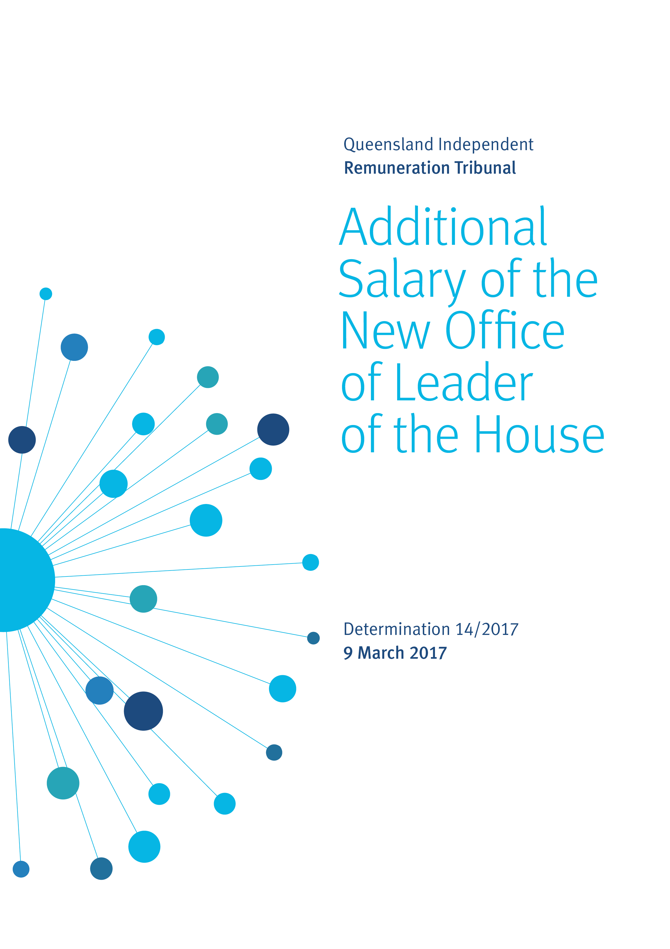

Reasons

Background
The Queensland Independent Remuneration Tribunal (the Tribunal) is an independent statutory authority established by the Queensland Independent Remuneration Tribunal Act 2013 (the Act).

The Tribunal has the power to make determinations in accordance with section 27 of the Act which provides for ‘…the power to make determinations about remuneration in connection with members [MPs] and former members of the [Queensland Legislative] Assembly’.

The definition of ‘remuneration’ under the Act includes the annual salary (s41), the additional salary (s42) and associated allowances (s54) payable to an MP for performing roles as an office holder in addition to that of an MP in the Queensland Legislative Assembly.

Introduction
On 14 February 2017 the Legislative Assembly approved that the Office of Leader of the House be created as an office entitled to be paid an additional salary under section 42 of the Act. The Tribunal has not previously considered the additional salary payable to this office and therefore a determination may be made in accordance with section 31B of the Act.

Role of Leader of the House
The Leader of the House is appointed by the Premier who announces the appointment in the Legislative Assembly.

The Leader of the House has responsibility for the arrangement and management of government business in the Legislative Assembly to ensure government business progresses efficiently and is not hindered. In consultation with the Premier, Ministers and the Opposition it is the responsibility of the Leader of the House to determine the order in which the items of government business will be dealt with and the time allotted for debate to ensure the passage of government business is not unduly delayed or disrupted. When issues arise in the Legislative Assembly the Leader of the House is also involved in determining strategy and tactics to be followed by the government.

Most procedural motions are moved by the Leader of the House on behalf of the government. This office holder works closely with government whips and liaises with the Manager of Opposition Business on matters that may have a bearing on the progress of government and general business.

The Leader of the House is a member of the Committee of the Legislative Assembly and is required to nominate to the Legislative Assembly chairpersons and members for Parliamentary committees.

Analysis
Previously, when determining the additional salary payable to office holders the Tribunal has grouped offices into 11 bands relative to the additional salary of the highest office holder, the Premier.

To ascertain the appropriate additional salary band for the Office of Leader of the House the Tribunal has:
- considered the roles and responsibilities of each office holder in the Legislative Assembly relative to the roles and responsibilities of the office of Leader of the House
- undertaken a jurisdictional scan to consider the additional salary payable to the office of Leader of the House in other jurisdictions, noting that Queensland has a unicameral system and the position is held concurrently with another office in the majority of jurisdictions, and
- consulted with the Clerk of the Parliament.

The Tribunal considers that the roles and responsibilities of the Office of Leader of the House are broader than the offices of Assistant Minister and Manager of Opposition Business but less complex than the offices of Speaker and the combined role of Assistant Minister and Leader of the House. The Tribunal notes the Clerk’s advice that the duties and responsibilities of Leader of the House have increased significantly in the two most recent parliaments, particularly with respect to coordinating, negotiating and managing committee, legislative and procedural matters in the Assembly.

In Determination 11/2016 the Tribunal determined the additional salary for the position of Minister and Leader of the House. The Tribunal determined a new band to accommodate the then new Office of Minister and Leader of the House at a relativity of 72.5% to the additional salary of the Premier.

The Tribunal notes that currently Bands 3 and 5 enable the Office of Leader of the House, when combined with the Office of Minister or Assistant Minister, to be accommodated at levels of relativity commensurate with the scope of those responsibilities. Current arrangements do not, however, make provision for the Office of Leader of the House as a stand-alone position.

The Tribunal has formed the view that the Legislative Assembly’s resolution of 14 February 2017 provides an opportunity to cater for all potential scenarios with respect to the Office of Leader of the House. Accordingly, the Tribunal has determined to create a new salary band for the Office of Leader of the House, bringing the total number of salary bands to 12. This band will be positioned between the current Bands 5 and 6 with 50% relativity to the Office of Premier as follows:

Figure 1 - New relativity of additional salaries between offices

Band | Office | Relativity between offices  %
1 | Premier | 100.00
2 | Deputy Premier | 80.0
3 | Minister and Leader of the House | 72.5
4 | - Minister  - Leader of the Opposition | 70.0
5 | - Speaker  - Assistant Minister and Leader of the House | 60.0
6 | Leader of the House | 50.0
7 | Deputy Leader of the Opposition | 40.0
8 | - Chief government whip  - Deputy Speaker  - Manager of Opposition Business  - Assistant Minister | 35.0
9 | - Opposition Spokesperson  - Leader in the Assembly of a recognised political party, other than the Leader or Deputy Leader of the Opposition  - Chairperson of a committee | 25.0
10 | - Senior government whip  - Opposition whip | 15.0
11 | - Government deputy whip  - Deputy Opposition whip | 12.5
12 | Member of a committee | 10.0

Determination
Any inconsistencies between earlier Tribunal Determinations and Determination 14/2017 are resolved in favour of Determination 14/2017. Matters in earlier Determinations not addressed in this Determination are confirmed by the Tribunal and not amended.

Additional salary of the Office of Minister and Leader of the House
The Tribunal determines that a new salary band be created to accommodate the Office of Leader of the House. It further determines that the additional salary payable to the Office of Leader of the House relative to the additional salary payable to the Office of the Premier be set at 50% effective 14 February 2017.

Professor Anne Tiernan
Chairperson
Mr Michael Noud
Member
Ms Karyn Walsh
Member

Date of Determination: 9 March 2017

