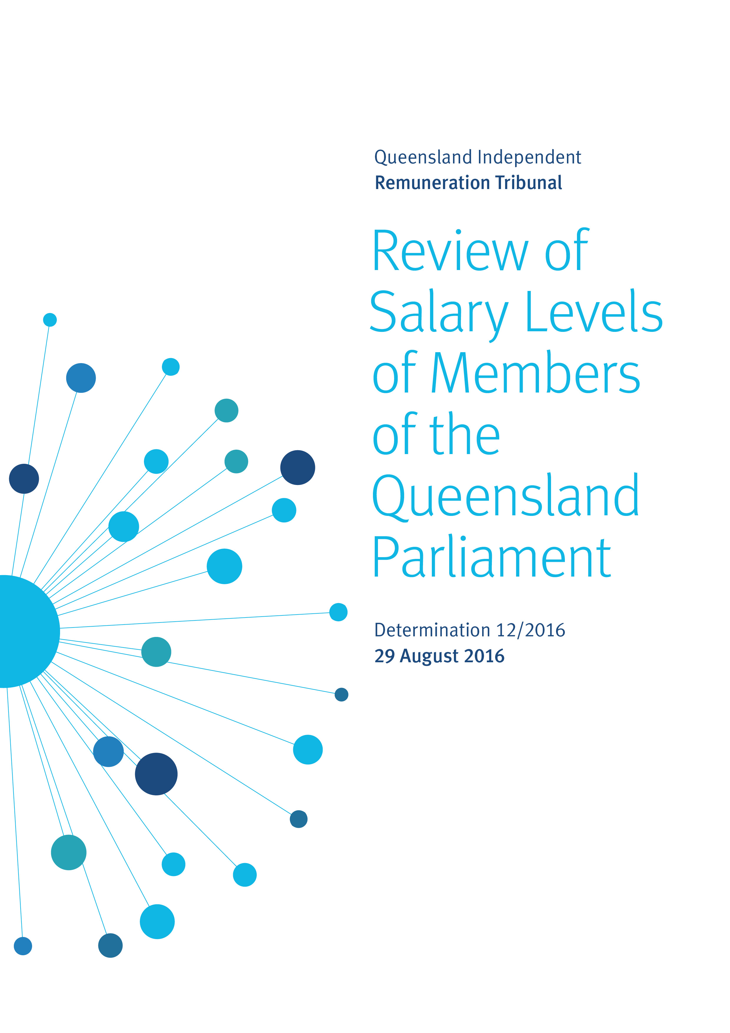

The Queensland Independent Remuneration Tribunal (the Tribunal) is an independent statutory authority established by the Queensland Independent Remuneration Tribunal Act 2013 (the Act).

The Tribunal has made salary determinations in accordance with section 27 of the Act (as amended) which provides for ‘…the power to make determinations about remuneration in connection with members [MPs] and former members of the [Queensland Legislative] Assembly [the Assembly]’.

The definition of ‘remuneration’ under the Act includes the annual salary (s41), the additional salary (s42) and associated allowances (s54) payable to an MP for performing roles as an office holder in addition to that of an MP in the Queensland Legislative Assembly.

Background

On 1 June 2015 the Act was amended. Sections 31A and 31B were added. Section 31A (1) provides that the Tribunal may not make a determination unless a public service salary decision has been made. That section further provides that the Tribunal must make determinations about members’ salary within 90 days of such a decision (s31A (2)). Section 31A (3) provides that members’ salaries may not increase by a rate that is higher than the rate of increase to the salary or wage of a departmental employee under the public service salary decision. Any increases to a member’s salary entitlement are to take effect at the same time as increases under such a decision (s31A (4)).

Section 72 of the Act (as amended) revoked the Tribunal’s Determination 7/2015 of 5 March 2015, which had increased the base salary for an MP and the levels of additional salaries of office holders by 2.58% effective from 6 April 2015. This amendment returned the base and additional salaries of MPs to 1 July 2013 rates.

On 1 December 2015 the Minister for Employment and Industrial Relations Directive: Remuneration for Certain Employees (Directive 5/15) came into effect. The Tribunal, then differently constituted, considered it to be a public service salary decision under section 31A of the Act and accordingly made salary determinations for members and office holders on 12 January 2016 (Determination 10/2016). The Tribunal determined that the annual base salary for members would increase by 1.73% and that the additional salary for the most senior office holder (the office of Premier) would also increase by 1.73% per annum. Determination 10/2016 confirmed the relativities decided in Determination 3/2014 for each office holder, relative to the additional salary of the most senior office holder, would remain unchanged. Consistent with the requirements of the Act and Directive 5/15, the increases took effect from 1 September 2015.
On 1 June 2016 the ‘State Government Entities Certified Agreement 2015’ was certified by the Queensland Industrial Relations Commission. This agreement (section 2.1(1)) provides for salary increases of 2.5% to public service employees on 1 September each year (commencing 1 September 2015) until the agreement expires on 31 August 2018.

The Tribunal views this agreement as a public service salary decision within the meaning of section 31A of the Act. Accordingly, it is our duty to make necessary salary determinations within 90 days of such decision.

In the circumstances, it is our considered view that a single determination should be made in relation to members’ annual base salaries, and the additional salaries payable to office holders to cover the period 1 September 2015, 1 September 2016 and 1 September 2017. The Tribunal has exercised its discretion and accordingly Determination 12/2016 will replace Determination 10/2016.

We have determined that the annual base salary for an MP will increase at the consistent rate of 2.25% per annum in respect of the above periods. We note, in respect of the year from 1 September 2015, that the increase of 1.73% paid and provided for under Determination 10/2016 will need to be offset against the increase of 2.25% for that year. The offsetting of the increase for the year from 1 September 2015 will likely be paid in the year from 1 September 2016, as such the effective increase for 2016 will appear to be 2.77% however, it must be considered that the 0.52% relates to the offsetting of the previous year from 1 September 2015. Therefore the current year base salary increase will not exceed 2.25% and is within the 2.5% limit set under section 31A (3) of the Act. It is the Tribunal’s intent that salaries received pursuant to Determination 10/2016 be offset against salary increase entitlements pursuant to the present determination for the year from 1 September 2015 and will not exceed 2.25% per annum.

Tribunal Duties in Making Determinations

Section 29 of the Act provides general principles that the Tribunal may have regard to in making a determination. These include:
- the value to the community of a member of the Assembly carrying out the member’s role, functions and responsibilities (s 29(1a));
- the importance of a member being appropriately remunerated for carrying out the member’s role, functions and responsibilities (s 29(1b);
- relevant laws applying to members (s 29(1c)) – of which we can identify none; and
- other matters we consider appropriate (s 29(1d)).

Pursuant to section 30(a) of the Act, the Tribunal must consult with, and consider the views of, the Clerk of the Parliament.

In discharging our responsibilities, we have followed the procedures provided for in section 28 of the Act. The Tribunal has consulted with the Clerk of the Parliament and has had regard to:
- The Queensland Parliamentary Procedures Handbook;
- The views of the members of the community as obtained previously;
- Economic criteria including:
  - Analysis of base salary in comparable jurisdictions;
  - Other salary indices including: average weekly earnings in the public and private sectors, including specifically in the Queensland core public service and the Senior Executive Service (SES);
  - The Consumer Price Index (CPI), including projections outlined in the 2016-17 Queensland State Budget; and
  - Analysis of Australia’s economic outlook, including the minutes of the July meeting of the Board of the Reserve Bank of Australia Board, and the final public speech delivered by the retiring Governor of the Reserve Bank, Glenn Stevens AC.
- The views of MPs obtained in the course of our inquiries.

Discussion

In addition to the findings of our consultations and analysis of the data noted above, the Tribunal has weighed a range of other factors in making this Determination. These include the important public duties and complex, demanding responsibilities of MPs as representatives of the people of Queensland and the critical contribution MPs and office holders make to the good governance of our state. Levels of remuneration must, in our view, recognise and reward the demands that accompany election to public office – the responsibilities and obligations that accrue to members as representatives, the long hours worked in serving their constituents, and the high standards of integrity, accountability and responsiveness that are rightly owed to the Parliament for the honour of taking a seat in the chamber.

The Tribunal considers it especially important that base salary levels for Queensland MPs should remain broadly consistent with representatives in other states and territories. At the same time, we recognise community expectations, and those of the members themselves for that matter.

We are confident our approach will avoid the need for more significant adjustments in the forward years.

Additionally, we considered that in the prevailing economic circumstances of uncertainty and concerns the global economy has entered a period of sustained low growth, restraint is called for.

In arriving at this Determination, the Tribunal has weighed carefully all the evidence available to us, including, but not simply, the economic indicators. We consider increases to base salary levels for MPs are justified.

However, we emphasise that we do not consider there is any specific link between public service and MP base salaries beyond the parameters established by the Act (that members’ salary increases should not exceed those set for public services wages).

The Tribunal has taken account of economic factors in determining additional salaries for office holders. We consider they have particular responsibilities in line with their office, as well as greater capacity to shape policies to address the softening outlook highlighted in the Tribunal’s analysis of economic indicators. We think it is reasonable that office holder salaries should be subject to the wage restraints being experienced by high-income earners in other sectors.

We note, for example, that CPI was 1.51% in 2014-15 and 1.49% in 2015-16. We also note that public service chief executives did not receive the 2.5% increase awarded under Directive 5/15, and that private sector wages increased only 0.15% in 2014-15 and are expected to remain subdued. Accordingly, we determine that the additional salary payable to the office of Premier should be increased by 1.5% over each of the three years, with other office-holders to receive the proportion as determined according to the relativities established in previous Determinations.

Determination

This Determination (12/2016) replaces Determination 10/2016. Any inconsistencies between earlier Tribunal Determinations and Determination 12/2016 are resolved in favour of Determination 12/2016. Matters in earlier Determinations not addressed in this Determination are confirmed by the Tribunal and not amended.

We determine that:
- The base salary of a member of the Legislative Assembly be increased by 2.25% per annum from 1 September 2015, and that the salary received by a member in accordance with Determination 10/2016 be offset against the salary increase established in Determination 12/2016.
- The base salary of a member increase by 2.25% from 1 September 2016.
- The base salary of a member increase by 2.25% from 1 September 2017.

The Tribunal further determines that the additional salary for the Office of the Premier be increased by 1.5% each year for three years, from 1 September 2015.

It is further determined that the relativity between office holders be as set out in earlier Determinations.

Professor Anne Tiernan
Chairperson
Mr Michael Noud
Member
Ms Karyn Walsh
Member

Date of Determination: 29 August 2016

Appendices

Appendix 1: Comparison of base salary across Australia
Jurisdiction | Annual base salary  as at 1 July 2013 | Annual base salary  as at 1 July 2016 | % total increase
New South Wales | $146,251 | $157,112 | 7.43%
South Australia | $153,130 | $157,040 | 2.55%
Western Australia | $148,638 | $156,536 | 5.31%
Northern Territory | $143,122 | $153,312 | 7.12%
Queensland | $144,485 | $151,425 | 4.80%
Victoria | $140,973 | $148,210 | 5.13%
Australian Capital Territory | $125,259 | $142,228 | 13.55%
Tasmania | $118,466 | $133,560 | 12.74%

Appendix 2: Annual changes in MP base salary and other salary indices
2000–16

Year | MP Base Salary | Average Weekly Earnings, Public Sector | Average Weekly Earnings, Private and Public Sector | CPI | Qld Core Public Service | SES
2000-01 | 3.93% | 6.97% | 6.70% | 6.15% |  | 3.14%
2001-02 | 3.37% | 4.18% | 3.79% | 3.03% |  | 3.13%
2002-03 | 4.03% | 3.19% | 5.22% | 2.68% |  | 3.97%
2003-04 | 3.92% | 4.44% | 4.95% | 3.13% | 3.80% | 3.96%
2004-05 | 4.12% | 4.61% | 7.41% | 2.53% | 3.80% | 0.00%
2005-06 | 7.05% | 5.42% | 2.25% | 4.19% | 4.00% | 3.95%
2006-07 | 6.85% | 4.54% | 5.65% | 2.60% | 4.00% | 8.16%
2007-08 | 0.00% | 3.99% | 5.57% | 5.07% | 4.00% | 4.00%
2008-09 | 0.00% | 4.96% | 6.16% | 1.98% | 4.50% | 2.50%
2009-10 | 3.14% | 5.17% | 6.05% | 3.23% | 4.00% | 2.50%
2010-11 | 2.50% | 5.12% | 4.23% | 3.86% | 4.00% | 2.50%
2011-12 | 2.50% | 4.15% | 3.77% | 0.90% | 0.00% | 2.20%
2012-13 | 5.35% | 3.80% | 7.65% | 1.99% | 0.00% | 2.20%
2013-14 | 3.02% | 2.43% | 1.07% | 3.22% | 2.20% | 2.20%
2014-15 | 0.00% | 1.56% | 0.15% | 1.51% | 2.20% | 2.20%
2015-16 | 1.73% | 3.54% | 1.35% | 1.49% | 2.50% | 2.50%
5-year ave | 2.51% | 3.09% | 2.76% | 1.82% | 1.37% | 2.26%
10-year ave | 2.49% | 3.92% | 4.14% | 2.58% | 2.73% | 3.08%

 | MP Base Salary | Average Weekly Earnings, Public Sector |  | Average Weekly Earnings, Private and Public Sector | CPI | Qld Core Public Service | SES
$1,000 indexed since 2004-05 | $1,425 | $1,620 | $1,647 |  | $1,378 | $1,413 | $1,408

DATA | SOURCE
MP Base Salary | MP Base Salary increase from 1 July in financial year
Average Weekly Earnings, Public Sector | ABS 6302.0 - Average Weekly Ordinary Time Earnings - Qld ; Persons ; Full Time ; Adult ; Public Sector
Average Weekly Earnings, Private and Public Sector | ABS 6302.0 - Average Weekly Ordinary Time Earnings - Qld ; Persons ; Full Time ; Adult ; Total (Public and Private Sector)
CPI | ABS 6401.0 - Consumer Price Index - All groups CPI; Brisbane
QLD Core Public Service | Wage increases of 'core' government departments and agencies, State Government Entities Certified Agreement (2003, 2006, 2009, 2013,2015)
SES Remuneration | Based on SES Remuneration Scale provided by the Public Service Commission

The Parliament of Queensland and Other Acts Amendment Bill 2015 was introduced in the Legislative Assembly by the Premier and Minister for the Arts to implement an election commitment to limit future salary increases for an MP to salary increases received by public sector employees.
We concur with and confirm Determination 1/2013 that analysis of salary increases in other state and territory jurisdictions is more appropriate and valid than comparisons with the Commonwealth Parliament.
See Appendix 1: Comparison of base salary across Australia.
See Appendix 2: Annual changes in MP base salary and other salary indices 2000-2016.
See appendix 2: Annual changes in MP base salary and other salary indices 2000-2016 and Budget Strategy and Outlook (Budget Paper 2) <http://budget.qld.gov.au/budget-papers/>
Glenn Stevens AC, Governor, Reserve Bank of Australia, Address to the Anika Foundation Luncheon, Sydney, 10 August 2016, An Accounting, <http://www.rba.gov.au/speeches/2016/sp-gov-2016-08-10.html>
Reserve Bank of Australia, Minutes of the Monetary Policy Meeting of the Reserve Bank Board, 5 July 2016, <http://www.rba.gov.au/monetary-policy/rba-board-minutes/2016/2016-07-05.html>
For the Northern Territory, the base salary is taken at August 2013.
Data provided by the Queensland Government’s Statistician’s Office.
The State Government Entities Certified Agreement 2015 (Core agreement) covers approximately 50,000 public sector employees.

