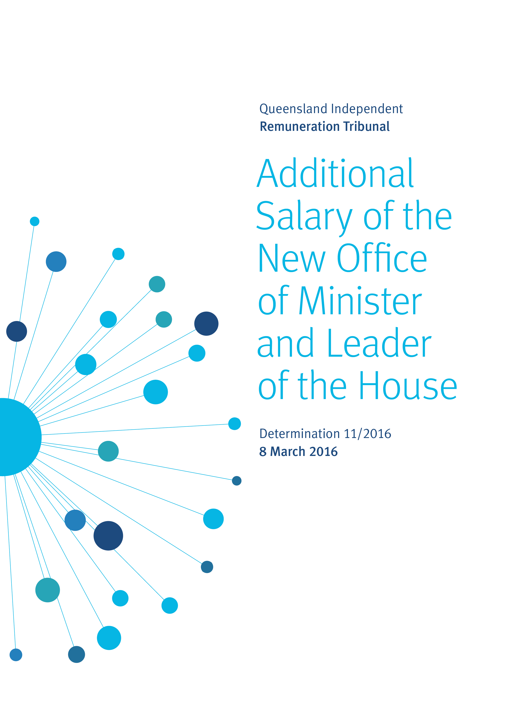
Executive Summary
On 16 February 2016, the Legislative Assembly approved that the Office of Minister and Leader of the House be created as an office entitled to be paid an additional salary under the Queensland Independent Remuneration Tribunal Act 2013 (the Act).
In the previous government, the position of Leader of the House was linked with the Office of Assistant Minister. However in the current Parliament the position of Assistant Minister and Leader of the House is no longer occupied, rather the Legislative Assembly has created the new position of Minister and Leader of the House. As this position has not previously been in existence since the establishment of the Tribunal, an additional salary for this new role now needs to be considered.
In the context of the additional salaries of office holders that were reviewed in Determination 3/2014, the Tribunal considers that the responsibilities of the Office of Minister and Leader of the House are greater than that of the (previous) Office of Assistant Minister and Leader of the House.
The Tribunal further considers that the Office of Minister and Leader of the House has a higher level of responsibility than that of a Minister, and falls between that of the Office of a Minister and the Office of Deputy Premier.
Therefore the Tribunal considers that the relativity for the position of Minister and Leader of the House should be set at 72.5%.
The effective date of this decision is 16 February 2016 which is the date on which the new office was formally created.

1 - Background
  - Overview
The Queensland Independent Remuneration Tribunal (the Tribunal) is an independent statutory authority established by the Queensland Independent Remuneration Tribunal Act 2013 (the Act) to determine remuneration in connection with Members of the Queensland Parliament (MPs) and former MPs.
The definition of ‘remuneration’ includes the additional salary and associated allowances payable to an MP for performing roles as an office holder in addition to that of an MP in the Queensland Legislative Assembly.
Section 42 of the Act provides a list of offices for which MPs may be entitled to be paid a salary in addition to the base salary of a backbench MP (an additional salary). The Act also provides that if another office is approved by resolution of the Legislative Assembly then that office may attract an additional salary. Note that only one salary (being the highest salary) is payable in the case where an MP holds multiple offices.

  - Previous consideration of additional salary
Additional salaries provided to office holders have previously been considered by the Tribunal in Determination 3/2014 after a detailed examination of the nature of each of the roles. Determination 3/2014 set the additional salary payable to each office holder relative to the additional salary payable to the highest office being the Office of Premier.
Since the issue of Determination 3/2014 the Tribunal has issued one further Determination in respect of establishing additional salaries. In 2015 the Legislative Assembly approved the establishment of the Office of Deputy Opposition Whip. Subsequently the Tribunal issued Determination 8/2015 which set the additional salary payable to this office.
The current relativities between additional salaries payable to the office holders are outlined in Figure 1.1.

Figure 1.1 – Current relativity between additional salaries of offices
Band | Office | Relativity between offices %
1 | Premier | 100.0
2 | Deputy Premier | 80.0
3 | Minister  Leader of the Opposition | 70.0
4 | Speaker  Assistant Minister and Leader of the House | 60.0
5 | Deputy Leader of the Opposition | 40.0
6 | Chief government whip  Deputy Speaker  Manager of Opposition Business  Assistant Minister | 35.0
7 | Opposition Spokesperson  Leader in the Assembly of a recognised political party, other than the Leader or Deputy Leader of the Opposition  Chairperson of a committee | 25.0
8 | Senior government whip  Opposition whip | 15.0
9 | Government deputy whip  Deputy Opposition whip | 12.5
10 | Member of a committee | 10.0
  - Office of the Minister and Leader of the House
On 16 February 2016, the Legislative Assembly approved that the Office of Minister and Leader of the House be created as an office that may be entitled to be paid an additional salary in accordance with section 42 of the Act.
The matter was subsequently referred to the Tribunal by the Clerk of the Parliament on 26 February 2016.
The purpose of this Determination is to set the additional salary payable to the Office of Minister and Leader of the House.
2 - Role of the position
The Office of Minister and Leader of the House combines the roles and responsibilities of both a Minister and the Leader of the House.
2.1 Role of a Minister
Ministerial responsibility
The maximum number of Ministers allowable under the Constitution of Queensland is 19 and there are currently 17 Ministers including the Premier in the 55th Parliament.
Ministerial responsibility and the role of a Minister in this context can be summarised as follows:
- Ministers, led by the Premier, provide advice to the Governor as the Queen’s representative in Queensland;
- as part of the government’s collective responsibility to the Legislative Assembly Ministers need to speak with one voice on Cabinet decisions; and
- Ministers are individually responsible to the Legislative Assembly for the administration of their portfolios, including the acts or omissions of public servants from their departments.
The Administrative Arrangements Order provides the current ministerial portfolios and responsibilities including the department, administrative units and Acts of Parliament administered.
Cabinet
While each Minister has ministerial responsibility for their individual portfolios they also have collective responsibility for all decisions made as part of Cabinet.
Cabinet is responsible for the development, approval and coordination of the government’s policies. Cabinet is collectively responsible for the policies and programs on which it makes decisions. As such, Ministers are required to speak with one voice on the policies and programs decided by Cabinet regardless of their individual views in Cabinet.
Ministers present proposals to Cabinet in the form of submissions which are circulated to all Ministers and portfolios prior to Cabinet consideration. Once a Cabinet decision is made regarding a submission the relevant Minister and portfolio who brought the submission will implement the decision and/or the matter will be brought to Executive Council or the Parliament to give the decision legal effect.
Executive Council
The Constitution requires that an Executive Council for the State be comprised of persons appointed as members by the Governor. The Governor attends and presides over all meetings of the Executive Council but is not a member of the Council.
It is customary in Queensland for those persons who comprise the Ministry to be appointed as Executive Councillors after being sworn in as Ministers. Therefore, in addition to ministerial duties, Ministers must also perform the role of Executive Councillors.
2.2 Leader of the House
The Leader of the House has responsibility for the arrangement and management of government business in the Legislative Assembly to ensure government business progresses efficiently and is not hindered.
In consultation with the Premier, Ministers and the Opposition it is the responsibility of the Leader of the House to determine the order in which the items of government business will be dealt with and determine the time allotted for debate to ensure the passage of government business is not unduly delayed or disrupted. When issues arise in the Legislative Assembly the Leader of the House is also involved in determining strategy to be followed by the government.
Generally procedural motions are moved by the Leader of the House on behalf of the government. This office holder works closely with government whips and liaises with the Manager of Opposition Business on matters that may have a bearing on the progress of government and general business.

3 - Benchmarks
3.1 Additional salary for the Leader of the House in Queensland
Prior to Determination 1/2013 being issued, the office holders entitled to receive an additional salary were noted in the Parliament of Queensland Act 2001. At various times, the Parliament of Queensland Act 2001 had classified the Leader of the House as either the Leader of the House or the Manager of Government Business.
In Determination 3/2014, the Tribunal undertook a comprehensive analysis of the additional salaries and entitlements of office holders in Queensland to set the relativities between offices.
At that time, the Office of Minister and Leader of the House was not a position listed under section 42 of the Act. As such, the Tribunal could not consider this position for an additional salary.
Further the position of Leader of the House was not a standalone office. Rather the role of the Leader of the House was embedded within the single position of Assistant Minister and Leader of the House. Hence in Determination 3/2014 the Tribunal determined an additional salary payable to the position of the Office of Assistant Minister and Leader of the House which was set at 60% (relative to the additional salary payable to the Office of Premier).
However on 8 December 2015 the position of Assistant Minister and Leader of the House became vacant. Further on 16 February 2016 the Legislative Assembly created the new position of Minister and Leader of the House. As this new position has not previously been considered for an additional salary since the establishment of the Tribunal, an additional salary for this role now needs to be considered.
3.2 Jurisdictional analysis
Figure 3.1 provides a comparison of the relativity of the additional salaries of the Leader of the House (or equivalent office) in Australian jurisdictions. These comparisons need to be interpreted with caution as the position of Leader of the House varies across jurisdictions.
Figure 3.1 – Comparative relativity of additional salaries of Leader of the House (or equivalent office)
Jurisdiction | Leader of the House (or equivalent office) | Relativity to the Office of Premier or equivalent
New South Wales | Leader of the House (currently held by a Minister) | 71%
South Australia | Leader of Government Business (currently held by a Minister) | 75%
Tasmania | Leader of Government Business (currently held by a Minister) | 61%
Victoria | Manager, Government Business (currently held by a Minister) | 75%
Western Australia | Leader of the House (currently held by a Minister) | 61%
Australian Capital Territory | Manager of Government Business (currently held by a Minister) | 64%
Northern Territory | Leader of Government Business (currently held by a Minister) | 65%
Average |  | 67%
Consistent with previous Determinations, the Tribunal does not place significant weight on a comparison with the Commonwealth Government. However it is worth noting that in the Commonwealth the position of Leader of the House is an office holder in its own right and the additional salary attributable to this role is higher than that attributable to a Minister although by only 3 percent.
In South Australia, Tasmania, Victoria, Western Australia and the Australian Capital Territory the Leader of the House is not designated as a specific office entitled to receive additional remuneration. However in these jurisdictions the MP performing the role is a Minister and thus receives the additional salary associated with their role as a Minister.
In New South Wales and the Northern Territory, the Leader of the House is an Office entitled to additional remuneration in its own right. Notwithstanding, in these two jurisdictions the duties and functions of the Leader of the House are currently performed by a Minister. The relevant MP in these circumstances only receives additional remuneration for the highest paid office being that of a Minister.
The average percentage of additional salary payable to the various roles which incorporate the duties and functions of the Leader of the House across the state and territory jurisdictions is 67% of the additional salary payable to the Office of Premier or Chief Minister. Of note in the larger states of New South Wales and Victoria the relevant percentage is 71% and 75% respectively.

3.3 Summary
The Tribunal has considered the relevant duties of the new position of Minister and Leader of the House. The Tribunal has also considered the additional salary payable to similar positions in other jurisdictions. In reaching a decision the Tribunal has to make an assessment of where this new role would sit within the contemporary relativities between office holders in the Queensland Parliament.
In the context of the additional salaries of office holders that were reviewed in Determination 3/2014, the Tribunal considers that the responsibilities of the Office of Minister and Leader of the House are greater than that of the (previous) Office of Assistant Minister and Leader of the House.
Further the Tribunal notes the argument that in Queensland the Office of Minister and Leader of the House may have a higher level of responsibility than that of the Office of Minister. However, the Tribunal also acknowledges that the cross-jurisdictional comparison is consistent with a view that there should be no additional salary payable to compensate a Minister for performing the additional role and functions of Leader of the House.
The Tribunal is cognisant of the history of associated positions in Queensland. Prior to the creation of the current office holder list in the Act the position of Minster and Leader of the House had previously existed. In the 2009 Members’ Entitlements Handbook the position of Minister and Leader of the House received an additional salary greater than that of a Minister. This premium in additional salary is consistent with the argument that there is a higher level of duties and responsibilities attaching to the role of Minister and Leader of the House.
On balance the Tribunal considers the Office of Minister and Leader of the House falls between the Office of a Minister and the Office of Deputy Premier. The Tribunal has consulted with the Clerk of the Parliament on this matter and the Clerk supports this view.
Therefore the Tribunal considers that the relativity for the Office of Minister and Leader of the House should be set at 72.5%.
The effective date of this change is designed to coincide with the date on which the new office was formally created.
As a consequence, this new office will require the creation of a new Band 3 to house the additional salary of this office, while the existing Bands 3 to 10 will be renumbered as Bands 4 to 11 without impacting on the existing amounts of additional salaries.
Figure 3.2 outlines the effect of the new bands of relativity between the additional salaries of all office holders.
Figure 3.2 – New relativity of additional salaries between offices
Band | Office | Relativity between offices %
1 | Premier | 100.0
2 | Deputy Premier | 80.0
3 | Minister and Leader of the House | 72.5
4 | Minister  Leader of the Opposition | 70.0
5 | Speaker  Assistant Minister and Leader of the House | 60.0
6 | Deputy Leader of the Opposition | 40.0
7 | Chief government whip  Deputy Speaker  Manager of Opposition Business  Assistant Minister | 35.0
8 | Opposition Spokesperson  Leader in the Assembly of a recognised political party, other than the Leader or Deputy Leader of the Opposition  Chairperson of a committee | 25.0
9 | Senior government whip  Opposition whip | 15.0
10 | Government deputy whip  Deputy Opposition whip | 12.5
11 | Member of a committee | 10.0

Determination 11/2016
Preamble
Determination 11/2016 is issued by the Queensland Independent Remuneration Tribunal (Tribunal) under the Queensland Independent Remuneration Tribunal Act 2013 (the Act).
Any inconsistencies between earlier Tribunal Determinations and Determination 11/2016 are to be resolved in favour of Determination 11/2016. Matters in earlier Determinations not addressed in this Determination are confirmed by the Tribunal and not amended.
All Tribunal Determinations must be read in the context of the relevant Background and Reasons.
Additional salary of the Office of Minister and Leader of the House
The Tribunal determines that the additional salary payable to the Office of Minister and Leader of the House relative to the additional salary payable to the Office of Premier be set at 72.5% effective from 16 February 2016.

Date of Determination: 8 March 2016

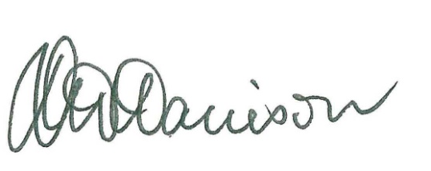
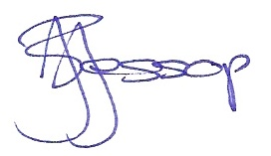
____________________ ___________________ ___________________
Professor Tim Brailsford Ms Joanne Jessop Mr David Harrison
Chair Member Member

Queensland Independent Remuneration Tribunal, Building a new remuneration structure for Members of the Queensland Parliament – Part two, Determination 3/2014 (27 March 2014), 69-70 <http://www.remunerationtribunal.qld.gov.au/assets/determination-03-14.pdf>.
The additional salary for the office of the Deputy Opposition Whip was set by the Tribunal in Determination 8/2015, effective from 27 March 2015: Queensland Independent Remuneration Tribunal, Additional Salary of Deputy Opposition Whip, Determination 8/2015 (12 May 2015), <http://www.remunerationtribunal.qld.gov.au/assets/determination-08-2015.pdf>.
Queensland Parliament, Record of Proceedings (Hansard) (16 February 2016), 21.
Constitution of Queensland 2001 (Qld) s 43 (4).
Queensland Parliament, The Executive Government of Queensland (2011) Explore Your Parliament <https://www.parliament.qld.gov.au/explore/about-us/parliament-overview/executive-government>.
The current Administrative Arrangements Order (No. 3) 2015 is available at https://www.qld.gov.au/about/how-government-works/government-responsibilities.
Cabinet consists of the Premier and a number of Ministers (Constitution of Queensland 2001 (Qld) s 42). Currently, in the 55th Parliament, all Ministers are members of Cabinet.
Department of the Premier and Cabinet, 2.4 Membership (27 August 2014) Executive Council Handbook <http://www.premiers.qld.gov.au/publications/categories/policies-and-codes/handbooks/exec-council-handbook/powers/membership.aspx>.

