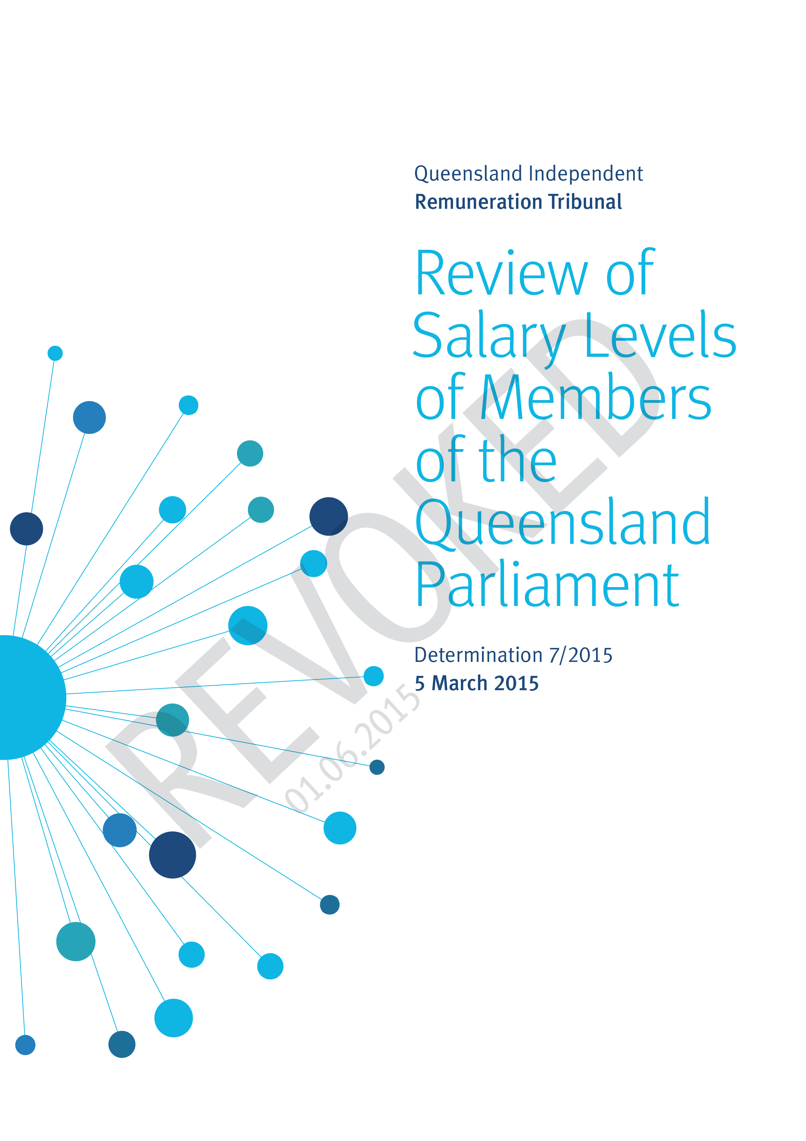
1 - Overview and Background
1.1 Overview
The Queensland Independent Remuneration Tribunal (the Tribunal) is an independent statutory authority established by the Queensland Independent Remuneration Tribunal Act 2013 to determine remuneration in connection with Members of the Queensland Parliament (MPs) and former MPs.
The definition of ‘remuneration’ includes the additional salary and associated allowances payable to an MP for performing roles as an office holder in addition to that of an MP in the Queensland Legislative Assembly.
Determination 7/2015 is the first consideration of the base salary for an MP since Determination 1/2013 was handed down setting the base salary as at 1 July 2013.
Subsequent to Determination 1/2013 the Tribunal has issued five further determinations which have dealt with additional salaries for office holders, the allowances system, termination arrangements and entitlements for former MPs.
Determination 7/2015 considers the level of the annual base salary for an MP and the levels of additional salaries of office holders.
Determination 1/2013, issued on 15 October 2013, holistically examined the role, functions and responsibilities of an MP in Queensland. A resultant decision was made in the Determination to set the base salary. Subsequently Determination 3/2014, issued on 27 March 2014, assessed each office holder’s role to determine the additional salary of each office holder.
The Tribunal considers that the role and work value of an MP and the various offices have not changed in a substantive way since Determinations 1/2013 and 3/2014 were issued.
Determination 7/2015 provides an analysis of benchmarks of base salary and examines a range of economic factors since Determinations 1/2013 and 3/2014 were issued.
1.2 Background
Base salary
Determination 1/2013 reviewed the base salary of an MP. In that Determination, the Tribunal undertook an assessment of the work value of an MP, examining:
- the role of an MP in Queensland;
- a comparison of the characteristics of this role and those of an employee; and
- the distinction between ‘work value’ and ‘work load’ of an MP.
To determine the base salary, the Tribunal conducted a detailed comparison of base salary levels to various benchmarks including general wage increases, the salaries of other occupations, salary levels in the public sector and base salaries of MPs in other jurisdictions. Determination 1/2013 also considered historical trends and a range of economic factors.
The Tribunal set the annual base salary for an MP at $144,485 effective from 1 July 2013 and subsequently determined that an increase of 3.02% was applicable to the base salary from 1 July 2013. Hence the annual base salary was increased to $148,848 which remains the current rate.
Additional salary
Additional salaries provided to office holders were set by the Tribunal in Determination 3/2014 after a detailed examination of the nature of such roles.
The Tribunal determined that the annual additional salary for the office of the Premier of Queensland be set at $223,560 and that the additional salary be increased by 3.02% from 1 July 2013 bringing the annual additional salary to $230,312.
The effect of Determination 3/2014 established the total annual salary of the office of the Premier at $379,160 (which included base salary of $148,848 and additional salary of $230,312) as at 1 July 2013. That rate remains current.
Determination 3/2014 also set the additional salary payable to each office holder relative to the additional salary payable to the office of the Premier as outlined in the following table:
Band | Office | Relativity between offices %
1 | Premier | 100.0
2 | Deputy Premier | 80.0
3 | Minister  Leader of the Opposition | 70.0
4 | Speaker  Assistant Minister and Leader of the House | 60.0
5 | Deputy Leader of the Opposition | 40.0
6 | Chief government whip  Deputy Speaker  Manager of Opposition Business  Assistant Minister | 35.0
7 | Opposition Spokesperson  Leader in the Assembly of a recognised political party, other than the Leader or Deputy Leader of the Opposition  Chairperson of a committee | 25.0
8 | Senior government whip  Opposition whip | 15.0
9 | Government deputy whip | 12.5
10 | Member of a committee | 10.0

2 - Comparison of Base Salary across Jurisdictions
2.1 Base Salary
The Tribunal considered comparable jurisdictions in Determination 1/2013 when arriving at the base salary. The Tribunal notes that allowances and other entitlements vary considerably across the Australian States and Territories and therefore jurisdictional comparisons of base salary need to be interpreted with caution.
Figure 2.1 provides a comparison of base salary across Australian States and Territories as at both 1 July 2013 and 1 January 2015, including the percentage increase (if any) over this period.
Figure 2.1 – Comparison of base salary across Australian States and Territories between 1 July 2013 and 1 January 2015
Jurisdiction | Annual base salary  as at 1 July 2013 | Annual base salary  as at 1 Jan 2015 | % increase
Western Australia | $148,638 | $154,223 | 3.76%
South Australia | $153,130 | $153,130 | -
New South Wales | $146,251 | $149,541 | 2.25%
Queensland | $144,485 | $148,848 | 3.02%
Northern Territory | $143,122 | $147,416 | 3.00%
Australian Capital Territory | $125,259 | $132,775 | 6.00%
Victoria | $140,973 | $144,497 | 2.50%
Tasmania | $118,466 | $118,466 | -

Figure 2.1 shows that the base salary in Queensland as at 1 July 2013 was ranked fourth behind South Australia, Western Australia and New South Wales respectively. At 1 January 2015, the base salary in Queensland was again ranked fourth with Western Australian and South Australia reversing positions.
The increases in base salary since mid-2013 across comparable jurisdictions have ranged from 2.25% to 6.00%. Of the six jurisdictions which have increased their base salary since 1 July 2013 (including Queensland), the average increase in the base salary has been 3.42%. If Queensland is excluded, the average rises to 3.50%.
From the above table it can be seen that the increase in the Australian Capital Territory (ACT) is at the higher end of the scale. However, prior to the 6.00% increase (effective 1 July 2014), the ACT Remuneration Tribunal did not make any changes to the base salary in either 2012 or 2013. When the ACT is excluded from the comparison, the average increase in the base salary has been 2.91%.
Figure 2.2 presents the relativities in the base salary across the various jurisdictions at 1 January 2015. However, the Tribunal again notes that the base salary is but one component of remuneration and that allowances paid, in addition to base salary, vary considerably across the States and Territories.
Figure 2.2 – Comparison of levels of base salary across Australian States and Territories as at 1 January 2015
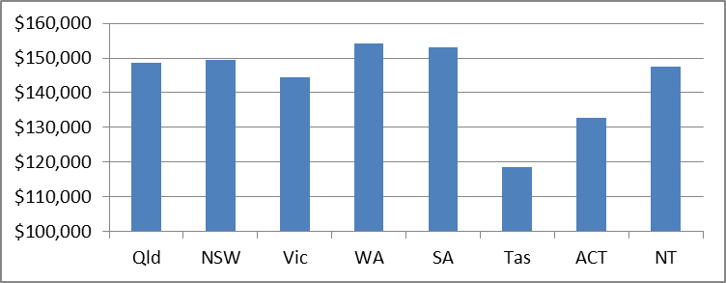
The discussion above reflects the current salary levels. It is expected that nearly all of the comparative jurisdictions will review or make changes to their respective base salary during 2015. In the case of South Australia changes to base salary are tied to the base salary of a Commonwealth MP, while in the Northern Territory the base salary is tied to a public sector wages agreement. In the case of Victoria, from 1 July 2015 the base salary will be indexed to a formula which is a function of the average weekly ordinary time earnings (AWOTE) of workers in Victoria.
With the exception of Tasmania, which is still awaiting an outcome from an earlier review, the other States and Territories are expected to make determinations in the latter half of this year. It is reasonable to expect, on the basis of previous decisions, that increases will be granted however the quantum of such increases will only be known once determined by the respective jurisdictions.
Figure 2.3 outlines the schedule of base salary reviews in other jurisdictions for 2015.
Figure 2.3 – Schedule of base salary reviews for 2015 in the Commonwealth and States and Territories (excluding Queensland)
Jurisdiction | Timing of 2015 base salary review
Commonwealth | Remuneration Tribunal to issue next annual determination prior to 14 May 2015.
New South Wales | Parliamentary Remuneration Tribunal to issue next annual determination prior to 31 August 2015.
Victoria | Change to base salary due to take effect from 1 July 2015.
Western Australia | Salaries and Allowances Tribunal to issue next annual determination prior to 24 June 2015.
South Australia | 2015 changes dependent on Commonwealth Remuneration Tribunal (see above). Base salary is annual salary at a rate equal to $42,000 less than the Commonwealth base salary.
Tasmania | The Tasmanian Government is yet to outline its response to a review and has not stated a position on MP salary.
Australian Capital Territory | Remuneration Tribunal to issue next annual determination prior to April 2015.
Northern Territory | A 3% increase in base salary will take effect from 16 August 2015.

As at 1 January 2015, the base salary for a Commonwealth MP is $195,130 compared to the base salary of $148,848 for a Queensland MP. As discussed in Determination 1/2013, the Tribunal notes that a comparison to the Commonwealth is tenuous because of the lack of direct equivalence of roles and policy matters. The Tribunal continues to consider that comparison of MP base salary across States is more valid than a comparison with the Commonwealth.
2.2 Economic Data
Figure 2.4 provides a comparison of key economic indicators across the States and Territories. In the last financial year Queensland’s economy ranked third behind New South Wales and Victoria in size and ranked third in economic growth (GSP) behind the Northern Territory and Western Australia.
Figure 2.4 – Comparison of economic indicators of Australian States and Territories
Jurisdiction | Gross State Product (GSP) 2013-14  levels  $M | GSP  Chain Volume measures, annual growth 2013-14  % | GSP  Chain Volume measures,  average annual compound growth  2004-05 to 2013-14  %
New South Wales | 487,637 | 2.1 | 2.0
Victoria | 343,819 | 1.7 | 2.4
Queensland | 295,142 | 2.3 | 3.5
Western Australia | 256,188 | 5.5 | 4.9
South Australia | 95,199 | 1.3 | 2.1
Australian Capital Territory | 35,566 | 0.7 | 2.7
Tasmania | 24,905 | 1.2 | 1.4
Northern Territory | 21,205 | 6.5 | 4.2

Last year, the State of the States report (issued January 2014) ranked the performance of Queensland’s economy as equal third. The current State of the States report (issued January 2015), indicates that Queensland’s economic activity is down 0.4% on the previous year and the state’s economic growth ranked fourth behind the Northern Territory, Western Australia and the Australian Capital Territory. Comparatively Queensland was the best performer in relation to equipment investment and construction work.

3 - Queensland Economic and Wage Considerations
3.1 Queensland Economic Conditions
With the outcomes and forecasts of overall economic growth now below those published in the 2014-15 State Budget, Queensland Treasury estimate that the pace of recovery in the labour market will also be weaker than previously expected.
Reflecting overall softer economic conditions, the forecast for wages growth has been revised down since the State Budget, while the 0.25 percentage point reduction in inflation for 2014-15 partly reflects removal of the carbon tax.
Figure 3.1 shows Queensland Treasury and Trade’s Mid-Year Fiscal and Economic Review (MYFER) forecasts for key economic variables in 2014-15 and 2015-16, compared with Budget forecasts.
Figure 3.1 – Economic Forecasts for the Queensland economy (year average, original terms)
 | 2013-14 | 2014-15 |  | 2015-16
Parameter | Outcome | Budget | MYFER | MYFER
Real GSP | 2.3 | 3.0 | 2.5 | 5.75
Employment | 1.8 | 2.0 | 1.5 | 1.75
Unemployment rate | 6.0 | 6.0 | 6.25 | 6.0
CPI | 2.8 | 2.75 | 2.5 | 2.5
Wage Price Index | 2.6 | 3.0 | 2.5 | 3.0
Population | 1.75 | 2.0 | 1.75 | 1.75

The CPI forecast for the end of the current financial year is 2.5% which is expected to be maintained through the 2015-16 financial year. Similarly the wage price index for the current financial year is expected to be 2.5% subsequently rising to 3.0% in the 2015-16 financial year.
Another relevant figure is the community grants indexation rate which is 3.25% in 2014-15. This figure is derived as a weighted composite of wage price indexation and CPI. The index is applied to State funded ongoing service procurement and operational grants to non-government organisations.
3.2 Queensland Wage Benchmarks
Over the last financial year there have been a series of increases in relevant wage benchmarks. The core public service has received an annual wage rise of 2.2% which was also applied to Senior Officers and the Senior Executive Service. The wage rise for core employees commenced on 1 December 2013, was applied again in December 2014 and will be applied again in December 2015. This wage rise was provided by a Ministerial Directive while arbitration proceedings were before the Queensland Industrial Relations Commission (QIRC). To date no determination has been made by the QIRC.
An alternative index that captures Queensland public sector employees such as teachers, police officers, nurses and mid-wives, medical officers, health practitioners, ambulance service employees and fire and rescue employees is the average weekly earnings of the public sector. Over 2013-14 this index increased by 2.43%.
A broader salary index that covers the economy is average weekly earnings across both the private and public sector. Over recent years this has been a particularly volatile number reflecting the fluid nature of the Queensland economy.
The historical context of the various benchmarks is provided below.
Figure 3.2 – Annual changes in MP base salary and other salary indices 2000–14
Year |  | MP Base Salary |  | Average Weekly Earnings, Public Sector | Average Weekly Earnings, Private and Public Sector | CPI | Qld Core Public Service | SES
2000-01 |  | 3.93% |  | 6.97% | 6.70% | 6.15% |  | 3.14%
2001-02 |  | 3.37% |  | 4.18% | 3.79% | 3.03% |  | 3.13%
2002-03 |  | 4.03% |  | 3.19% | 5.22% | 2.68% |  | 3.97%
2003-04 |  | 3.92% |  | 4.44% | 4.95% | 3.13% | 3.80% | 3.96%
2004-05 |  | 4.12% |  | 4.61% | 7.41% | 2.53% | 3.80% | 0.00%
2005-06 |  | 7.05% |  | 5.42% | 2.25% | 4.19% | 4.00% | 3.95%
2006-07 |  | 6.85% |  | 4.54% | 5.65% | 2.60% | 4.00% | 8.16%
2007-08 |  | 0.00% |  | 3.99% | 5.57% | 5.07% | 4.00% | 4.00%
2008-09 |  | 0.00% |  | 4.96% | 6.16% | 1.98% | 4.50% | 2.50%
2009-10 |  | 3.14% |  | 5.17% | 6.05% | 3.23% | 4.00% | 2.50%
2010-11 |  | 2.50% |  | 5.12% | 4.23% | 3.86% | 4.00% | 2.50%
2011-12 |  | 2.50% |  | 4.15% | 3.77% | 0.90% | 0.00% | 2.20%
2012-13 |  | 5.35% |  | 3.80% | 7.65% | 1.99% | 0.00% | 2.20%
2013-14 |  | 3.02% |  | 2.43% | 1.07% | 3.22% | 2.20% | 2.20%
5-year ave |  | 3.30% |  | 4.13% | 4.53% | 2.63% | 2.02% | 2.32%
10-year ave |  | 3.43% |  | 4.42% | 4.96% | 2.95% | 3.04% | 3.00%
$1,000 indexed since 2004-05 |  | $1,401 |  | $1,540 | $1,623 | $1,338 | $1,349 | $1,344
 | DATA |  | SOURCE
 | MP Base Salary |  | MP Base Salary increase
 | Average Weekly Earnings, Public Sector |  | ABS 6302.0 - Average Weekly Ordinary Time Earnings - Qld ; Persons ; Full Time ; Adult ; Public Sector
 | Average Weekly Earnings, Private and Public Sector |  | ABS 6302.0 - Average Weekly Ordinary Time Earnings - Qld ; Persons ; Full Time ; Adult ; Total (Public and Private Sector)
 | CPI |  | ABS 6401.0 - Consumer Price Index - All groups CPI; Brisbane
 | QLD Core Public Service |  | Wage increases of 'core' government departments and agencies, State Government Departments Certified Agreement (2003, 2006, 2009, 2013)
 | SES |  | Based on SES Remuneration Scale provided by the Public Service Commission

Over the last financial year the average increase in non-MP salary indices, including the public sector, SES and the private sector in Queensland was 1.98%. In comparison the CPI increase over the same period was 3.22%.
A comparison of averages over both the last five and ten years reveals that increases to the MP base salary have been less than the increases in average weekly earnings of the public and private sector but more than the increase in core public service salary.
The last row provides the indexed value of $1,000 over the last 10 years. All salary indexation has exceeded the rate of CPI indexation.
In relation to the current financial year, there is an absence of available forecasts for many of the wage indices. However the most recent figure for average weekly earnings of the private and public sector in Queensland across December quarters to December 2014 was 2.45% p.a.

4 - Discussion
In addition to considering changes in base salary in comparable jurisdictions, the Tribunal has considered the following factors and economic indicators:
- inflation and price level increases
- average weekly earnings
- Queensland wage indices
- public sector wage comparisons
- State indexation
- economic data.
The Tribunal has placed particular weight on more recent wage decisions in Queensland and Queensland specific forecasts of price indices. The Tribunal has arrived at the base salary increase through a combination of averages of relevant inputs.
Consequently the Tribunal has determined that the base salary and additional salaries of office holders will increase by 2.58% from 6 April 2015. By applying the same percentage increase to the additional salaries of office holders the relativity in levels of these additional salaries is maintained. This increase moves the base salary from $148,848 to $152,688 (an increase of $3,840).

Determination 7/2015
Preamble
Determination 7/2015 is issued by the Queensland Independent Remuneration Tribunal (Tribunal) under the Queensland Independent Remuneration Tribunal Act 2013 (the Act).
Any inconsistencies between earlier Tribunal Determinations and Determination 7/2015 are to be resolved in favour of Determination 7/2015. Matters in earlier Determinations not addressed in this Determination are confirmed by the Tribunal and not amended.
All Tribunal Determinations must be read in the context of the relevant Background and Reasons.
Determination 7/2015 takes effect from the next quarter on 6 April 2015.
Base salary
- The Tribunal determines that the annual base salary for an MP will increase by 2.58% thereby setting the annual base salary at $152,688 effective from 6 April 2015.
Additional salary
- The Tribunal determines that the additional salary for the most senior office holder (the office of Premier) will also be increased by 2.58% effective from 6 April 2015. The Tribunal confirms that the relativities decided in Determination 3/2014 for each office holder, relative to the additional salary of the most senior office holder, remain unchanged.

Date of Determination: 5 March 2015

____________________ ___________________ ___________________
Professor Tim Brailsford Ms Joanne Jessop Mr David Harrison
Chair Member Member

Queensland Independent Remuneration Tribunal, Building a new remuneration structure for Members of the Queensland Parliament, Determination 1/2013 (15 October 2013), 105 <http://www.remunerationtribunal.qld.gov.au/assets/determination-01-2013.pdf>
Queensland Independent Remuneration Tribunal, Building a new remuneration structure for Members of the Queensland Parliament – Part two, Determination 3/2014 (27 March 2014), 69-70 <http://www.remunerationtribunal.qld.gov.au/assets/determination-03-14.pdf>.
For the Northern Territory, the base salary is as at August 2013.
Sections 7 and 8 of the Remuneration Tribunal Act 1973 (Commonwealth).
Government Gazette of the State of New South Wales, Number 15, Friday, 27 February 2015, 625 <http://gazette.legislation.nsw.gov.au/so/download.w3p?id=Gazette_2015_2015-15.pdf>.
Section 3 of the Parliamentary Salaries and Superannuation Act 1968 (Victoria).
Sections 6 and 8 of the Salaries and Allowances Act 1975 (Western Australia).
Section 3 of the Parliamentary Remuneration Act 1990 (South Australia).
Will Hodgman, Premier of Tasmania, Report into MPs’ Pay, 3 June 2014 <http://www.premier.tas.gov.au/releases/report_into_mpsa_pay>.
Sections 9 and 13 of the Remuneration Tribunal Act 1995 (Australian Capital Territory).
Section 3 of the Assembly Members and Statutory Officers (Remuneration and Entitlements) Act (Northern Territory).
Remuneration Tribunal (Commonwealth), Determination 2014/10, Members of Parliament – Base Salary, Additional Salary for Parliamentary Office Holders, and Related Matters (14 May 2014), 1 <http://www.remtribunal.gov.au/media/documents/2015/2014-determinations/2014-10-principal-determination-members-of-parliament-basesalary,-additional-salary-for-parliamentary-office-holders,-and-related-matters/2014-10-MPs-Base-Salary,-Additional-Salary-for-Parl-OH-Determination-for-1.7.2014.pdf>.
Queensland Independent Remuneration Tribunal, Building a new remuneration structure for Members of the Queensland Parliament, Determination 1/2013 (15 October 2013), 58 <http://www.remunerationtribunal.qld.gov.au/assets/determination-01-2013.pdf>.
Australian Bureau of Statistics (5220.0), Australian National Accounts: State Accounts, 2013-14, Table 1, Gross State Product, Chain volume measures and current prices <http://www.ausstats.abs.gov.au/ausstats/abs@archive.nsf/log?openagent&5220001_annual_gross_state_product_all_states.xls&5220.0&Time%20Series%20Spreadsheet&B23B7642D875C0ECCA257DA1001020DF&0&2013-14&02.12.2014&Latest>.
Australian Bureau of Statistics (5220.0), Australian National Accounts: State Accounts, 2013-14, Analysis of Results <http://www.abs.gov.au/ausstats/abs@.nsf/mf/5220.0>.
Ibid.
Queensland Independent Remuneration Tribunal, Building a new remuneration structure for Members of the Queensland Parliament – Part two, Determination 3/2014 (27 March 2014), 46 <http://www.remunerationtribunal.qld.gov.au/assets/determination-03-14.pdf>
CommSec, State of the States (January 2015) State and Territory economic performance report, <https://www.commsec.com.au/content/dam/EN/campaigns/stateofstates.pdf?icid=123849:commsec:m:public:Public_Home:::State_of_the_States:Download_Bottom>.
Queensland Treasury and Trade, State Budget 2014-15 Mid Year Fiscal and Economic Review, 7 <https://www.treasury.qld.gov.au/publications-resources/mid-year-review/mid-year-review-2014-15.pdf>.
Ibid, 8.
Ibid, 8.
2014-15 Queensland State Budget – Service Delivery Statements – Department of Communities, Child Safety and Disability Services, 3 <http://www.budget.qld.gov.au/budget-papers/2014-15/bp5-doccsds-2014-15.pdf>.
Data provided by the Queensland Government’s Statistician’s Office.
The State Government Departments Certified Agreement 2013 (Core agreement) covers approximately 48,000 public sector employees.

