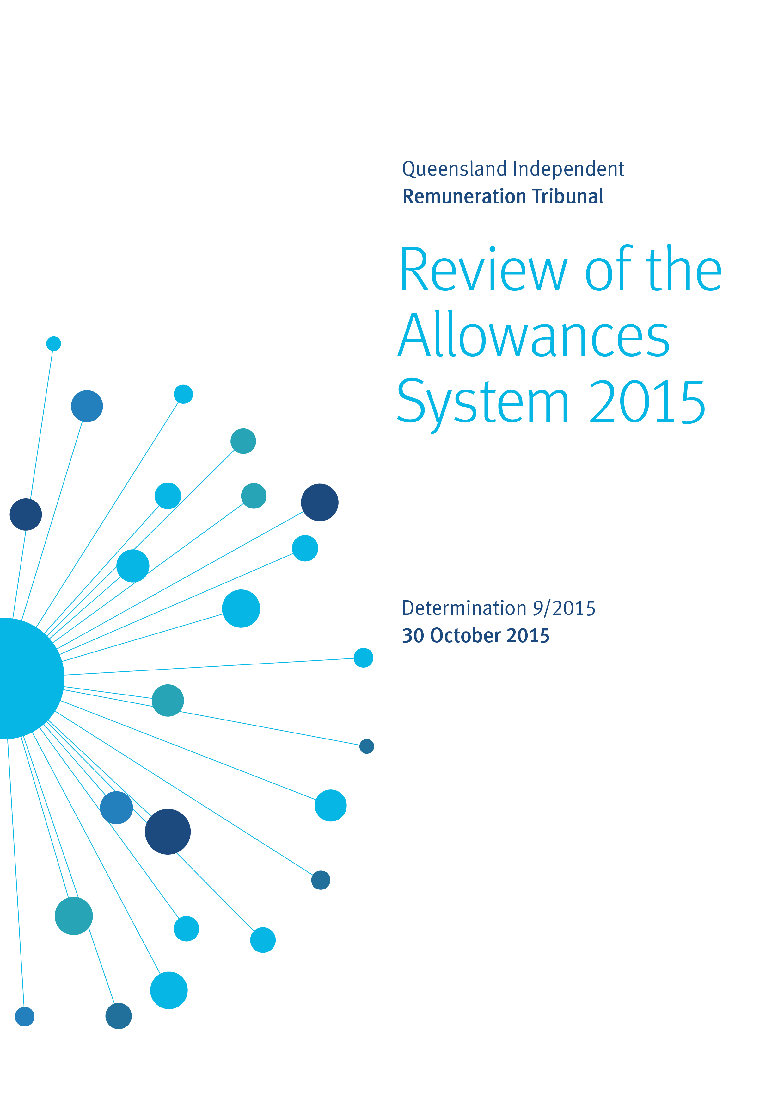
Executive Summary
- The Queensland Independent Remuneration Tribunal (the Tribunal) significantly changed the system of MP allowances when it handed down Determination 1/2013 on 15 October 2013. The previous system of over 30 allowances was collapsed into three general allowances covering electorate expenses, information and communication expenses, and travel expenses. The changes also involved the establishment of new expenditure limits associated with each allowance, and the introduction of an acquittal and reporting process to enhance accountability and transparency.
- In 2014, the new system was reviewed after its first six months of operation which included an analysis of expenditure data. The Tribunal’s findings were published in Determination 6/2014, handed down on 11 November 2014. Various adjustments were made to the allowances system in that Determination, designed to increase flexibility while maintaining accountability and transparency.
- The Tribunal committed to a further review during 2015 to include a full financial year of data. This current Determination reports on that review and includes an analysis of expenditure over the recent financial year 2014-15.
- The review process involved an examination of the expenditure of MPs across the three categories of allowances in addition to receiving written submissions and conducting interviews with various MPs and the Clerk of the Parliament.
- The data reveal that the majority of MPs have spent within the limits of their Electorate Allowance but have struggled to spend within the limits of their Information and Communication Allowance. For instance, 88% of MPs spent within their Electorate Allowance while 66% of MPs overspent their Information and Communication Allowance. Note that any overspend of these allowances is at the personal cost to the MP.
- The Tribunal has examined various options to address the imbalance between the expenditure patterns across the two allowances and concluded that the simplest and most efficient solution is to merge the two allowances. Hence, the Tribunal has determined to create a new allowance known as the ‘Electorate and Communication Allowance’ which will enhance the flexibility of the system. This new Allowance will be established from 1 July 2015.
- The amount of the Electorate and Communication Allowance will be set by combining the two existing allowances, and in recognition of cost increases since Determination 1/2013, the aggregate amount will increase by 2.5% from 1 January 2016.
- The acquittal system associated with the new allowance will remain. However, disclosure of spending across categories will now be required in the Clerk’s annual report.

- In relation to travel matters, 94% of MPs spent less than 80% of their General Travel Allocation. A detailed analysis of the data finds that MPs with electorates classified in band 3 are over-represented near the limit of the allowance. Specifically, of the six MPs who spent more than 90% of their allocation, three of these MPs are in electorates classified in Band 3 and the one MP who overspent the allowance also is located in Band 3. These electorates include the five largest regional electorates in the State.
- The Tribunal recognises the challenges of travel within Band 3 electorates associated with their geographical size and the significant distances that MPs need to traverse. In many cases, commercial air travel is not a feasible option and MPs must either book charter flights or undertake long trips by road with overnight stays. The Tribunal considers that it is more efficient for these MPs to use air travel within their electorate rather than drive.
- In recognition of the geographical size and population spread in Band 3 electorates, the General Travel Allocation will increase by $16,000 per annum for an MP in these electorates. This increase is provided to allow greater use of flights within the electorate and enhanced capacity to overnight within the electorate and hence reduce the amount of travel time. The Tribunal has received advice that the approximate cost of a daily charter flight is around $4,000 and hence the additional allowance is set with the broad aim of providing an additional four charter flights per annum or the equivalent of an extra flight per quarter. This change will take effect from 1 October 2015 on a pro-rata basis.
- In a similar vein, the Tribunal considers that there is a case to increase the Motor Vehicle Allowance for MPs in Band 3 particularly as these electorates almost necessitate the use of four-wheel drive vehicles. MPs in Band 3 generally need to purchase or lease a larger vehicle and are required to travel the greatest distances to service their electorate. Accordingly, the Motor Vehicle Allowance will increase by $2,000 per annum for an MP with an electorate in Band 3. This change will take effect from 1 October 2015 on a pro-rata basis.
- A number of MPs submitted that they need staff to travel with them to assist in carrying out their duties and that this expense could be claimed from the General Travel Allocation. The Tribunal consulted with the Clerk of the Parliament on this matter. The Clerk confirmed that the Parliament does not provide a budget for electorate office staff travel other than for training.
- The Tribunal considers that it is appropriate at certain times and events for an MP to be accompanied by a member of staff. As such, it is appropriate for these travel expenses to be acquitted against the General Travel Allocation. These staff include electorate office staff and research policy officers. However, the Tribunal recognises that some guidance needs to be given as to the circumstances when such travel expenses can be claimed. This Determination outlines the circumstances for claimable travel by staff.
- Various other matters have been considered in this review. An analysis of acquittals and non-receipted transactions finds that MPs have adapted well to the system. Over the recent financial year, non-receipted claims by the large majority of MPs were less than $500 in each of the allowances. Where MPs had acquitted non-receipted transactions, the large majority were of small individual value and of minor aggregate value. The Tribunal is satisfied that, based on the data, an annual limit of $1,000 for non-receipted expenditure for the Electorate and Communication Allowance is appropriate.
- The Tribunal also examined the issue of GST credits following submissions from MPs. The Tribunal notes that the allowances system has been established on a GST-inclusive basis. GST credits do not accrue to individual MPs, rather they are considered part of consolidated government accounting. Further, the nature of GST does not apply equally to every transaction and hence any other system would require individual accounting to be established for each Member. During the financial year of 2014-15, there were 21,026 transactions undertaken by MPs through the allowances system. Accordingly, the Tribunal considers that any change would be complex and consume administrative resources that would not generate any additional net benefit.
- At present, wages for relief staff engaged by MPs are currently met through the Information and Communication Allowance. The Tribunal considers that the establishment of the new Electorate and Communication Allowance will provide MPs with the flexibility to make decisions about managing costs associated with running their electorate office, including the engagement of relief for electorate office staff.

1 - Introduction
1.1 Establishment of the Queensland Independent Remuneration Tribunal
The Queensland Independent Remuneration Tribunal (the Tribunal) is an independent statutory authority established by the Queensland Independent Remuneration Tribunal Act 2013 (the Act) to determine remuneration in connection with Members of the Queensland Parliament (MPs) and former MPs.
The definition of ‘remuneration’ includes the salary, allowances or entitlements payable to an MP in connection to their role as an MP in the Queensland Legislative Assembly.
Under the Act, the Tribunal is required to ensure that allowances reflect the reasonable expenses incurred by an MP in servicing their electorate and are not a substitute for other remuneration. Since its establishment, the Tribunal has aimed to increase the accountability and transparency of allowances and entitlements for Queensland MPs while at the same time ensuring MPs have flexibility to meet the diverse needs of their electorates.
1.2 Brief history of allowances
The Tribunal significantly changed the system of MP allowances when it handed down Determination 1/2013 on 15 October 2013. The previous system of over 30 allowances was collapsed into three general allowances covering electorate expenses, information and communication expenses, and travel expenses. The changes also involved the establishment of new expenditure limits associated with each allowance and the introduction of an acquittal and reporting process to enhance accountability and transparency.
An Electorate Allowance was introduced to assist an MP to discharge their electorate and constituency responsibilities. The quantum of the allowance was determined using a combination of population and size. Each electorate was categorised into one of three bands (Bands 1 to 3) and MPs currently receive $27,500, $30,000 or $34,000 respectively.
The Tribunal considered it essential for an MP to be able to obtain and disseminate information to fulfil their electorate and parliamentary roles. An Information and Communication Allowance of $34,000 was established to provide for such expenses. The allowance is in addition to office and related support which is already supplied to MPs by the Parliamentary Service under the Parliamentary Service Act 1988.
A General Travel Entitlement was also introduced to simplify and streamline the current arrangements for travel undertaken by an MP. This entitlement consists of a Motor Vehicle Allowance, a General Travel Allocation and Commercial Air Travel Allocation (Air Warrants) and Alternate Travel (applicable for MPs representing certain regional/remote electorates).
The Motor Vehicle Allowance was introduced in recognition of the need for an MP to respond to constituent issues and events within and across their electorate. The Tribunal has divided electorates into three bands based on the size of the electorate. Members with electorates in the first band currently receive $25,500, the second band $32,000 and the third band $40,000.
The General Travel Allocation is held by the Clerk to meet the costs of MPs travelling on Parliamentary Business (as defined in Determination 4/2014) by a range of ground and air transport options. Like the Motor Vehicle Allowance, the General Travel Allocation is divided into three bands depending on the size of the electorate. Electorates in the first band are currently allocated $18,360, the second band $30,040 and the third band $61,720.
The Commercial Air Travel Allocation (Air Warrants) was largely unchanged under the new system with the exception of the abolition of Alternative Travel ‘kilometric allowances’. Regional and remote electorates listed in the Members’ Remuneration Handbook are entitled to Air Warrants based on the principle that remote/regional MPs should not be disadvantaged in terms of travelling to and from Brisbane to conduct Parliamentary Business. These same MPs are able to utilise alternate travel options where commercial air travel options are unsuitable.
1.3 Summary of 2014 review
At the time of Determination 1/2013, there were no data available on the patterns and types of expenditure incurred under the then allowances system as it was a system that involved little central record keeping. The Tribunal flagged in its Annual Report for 2013-14 that a priority was to conduct a review of the then recently implemented allowances system. The review took place in the second half of 2014 and the Tribunal’s findings were published in Determination 6/2014, handed down on 11 November 2014.
The review process included consideration of submissions and conducting meetings with individual MPs, the Committee of the Legislative Assembly and the Clerk of the Parliament. Feedback received was generally positive, particularly considering the extent of the changes implemented after Determination 1/2013. Various matters were raised including a potential lack of flexibility in the new system, the quantum of allowances especially the Information and Communication Allowance, and the administrative burden imposed by the new acquittal and reporting procedures.
Data concerning expenditure by MPs for the first period of the new allowance system
(1 January 2014 to 30 June 2014) were also considered. These data revealed that a large majority of MPs incurred expenditure within the limits of the various allocations.
In response to feedback, minor adjustments were made to the allowances system in Determination 6/2014 that were designed to increase flexibility. In relation to the Electorate Allowance and the Information and Communication Allowance, it was determined that if an MP had overspent one allowance but underspent the other allowance at the end of the financial year, up to 20% of the unspent allowance paid to an MP during the financial year could be used to meet over expenditure in the other allowance.
Further, the expenditure categories under both the Electorate Allowance and the Information and Communication Allowance were amended in recognition that there were generally three or four key expenditure categories used on a regular basis. The Tribunal also removed the $100 limit per individual non-receipted transaction.
Following Determination 6/2014, the Tribunal committed to a further review during 2015 to include a full financial year of reporting (1 July 2014 to 30 June 2015). This current Determination reports on this review.

2 - Process
2.1 Overview
As part of this review, the Tribunal considered correspondence, conducted meetings and held discussions with a range of stakeholders. These stakeholders included various MPs, the Clerk of the Parliament and staff in the Parliamentary Service. The Tribunal also gave further consideration to the views of over 2,500 members of the public regarding an appropriate allowances system, which were submitted to the Tribunal during its initial review of the allowances system.
2.2 Consultation with MPs
On 18 June 2015 the Tribunal wrote to all MPs inviting submissions.
Feedback from MPs was received regarding general issues concerning the allowances system and in response to specific matters the Tribunal had outlined.
Various matters and suggestions were raised which included, in no particular order:
- further simplification of the system by combining the Electorate Allowance and the Information and Communication Allowance;
- comments that the expense categories in the Information and Communication Allowance and the Electorate Allowance were ambiguous and could be simplified if a single allowance was created;
- the amount of the Information and Communication Allowance being insufficient to enable effective communication with constituents, particularly for those MPs with more populous electorates;
- comments that general post is still the best way to reach all constituents as digital communication and social media only account for a small portion of communication methods;
- the need to access the Information and Communication Allowance to cover electorate office staff absences;
- allowing the costs of travel for electorate office staff to be claimable against the General Travel Allocation, and that the quantum of the General Travel Allocation be adjusted to reflect this;
- the General Travel Allocation should be increased, particularly for MPs with electorates in Band 3;
- providing MPs who are entitled to Air Warrants with the ability to “cash in” unused warrants to supplement their General Travel Allocation;
- allowing MPs to rollover any unspent General Travel Allocation from one financial year to the next within the term of a Parliament;
- the Motor Vehicle Allowance being insufficient for MPs in electorates in Band 3 who require a four-wheel drive vehicle;
- the Electorate Allowance should be increased due to the rising costs of goods and services;
- the onerous nature of the acquittal system, particularly where an MP has more than one official electorate office; and
- allowing MPs to recoup the GST credits available to Parliament (from allowance expenditure) as a means of increasing the allowances they receive.

A common theme raised by MPs was frustration with the boundaries between the Electorate Allowance and the Information and Communication Allowance. For some MPs the balance between the two allowances was not set appropriately resulting in an overspend in one allowance and an underspend in the other allowance. Rather, it was argued that there is considerable diversity of needs across Queensland electorates, and that MPs have diverse individual needs in servicing their electorates. Hence, MPs are best placed to determine the relative spend across the allowances having regard to the specific circumstances of their electorate.
A further theme raised in some submissions was that the quantum of the Information and Communication Allowance was insufficient. MPs expressed a clear preference for direct mail as a means of communication with their electorate and the Tribunal was provided with several examples of how the cost of postage made it difficult to manage within the quantum of this allowance.
A third theme involved the quantum of the General Travel Allocation for regional MPs. Specifically it was submitted that the significant distances travelled within most Band 3 electorates, combined with the lack of commercial air travel options, results in significant costs of travel due to frequent overnight stays and the hiring of charter flights.
2.3 Consultation with the Clerk of the Parliament
The Clerk of the Parliament provided evidence that the overall spend of allowances generally remains within the allocated limits, however the current system limited the ability to transfer a portion of one allowance to the other.
The Clerk advised that the preference of the Parliamentary Service was to merge the Electorate Allowance and the Information and Communication Allowance into a single allowance. The Clerk commented that there is a regular and high number of enquiries from MPs about which allowance should be accessed. Further, as both allowances are subject to the same acquittal process, the Parliamentary Service believes that there would be no loss in accountability or transparency arising from a merger of the two allowances.
Similarly the Clerk noted that, out of the two allowances, anecdotal evidence was consistent with the view that the quantum of the Information and Communication Allowance was unduly restrictive and that there was some merit in increasing this allowance. Alternatively, a merger of the Electorate Allowance and the Information and Communication Allowance could ease the pressure on the spending limits as some of the Electorate Allowance could be spent on items related to the Information and Communication Allowance.
The Tribunal also consulted with the Clerk on a number of specific issues raised by MPs. In particular, the Tribunal sought the Clerk’s views on travel undertaken by electorate office staff, the daily travel allowance, relief coverage for electorate office staff, the travel allowance in regional electorates and the issue of GST credits. An analysis of these matters is covered later in Chapter 4.
The Clerk commented on the 2015 State General Election which occurred during the period under review. As a practical matter, the turnover of MPs meant that newly elected MPs would inevitably take time to understand the system. The advent of the General Election meant that analysis of the data should be undertaken with caution as the period includes circumstances where two different MPs were in office in some of the electorates.

3 – Data analysis
3.1 Background
Since Determination 1/2013 and the subsequent implementation of the new allowances system, reports detailing expenditure categories and patterns are tabled by the Clerk in the Parliament following the end of each financial year.
In this chapter an analysis is undertaken of these data covering the full year from 1 July 2014 to 30 June 2015. As noted in Chapter 2, the General Election was held on 31 January 2015. Due to the changes to the structure of the Parliament, the data tabled by the Clerk include the 134 MPs who held office during 2014-15. Of note, there were 45 new MPs that served during the period arising from seven retirements and the electoral defeat of a further 38 MPs.
3.2 Quantum of the allowances
The Tribunal reviewed both the Electorate Allowance and the Information and Communication Allowance and considered the collective quantum across these two allowances.
In relation to the General Election, MPs who did not retain or contest their seat or who took office on 31 January 2015 received a pro-rata amount of the annual allocation for each allowance.
In order to capture total expenditure, MPs were encouraged to report all expenditures. In instances where MPs expended more than the allocated allowance and were not able to make use of the off-set arrangements, the overspend was a personal cost. In such cases, the overspend may be claimable as a personal income tax deduction (TR 1999/10).
As a consequence of the General Election, 134 MPs served over the year and hence the amount of the allowance varies across the MPs depending on how long they served in office over the previous 12 month cycle. Therefore the analysis below of MP expenditure focuses on the percentage of the pro-rata allowance that was spent.
In relation to the Electorate Allowance, the pattern of expenditure relative to the limit of the allowance is presented in Figure 3.1.

Figure 3.1 – Electorate Allowance expenditure
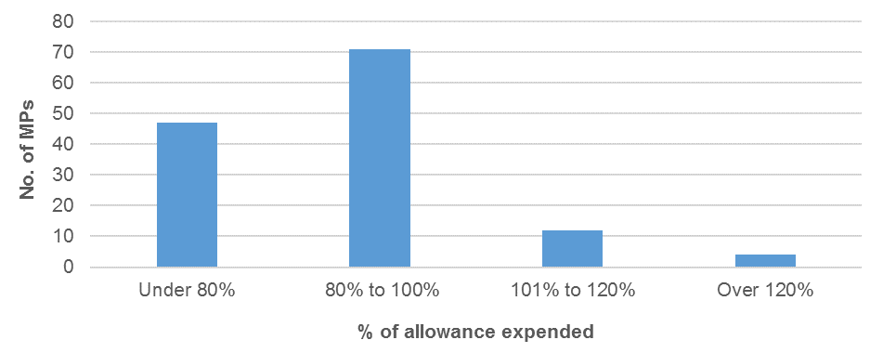
From Figure 3.1 the Electorate Allowance expenditure can be examined by number and percentage across the 134 MPs that were in office over the period:
- 47 MPs spent under 80% of their Electorate Allowance
- 71 MPs spent between 80% and 100% of their Electorate Allowance
- 12 MPs spent between 101% and 120% of their Electorate Allowance
- 4 MPs spent more than 120% of their Electorate Allowance.
In summary, 88% of MPs spent at or under the limit of the allowance. Of note, 7% of MPs spent less than 50% of their allowance.
In relation to the Information and Communication Allowance the pattern of expenditure, relative to the limit of the allowance, is presented in Figure 3.2. Again, note that the limit of the allowance varies across the MPs depending on how long they served in office over the previous 12 month cycle.
Figure 3.2 – Information and Communication Allowance expenditure
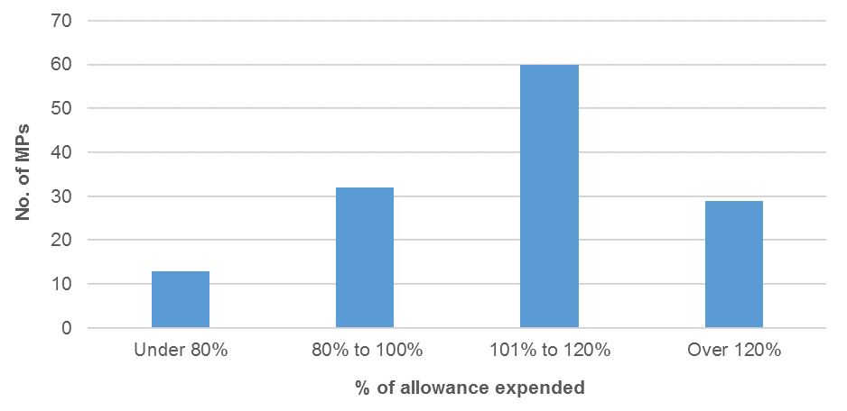
From Figure 3.2 Information and Communication Allowance expenditure can also be examined by number and percentage across the 134 MPs:
- 13 MPs spent under 80% of their Information and Communication Allowance
- 32 MPs spent between 80% and 100% of their Information and Communication Allowance
- 60 MPs spent between 101% and 120% of their Information and Communication Allowance
- 29 MPs spent over 120% of their Information and Communication Allowance.
In summary, 66% of MPs overspent their allowance. A further 21% of MPs spent more than 120% of their allowance. These observations are consistent with verbal feedback from the Clerk and MPs themselves that they are struggling to keep their expenditure within the limit of this allowance.
A conclusion that can be drawn from this analysis is that the relative split between the limits of the Electorate Allowance and the Information and Communication Allowance is unbalanced when mapped against the spending patterns of MPs.
This conclusion leads to options for possible change.
One possibility is to adjust the limits of each allowance which would involve increasing the Information and Communication Allowance whilst decreasing the Electorate Allowance. However such a change would involve setting somewhat arbitrary new limits for the two allowances which would not solve the issue for all MPs. For instance, those MPs that spend a significant percentage of the Electorate Allowance would potentially be disadvantaged by such an amendment.
A second possibility is to merge the two allowances. This would create the opportunity for individual MPs to align their expenditure patterns to a single allowance without being restricted by the current individual allowance limits. In effect this change would enhance the flexibility of the allowances system.
3.3 Acquittal system
The system established in Determination 1/2013 included seven expenditure categories in the Electorate Allowance and eight expenditure categories in the Information and Communication Allowance. In the Tribunal’s first review of the allowances system, the Tribunal noted that for both the Electorate Allowance and the Information and Communication Allowance there were generally three or four key expenditure categories used on a regular basis compared to other minor categories which had not been widely used.
In Determination 6/2014, the Tribunal amended the acquittal system to four expenditure categories for the Electorate Allowance and five expenditure categories for the Information and Communication Allowance.
In relation to the Electorate Allowance, data on expenditure in the categories that were abolished during the reporting period (patron expenses, membership fees, donations and gifts) are included in the ‘other’ category.
The number of items acquitted during the last financial year in the Electorate Allowance listed by category is presented in Figure 3.3.
Figure 3.3 – Electorate Allowance acquittals in each category
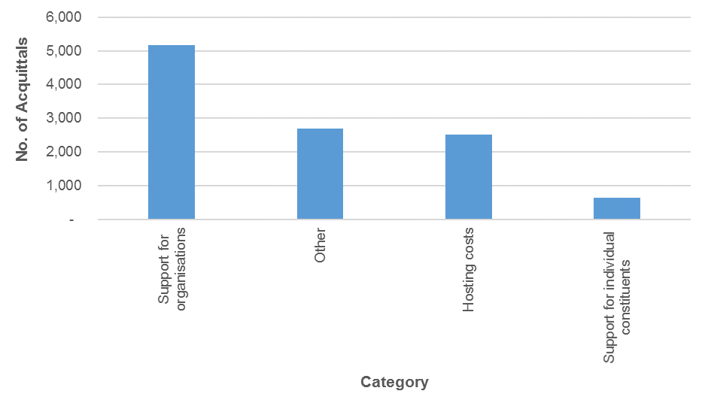
The relative spend by dollar value across categories of the Electorate Allowance is presented in Figure 3.4.
Figure 3.4 – Electorate Allowance acquitted expenditure by category
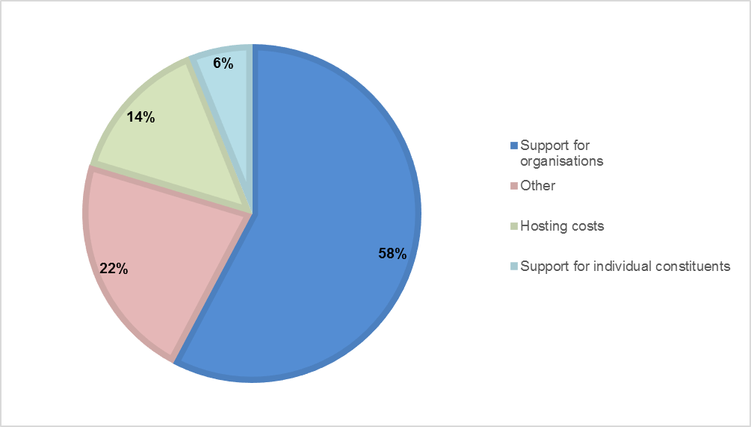
From Figures 3.3 and 3.4, the Electorate Allowance acquittal patterns can be examined by number and percentage across MPs:
- 58% of the dollar value of acquitted transactions and 47% of the total number of these transactions occurred in the category of ‘support for organisations’ which includes items such as financial assistance to schools, clubs, charities and educational institutions.
- The next most populous single category of expenditure was ‘other’ where 22% of the dollar value of transactions appeared.
- ‘Hosting costs’ accounted for 14% of the total expenditure while ‘support for individual constituents’ accounted for only 6%. However, the Tribunal recognises that the distinction between the categories of ‘support for organisations’ and ‘support for constituents’ is potentially ambiguous.
Turning to the Information and Communication Allowance, data on expenditure in the categories that were abolished during the reporting period (consumables, additional staffing, education and administrative costs) are included in the ‘office expenses’ category.
The number of items acquitted during the last financial year in the Information and Communication Allowance by category is presented in Figure 3.5.
Figure 3.5 – Information and Communication Allowance acquittals in each category
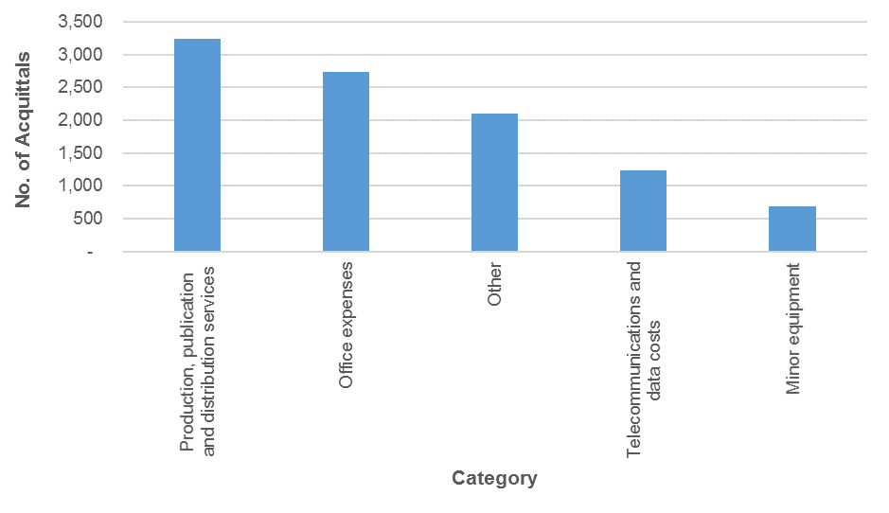
The relative spend by dollar value across categories of acquitted expenditure in the Information and Communication Allowance is presented in Figure 3.6.
Figure 3.6 – Information and Communication Allowance acquitted expenditure by category
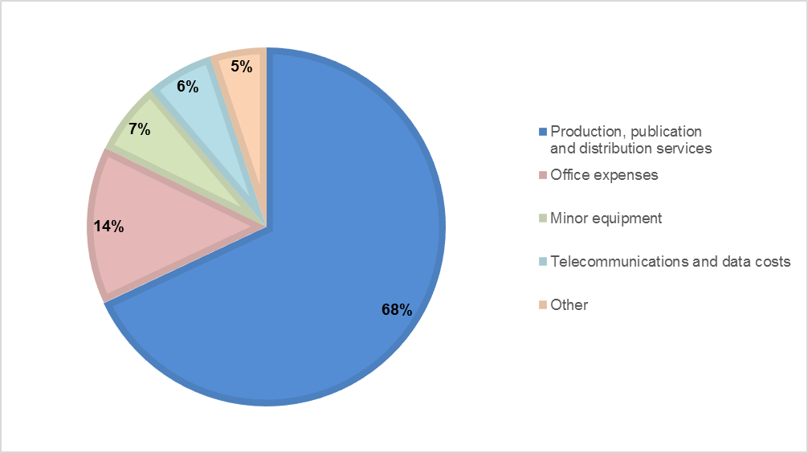

In comparison to the Electorate Allowance, the number of transactions in the Information and Communication Allowance tend to be more uniform as demonstrated by a comparison of Figures 3.3 and 3.5. However the relative percentage of the expenditure amounts in the Information and Communication Allowance is concentrated in one category being ‘production, publication and distribution services’.
Further examination of Figures 3.5 and 3.6 reveals:
- The total number of acquitted transactions does not exceed 50% for any category.
- In contrast, the relative percentage of expenditure is dominated by the category of ‘production, publication and distribution services’ in which 68% of expenditure occurs.
- The next highest category of expenditure is ‘office expenses’ at 14%, while the remaining categories are each less than 10%.
An interpretation of these data is the Information and Communication Allowance is mainly spent on the publication and mail costs of hard copy information. This is consistent with other evidence provided by MPs that their major expenditures are associated with the direct mail-out of publications, newsletters and the like to their constituents.
To gain further insight into expenditure patterns, Figure 3.7 shows the average dollar value per transaction separately for the Electorate Allowance and the Information and Communication Allowance.
Figure 3.7 – Average dollar value per transaction
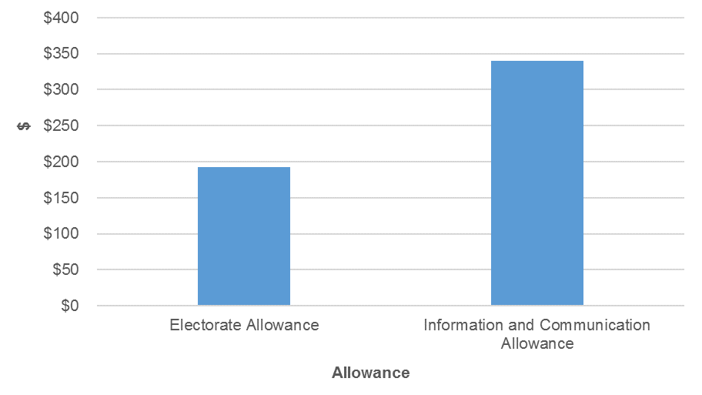

As shown in Figure 3.7, the average expenditure in the Electorate Allowance is $192 per transaction which is lower than the average expenditure in the Information and Communication Allowance of $340 per transaction. Again, these data are consistent with a higher item spend in the Information and Communication Allowance.
3.4 Travel matters
The General Travel Entitlement comprises three elements.
First, each MP is provided with a Motor Vehicle Allowance which is paid on a quarterly basis. Individual MPs then make their own arrangements in respect of their motor vehicles.
Secondly, the Parliamentary Service administers a system of Air Warrants which provide for the air travel of MPs from regional and remote electorates who travel to and from Brisbane to conduct Parliamentary Business. MPs are allocated a set number of Warrants each year to be used on an as needs basis.
Not all eligible Members use all available Warrants, so the Parliamentary Service formulates an annual budget for Air Warrant travel based upon the historical collective cost of such travel, rather than setting individual budgets for each eligible MP.
Thirdly, a General Travel Allocation is held by the Parliamentary Service for each MP, the amount of which varies depending upon the electorate represented. This allocation is accessed by MPs on the basis of actual travel. Similar to Air Warrants, the budget held by the Parliamentary Service for the General Travel Allocation does not provide for 100 percent coverage of the full allocation, rather, the budget is set based on the historical collective cost of travel claims. In the case of any unspent budget, these amounts remain with the Parliamentary Service.
In relation to the General Travel Allocation the pattern of expenditure for the period, relative to the allocation, is presented below in Figure 3.8. Again, in relation to the MPs who took office after the General Election in January 2015, they were entitled to a pro-rata amount of the annual General Travel Allocation.

Figure 3.8 – General Travel Allocation expenditure
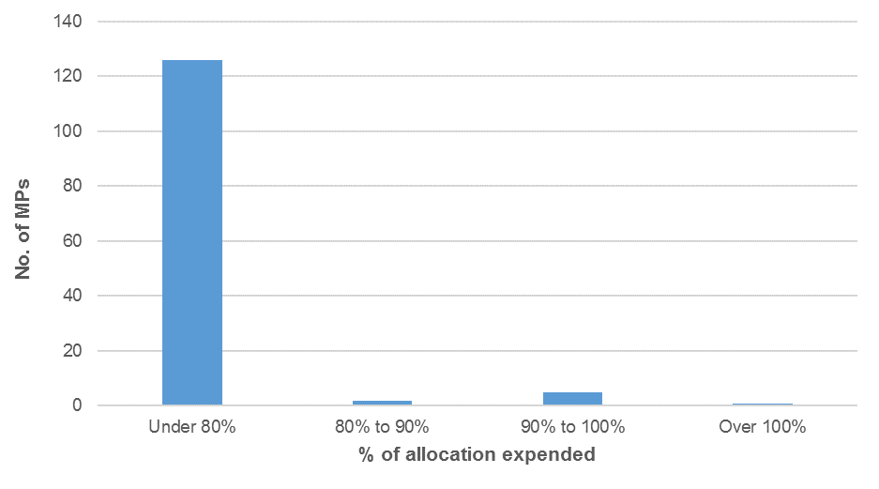
From Figure 3.8, expenditure in the General Travel Allocation can be examined across the 134 MPs:
- 126 MPs spent under 80% of their General Travel Allocation
- 2 MPs spent between 80% and 90% of their General Travel Allocation
- 5 MPs spent between 90% and 100% of their General Travel Allocation
- 1 MP spent over 100% of their General Travel Allocation.
In percentage terms, 94% of MPs spent less than 80% of their General Travel Allocation and 99% of MPs spent at or below the amount of the allocation. Further, 59% of MPs spent 25% or less of their travel allocation, and 38% of MPs spent less than 10% of their travel allocation. Of note, 12 MPs (or 9%) did not claim any travel and eight of these MPs were new to Parliament following the General Election.
At first glance these data are consistent with a view that the General Travel Allocation is set at an appropriate level. However, more detailed analysis of the data across electorates reveals some complexities.
The vast majority of MPs that underspent their allocation by a significant amount are located in electorates classified in Band 1. In contrast, of the six MPs who spent more than 90% of their allocation, three of these MPs are in electorates classified in Band 3. Further the one MP who overspent the allocation is also located in Band 3. The electorates classified in Band 3 include the five largest regional electorates which receive the highest General Travel Allocation because of their geographical size and the significant distances that these MPs need to travel within their electorates.
3.5 Non-receipted expenditure
When reforming the allowances system, the Tribunal established a provision for non-receipted expenditure against the Electorate Allowance and the Information and Communication Allowance. This provision was designed to recognise the small cash expenses that MPs incur, sometimes on a regular basis, when it is not feasible to obtain a receipt.
Determination 6/2014 reviewed the pattern of non-receipted transactions and considered that for the large majority of MPs non-receipted transactions are of small individual value and of minor aggregate value. In recognition of the administrative costs of processing many items of small value, Determination 6/2014 removed the $100 limit per individual non-receipted transaction but the annual limit for non-receipted expenditure remained unchanged.
In relation to the Electorate Allowance the pattern of non-receipted transactions is presented below in Figure 3.9.
Figure 3.9 – Non-receipted transactions for the Electorate Allowance
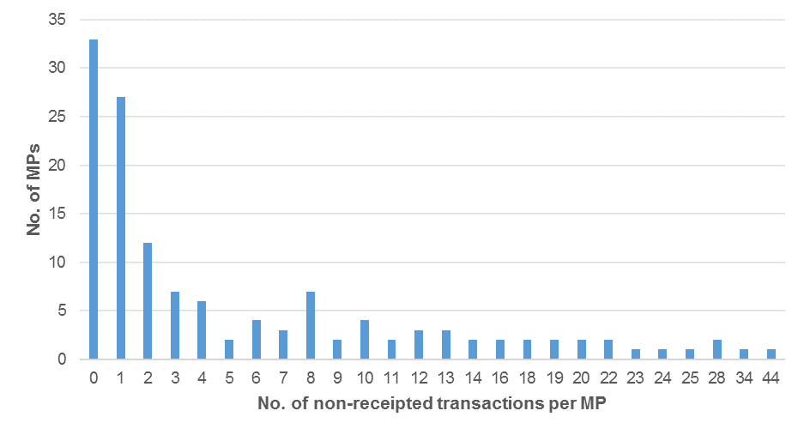
The average value of non-receipted transactions in the Electorate Allowance was $56. Of note, for 69% of MPs the total value of non-receipted transactions in this allowance was less than $500.
In relation to the Information and Communication Allowance the pattern of non-receipted transactions is presented below in Figure 3.10.
Figure 3.10 – Non-receipted transactions for the Information and Communication Allowance
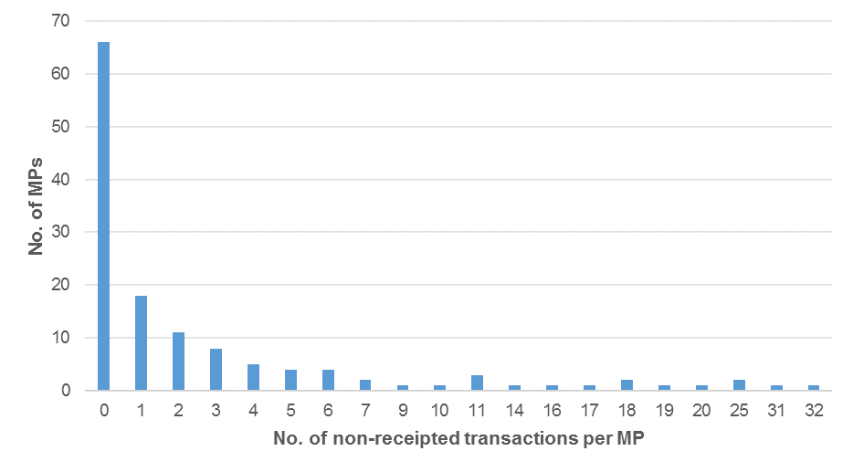
The average value of non-receipted transactions in the Information and Communication Allowance was $50. Of note, for 87% of MPs the total value of non-receipted transactions in this allowance was less than $500.
The evidence from Figures 3.9 and 3.10 suggests that many MPs did not acquit low value transactions without a receipt. However, where MPs have acquitted non-receipted transactions, the large majority were of small individual value and of minor aggregate value. The Tribunal is satisfied that, based on the data, an annual limit of $1,000 for non-receipted expenditure is appropriate.

4 - Discussion
4.1 Electorate Allowance and Information and Communication Allowance
From the analysis of the data in Chapter 3, it appears to be more difficult for MPs to manage expenditure within the limits of the Information and Communication Allowance as compared to the Electorate Allowance. However, this is not the case for every MP as their individual circumstances vary.
The Tribunal has previously recognised this situation in Determination 6/2104 which provided for a transfer of up to 20% of the amount of unspent funds in either the Electorate Allowance or the Information and Communication Allowance to cover an overspend in the other allowance. While this amendment did not alter the total amount of funds available to any MP, it enhanced flexibility.
The Tribunal has received feedback that while the intent of these amendments introduced in Determination 6/2014 were to improve flexibility, the changes introduced a layer of complexity for MPs.
The Tribunal holds the view that the merger of the Electorate Allowance and the Information and Communication Allowance would further improve both flexibility and simplicity for MPs and the Parliamentary Service. The Tribunal does however hold a concern that the merger of the two allowances would allow MPs, in some cases, to spend the full amount of funds on direct mail and the like and nothing on items that are currently covered by the Electorate Allowance such as support for organisations and constituents. While such a bias in spending patterns may be justified in specific circumstances, the Tribunal believes that it is important to continue to disclose the spending of these allowances.
On balance, the Tribunal concurs that there does appear to be legitimate argument for merging the two allowances to enable MPs to individually manage their expenditure across diverse electorates. A merger of the two allowances is supported by the Clerk and the Tribunal notes that such a move would further simplify the allowances system, while also maintaining accountability and transparency through the acquittal and reporting process.
Accordingly, the Tribunal concludes that the Electorate Allowance and the Information and Communication Allowance should be merged and the Electorate and Communication Allowance be established, effective from 1 July 2015. However as noted below, the reporting requirements will be amended to enhance the disclosure around the types of expenditure.
In relation to determining the quantum of the new Electorate and Communication Allowance, the Tribunal has considered the total expenditure across both allowances against the collective quantum of the total allocated allowances. The Tribunal considers it appropriate for the quantum of the new allowance to be based on the combined total of the Electorate Allowance and the Information and Communication Allowance. The rate of the new Electorate and Communication Allowance is:
Figure 4.1 – Electorate and Communication Allowance amounts and bands effective 1 July 2015
Electorate
ECA Band 1 – Electorate and Communication Allowance of $61,500
Ashgrove
Aspley
Beaudesert
Broadwater
Buderim
Bulimba
Bundaberg
Burdekin
Burleigh
Burnett
Callide
Caloundra
Capalaba
Chatsworth
Clayfield
Cleveland
Currumbin
Dalrymple
Everton
Ferny Grove
Glass House
Greenslopes
Gympie
Hervey Bay
Hinchinbrook
Indooroopilly
Ipswich
Ipswich West
Kallangur
Kawana
Keppel
Lockyer
Logan
Lytton
Mackay
Mansfield
Maroochydore
Maryborough
Moggill
Mount Coot-tha
Mt Ommaney
Mulgrave
Mundingburra
Nanango
Nicklin
Noosa
Pine Rivers
Redcliffe
Redlands
Rockhampton
Sandgate
South Brisbane
Southern Downs
Springwood
Stafford
Sunnybank
Toowoomba North
Toowoomba South
Townsville
Warrego
Yeerongpilly
ECA Band 2 – Electorate and Communication Allowance of $64,000
Algester
Barron River
Brisbane Central
Cairns
Condamine
Cook
Gaven
Gladstone
Gregory
Inala
Mermaid Beach
Mirani
Morayfield
Mount Isa
Mudgeeraba
Nudgee
Pumicestone
Southport
Stretton
Surfers Paradise
Thuringowa
Whitsunday
ECA Band 3 – Electorate and Communication Allowance of $68,000
Albert
Bundamba
Coomera
Murrumba
Waterford
Woodridge

Further, the amount of the Electorate Allowance and the Information and Communication Allowance has not changed since Determination 1/2013 and there is recognition that costs have increased in the period since. Of further relevance, the Tribunal notes that 99% of the total allocation for the Electorate Allowance and the Information and Communication Allowance for the 2014-15 period was spent. On this basis, the Tribunal considers merit in the argument that the amount of these allowances could be increased. Having regard to the economic climate, various cost indicators such as the CPI, and the overall environment of financial prudence, the Tribunal considers an increase of 2.5% to the new Electorate and Communication Allowance is appropriate, effective from 1 January 2016.
As such, after applying the increase (rounded to the nearest $100), the rate of the Electorate and Communication Allowance will be:
Figure 4.2 – Electorate and Communication Allowance amounts effective 1 January 2016
Electorate
ECA Band 1 – Electorate and Communication Allowance of $63,000
ECA Band 2 – Electorate and Communication Allowance of $65,600
ECA Band 3 – Electorate and Communication Allowance of $69,700

The Tribunal notes that the principles behind the introduction of an acquittal and reporting system remain valid. Under the new allowance, MPs will still be required to acquit expenditure and the reporting will be revised as detailed below.
The limit on non-receipted expenditure is set at $1,000 which will be applied to the new Electorate and Communication Allowance.
As outlined earlier (see section 3.3), the Tribunal reduced the number of expense categories for both the Electorate Allowance and the Information and Communication Allowance in Determination 6/2014. The Tribunal also introduced a category ‘other’ to each of the allowances to capture items of an occasional nature that do not fall into one of the new categories.
The Tribunal concludes that the changes to expenditure categories following Determination 6/2014 have had the desired effect of streamlining the acquittal system. Therefore the existing expenditure categories will remain in effect for the new Electorate and Communication Allowance, noting that there will only be one ‘other’ category. A further change is the merging of the two categories ‘support for organisations’ and ‘support for individual constituents’ as the distinction has not always been clear. Thus, the categories for the new Electorate and Communication Allowance will be:
  - hosting costs
- minor equipment
- office expenses – including consumables, additional staffing, staff training and development, education and administrative costs
- production, publication and distribution services
- support for constituents and organisations
- telecommunications and data costs
  - other.
In Determination 1/2013, the Tribunal established a reporting system for the Clerk of the Parliament to provide an annual report to Parliament within three months of the end of the second biannual period which contains information on all expenditure incurred by each Member against the Electorate Allowance and the Information and Communication Allowance.
Given that the Clerk is currently required to table a separate report on each of the allowances, the Tribunal considers it important to maintain a high level of transparency and accountability for reporting on expenditure of the new Electorate and Communication Allowance.
The Tribunal therefore determines that the Clerk’s annual report to Parliament for the new Electorate and Communication Allowance include the total expenditure incurred by each MP under each category listed above. An example of this new report is included below in Figure 4.3.

Figure 4.3 – Example Clerk of the Parliament Annual Report to Parliament 2015-16 – Electorate and Communication Allowance

PART A: ACTUAL EXPENDITURE ACQUITTED FOR PERIOD BY CATEGORY | $
Support for constituents and organisations | x
Hosting costs | x
Production, publication and distribution services | x
Telecommunications and data costs | x
Minor equipment | x
Office expenses | x
Other | x
Total expenditure acquitted | xx

PART B: ALLOWANCE RECONCILIATION | Note | $
Allowance paid for the period
Allowance as per Handbook |  | xx
Less amounts withheld due to underspend in previous period | 1 | (x)
Equals cash payment to Member in this period |  | xx
Allowance to be acquitted for the period
Cash payments for the period (as per above) |  | xx
Plus amount paid in previous period but not acquitted | 1 | x
Plus carryover from previous period | 2 | x
Equals total allowance to be acquitted in this period |  | xx
Actual expenditure for the period
Amount acquitted |  | xx
Amount un-acquitted/(overspent) | 3 | x
Carry-over to next period | 2 | x
Reduction in future payments | 1 | (x)

Notes
- When a Member underspends in one period (beyond that allowable as a carry-over), future allowance payments are reduced by the underspent amount. The Member is then required to acquit the unspent allowance in the following reporting period.
- Up to 10% of the total allowance amount that is unexpended for each reporting period (excluding any reductions or carry-overs from previous years) may be retained by the Member and acquitted in the following reporting period.
- When a Member overspends the Allowance, any over-expenditure is met personally by the Member.

PART C: CERTIFICATIONS
Certification by the Member | Certification by the Clerk
I certify that -  - the above summary is a true and correct record of the expenditure acquitted by me against the Allowance; and  - use of the Allowance has been in accordance with the requirements of the Members’ Remuneration Handbook and supplementary written advice provided by the Clerk.  …………………………………………..  Member of the Legislative Assembly (signature) | I certify that -  - the total allowance amounts to be acquitted in the above summary are correct and have been duly paid to the Member;  - the total acquittal amounts correctly reflect the total individual acquittals submitted by the Member;  - based on the information provided to me by the Member I am satisfied that the above summary represents allowable acquittals in accordance with the provisions of the Members’ Remuneration Handbook;  - in accordance with the requirement of the Members’ Remuneration Handbook to conduct a rolling audit program, individual acquittals provided by the Member may be subject to a future detailed audit to test and verify compliance; and  - while no such audit has been completed at this time for the 2015-16 acquittal period, should the results of the audit be material and require a variation to the above summary, a disclosure will be made in the future Report.  …………………………………………..  Clerk of the Parliament  (signature)

4.2 General Travel Allocation
The analysis in Chapter 3 indicates that the quantum of the General Travel Allocation is sufficient for the large majority of MPs. As noted earlier, MPs that spend the highest percentage of their General Travel Allocation tend to be in Band 3 electorates. Specifically, of the eight MPs that served in Band 3 electorates over the past year, five of these MPs are represented in the top 10% of all MPs when ranked by travel expenditure. These electorates include regional areas with large geographical size and generally multiple population centres.
When determining the quantum of the General Travel Allocation for each band in Determination 1/2013, the Tribunal considered that MPs in Band 3 may be required to use air travel within their electorate, either by commercial airlines or charter flights.
Based on the evidence provided to the review, the Tribunal considers that it is more efficient for certain MPs to use air travel within their electorate rather than drive. Of note, the basis for the General Travel Allocation outlined in Determination 1/2013 referenced a notional quantum of $30,000 for intra-electorate flights in Band 3 electorates. In recognition of the unique geography of Band 3 electorates, the General Travel Allocation will increase by $16,000 per annum for an MP in a Band 3 electorate. This increase is provided to allow greater use of flights and enhanced capacity to overnight within the electorate and hence reduce the amount of travel time. The Tribunal has received advice that the approximate cost of a daily charter flight is around $4,000 and hence the additional allowance is set with the broad aim of providing an additional four charter flights per annum or the equivalent of an extra flight per quarter.
Accordingly, while the General Travel Allocations for Band 1 and 2 remain the same, the General Travel Allocation will be set at $77,720 per annum for Band 3. These electorates are:
Figure 4.4 – General Travel Allocation for Band 3 electorates
Electorate
GTA Band 3 – General Travel Allocation of $77,720
Cook

Dalrymple

Gregory

Mount Isa

Warrego

The implementation of this change is effective from 1 October 2015 on a pro-rata basis meaning that the increase for the 2015-16 financial year is $12,000.

4.3 Motor Vehicle Allowance
One theme that emerged from the submissions and meetings with MPs was that the Motor Vehicle Allowance appeared to be insufficient for MPs representing an electorate in Band 3.
The Tribunal considers that there is a case to increase the Motor Vehicle Allowance for MPs in Band 3. These electorates, due to their geographical size and spread, almost necessitate the use of four-wheel drive vehicles. MPs in Band 3 generally need to purchase or lease a larger vehicle and are required to travel the greatest distances to service their electorate. In comparison to Band 2 electorates which range from 1,582km² to 8,434km² in size, Band 3 electorates range from 13,885km² to 570,502km².
Accordingly, while the Motor Vehicle Allowance remains the same for Bands 1 and 2, the Motor Vehicle Allowance will increase by $2,000 per annum for an MP with an electorate in Band 3, thereby setting the allowance at $42,000 per annum for Band 3. These electorates are:
Figure 4.5 – Motor Vehicle Allowance for Band 3 electorates
Electorate
MVA Band 3 – Motor Vehicle Allowance of $42,000
Burdekin
Callide
Cook
Dalrymple
Gregory
Mirani
Mount Isa
Nanango
Southern Downs
Warrego

Again, the implementation of this change is effective from 1 October 2015 on a pro-rata basis meaning that the increase for the 2015-16 financial year is $1,500.
4.4 Electorate office staff and research officer travel
As noted in Chapter 2, when seeking feedback from MPs on the operation of the allowances system, the Tribunal requested MPs comment on the appropriateness of costs of electorate office staff travel (if accompanying an MP on Parliamentary Business) being acquitted against the General Travel Allocation.
A number of MPs submitted that they need staff to travel with them to assist in carrying out their duties and they suggested that there would be benefit in this expense being claimed from the General Travel Allocation.
The Tribunal consulted with the Clerk of the Parliament on this matter. The Clerk confirmed that the Parliament does not provide a budget for electorate office staff travel other than for staff training.
The Tribunal considers it appropriate at certain times and for certain events for an MP to be accompanied by a member of staff. As such it is appropriate for these travel expenses to be acquitted against the General Travel Allocation. However the Tribunal recognises that some guidance needs to be given as to the circumstances when such travel expenses can be claimed.
The definition of Parliamentary Business was approved by the Tribunal in Determination 4/2014. This definition is included in the Members’ Remuneration Handbook and provided to all MPs. The Tribunal therefore advises that claimable travel by staff is limited to those circumstances of Parliamentary Business when an MP is:
(f) Attending to business (including attending conferences, functions, meetings or seminars) directly relating to a Member’s Electorate; or
(g) Attending to business directly related to a matter of current parliamentary debate or addressing conferences, meetings and seminars to which a Member has been invited in his/her capacity as an MP; or
(j) Studies, investigations, or inquiries on matters related to duties and responsibilities as an MP (including addressing or attending conferences, meetings, functions or seminars) provided that the nature, official purpose, place and other relevant information is stated by the Member to identify the Parliamentary Business involved.
The Tribunal also considers that if the Premier approves an MP be provided with additional staff such as research officers and these arrangements are specified in the Members’ Remuneration Handbook, travel for these officers can also be met from the Member’s General Travel Allocation under the above guidelines.
In summary, where a Member travels on Parliamentary Business and requires one or more of their staff to accompany them, the cost of the staff travel may be met from the Member’s General Travel Allocation under the following conditions:
- the Member must only be conducting Parliamentary Business according to categories (f); (g); and (j) of the definition of Parliamentary Business; and
- costs will be reimbursed in accordance with amounts contained in the Parliamentary Service staff travel policy.
The Tribunal notes that such circumstances would not include events organised principally by the media or events where media and publicity is the principal purpose.

4.5 Daily Travel Allowance
During consultation, MPs raised issues associated with overnight accommodation in the Parliamentary Annexe. On occasion, Members who are provided with overnight accommodation in the Parliamentary Annexe may stay elsewhere in Brisbane, either by choice or necessity. There appears to be confusion among some MPs as to whether the Daily Travel Allowance (currently one third of the capital city rate) is claimable in such circumstances.
The Tribunal holds the view that in such circumstances it is reasonable for an MP to claim an allowance to cover meals and incidental expenses but not the cost of the accommodation itself. The Tribunal notes that this is consistent with similar claimable daily travel entitlements for Queensland Public Service employees when they are travelling on official duty and stay overnight in private accommodation.
The Tribunal consulted with the Clerk of the Parliament on this matter. The Clerk advised that current practice was to allow Members to claim the Daily Travel Allowance (one third of the capital city rate) for an overnight stay in Brisbane if alternative accommodation is at their own expense and they are conducting Parliamentary Business.
4.6 GST credits
A submission received by the Tribunal and discussed with the Clerk considered whether MPs should be allowed to recoup the GST credits associated with expenditure of an allowance.
The Tribunal notes that the allowances system has been established within a framework that is inclusive of GST. The Tribunal does not regard Members as akin to possessing contractor status or operating as a separate business unit, rather MPs form part of the whole of government. The Tribunal regards payments made through the allowances system as transactions made between third parties which requires the transaction to be levied on a GST-inclusive basis. As such, the amounts of the various allowances have been set within this framework.
An alternative system which operates on a GST-exclusive basis would need to have its parameters re-set. This would involve reducing the current amount of the allowances to operate on a pre-GST basis and then tracking the GST associated with each transaction. The nature of GST does not apply equally to every transaction and hence individual accounting would need to allocate the GST associated with every transaction to an individual Member. To put this in context, during the financial year of 2014-15, there were 21,026 transactions undertaken by MPs through the allowances system.
The Tribunal notes that the current allowances system has been designed on a GST-inclusive basis and that any change would be complex and consume administrative resources that would not generate any additional net benefit.
4.7 Relief for electorate office staff
At present, employment costs associated with relief staff engaged by MPs are currently met through the Information and Communication Allowance. However submissions have been made to the Tribunal that these costs are not always claimed because the quantum of the overall allowance is insufficient.
The Tribunal consulted with the Clerk of the Parliament on the matter and the Clerk advised the Tribunal that the Parliament does not provide a budget for this expense.
The Tribunal considers that the establishment of the new Electorate and Communication Allowance will provide MPs with the flexibility to make decisions about managing costs associated with running their electorate office, including the engagement of relief for electorate office staff.
Determination 9/2015
Preamble
Determination 9/2015 is issued by the Queensland Independent Remuneration Tribunal (Tribunal) under the Queensland Independent Remuneration Tribunal Act 2013.
Any inconsistencies between earlier Tribunal Determinations and Determination 9/2015 are to be resolved in favour of Determination 9/2015. Matters in earlier Determinations not addressed in this Determination are confirmed by the Tribunal and not amended.
All Tribunal Determinations must be read in the context of the relevant Background and Reasons.
Electorate and Communication Allowance
- The Tribunal determines that the Electorate Allowance and the Information and Communication Allowance be merged to form the new Electorate and Communication Allowance, backdated to 1 July 2015. Consequently the Electorate and Communication Allowance is initially set at the following annual amounts:
  - ECA Band 1 – $61,500
  - ECA Band 2 – $64,000
  - ECA Band 3 – $68,000
- Effective 1 January 2016, the Tribunal determines that the Electorate and Communication Allowance will increase by 2.5% to the following annual amounts:
  - ECA Band 1 – $63,000
  - ECA Band 2 – $65,600
  - ECA Band 3 – $69,700
- In the acquittal system, the expenditure categories under the new Electorate and Communication Allowance are as follows:
  - hosting costs
  - minor equipment
  - office expenses – including consumables, additional staffing, staff training and development, education and administrative costs
  - production, publication and distribution services
  - support for constituents and organisations
  - telecommunications and data costs
  - other.
- The Tribunal determines that the Clerk’s annual report to Parliament must include the total expenditure acquitted by each Member under each category listed above in the new Electorate and Communication Allowance.
Travel Entitlements
- The Tribunal determines that where a Member travels on Parliamentary Business and requires one or more of their staff to accompany them (including research officers), the cost of the staff travel may be met from the Member’s General Travel Allocation under the following conditions:
- the Member must only be conducting Parliamentary Business according to categories (f); (g); and (j) of the definition of Parliamentary Business; and
- costs will be reimbursed in accordance with amounts contained in the Parliamentary Service staff travel policy.
- The Tribunal determines that the General Travel Allocation will increase by $16,000 per annum for an MP with an electorate in GTA Band 3, thereby setting the allocation at $77,720 per annum for GTA Band 3.
- The Tribunal determines that the Motor Vehicle Allowance will increase by $2,000 per annum for an MP with an electorate in MVA Band 3, thereby setting the allowance at $42,000 per annum for MVA Band 3.
- Clauses 6 and 7 take effect from 1 October 2015 on a pro-rata basis.

Date of Determination: 30 October 2015

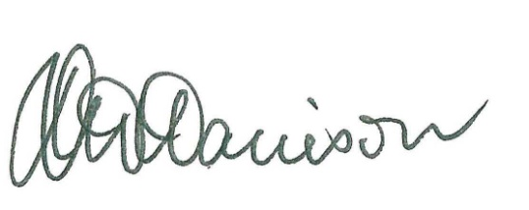
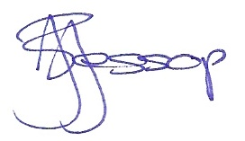
____________________ ___________________ ___________________
Professor Tim Brailsford Ms Joanne Jessop Mr David Harrison
Chair Member Member

Queensland Independent Remuneration Tribunal Act 2013 (Qld), 30.
See Chapter 2: Consultation, Determination 1/2013, 15 October 2013, Building a new remuneration structure for Members of the Queensland Parliament, 11.
See http://www.parliament.qld.gov.au/work-of-assembly/tabled-papers/online-tabled-papers reference nos 1207, 1208, 1209 and 1210; tabled on 30 September 2015.
Australian Taxation Office, Income tax and fringe benefits tax: Members of Parliament – allowances, reimbursements, donations and gifts, benefits, deductions and recoupments, TR 1999/10, 21 March 2012.
Determination 1/2013, 15 October 2013, Building a new remuneration structure for Members of the Queensland Parliament, 93.
Directive No 9/11, September 2011, Domestic Travelling and Relieving Expenses, 4 http://www.psc.qld.gov.au/publications/directives/assets/2011-9-domestic-travelling-and-relieving-expenses.pdf.

