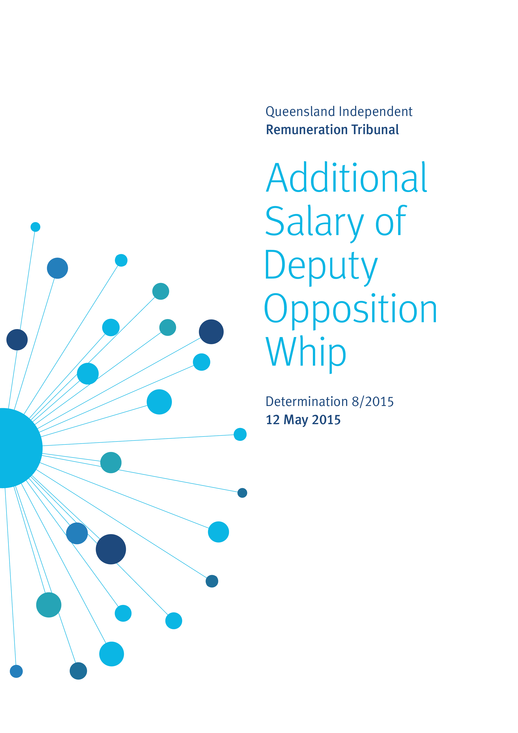
1 - Background
1.1 Overview
The Queensland Independent Remuneration Tribunal (the Tribunal) is an independent statutory authority established by the Queensland Independent Remuneration Tribunal Act 2013 (the Act) to determine remuneration in connection with Members of the Queensland Parliament (MPs) and former MPs.
The definition of ‘remuneration’ includes the additional salary and associated allowances payable to an MP for performing roles as an office holder in addition to that of an MP in the Queensland Legislative Assembly.
Section 42 of the Act provides a list of offices for which MPs may be entitled to be paid a salary in addition to the base salary of a backbench MP (an additional salary). The Act also provides that if another office is approved by resolution of the Legislative Assembly then that office may attract an additional salary. Note that only one salary (being the highest salary) is payable in the case of an MP holding multiple offices.
1.2 Previous consideration of additional salary
Additional salaries provided to office holders were considered by the Tribunal in Determination 3/2014 after a detailed examination of the nature of each of the roles. The Determination set the additional salary payable to each office holder relative to the additional salary payable to the highest office being the Office of the Premier. These relativities between additional salaries are outlined in the following table:
Band | Office | Relativity between offices %
1 | Premier | 100.0
2 | Deputy Premier | 80.0
3 | Minister  Leader of the Opposition | 70.0
4 | Speaker  Assistant Minister and Leader of the House | 60.0
5 | Deputy Leader of the Opposition | 40.0
6 | Chief government whip  Deputy Speaker  Manager of Opposition Business  Assistant Minister | 35.0
7 | Opposition Spokesperson  Leader in the Assembly of a recognised political party, other than the Leader or Deputy Leader of the Opposition  Chairperson of a committee | 25.0
8 | Senior government whip  Opposition whip | 15.0
9 | Government deputy whip | 12.5
10 | Member of a committee | 10.0

1.3 Office of the Deputy Opposition Whip
With the advent of the 55th Queensland Parliament following the Queensland State General Election on 31 January 2015, the Legislative Assembly agreed to a motion on 27 March 2015 that the Office of Deputy Opposition Whip be approved as an office entitled to be paid an additional salary.
The matter was referred to the Tribunal by the Clerk of the Parliament on 8 April 2015.
The purpose of this Determination is to set the additional salary payable to the Office of the Deputy Opposition Whip.
2 - Role of the Position
Whips are appointed within their political parties and are announced in the Legislative Assembly by the party leaders.
The main function of the position of whip is to act as the administrative officer to their Parliamentary political parties. Whips essentially are responsible for arranging the number and order of MPs who wish to speak in Parliamentary debates, ensuring attendance of party members for divisions, ensuring that quorum calls are satisfied, and acting as a teller or reporter of votes (advising the Speaker the way their party is voting) in divisions. Whips also grant leave to MPs who are unable to attend Parliamentary sessions so as to maintain the party’s relative numbers in the Legislative Assembly.
The Government of the (previous) 54th Queensland Parliament appointed a Chief Government Whip, Senior Government Whip and two Government Deputy Whips (i.e. four whips). In part, this structure reflected the large majority of the previous Government.
In the same Parliament, the Opposition appointed two MPs to be the Opposition Whip and Deputy Opposition Whip (who were paid an additional salary at the higher level of Opposition Spokesperson). However, the position of Deputy Opposition Whip was not a position listed under section 42 of the Act.
The current 55th Queensland Parliament has a more balanced composition of elected members. Since taking Government, the ruling party has appointed a Chief Government Whip, Senior Government Whip and Government Deputy Whip (i.e. three whips). The Opposition has appointed an Opposition Whip and a Deputy Opposition Whip.
Queensland is the only State in Australia that is unicameral consisting of the Legislative Assembly and no Upper House. As a result of the unicameral system, Queensland MPs perform the full function of passing legislation in its entirety. As such, Queensland MPs have total responsibility to their constituents for their decisions. The unicameral nature of the Queensland Parliament arguably places a greater responsibility on office holders such as whips in the Legislative Assembly. The Tribunal placed weight on this consideration when considering the additional salaries of whips, particularly the position of Chief Government Whip.
Changes to the structure of the Queensland Parliament since the 2015 Queensland State General Election magnify the responsibilities and challenges of the role carried out by both Government and Opposition whips because of the fine balance of elected MPs within the Parliament.
3 - Benchmarks
3.1 Additional salary for whips in Queensland
Current entitlements
Determination 3/2014 set the additional salary payable (relative to the additional salary payable to the Office of Premier) at 35% for a Chief Government Whip, 15% for a Senior Government Whip and 12.5% for a Government Deputy Whip.
The Tribunal also determined that the Opposition Whip receive an additional salary of 15%. However, the Tribunal did not determine additional salary for the position of Office of the Deputy Opposition Whip as it was not a position listed in section 42 of the Act. As such, the Tribunal could not consider this position for an additional salary. The Act restricts the Tribunal in making Determinations relating to additional salary to only those office holders listed in section 42.
On 27 March 2015, the Legislative Assembly agreed to a motion that the Office of Deputy Opposition Whip be approved as an office entitled to be paid an additional salary.
Historical analysis
Prior to Determination 1/2013 being issued, the office holders entitled to receive an additional salary were noted in the Parliament of Queensland Act 2001. Remuneration arrangements were approved by the Premier and set out in the Members’ Entitlements Handbook (the Handbook).
The Deputy Opposition Whip was not an office holder listed in the Parliament of Queensland Act 2001 entitled to receive an additional salary and historically the office holder has not been paid an additional salary. However, in accordance with the Handbook in effect immediately prior to Determination 1/2013, a Deputy Opposition Whip could elect to be provided with a fully maintained motor vehicle (vehicle make and model to be determined by the Committee of the Legislative Assembly) and was entitled to be reimbursed for the full cost of one nominated telephone line and 100% of the cost of all calls. Determination 1/2013 abolished these entitlements effective 1 January 2014.
In Determination 3/2014 the Tribunal undertook a comprehensive analysis of the additional salaries and entitlements of office holders in Queensland to set the relativities between offices. Figure 3.1 provides an historical analysis of the salary of whips in Queensland. The salary needs to be seen in the context of overall remuneration which includes allowances, as the nature and amount of allowances has changed considerably over this period.

Figure 3.1 – Historical comparison of the salary of whips in Queensland
Office holder |  | Parliamentary Members’ Salaries Act 1998 (as at April 1998) | Prior to QIRT (as at 30 June 2013) | Following Determination 3/2014 (as at 30 March 2015)
 | Base salary | $81,356 | $137,149 | $148,848
Chief government whip | Relativity between office |  | 14.8% | 35%
Chief government whip | Additional salary |  | $21,168 | $80,609
Chief government whip | Annual aggregate salary |  | $158,317 | $229,457
Senior government whip | Relativity between office | 11.2% | 11.2% | 15%
Senior government whip | Additional salary | $5,535 | $16,043 | $34,547
Senior government whip | Annual aggregate salary | $86,891 | $153,192 | $183,395
Government deputy whip | Relativity between office | 5.7% | 5.7% | 12.5%
Government deputy whip | Additional salary | $2,835 | $8,217 | $28,789
Government deputy whip | Annual aggregate salary | $84,191 | $145,366 | $177,637
Opposition whip | Relativity between office | 11.2% | 11.2% | 15%
Opposition whip | Additional salary | $5,535 | $16,043 | $34,547
Opposition whip | Annual aggregate salary | $86,891 | $153,192 | $183,395

3.2 Jurisdictional analysis
Figure 3.2 compares the salaries of opposition whips in Australian jurisdictions. The comparisons need to be interpreted with caution as the position of whip varies across jurisdictions and the number of whips varies across jurisdictions. Further, the allowances provided to whips also vary across jurisdictions and these allowances would need to be considered before reaching a conclusion about total remuneration.
Figure 3.2 – Comparative salaries of an Opposition Whip
Jurisdiction | Base annual salary as a backbench MP  (at 30 March 2015)  $ | Annual additional salary  $ | Annual Expense of Office Allowance  $ | Annual total salary  $
Qld | 148,848 | 34,547 | N/A | 183,395
WA | 154,223 | 26,755 | N/A | 180,978
SA | 153,130 | 27,563 | N/A | 180,693
NSW | 149,541 | 19,440 | 10,468 | 179,449
NT | 147,416 | 21,008 | N/A | 168,424
Vic | 144,497 | 15,895 | N/A | 160,392
ACT | 132,775 | 13,278 | N/A | 146,053
Tas | 118,466 | 7,108 | N/A | 125,574

The jurisdictional comparison reveals that while there is some variability in the additional salary, the annual total salary of an Opposition Whip tends to be similar particularly across the major States.
In relation to the position of Deputy Opposition Whip, Queensland is the only State that has formally established this office with an entitlement to an additional salary. Hence it is impossible to make a direct comparison across jurisdictions of this position.
3.3 Summary
In the context of the office holders that were reviewed in Determination 3/2014, the Tribunal considers that the Deputy Opposition Whip performs a similar role to that of the Government Deputy Whip. The Tribunal has consulted with the Clerk of the Parliament and the Clerk supports this view.
Determination 3/2014 set the additional salary payable to the Office of the Government Deputy Whip relative to the additional salary payable to the Office of Premier at 12.5%. Therefore the Tribunal considers that the relativity for the Deputy Opposition Whip should be set at 12.5% (Band 9 of the schedule of additional salaries).
Determination 8/2015
Preamble
Determination 8/2015 is issued by the Queensland Independent Remuneration Tribunal (Tribunal) under the Queensland Independent Remuneration Tribunal Act 2013 (the Act).
Any inconsistencies between earlier Tribunal Determinations and Determination 8/2015 are to be resolved in favour of Determination 8/2015. Matters in earlier Determinations not addressed in this Determination are confirmed by the Tribunal and not amended.
All Tribunal Determinations must be read in the context of the relevant Background and Reasons.
Additional salary of the Office of the Deputy Opposition Whip
The Tribunal determines that the additional salary payable to the Office of the Deputy Opposition Whip relative to the additional salary payable to the Office of Premier be set at 12.5% effective from 27 March 2015.

Date of Determination: 12 May 2015

____________________ ___________________ ___________________
Professor Tim Brailsford Ms Joanne Jessop Mr David Harrison
Chair Member Member

Queensland Independent Remuneration Tribunal, Building a new remuneration structure for Members of the Queensland Parliament – Part two, Determination 3/2014 (27 March 2014), 69-70 <http://www.remunerationtribunal.qld.gov.au/assets/determination-03-14.pdf>.
Queensland Parliament, Record of Proceedings (Hansard) (27 March 2015), 210 <https://www.parliament.qld.gov.au/documents/hansard/2015/2015_03_27_WEEKLY.pdf>.
Parliament of Australia, House of Representatives Practice (6th Ed) Chapter 2: House, Government and Opposition (6 September 2012) House of Representatives, 55 <http://www.aph.gov.au/~/media/05%20About%20Parliament/53%20HoR/532%20PPP/Practice6/PDF/Chapters/6Chap02.ashx> for the origins of the term whip.
Queensland Parliament, Record of Proceedings (Hansard) (27 March 2015), 210 <https://www.parliament.qld.gov.au/documents/hansard/2015/2015_03_27_WEEKLY.pdf>.
At the time, this office was known as Government Whip.

