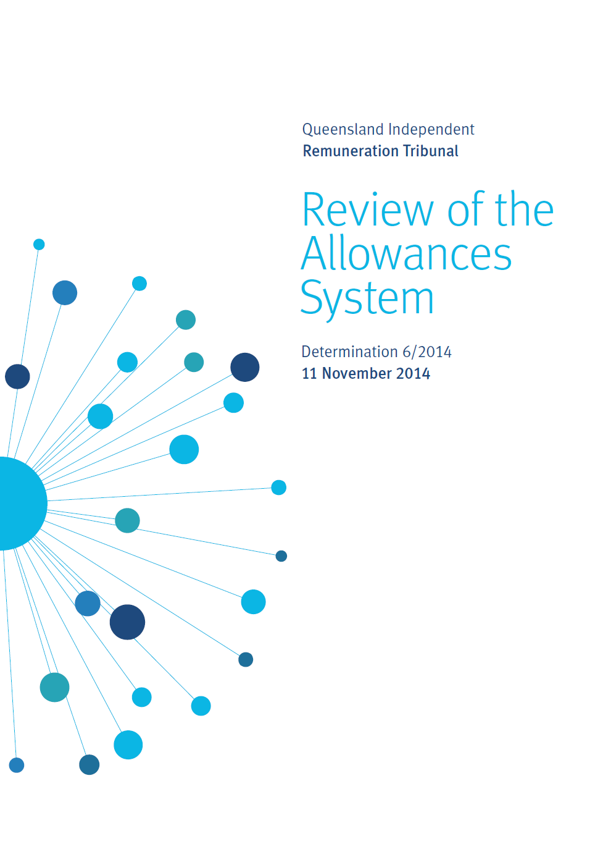
Executive Summary
  - The Queensland Independent Remuneration Tribunal (the Tribunal) is an independent statutory authority established to determine remuneration in connection with Members and Former Members of the Queensland Legislative Assembly.
  - This Determination reports on an initial review of the new system of MP allowances which was implemented on 1 January 2014.
  - In late 2013, the Tribunal announced significant changes to the system of MP allowances which involved collapsing the previous system of over 30 allowances into three general allowances covering electorate expenses, information and communication expenses, and travel expenses. These changes also involved the establishment of new expenditure limits associated with the new allowances.
  - At the time of Determination 1/2013, the Tribunal had little data available on the nature or types of MP expenditures as the previous system provided for a high degree of MP discretion and no central recordkeeping.
  - The new system introduced on 1 January 2014 involves an acquittal and reporting process that enhances accountability and transparency. Another benefit of the new system is that data can be aggregated to assist with a review of MP expenditure and provide insight in evaluating the performance of the new system.
  - Part of the review process has included consideration of submissions and conducting meetings with individual MPs, the Committee of the Legislative Assembly and the Clerk of the Parliament. Data concerning expenditure by MPs tabled by the Clerk in the Parliament on 30 September 2014 has also been considered.
  - Feedback received was generally positive particularly considering the extent of the changes. Various matters were raised including a potential lack of flexibility in the new system, the quantum of allowances especially the Information and Communication Allowance, and the administrative burden imposed by the new acquittal and reporting procedures.
  - An analysis of the data over the first period of the new allowance system (1 January 2014 to 30 June 2014) reveals that the large majority of MPs incurred expenditure within the limits of the various allocations. In those cases where there was over expenditure, the overspent amount was relatively larger for the Information and Communication Allowance compared to the Electorate Allowance although this varied across MPs.
  - To provide enhanced flexibility the Tribunal determines that in relation to the Electorate Allowance and the Information and Communication Allowance, if an MP has overspent one allowance but has underspent the other allowance at the end of the financial year a portion of the unspent allowance can be used to meet over expenditure in the other allowance. The amount of the unspent allowance which may be used for this purpose is limited to that amount necessary to offset over expenditure in the other allowance up to a maximum of 20% of the allowance paid to the MP during the financial year.
  - An analysis of the number, type and amount of expenditures in both the Electorate Allowance and the Information and Communication Allowance reveals that 80-90% of the transactions relate only to a few categories of items. As such, the reporting of transactions can be simplified by reducing the number of categories.
  - An analysis of non-receipted expenditure reveals that for the large majority of MPs, non-receipted transactions are of small individual value and of minor aggregate value. When the administrative costs of processing many transactions of small value are considered there is strong argument that the system is imposing inefficiencies for little benefit. Therefore, to reduce and simplify the reporting requirements, the limit of $100 per non-receipted transaction is removed but the aggregate limit of non-receipted transactions remains.
  - An analysis of the General Travel Allocation data reveals that there does not appear to be any significant concern or need to vary the allocation across the three travel bands. Electorates in Band 3 experienced the highest travel expenditure on average and this band includes regional electorates that receive the highest General Travel Allocation because of their large geographical size and the significant distances that the MPs need to traverse within these electorates. However, at this stage there is no overwhelming evidence that the current General Travel Allocation amounts are insufficient and the Tribunal will keep a watching brief in this area.
  - The matter of maintaining and servicing an MP’s private aircraft is noted and the Tribunal has requested that the Clerk amend the Members’ Remuneration Handbook to enable direct operating costs from private aircraft travel (as determined reasonable by the Clerk) to be claimed against the General Travel Allocation.
  - The Tribunal has considered the cleaning costs of electorate offices and notes that the Committee of the Legislative Assembly has jurisdiction over this matter.
1 - Introduction
On 15 October 2013, the Queensland Independent Remuneration Tribunal (Tribunal) handed down Determination 1/2013.
Determination 1/2013 introduced significant changes to the then system of MP allowances consistent with enhanced accountability and transparency. These changes became effective from 1 January 2014.
The previous system, comprising over 30 allowances, was collapsed into three categories of allowances each with acquittal and reporting requirements:
- Electorate Allowance (e.g. expenditure incurred in supporting an MPs electorate and its constituents)
- Information and Communication Allowance (e.g. expenditure incurred in obtaining and disseminating constituency and legislative information)
- General Travel Entitlement (e.g. expenditure incurred in travelling to conduct electorate and parliamentary business but excluding political party business) comprising:
  - Motor Vehicle Allowance
  - General Travel Allocation
  - Commercial Air Travel or Warrant Allocation.
At the time of Determination 1/2013, there were little data available on the patterns and types of expenditure incurred under the then allowances system as it was a system with very little central record keeping. Hence, at the time, the Tribunal was heavily reliant on anecdotal evidence when making decisions about allowances.
Under the new allowances system it is possible to examine aggregate data concerning general expenditure patterns. These data are potentially informative in assisting the Tribunal to review the new system.
The Tribunal has previously advised that it would review the new allowances system following the first six months of operation. This Determination reports on this review.
2 - Background
The new system of allowances, introduced on 1 January 2014, consists of three broad allowances - the Electorate Allowance, Information and Communication Allowance and General Travel Entitlement.
The Electorate Allowance, Information and Communication Allowance and the Motor Vehicle Allowance (contained within the General Travel Entitlement) are all paid in advance. MPs are then required to acquit the Electorate Allowance and Information and Communication Allowance to the Clerk within one month of the end of the relevant six month period. In relation to the Motor Vehicle Allowance tax is withheld according to the relevant ATO requirements.
MPs are required to retain all receipts relating to expenditure under the Electorate and Information and Communication Allowances with the exception of any single item under $100. Further, the maximum amount of non-receipted expenditure that can be incurred equates to $2,000 on an annual basis.
For the Electorate Allowance and Information and Communication Allowance up to 10% of the total allowance paid for each financial year (excluding any reductions or carry-overs from previous years) that is unexpended at 30 June is able to be retained by the MP and carried over for use in the next financial year.
The administration of the allowances system is the responsibility of the Clerk of the Parliament and the administrative rules and guidelines are published in the Members’ Remuneration Handbook, also the responsibility of the Clerk. Interpretative decisions of the Members’ Remuneration Handbook are made by the Clerk and, as required, the Clerk may seek the advice of the Tribunal on specific matters.
2.1 Electorate Allowance
In Determination 1/2013 the Tribunal noted the importance of an Electorate Allowance to assist an MP to discharge their electorate and constituency responsibilities. The Tribunal considered the following general uses of the Electorate Allowance to be appropriate:
- donations (e.g. prizes for school raffles, trophies or prizes for school achievement etc)
- support for constituents (e.g. emergency financial assistance, charitable works)
- support for organisations (e.g. minor financial assistance to schools, clubs, charities, educational institutions)
- patron expenses (e.g. hosting minor hospitality for organisations)
- membership fees (e.g. community groups)
- hosting costs (e.g. providing light refreshments in electorate office or hosting electorate ‘town hall’ meetings)
- gifts (e.g. flowers for funerals or wreaths for Anzac day).
Using a formula based on a combination of population (60 cents per head) and size (1.5 cents per square kilometre of electorate) the 89 electorates are grouped into three bands each carrying an entitlement to a specified amount of the Electorate Allowance. The first band receives an Electorate Allowance of $27,500, the second band receives $30,000 and the third band receives $34,000.
2.2 Information and Communication Allowance
The Information and Communication Allowance provides an annual amount of $34,000 to each MP. This Allowance is in addition to office and related support provided by Parliament under the Parliamentary Service Act 1988.
The Tribunal considered the following general uses of the Information and Communication Allowance to be appropriate:
- production, publication and distribution services (e.g. costs such as producing, publishing and distributing hardcopy newsletters and other similar publications, postage and other delivery costs, purchasing electronic services including computer software not provided by the Parliamentary Service, costs associated with developing and maintaining software and, constituency management software)
- telecommunications (e.g. home and mobile telephony and data costs)
- consumables (e.g. stores and stationery for the electorate office, business cards, personalised stationery expenses)
- minor equipment (e.g. minor electorate office equipment costs not provided by the Parliamentary Service)
- additional staffing (e.g. additional temporary and casual staffing costs beyond that provided by the Parliamentary Service) to cover seasonal workload peaks and leave periods of regular staff
- education (e.g. training and development, conference/seminar fees)
- administrative costs (e.g. book keeping, account keeping, bank charges or other software costs)
- incidental office expenses.
2.3 General Travel Entitlement
The General Travel Entitlement consists of a Motor Vehicle Allowance, a General Travel Allocation and Commercial Air (Warrant) Travel and Alternative Travel (applicable for MPs representing certain regional/remote electorates).
The Motor Vehicle Allowance was introduced in recognition of the need for an MP to respond to constituent issues and events within and across their electorate. The Tribunal has divided electorates into three bands based on the size of the electorate. Electorates in the first band receive $25,500, the second band $32,000 and the third band $40,000.
The General Travel Allocation is held by the Clerk to meet the costs of MPs (and spouses where approved) travelling on Parliamentary Business (as defined in Determination 4/2014) by a range of ground and air transport options. Like the Motor Vehicle Allowance, the General Travel Allocation is divided into three bands depending on the size of the electorate. Electorates in the first band receive $18,360, the second band $30,040 and the third band $61,720.
Commercial Air Travel Allocation (Air Warrants) was largely unchanged under the new system with the exception of the abolition of Alternative Travel ‘kilometric allowances’. Regional and remote electorates listed in the Members’ Remuneration Handbook are entitled to Air Warrants based on the principle that remote/regional MPs should not be disadvantaged in terms of travelling to and from Brisbane to conduct Parliamentary Business. These same MPs are able to utilise alternate travel options where commercial air travel options are unsuitable (up to the value of the lowest commercial flight cost for travel between the electorate and Brisbane).
3 - Consultation
3.1 Overview
The process of consultation for this review involved correspondence, meetings and discussion with a range of stakeholders. These stakeholders included various MPs, the Committee of the Legislative Assembly (CLA) and the Clerk of the Parliament. In addition to general correspondence received on the matter, the Tribunal also wrote to all MPs on 12 June 2014 inviting submissions.
3.2 Consultation with MPs
The Tribunal received general correspondence from MPs regarding issues with the allowances system which in some cases was specific to their electorates. Matters raised included:
- the resourcing of electorate offices and associated staffing support
- the lack of flexibility within the new system
- the amount of the Information and Communication Allowance being insufficient to enable effective communication with constituents
- additional administrative burden placed on electoral office staff
- the allocation for office cleaning costs provided by Parliamentary Services being insufficient
- practices for recognising privately owned aircraft maintenance and operating costs as a legitimate entitlement within the General Travel Allocation principles and guidelines.
These comments were followed up in meetings with specific MPs, the CLA and the Clerk.
A common suggestion from MPs was that the Electorate Allowance and Information and Communication Allowance should be merged. The rationale was that there is considerable diversity of needs across Queensland electorates. Further, it was argued that the 89 MPs had diverse individual needs in servicing their electorates. Hence it was put forward that enhanced flexibility in general would be desirable in any revision of the allowances system.
As noted above, a further concern raised in some submissions was that the quantum of the Information and Communication Allowance was insufficient to fund the range of activities required to service a diverse range of electorates. For instance, printing and postage costs vary according to the size of the population and/or size of the electorate. Thus, it was submitted that the amount of this allowance should be increased.
A separate concern related to expenditure categories of the various allowances. Specifically, there was a lack of clarity (at the margin) regarding whether some items could be classified within either the Electorate Allowance or the Information and Communication Allowance. It was argued that this specificity imposed unnecessary rigidity and limited genuine expenditure; and a possible remedy to improve clarity would be to remove some or all of the expenditure categories.
Related to this, some submissions argued that the categories within each of the allowances were too tightly defined leading to an unnecessary administrative burden. Given that the transactions need to be acquitted within each of the allowances, the classification of expenditure within a specific allowance is a reporting exercise and hence the question arises as to whether the benefits from such detailed reporting outweigh the administrative costs.
Some regional MPs raised concerns with the quantum of the General Travel Allocation in light of the significant distances required to be travelled within their electorates and the limitations of commercial air travel in these electorates.
Some MPs also raised a concern that the system does not adequately provide coverage for additional staffing resources that are required at peak times and other periods when permanent staff are on leave.
Further, some MPs raised concerns that the limit for non-receipted expenditure was too low.
Overall, the Tribunal received positive feedback regarding the new system and in particular the Motor Vehicle Allowance component of the new General Travel Entitlement.
3.3 Consultation with the Clerk of the Parliament
The Clerk of the Parliament has commented that the new system of allowances signifies the biggest change to MP allowances in 40 years. The Clerk advised that despite the significant change in the system, MPs have generally accepted and adapted to the new arrangements and that feedback is generally positive.
However, there are reports that some MPs and their electorate staff consider the acquittal requirements to be time consuming. Further, there appears to be some legitimate issues concerning the lack of flexibility in the new system, with members finding the quantum of one allowance (usually the Information and Communication Allowance) to be insufficient.
In particular, the Clerk submitted that it would be simpler for the Electorate Allowance and Information and Communication Allowance to be combined into a single allowance, noting that the Tribunal’s goal of transparency would still be achieved because of the requirement to acquit expenditure.
Other suggestions from the Clerk included simplifying the categories of expenditure acquittal and consideration to increasing the Information and Communication Allowance.
The Clerk also raised concerns about the impact of Fringe Benefits Tax relating to minor equipment being purchased through the Information and Communication Allowance.
3.4 Summary of consultation
The Tribunal’s assessment of the issues raised during consultation is that overall the new allowances system is functioning well. Given the significance of the changes and noting that the changes impacted on people, systems and culture, it is to be expected that there would be some issues in the early stages. Specifically, there appears to be some legitimate concerns regarding lack of flexibility in the system and the need to reduce the administrative burden whilst retaining an appropriate level of transparency and accountability. These issues are further discussed in the next chapter.
4 – Key issues
4.1 Background
Prior to the new allowance system, there was limited transparency and very limited data on which to make evidence based decisions concerning the quantum and appropriate classification of allowances. Since Determination 1/2013 and the subsequent implementation of the new allowances system, reports detailing expenditure categories and patterns are tabled by the Clerk in the Parliament following the end of each financial year. In this chapter a review is undertaken of these data covering the first period of operation of the new system (1 January 2014 to 30 June 2014).
In assessing these data, the Tribunal notes that expenditure will fluctuate throughout the year and within the electoral cycle and therefore the initial six month period needs to be considered in a broader context. As more data become available the Tribunal will be able to better assess the cyclical nature of MP expenditure.
4.2 Quantum of the allowances
The Tribunal separately reviewed both the Electorate Allowance and Information and Communication Allowance and also considered the collective quantum across these two allowances.
In order to capture total expenditure, MPs were encouraged to report all expenditure for both allowances. In instances where MPs have expended more than the allocated allowance, it has been at their personal cost and not at a cost to the Parliament. In such cases, the overspend will presumably give rise to a personal income tax deduction if it is allowed by the Tax Ruling for Members of Parliament (TR 1999/10).
In relation to the Electorate Allowance the pattern of expenditure for the six month period, relative to the limit of the allowance, is presented in Figure 4.1.
Figure 4.1 – Electorate Allowance expenditure
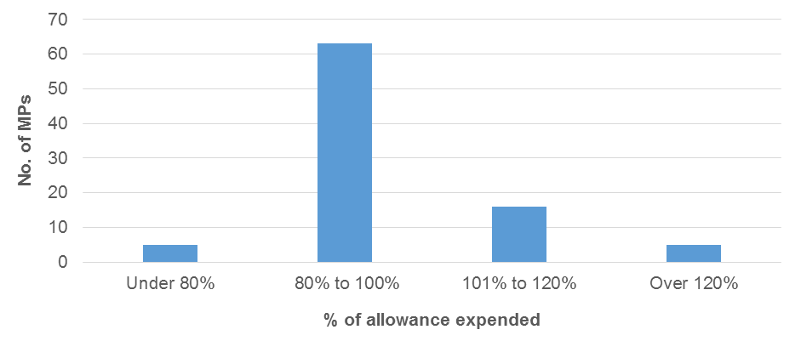
From Figure 4.1 Electorate Allowance expenditure can also be examined by number and percentage across the 89 MPs:
- 5 MPs spent under 80% of their Electorate Allowance
- 63 MPs spent between 80% and 100% of their Electorate Allowance
- 16 MPs spent between 101% and 120% of their Electorate Allowance
- 5 MPs spent more than 120% of their Electorate Allowance.
In summary, 79 MPs (or 89%) spent within +/- 20% of their full allocation. Of the 5 MPs who spent more than 120% of their allocation the highest over expenditure was 134%.
In relation to the Information and Communication Allowance the pattern of expenditure for the six month period, relative to the limit of the allowance, is presented in Figure 4.2.
Figure 4.2 – Information and Communication Allowance expenditure
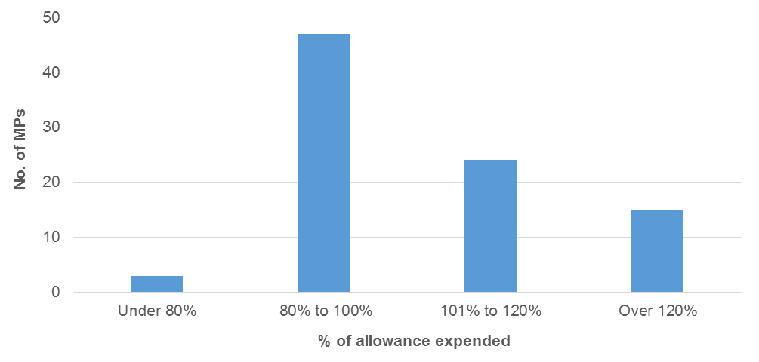
From Figure 4.2 Information and Communication Allowance expenditure can also be examined by number and percentage across the 89 MPs:
- 3 MPs spent under 80% of their Information and Communication Allowance
- 47 MPs spent between 80% and 100% of their Information and Communication Allowance
- 24 MPs spent between 101% and 120% of their Information and Communication Allowance
- 15 MPs spent over 120% of their Information and Communication Allowance.
In summary, 71 MPs (or 80%) spent within +/- 20% of their full allocation. Of the 15 MPs who spent more than 120% of their allocation the highest over expenditure was 162%.
Hence from analysis of the data it appears to be more difficult for MPs to manage expenditure within the Information and Communication Allowance as compared to the Electorate Allowance. However, as noted earlier there are likely to be ‘seasonal aspects’ in expenditure types and patterns within each of these allowances, across the year and across electorates. On balance the Tribunal holds the view that there does appear to be legitimate argument for greater flexibility between the two allowances to enable MPs to better manage expenditure across diverse electorates.
A question that follows is the extent to which amounts can be transferred between the two allowances. It follows from Figures 4.1 and 4.2 that an amount of 20% in either direction would significantly increase flexibility and satisfy the majority of the cases of over expenditure.
Of note, analysis was conducted using a range of other filters (in addition to 20%) and there was minimal impact, and therefore minimal additional benefit using filters higher than 20%.
Accordingly, a portion of the Electorate Allowance will be allowed to be transferred to the Information and Communication Allowance and vice versa as required by individual MPs. The amount of the unspent allowance which may be used for this purpose is limited to that amount necessary to offset over expenditure in the other allowance, up to a maximum of 20% of the allowance paid to the MP.
This change does not alter the quantum of each annual allowance. Rather, if as a consequence of unforeseen circumstances that have arisen during the year an MP elects to make this transfer between allowances, then the MP must liaise with the Clerk towards the end of the annual reporting period.
4.3 Acquittal system
The Tribunal notes that for both the Electorate Allowance and Information and Communication Allowance there are generally three or four key expenditure categories used on a regular basis compared to other categories which have not been widely used.
In relation to the Electorate Allowance the number of acquittal items by category is presented in Figure 4.3.
Figure 4.3 – Electorate Allowance acquittals in each category
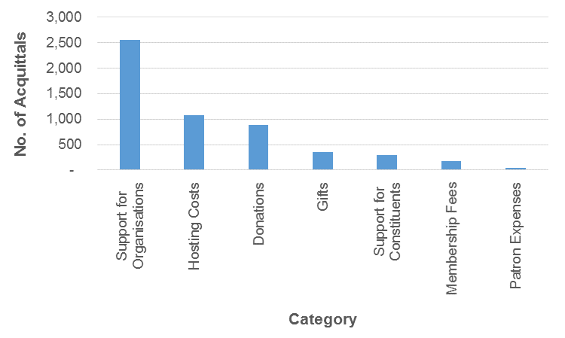
The dollar amount by category of acquitted expenditure in the Electorate Allowance is presented in Figure 4.4.
Figure 4.4 – Electorate Allowance acquitted expenditure by category
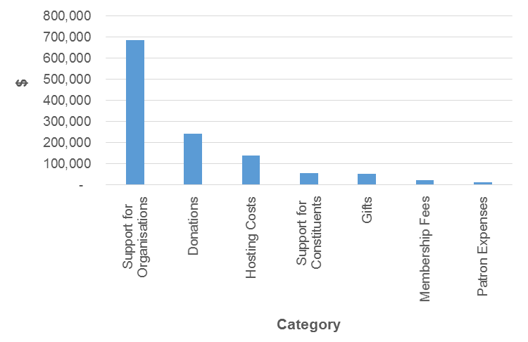
From Figures 4.3 and 4.4 Electorate Allowance acquittal patterns can be examined by number and percentage across the 89 MPs:
- 84% of the total number of acquitted transactions were in three categories being support for organisations; hosting costs; and donations
- similarly, 88% of the dollar value of acquitted transactions were in the same three categories of support for organisations; hosting costs; and donations
- only 10% of the total number of transactions acquitted were in the categories of gifts, support for constituents; membership fees; and patron expenses
- similarly, just 7% of the dollar value of acquitted transactions was in the categories of support for constituents; membership fees; and patron expenses.
In relation to the Information and Communication Allowance the number of acquittal items by category is presented in Figure 4.5.
Figure 4.5 – Information and Communication Allowance acquittals in each category
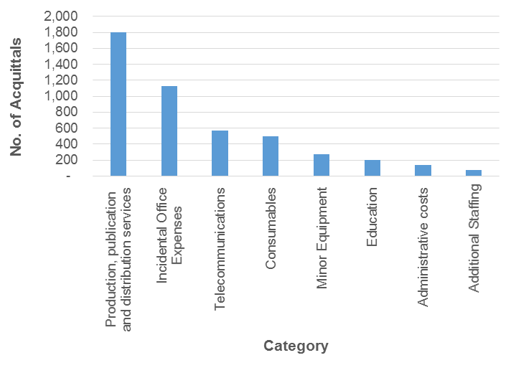
The dollar value by category of acquitted expenditure in the Information and Communication Allowance is presented in Figure 4.6.
Figure 4.6 – Information and Communication Allowance acquitted expenditure by category
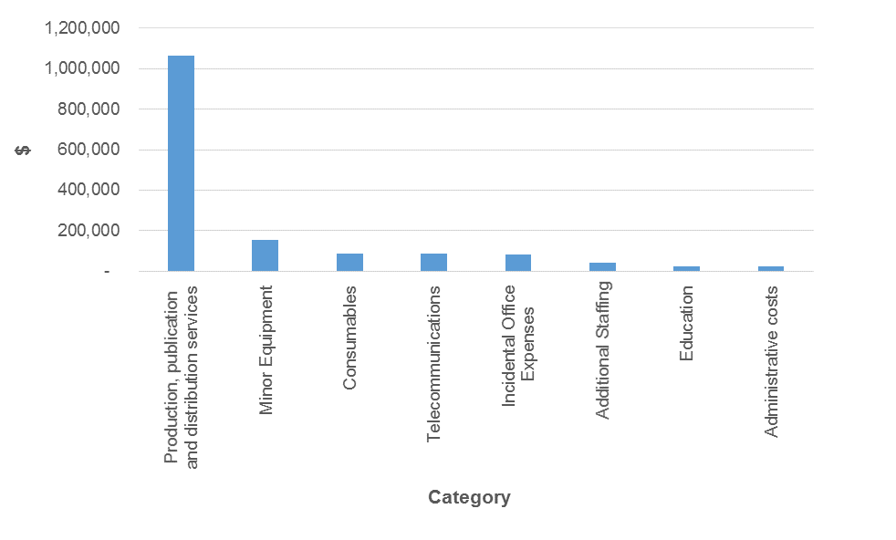
From Figures 4.5 and 4.6 Information and Communication Allowance acquittal patterns can be examined by number and percentage across the 89 MPs:
- 75% of the total number of acquitted transactions were in three categories - production, publication and distribution services; incidental office expenses; and telecommunications
- similarly, 84% of the total dollar value of acquitted transactions were in three categories - production, publication and distribution services; minor equipment; and consumables
- only 9% of the total number of acquitted transactions were in the categories of education; administrative costs; and additional staffing
- similarly, just 6% of the total dollar value of acquitted transactions were in the same categories of education; administrative costs; and additional staffing
- in relation to additional staffing, contrary to some anecdotal evidence, just 3% of the allowance was spent on this item.
To gain further insight into expenditure patterns, Figure 4.7 shows the average dollar value per transaction separately for the Electorate Allowance and the Information and Communication Allowance.
Figure 4.7 – Average dollar value per transaction
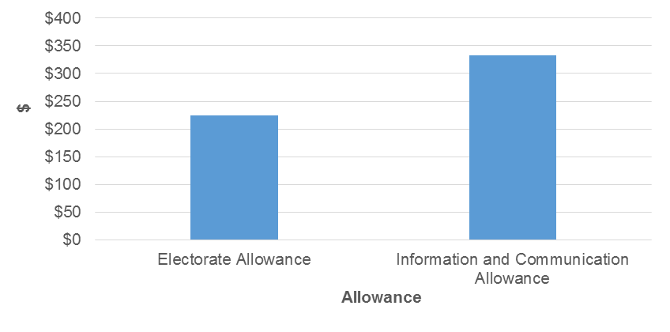
From Figure 4.7 average expenditure in the Electorate Allowance is $225 per transaction which is lower than average expenditure in the Information and Communication Allowance of $333 per transaction. The data collected over the six months show that the Information and Communication Allowance expenditure tends to be incurred for larger cost items such as mail-outs.
A conclusion from the above analysis is that there are relatively few transactions in some categories and the relative value of those transactions is small. Therefore reporting at this level of detail is of limited value for future reviews; and moreover, there are costs associated with reporting at this level of granularity.
On balance the Tribunal is satisfied that broadening the categories within each allowance will not impact adversely on the appropriate levels of accountability and transparency but will assist to reduce both the level of complexity and administrative burden of the acquittal system.
The Tribunal also recognises that the current categories may be too restrictive. Accordingly the Tribunal will reduce the number of categories to provide MPs more flexibility whilst maintaining the requirement to acquit expenditure.
A category of ‘other’ will be introduced to each of the allowances to capture items of an occasional nature that do not fall into one of the new categories.
4.4 Non-receipted expenditure
As stated in previous determinations a provision for non-receipted expenditure has been established.
In relation to the Electorate Allowance the pattern of non-receipted transactions is presented below in Figure 4.8.
Figure 4.8 – Non-receipted transactions for the Electorate Allowance
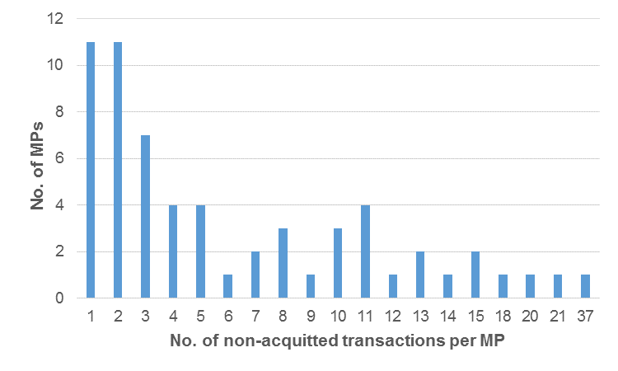
The average value of non-receipted transactions in the Electorate Allowance was $45. Of note, for 76% of MPs the total value of non-receipted transactions in this allowance was less than $500.
In relation to the Information and Communication Allowance the pattern of non-receipted transactions is presented below in Figure 4.9.
Figure 4.9 – Non-receipted transactions for the Information and Communication Allowance
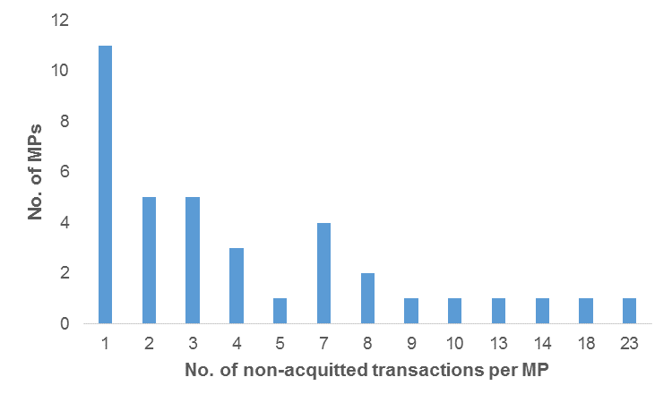
The average value of non-receipted transactions in the Information and Communication Allowance was $35. Of note, for 92% of MPs the total value of non-receipted transactions in this allowance was less than $500.
The evidence from Figures 4.8 and 4.9 reveals that for the large majority of MPs non-receipted transactions are of small individual value and of minor aggregate value. When considering the administrative costs of processing many items of small value it is apparent that the system may be imposing inefficiencies for little benefit.
The Tribunal is satisfied that, based on the data, the overall limit of non-receipted expenditure is appropriate. However, to reduce and simplify reporting requirements, the limit of $100 per individual non-receipted transaction is removed.
4.5 Travel matters
In relation to the General Travel Allocation the pattern of expenditure for the six month period, relative to the limit of the allowance, is presented below in Figure 4.10.
Figure 4.10 – General Travel Allocation expenditure
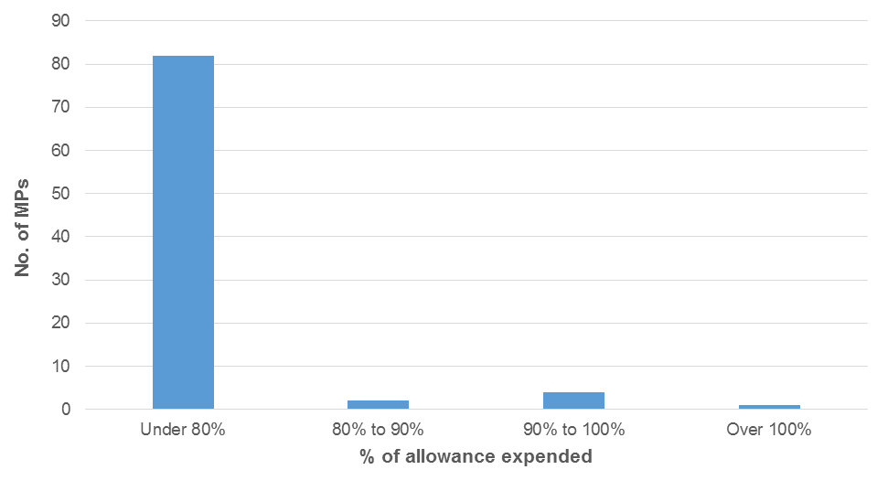
From Figure 4.10 General Travel Allocation expenditure can also be examined by number and percentage across the 89 MPs:
- 82 MPs spent under 80% of their General Travel Allocation
- 2 MPs spent between 80% and 90% of their General Travel Allocation
- 4 MPs spent between 90% and 100% of their General Travel Allocation
- 1 MP spent over 100% of their General Travel Allocation.
Of the five MPs who spent over 90% of their General Travel Allocation four MPs are in electorates in Band 3. One of these was the only MP to overspend their General Travel Allocation and this was by approximately $5,000. As noted earlier, any overspend is at personal cost to the MP.
Band 3 includes five regional electorates which receive the highest General Travel Allocation because of their large geographical size and the significant distances that these MPs need to traverse within their electorates.
Hence, at this stage there is no overwhelming evidence that the current General Travel Allocation amounts are insufficient. However, the Tribunal notes that travel may be subject to seasonal fluctuations and will monitor the adequacy of the General Travel Allocation, particularly for MPs in Band 3 electorates.
The Tribunal has considered the matter of maintaining and servicing an MP’s private aircraft and recommends that the Clerk of the Parliament amend the Members’ Remuneration Handbook so to enable direct operating costs from private aircraft travel (as determined reasonable by the Clerk) to be claimed against the General Travel Allocation.
4.6 Electorate Office matters
The CLA provides for cleaning costs of electorate offices. Some MPs have questioned whether the current provision is sufficient to cover the full amount of cleaning costs. The Tribunal notes that the CLA has jurisdiction over this matter and is able to increase the cleaning allocation should it choose to do so.
4.7 Summary
The new allowances system represents a very significant change from the previous system and some issues in the early stages were to be expected. However it appears that most of these issues have been resolved. The changes outlined in this Determination should further improve the system and alleviate many of the concerns raised in the consultation process.
The three categories of allowance reflect the three key roles of an MP being to assist their electorate, to communicate with their electorate, to attend Parliament and travel around their electorate. Accordingly, Determination 6/2014 maintains each of the allowances as distinct but provides for additional flexibility and simplification.
Determination 6/2014
Preamble
Determination 6/2014 is issued by the Queensland Independent Remuneration Tribunal (Tribunal) under the Queensland Independent Remuneration Tribunal Act 2013 (the Act).
Any inconsistencies between earlier Tribunal Determinations and Determination 6/2014 are to be resolved in favour of Determination 6/2014. Matters in earlier Determinations not addressed in this Determination are confirmed by the Tribunal and not amended.
All Tribunal Determinations must be read in the context of the relevant Background and Reasons.
Quantum of allowances
- The quantum of each allowance remains unchanged from Determination 1/2013.
- The Tribunal determines that in relation to the Electorate Allowance and the Information and Communication Allowance, if an MP has overspent one allowance but has underspent the other allowance at the end of the financial year a portion of the unspent allowance can be used to meet over expenditure in the other allowance.
- The amount of the unspent allowance which may be used for this purpose is limited to that amount necessary to offset over expenditure in the other allowance up to a maximum of 20% of the allowance paid to the MP during the financial year.
- Clauses 1, 2 and 3 concerning the quantum of allowances take effect immediately.
Acquittal system
- In the acquittal system the expenditure categories under the Electorate Allowance are amended to the following:
- support for organisations
- support for individual constituents
- hosting costs
- other.
- In the acquittal system the expenditure categories under the Information and Communication Allowance are amended to the following:
- production, publication and distribution services
- minor equipment
- office expenses – including consumables, additional staffing, education and administrative costs
- telecommunications and data costs
- other.
- The Tribunal confirms that the annual limit for non-receipted expenditure remains unchanged, however the $100 limit per individual non-receipted transaction is removed.
- Clauses 5, 6 and 7 in relation to the acquittal system take effect on 1 January 2015.

Date of Determination: 11 November 2014

_______________________ ___________________ ___________________
Professor Tim Brailsford Ms Joanne Jessop Mr David Harrison
Chair Member Member

See http://www.parliament.qld.gov.au/work-of-assembly/tabled-papers/online-tabled-papers reference nos 6081, 6078, 6077 and 6076 tabled on 30 September 2014.
Australian Taxation Office, Income tax and fringe benefits tax: Members of Parliament – allowances, reimbursements, donations and gifts, benefits, deductions and recoupments, TR 1999/10, 21 March 2012.

