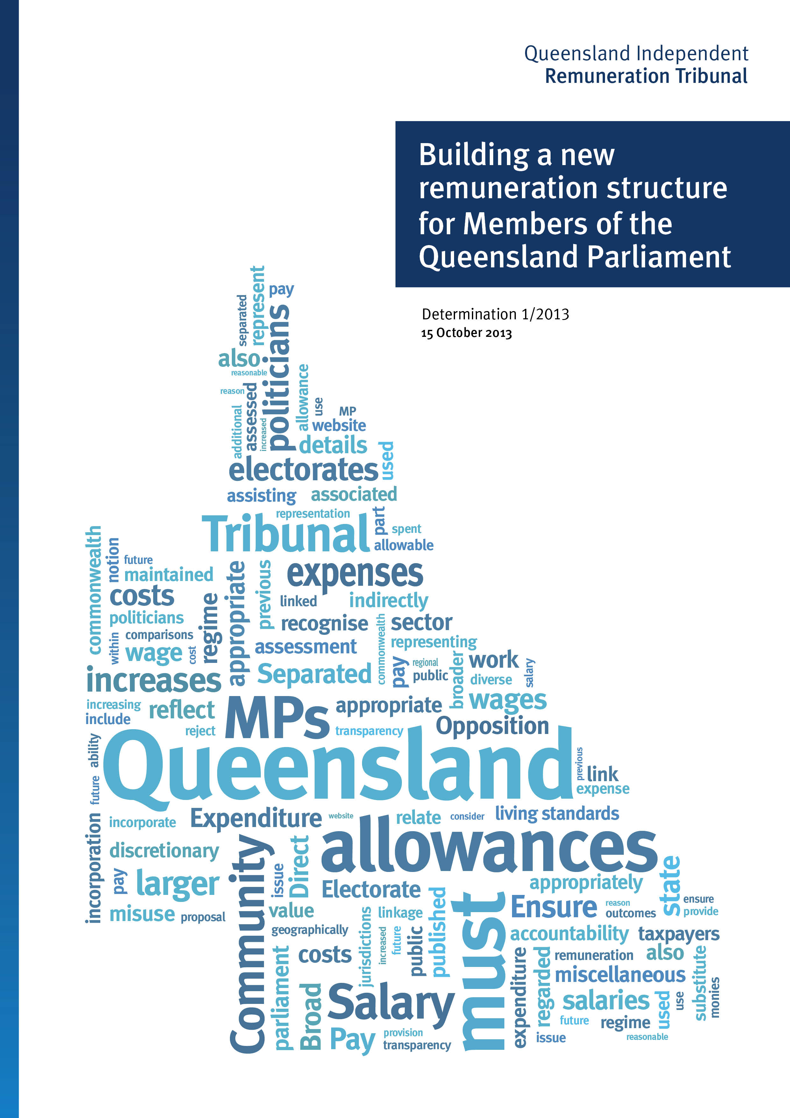

The Queensland Independent Remuneration Tribunal is an independent statutory authority that has been established to determine salaries, allowances and entitlements of Members of the Queensland Parliament (MPs) and former MPs.
The Tribunal was initially formed in July 2013 and subsequently established as a statutory authority by the Queensland Independent Remuneration Tribunal Act 2013 on 9 August 2013.

Professor Tim Brailsford (Chair)
Professor Brailsford is the Vice Chancellor and President of Bond University. Professor Brailsford’s previous positions include Executive Dean at the University of Queensland, Dean at the Australian National University in Canberra, and other senior positions at the University of Melbourne and Monash University. Professor Brailsford’s area of expertise is financial economics. He holds a PhD, masters and honours degrees and is a Senior Fellow of the Financial Services Institute of Australasia, Fellow of the Australian Institute of Management and Fellow of CPA Australia. He was appointed as the inaugural Frank Finn Professor of Finance at the University of Queensland.

David Harrison
Mr Harrison is an experienced non-executive company director having served on a variety of private and public sector boards since 1987 and with more than 30 years of experience in industrial relations. His current director roles are as Chairman of QMI Solutions Limited Board (since December 2004) and Director of the Workers’ Compensation Regulatory Authority – QCOMP (since July 2012). In his spare time, Mr Harrison serves as Chairman of the Ferny Grove Bowls Sports and Community Club Inc.
Mr Harrison has filled many directorships and chairman roles for many organisations over the years, including Australia TradeCoast Limited (2005 to 2012), Port of Brisbane Corporation (1999 to 2010), QIC Limited (1998 to 2011), Brisbane Airport Corporation (2005 to 2012), Sunsuper Pty Ltd (1994 to 2005), Queensland Theatre Company (2001 to 2004) and Sugar Manufacturers of Australia Retirement Trust Pty Ltd (1987 to 1994). His industrial relations experience includes nine years as Queensland Secretary of the Australian Manufacturing Workers’ Union and 10 years as Honorary President of the Queensland Council of Unions. In 2003, he was awarded the Centenary Medal for distinguished services to industrial relations and he is a Fellow of the Australian Institute of Company Directors.

Joanne Jessop
Ms Jessop has served as Chief Executive Officer of Multicap since 2006 and is Vice-Chair of the Queensland National Disability Services committee. Ms Jessop has extensive international experience in senior management roles in the healthcare and human services sectors and holds an MBA from the University of Queensland. She is a graduate of the Australian Institute of Company Directors and a Fellow of the Australian Institute of Management.
Front Cover – A pictorial representation of key words from all public submissions.
ISBN: 978-1-921960-03-1 (Print)
ISBN: 978-1-921960-04-8 (Online)
© State of Queensland (Queensland Independent Remuneration Tribunal) 2013.
With the exception of any material protected by a trade mark, third party copyright material and where otherwise noted, all material in this report is licensed under a Creative Commons Attribution (CC BY) 3.0 Australia licence, available at http://creativecommons.org/licences/by/3.0/au/deed.en. In essence, content from this report may be adapted and copied for use, and attributed to the State of Queensland (Queensland Independent Remuneration Tribunal).
Further information is available at www.remunerationtribunal.qld.gov.au/tools/copyright.aspx.
Contents
Executive Summary i
Chapter 1: Background and overview 1
1.1 Formation of the Queensland Independent Remuneration Tribunal 1
1.2 Functions and Powers of the Tribunal 2
1.3 Meaning of ‘remuneration’ under the Act 3
1.4 Comparative approaches in other jurisdictions 4
1.5 How the Tribunal approached its task 5
1.6 Summary of key activities 6
1.7 History of MP salaries, allowances and entitlements in Queensland 7
1.8 Scope of review 9
1.9 Future work 9
Chapter 2: Consultation 11
2.1 Legislative powers 11
2.2 The consultation process 11
2.3 Public submissions 12
2.4 MPs and former MPs 24
2.5 The Clerk of the Parliament and QSuper 26
2.6 Summary and conclusions 27
Chapter 3: Fundamental considerations 29
3.1 Legislative principles 29
3.2 Role of a Queensland MP 29
3.3 MPs and Ministers 33
3.4 Employee versus MP 33
3.5 Work value and work load 38
Chapter 4: Base salary – historical and comparative analysis 45
4.1 Overview 45
4.2 History of changes in the base salary 45
4.3 Comparison to general wage increases 51
4.4 Comparison to selected professions 53
4.5 Comparison to the public sector 55
4.6 Comparative salaries from international jurisdictions 57
4.7 Comparative salaries from the states and territories 58
4.8 Summary 62
Chapter 5: Allowances and entitlements 65
5.1 History of allowances and entitlements in Queensland 65
5.2 The allowance system 68
5.3 Allowances and entitlements 73
5.4 Opposition Spokesperson’s Allowance 77
5.5 Discussion 79
5.6 A new allowance and entitlement system 81
5.7 The new Electorate Allowance 84
5.8 The new Information and Communication Allowance 88
5.9 The new General Travel Entitlement 89
Chapter 6: Discussion 97
6.1 Base salary 97
6.2 Additional salaries 98
6.3 The allowances system 99
6.4 Superannuation 102
6.5 Former MP entitlements 103
Determination 1/2013 105
Appendix to the Determination 109

Executive Summary
Background and overview
  - The Queensland Independent Remuneration Tribunal (the Tribunal) was established on 16 July 2013 following the five point plan to reform Queensland Parliament’s entitlements system announced by the Premier, the Honourable Campbell Newman MP.
  - The Tribunal is charged with responsibility for determining the remuneration, including salaries allowances and entitlements, of Members of the Queensland Parliament (MPs) and former MPs. Details of the Tribunal’s powers, the principles it may have regard to and the matters it must take into account are prescribed under the Queensland Independent Remuneration Tribunal Act 2013 (the Act).
  - Pursuant to the Premier’s announcement of the five point plan the Act:
- breaks the legislative nexus between the salaries of Queensland and Commonwealth MPs
- formally establishes the Queensland Independent Remuneration Tribunal under legislation
- provides that the determinations of the Tribunal are independent, binding and are not subject to change by MPs
- legislates to rescind a recent 41.9% pay rise and ensure that back pay for current and former MPs is only applicable from 1 July 2013
- provides that the Tribunal must ensure that any allowances are to reflect the amount of reasonable expenses incurred by a MP in servicing their electorate and that the allowances are not a substitute for other remuneration.
  - The establishment of an independent remuneration tribunal in Queensland brings the state largely in line with the processes used to determine MP remuneration in other Australian jurisdictions and increases independence and transparency to decisions about MP remuneration.
  - This report is the first Determination of the Tribunal. It initially discusses comparative approaches of reviewing MP remuneration in other jurisdictions, and provides an overview of how the Tribunal went about its work, including a summary of the key activities undertaken.
  - The history of MP salaries, allowances and entitlements in Queensland is a complex one that has proceeded in an incremental fashion over many years. At various times the base salary has been set by legislation; linked to certain classifications in the State Public Sector Award; increased by former Cabinets using indexing to the average minimum weekly wage or CPI; and linked to an amount that is $500 less than the annual base salary of a Commonwealth MP. A comprehensive review of an MP’s remuneration has not been undertaken for around 50 years.
  - Upon commencement of the Act on 9 August 2013, the legislative nexus between salaries of Commonwealth and Queensland MPs was broken and the 41.9% salary increase which had been received as at 1 July 2013 rescinded. Salaries were returned to their 30 June 2013 levels pending the Tribunal’s first Determination.
  - In terms of the scope of this review, given the significant breadth of issues in relation to MP and former MP salaries and allowances and the limited time available to make its first Determination, the Tribunal decided to focus on the core task of reviewing the base salary and conducting a comprehensive review of MP allowances.
  - The Tribunal has determined that the following matters are out of scope of this first review, but will be subject to review as part of the Tribunal’s ongoing program of work:
- additional salaries provided to office holders
- former MP travel entitlements and associated entitlements of spouses and other related persons.
Consultation
  - The Tribunal decided to engage in a public consultation process for this first review. In calling for public submissions, the Tribunal released a discussion paper to assist those wishing to make a submission.
  - A total of 2,568 submissions were received by the Tribunal including:
- two submissions from current MPs
- one submission from a current office holder
- 26 submissions from former MPs.
  - Submissions received by the Tribunal have been de-identified and are available at www.remunerationtribunal.qld.gov.au.
  - The Tribunal acknowledges and sincerely thanks members of the public who showed an interest in and provided submissions about remuneration and entitlements of both current and former MPs for the Tribunal’s consideration.
  - In addition to receiving public submissions, the Tribunal consulted with the Clerk of the Parliament and also sought advice from representatives of QSuper in relation to the history of superannuation entitlements.
  - The public submissions confirm that MPs’ remuneration is an emotive and highly charged issue. Many of the submitters were unaware that in mid-August 2013 the 41.9% pay rise awarded in July was rescinded and MPs’ salaries reverted to the 30 June 2013 levels. Submitters provided the Tribunal with a range of benchmarks and comments regarding the setting of the base salary of an MP. Many submitters made reference to the importance of having clear separation between the salary of an MP and their allowances, entitlements and expenses. There was a common view that this distinction would provide greater accountability and transparency regarding the whole remuneration package and ensure that allowances are not a substitute for salary.
Considerations
  - In undertaking its task of reviewing MP remuneration, the Tribunal examined:
- the role of an MP in Queensland
- a comparison of the characteristics of this role with those of an employee
- the distinction between ‘work value’ and ‘work load’ of an MP.
  - The Tribunal gave detailed consideration to the role of an MP, consistent with the legislative principle that the Tribunal may have regard to the value to the community of an MP carrying out their role, functions and responsibilities. Unlike jobs in both the private and public sectors there is no specific position description attached to the role of an MP. It is not like a typical job where a person submits their package of skills, experience and qualifications through an application process to an employer. Rather, there are no formal barriers to entry when seeking to become an MP. Thus, MPs come from a wide variety of backgrounds and have a wide variety of skills, experience and qualifications.
  - The role of an MP may be described as:
- a representative of the people in their electorate who must play an active role in their community; listening and providing advice to; and advocating for their constituents
- providing a direct link between their electorate and parliament
- advocating on behalf of their constituency
- contacting and supporting the communities within their electorate
- performing parliamentary functions as a member of the Legislative Assembly, such as debating legislation, scrutinising the actions of the executive government through asking questions on notice or without notice and making speeches, particularly on topics that affect their constituency
- serving on parliamentary committees, as required, to examine specific issues and legislation that comes before parliament
- participating in internal party processes where applicable.
  - Other factors that are specific to the role of a Queensland MP also need to be considered. Queensland is the only state in Australia that has a single House of Parliament (i.e. ‘unicameral’) where MPs perform the full function of passing legislation in its entirety. Similar to Western Australia, Queensland is a large decentralised state that requires some MPs to travel large distances to service their electorate.
  - Given the importance of the role of an MP to the system of representative democracy, it is in the interests of all Queenslanders that the level of remuneration of MPs is such that it does not discourage suitable people from seeking election, but it is also not the primary driver for people seeking election to the role.
  - Whilst there is no single feature of the role of an MP that is unique, the Tribunal considers that it is the combination of these features that makes the role of MP unique. When comparing the characteristics of an MP with an employee there are a number of aspects that are similar and some that are not. It follows that there is no identifiable single benchmark for the base salary of an MP. Accordingly, a comparison must be made against a range of benchmarks.
  - The traditional method of assessing work value is the approach adopted by many human resources areas within the private and public sector, namely, the job evaluation and classification methodology. This methodology does not readily apply to the role of an MP given its unique characteristics.
  - There is clear evidence the work load of an MP is high. In the current age of continuous media and communication, an MP is on call constantly, although it is acknowledged that similar workload requirements are demanded of many professions.
  - In comparing the parliamentary workload in recent years with MPs in other jurisdictions, the total number of sitting hours per year for a Queensland MP has been consistently at the higher end.
  - Having regard to these matters, the Determination makes a delineation between the base salary of an MP in fulfilling their role and the provision of allowances and entitlements which are necessary expenses incurred by an MP in carrying out electorate responsibilities and parliamentary obligations.
Base salary
  - The Tribunal wishes to clarify matters relating to the recent 41.9% pay rise. The Act which established the Tribunal also rescinded the 41.9% increase in base salary for Queensland MPs which took effect on 1 July 2013. Salary rates that were applicable on 30 June 2013 were reinstated pending this first Determination by the Tribunal.
  - In relation to determination of the base salary of an MP, the Tribunal has holistically examined the role, functions and responsibilities of a Queensland MP taking into account, among other things, submissions received during the consultation process. References made in submissions to examining the role and work value of an MP have also been considered.
  - The Tribunal has undertaken a detailed comparison between historical changes in the base salary and various benchmarks. These benchmarks include general wage increases, the salary of other occupations, salary levels in the public sector and base salaries of MPs in other jurisdictions.
  - This analysis shows that the average annual increase in base salary has been 6.67% over the past 50 years. More recently from 1988 to 2007, the average annual change in base salary has been 5.23%. There has been no increase in base salary since August 2011.
  - In recent years the cumulative growth in the base salary has been lower than the cumulative growth in average weekly earnings. For instance, $1,000 in 2005–06 at the average annual growth in average weekly earnings would have a compounded value of $1,438 in 2012–13. In contrast the equivalent amount at the average annual growth rate in base salary would have a compounded value of $1,239.
  - The Tribunal has undertaken a comparison of the salary of an MP to other selected occupations including Teacher (base), Registered Nurse, Police Constable (first year), District Court Judge and the Auditor-General. The relativity of base salary has generally trended downward against these other professions.
  - The Tribunal has also undertaken a comparison of the growth over the last decade in base salary to various salary indices relating to the Queensland public service. The growth in base salary has been marginally less than the growth in salaries of the executive public service and less than the growth in salaries of the core public service. However the growth in the average public service salary exceeded the growth in MP base salary.
  - The Tribunal has further compared the base salary of a Queensland MP to those of other MPs in selected international jurisdictions and Australian jurisdictions. In terms of Australian state jurisdictions, the analysis reveals that over the past 10 years, the relativity of the base salary in Queensland has fallen behind that of the average of the other states. Presently, the base salary of a Queensland MP is lower (at 96.9%) than the average base salary of the other states. In dollar terms, this difference translates to $4,342. The difference becomes larger in the comparison with NSW, Victoria and Western Australia, with the base salary in Queensland now falling to 94.4% of the average base salary of these states. In dollar terms this difference translates to $8,138.
  - The Tribunal considers that the closest comparator is the base salaries paid to MPs in other states noting also that many of these salaries are set by independent tribunals within these jurisdictions which would have most likely carefully considered many of the factors that the Queensland Tribunal has had to consider.
  - The Tribunal concludes that an increase in MP base salary is justified. The Tribunal has concluded that no single benchmark is appropriate but rather a holistic approach is required that considers a range of benchmarks. In reaching its decision the Tribunal constructed a series of averages and determines that the base salary, as at 1 July 2013, be set at $144,485. The new salary level represents a total increase of 5.35% since August 2011.
  - In relation to the base salary increase for 2013–14 the Tribunal considered a range of factors and economic indicators. Using these benchmarks an average series has been developed for the period 1 July 2013 to 30 June 2014. The applicable rate for this
12 month period is 3.02%. The Tribunal will therefore apply an increase of 3.02% to the base salary from 1 July 2013.
  - The net effect of the Tribunal’s Determination of the base salary and percentage increase for 2013–14 results in a total base salary of $148,848 applicable from 1 July 2013.
Allowances and Entitlements
  - Allowances provide MPs with the resources necessary to perform their roles, and in doing so, meet community expectations. Allowances have been referred to as ‘tools of trade’ and represent necessary expenses.
  - Following an examination of the allowances and entitlements currently provided to MPs, as detailed in the Members’ Entitlements Handbook and Members’ Office Support Handbook, it is evident that the current system has a number of issues. It does not reflect modern society or advances in transport, technology and communication. It also lacks a comprehensive and transparent acquittal process.
  - The Tribunal notes that there is limited accountability and transparency in the current system, particularly in relation to the Members (Electorate) and Miscellaneous Allowances, and that this matter was raised by the majority of public submissions. In developing the new allowance system the Tribunal has endeavoured to increase the accountability and transparency of allowances and entitlements for MPs while at the same time enabling them flexibility to meet the diverse needs of their electorates.
  - The method by which entitlements and allowances are currently calculated also does not sufficiently take into account individual circumstances of an electorate or the role of an MP. For instance, a number of allowances are adjusted according to variations in the Consumer Price Index (CPI) rather than reflecting the changing needs of individual electorates and their constituents.
  - The Tribunal has determined a major overhaul to the allowances system. The new system, developed in close consultation with the Clerk of the Parliament and taking into account suggestions received from the public consultation, will provide a contemporary, transparent and accountable framework for MP allowances and entitlements.
  - Given the magnitude of the changes, some time is required to allow the administrative processes to be developed that will support the new system. The Tribunal has therefore set the remainder of 2013 as the period of transition with the new allowances system to be effective from 1 January 2014.
  - There will be three new categories of allowances and entitlements each with acquittal and reporting requirements. On 1 January 2014 the new system with three new categories of allowances for Queensland MP’s will be established. The three categories are:
- Electorate Allowance (e.g. expenditure incurred in supporting their electorate and its constituents)
- Information and Communication Allowance (e.g. expenditure incurred in obtaining and disseminating constituency and legislative information)
- General Travel Entitlement (e.g. expenditure incurred in travelling to conduct electorate and parliamentary business—excluding political party business as currently defined in the Entitlements Handbook—including:
  - Motor Vehicle Allowance
  - General Travel Allocation
  - Commercial Air Travel or Warrant Allocation.)
  - The Tribunal’s review of the system has identified a large number of current allowances and entitlements that will be abolished noting that many of these are incorporated into the new categories of allowances and entitlements referred to above.
  - The Tribunal is also establishing new acquittal and reporting requirements for these allowances. These requirements are detailed in the Determination. The new system provides for a higher level of accountability as it requires acquittal and reporting for all items (apart from items below a materiality threshold) across all categories of allowances. This change will require MPs to undertake a greater level of record keeping but no more onerous than that required by the Australian Taxation Office for deductible expense claims or that required by many employers. As the new system will be introduced from 1 January 2014, MPs will be required to implement new record keeping systems from that date.
  - There are two allowances that relate to office holders. These are the expense of office and the opposition spokespersons allowance. The additional salary payable to office holders will remain at the current dollar value pending a further review by the Tribunal in the first half of 2014. It logically follows that there should not be ad hoc changes to the allowances associated with these positions; rather these allowances should be reviewed in line with the review of additional salary. Hence, these two allowances will remain until 30 June 2014.

Other matters
  - Many MPs also undertake other roles within the Queensland Parliament, or within the executive government, which attracts an additional salary. Some of these roles also carry an allowance to cover the expense of the office. In order to make a determination about the appropriate level of remuneration for office holders and officials the Tribunal requires a detailed understanding of the nature of such roles. The Tribunal will review the additional salary payable to office holders and officials as part of its ongoing program of work. In the interim, the Tribunal has determined to maintain the existing salary amounts so not to impose ad hoc changes to the additional salary system.
  - The Tribunal has examined the superannuation and pension entitlements available to MPs. The Tribunal notes the effect of changes in the base salary upon the superannuation arrangements of some MPs and some former MPs and has decided to make no adjustments in this regard.
  - Upon leaving Parliament former MPs may be entitled to ongoing benefits under the Members Entitlements’ Handbook. Where a former MP meets certain eligibility conditions they are entitled to:
- commercial air travel benefits
- rail travel with a Railways of Australia Gold Pass
- rail travel with a Queensland Rail Gold Pass
- spouse travel for the above.
  - The Tribunal notes that entitlements to former MPs are relatively modest compared to the Commonwealth system and the overall Queensland parliamentary travel budget, and that their use is already subject to public reporting by the Clerk of the Parliament. Accordingly, given the Tribunal’s other priorities for this review, these entitlements have not formed a part of this review but will be reviewed as part of the Tribunal’s ongoing program of work. However, in order to provide certainty and allow for forward planning, changes to former MP entitlements will not take effect until 1 January 2015.

Chapter 1: Background and overview
Chapter one provides the background regarding formation of the Queensland Independent Remuneration Tribunal (the Tribunal), as a result of the five point plan to reform Queensland Parliament’s entitlements system announced by the Premier, the Honourable Campbell Newman MP, in July 2013.
The chapter explains the term ‘remuneration’ as it is defined under the Queensland Independent Remuneration Tribunal Act 2013 (the Act), and therefore the legislative scope of the Tribunal’s review powers regarding the remuneration of Members of the Queensland Parliament (MPs) and former MPs. It details the Tribunal’s powers, the principles it may have regard to, and the matters it must take into account under the Act.
Chapter 1 discusses comparative approaches of reviewing MP remuneration in other jurisdictions, and then provides an overview of how the Tribunal went about its work, including a summary of the key activities undertaken. The history of MP salaries, allowances and entitlements in Queensland is also discussed.
The chapter concludes by setting out the scope of the Tribunal’s first review of MP remuneration and future work of the Tribunal.
1.1 Formation of the Queensland Independent Remuneration Tribunal
The current framework for remuneration of Members of the Queensland Parliament (MPs) might best be described as outdated, based largely on a 1960s entitlements regime which does not reflect contemporary practice. This framework has not been subjected to independent review for almost 50 years, but has undergone numerous ad hoc changes which have fundamentally undermined the integrity of many of the entitlements. It is apparent the framework no longer meets the needs of MPs in fulfilling their roles and does not hold the requisite degree of confidence from the Queensland community that is required in a representative democracy.
Increasing public frustration with the current system became evident in early July 2013 when MP salaries were increased by 41.9% to restore the legislative nexus between the base salary of a Queensland MP and that received by a Commonwealth MP.
It is against this background that the Premier established the Queensland Independent Remuneration Tribunal as an independent entity on 16 July 2013 to review and decide the remuneration of MPs. The Premier appointed Professor Tim Brailsford (Chair), Mr David Harrison and Ms Joanne Jessop as inaugural members to the Tribunal.
Subsequently, on 9 August 2013 the Tribunal was established as an independent statutory authority under the Act. The Tribunal Chair and members were then appointed under the Act by the Governor in Council on 15 August 2013.
Pursuant to the Premier’s announcement of the government’s five point plan to reform the Queensland Parliament’s entitlements system, the Act:
- breaks the legislative nexus between the salaries of Queensland and Commonwealth MPs
- formally establishes the Tribunal under legislation
- provides that the determinations of the Tribunal are independent, binding and not subject to change by MPs
- legislates to ensure that any back pay for current and former MPs is only applicable from 1 July 2013
- provides that the Tribunal must ensure that any allowances are to reflect the amount of reasonable expenses incurred by an MP in servicing their electorate and that the allowances are not a substitute for other remuneration.
1.2 Functions and Powers of the Tribunal
Under the Act, the Tribunal has the following functions:
- to review remuneration in connection with MPs and former MPs of the Queensland Legislative Assembly
- to make determinations under the Act about this remuneration.
The Act also provides the Tribunal with all the powers which are ‘necessary or convenient’ for the Tribunal to perform its functions.
A determination by the Tribunal may provide for different remuneration in connection with different MPs and former MPs. This allows the Tribunal to factor into its review and determination, any flow on effects to MPs and former MPs superannuation or pensions arising out of a change to the existing MP base salary rate.
In making a determination, the Tribunal may inquire into and inform itself of anything in the way it considers appropriate, may seek and receive written or oral statements and is not bound by the rules of evidence. The Tribunal must have regard to effective and efficient processes in carrying out its functions.
The Tribunal may consider the following principles:
- the value to the community of an MP carrying out their role, functions and responsibilities
- the importance of an MP being appropriately remunerated for carrying out their role, functions and responsibilities
- relevant laws that apply to MPs
- any other matter the Tribunal considers appropriate (eg. the size of an MP’s electorate).
Under the Act, the Tribunal must:
- consult with and consider the views of the Clerk of the Queensland Parliament (the Clerk)
- ensure any allowances paid to an MP reflect the amount of reasonable expenses incurred by an MP in servicing the their electorate
- ensure these allowances are not a substitute for other remuneration
- ensure accommodation, services or other entitlements mentioned in s. 55 of the Act are not taken into account (s. 55 is explained below under 1.3).
In performing its functions, the Tribunal must also act independently, impartially and fairly.
To preserve the Tribunal’s independence, it is not subject to direction from a Minister and its decisions are legally binding and cannot be appealed.
To ensure the Tribunal operates in a transparent manner, it must include written reasons for its determinations, provide a copy of the determination and reasons to the Clerk for tabling in parliament, and make the determination and reasons publicly available.
1.3 Meaning of ‘remuneration’ under the Act
Under the Act, the term ‘remuneration’ refers to salary, allowances or entitlements in connection with an MP or former MP (including associated recipients such as spouses), and includes all ‘expense allowances’ and entitlements referred to in the Members’ Entitlements Handbook, the current Queensland Parliamentary publication regarding these matters. Remuneration also includes the base salary of an MP as well as any additional salary an MP receives to perform additional roles, such as a member of a parliamentary committee, a minister or assistant minister.
However, under s. 55 of the Act, remuneration does not include the following:
- accommodation and services provided by the Parliamentary Service at Parliament House
- accommodation and services provided in electorate offices, such as offices, staff, IT infrastructure and other major office equipment
- entitlements a minister or assistant minister receives to perform that role under the Queensland Ministerial Handbook
- entitlements the Leader of the Opposition receives to perform that role under the Queensland Opposition Handbook
- entitlements the Speaker of the Legislative Assembly receives under the Guidelines for the Financial Management of the Office of the Speaker.
1.4 Comparative approaches in other jurisdictions
The Tribunal considered how other jurisdictions have approached the task of reviewing and determining MP remuneration. This is set out below in Figure 1.1.
There is a trend in Australia and overseas jurisdictions for base and additional salaries and allowances to be set by a remuneration tribunal. The Commonwealth, New South Wales, Western Australia, Australian Capital Territory, and New Zealand all have base salaries and allowances determined by a remuneration tribunal or authority. In South Australia, only allowances are determined by the remuneration tribunal, while in the Northern Territory only entitlements are determined by a remuneration tribunal. Tasmania’s first MP remuneration tribunal was established in June 2013 and has 12 months to prepare a report on MP remuneration. In the meantime, MP base and additional salaries have been prescribed in an Act of Parliament with bridging legislation in place for two years which set increases at 2% each year. Victoria is the only Australian jurisdiction with no actual or proposed link to a tribunal. In Victoria, MP base salaries and allowances are set by an Act of Parliament with no link to base salaries of Commonwealth MPs. See Figure 1.1 for a comparison across the listed jurisdictions.
Prior to legislative establishment of the Queensland Independent Remuneration Tribunal, Queensland and South Australia were the only remaining Australian jurisdictions where there was a legislative nexus between the Commonwealth and the State base salary of an MP. The Queensland Independent Remuneration Tribunal brings Queensland largely into line with the processes used to determine MP remuneration in other Australian jurisdictions and now aligns with longstanding, widespread public policy that salaries and allowances of MPs should be determined by an independent tribunal.
Figure 1.1: Salaries and allowances of Commonwealth, state, Territory and New Zealand MPs
Jurisdiction | Date tribunal est. | Basis for decisions
Commonwealth | 1973 (under the Act)  First meeting in February 1974 | MP base and additional salaries and allowances determined by the Commonwealth Remuneration Tribunal.
New South Wales | 1989 (in its current form under the Act) | MP base and additional salaries and allowances determined by the New South Wales Parliamentary Remuneration Tribunal.  In relation to base salaries, legislation currently provides that salaries cannot increase by more than 2.5% per annum.
Victoria | N/A | No tribunal. MP base salaries and allowances prescribed in an Act of Parliament.  No link to base salaries of Commonwealth MPs
Western Australia | 1967 – Introduction of legislation to create a tribunal.  The first report was issued in 1968.  Current Tribunal established in 1975 | MP base and additional salaries and Allowances determined by the Western Australian Salaries and Allowances Tribunal.
South Australia | 1990 (under the Act) | MP base salaries are prescribed in an Act of Parliament by a link to Commonwealth MPs. The base annual salary of a South Australian MP is currently set at $42,000 less than the base annual salary of a Commonwealth MP.  MP allowances are determined by the Remuneration Tribunal of South Australia.
Tasmania | June 2013 | MP base salaries were prescribed in an Act of Parliament – there is bridging legislation for two years which sets increases at 2% each year.  Tribunal established 26 June 2013 to prepare a report to determine salary and other matters. The report must be prepared and provided to the Premier of Tasmania before 31 May 2014.
Australian Capital Territory | December 1995 | Base and additional salary and allowances are determined by the ACT Remuneration Tribunal
Northern Territory | Established under legislation in June 1981 | MP base salaries are prescribed in an Act of Parliament. There is a link to Public Service salary rates. Previously MP base salaries were linked to the Commonwealth MP base salary rates; this link has been broken via legislation.  Note: the Northern Territory Remuneration Tribunal makes determinations about MPs entitlements.
New Zealand | Established as the Higher Salaries Commission in 1974.  Set up as a statutory body in 1977. | Base and additional salaries are determined by the New Zealand Independent Remuneration Authority

1.5 How the Tribunal approached its task
The Tribunal held its first meeting on 18 July 2013, two days after its establishment. One of its first tasks was to provide input into development of the Act, particularly in relation to the principles under which the Tribunal operates. Following commencement of the Act, the Tribunal turned its attention to its primary task of reviewing MP and former MP remuneration so as to enable the Tribunal to make its first Determination by 15 October 2013 as prescribed by the Act.
The Tribunal approached its task by first preparing a discussion paper and calling for public submissions, then researching and analysing historical and comparative data, identifying work value benchmarks and receiving advice from the Clerk of the Queensland Parliament (the Clerk) and other key stakeholders. Tribunal members also met with MPs to discuss their electorate roles and attended a sitting of Parliament to gain first hand insight into an MP’s parliamentary role.
A wide range of benchmarks, forming an evidence based framework, was used by the Tribunal in approaching the task of reviewing Queensland MPs and former MPs remuneration.
1.6 Summary of key activities
Since establishment of the Tribunal, the key activities in reviewing MP remuneration and preparing this Determination can be summarised as follows:
- 18 July to 9 August: The Tribunal provided input into development of the Act and conducted background research on MP and former MP remuneration

- 5 August: The Tribunal’s website was launched providing information to the public about the Tribunal’s role in reviewing MP and former MP remuneration.

- 16 August to 3 September: The Tribunal conducted targeted consultation with key stakeholders including QSuper and the Clerk of the Queensland Parliament (the Clerk). The Clerk provided the Tribunal with detailed information and historical data that had been compiled by the Queensland Parliamentary Service.

- 20 August to 10 September: The Tribunal conducted targeted consultation with MPs and former MPs.

- 23 August to 10 September: The Tribunal released a discussion paper through its website, and called for public submissions on the issue of MP remuneration. On 24 August, advertisements were placed in the Courier-Mail and the Weekend Australian calling for submissions from the public and referred them to the discussion paper on the Tribunal’s website. A notice was also placed on the Queensland Parliament’s website advising of the public consultation.

- 11 September: Tribunal members attended Parliament House to observe a parliamentary sitting day for an MP (including parliamentary committees that were also meeting).

- 12 September to 26 September: The Tribunal commenced finalising its draft report and Determination, based on all research conducted and submissions received.

- 26 September to 10 October: The Tribunal finalised its report and Determination.

In conducting its review, the Tribunal referred to and considered several information and data sources.
1.7 History of MP salaries, allowances and entitlements in Queensland
The history of MP salary, allowances and entitlements is a complex one that has proceeded in an incremental fashion over many years. The Tribunal has attempted to accurately and succinctly document this history.
General History from 1866–1980s:
- 1866 to 1953: MP salary rates were provided for in various Acts of Parliament from time to time. The Payment of Members Act 1892 reduced the salary of an MP from £300 to £150 per annum rather than increasing it.

- 1953 to 1957: MP and Ministerial salaries were linked to certain classifications in the State Public Sector Award.

- 1957: the link to the State Public Sector Award was broken as MP salaries were deemed to be ‘rising too fast’, due to public service wage increases that had occurred, and as a result MP salaries were frozen.

- 1960s: throughout the 1960s various Committees of Inquiry reviewed MP salaries and made recommendations about the rates to apply. The Done Report of 1965 was of particular significance being the last comprehensive independent review of MP salaries, allowances and entitlements in Queensland. In essence, the Committee recommended an increase to the base salary and additional salaries of office holders, and a decrease in electorate allowances. It also recommended that the base salary be automatically varied in accordance with changes in the average minimum weekly wage (for males) in Queensland.

- 1970s and 1980s: MP salaries were often increased by Cabinet decision using the same percentage movement in the index figure relating to Average Minimum Weekly Wage rates. Decisions were taken by Cabinet from time to time and sometimes the CPI for Brisbane was used.

- Prior to the Parliamentary Members’ Salaries Act 1988, the base salary of a Queensland MP was linked to a grade in the Queensland Public Service. That grade was a Level I-17 which in current Queensland Public Service grades would equate to a Level A08-4.
Detailed History since 1988
- April 1988: legislation was passed (Parliamentary Members’ Salaries Act 1988) to provide that Queensland MPs are entitled to a base annual salary that is $500 less than the base annual salary of a member of the House of Representatives of the Parliament of Australia and linking timing of any variations to those applying to Commonwealth MPs.
The legislation also provided:
  - a framework to determine the additional salary that an office holder (e.g. Premier, Minister, Speaker, Leader of the Opposition, Whip, Committee Chair) would receive relative to the MP base salary
  - that whenever a variation to the base salary takes effect that the additional salary payable to Officer Holders is also to be varied by the same percentage and from the same day.
- 2001: the Parliamentary Members’ Salaries Act 1988 was essentially rolled into the Parliament of Queensland Act 2001 and the Parliamentary Members’ Salaries Act 1988 was repealed.

- April 1988 to September 2009: the Parliamentary Members’ Salaries Act 1998 and the Parliament of Queensland Act 2001 were complied with, resulting in every salary increase received by Commonwealth MPs being passed on to Queensland MPs to ensure that the $500 salary nexus provided in legislation was maintained.

- September 2009: the then Government determined that the 3.14% salary increase required for Queensland MPs to match the Commonwealth MP salary increase would not take effect until 1 January 2010.

- 1 January 2010: Queensland MPs received a 3.14% salary increase.

- August 2010: the then Government determined that a 4.29% salary increase required for Queensland MPs to match a Commonwealth MP salary increase would not take effect, and would be limited to 2.5%. On 1 August 2010, Queensland MPs received a 2.5% salary increase, which in effect severed the $500 nexus under the Parliament of Queensland Act 2001.

- August 2011: the then Government determined that a 3.1% salary increase required for Queensland MPs to match a Commonwealth MP increase would again not take effect, and would be limited to 2.5%. On 1 August 2011, Queensland MPs received a 2.5% salary increase, further widening the gap of the salary nexus with Commonwealth MPs.

- 15 March 2012: (during the 2012 Queensland State Election campaign period), Commonwealth MPs received a 31.2% salary increase following a detailed review of Commonwealth MP remuneration by the Commonwealth Remuneration Tribunal.

- 1 July 2012: Commonwealth MPs received a further 3% salary increase.

- 1 July 2013: Commonwealth MPs received a 2.4% salary increase.

- The March 2012, July 2012 and July 2013 increases were not passed on to Queensland MPs as it was determined that resolving the salary nexus issue with Commonwealth MPs was not a priority for the Government at that time.

- 1 July 2013: The $500 nexus between Commonwealth and Queensland MP salaries was reinstated and on 5 July 2013 the Governor in Council published by gazette notice a 41.9% salary increase for Queensland MPs with effect from 1 July 2013.

- 9 August 2013: upon commencement of the Queensland Independent Remuneration Tribunal Act 2013, the legislative nexus between the salaries of Commonwealth and Queensland MPs was broken and the 41.9% salary increase was rescinded. Salaries were returned to their 30 June 2013 levels pending publication of the Tribunal’s first Determination.
1.8 Scope of review
Given the significant scope and breadth of MP and former MP salaries and allowances and the limited time available to make its first Determination, the Tribunal focused on the core task of reviewing the base salary of an MP and conducting a comprehensive review of MP allowances.
As part of the review of allowances the Tribunal has developed a new allowance system that improves accountability and transparency protocols. This system is designed to ensure allowances are properly accounted for as being reasonable expenses incurred in servicing an MP’s electorate.
The Tribunal has determined that the following matters are out of scope of this first review:
- additional salaries provided to office holders

- former MP travel entitlements and associated entitlements of spouses and other related persons.
1.9 Future work
The Tribunal acknowledges submissions received from the public in relation to additional salaries provided to office holders and entitlements of former MPs. The Tribunal confirms these submissions will be considered in a future review.
Following this first Determination the Tribunal, as part of its program of work over the next
12 months, will review additional salaries paid to office holders.
Further, former MP entitlements will be included in the Tribunal’s ongoing program of work. To provide certainty any potential changes to former MP entitlements will not take effect until 1 January 2015.
Chapter 2: Consultation
Chapter two provides a summary of the Tribunal’s consultation process for this first review of MP remuneration and the key themes and issues arising out of this consultation.
It provides detail on the process including issuing of a discussion paper for public consultation purposes.
The chapter then examines in detail the key issues arising out of the consultation process and provides the Tribunal’s summary and conclusions regarding these issues, in particular, the appropriate level of MP base salary and the need to improve accountability and transparency of the allowances framework.
2.1 Legislative powers
The Queensland Independent Remuneration Tribunal Act 2013 (the Act) provides the basis for the Tribunal’s consultation process for any determination.
The Tribunal, in making a determination, has the power to inquire into and inform itself of anything in the way it considers appropriate including seeking and receiving written or oral statements from any entity.
For this first Determination the Tribunal invited public submissions.
2.2 The consultation process
The Tribunal called for public submissions from 23 August 2013 until 10 September 2013. These dates allowed the widest possible time frame for submissions to be made while enabling the Tribunal to meet its legislative deadline of 15 October 2013 for its first Determination. A grace period of 24 hours was applied beyond 10 September to allow late submissions to be received and considered.
In addition to public submissions the Tribunal wrote to current and former MPs inviting them to make written submissions during the public submission period.
Since 16 July 2013 the Tribunal has also undertaken targeted consultation with the Clerk of the Queensland Parliament (the Clerk) and representatives from QSuper given their specialist knowledge.

2.3 Public submissions
Public submission notification
The Tribunal used a number of methods to notify the general public of the consultation and submission process:
- a notice was posted on the Tribunal’s website (www.remunerationtribunal.qld.gov.au) and on Queensland parliament’s website (www.parliament.qld.gov.au).
- On Saturday 24 August 2013 the Courier-Mail and the Weekend Australian contained an advertisement calling for submissions.
- A media alert was issued to Tribunal media subscribers.
- The Tribunal Chair was interviewed by a number of media outlets. This resulted in articles about the public submission process being included in the Courier-Mail and the Herald Sun and an interview with the Chair being broadcast via radio on ABC Gold Coast.
In calling for public submissions the Tribunal released a discussion paper to provide guidance for those wishing to make a submission. A copy of the discussion paper is available on the Tribunal’s website (www.remunerationtribunal.qld.gov.au) by following the link to “Resources”.
The intent of the discussion paper was to provide a clear, easily understandable statement of what the Tribunal’s role is in reviewing MP remuneration and some of the key issues involved. In addition to seeking general views from Queenslanders on the issue of MP remuneration, the Tribunal also posed the following specific questions:
- In considering the role of a Queensland MP do you believe an appropriate remuneration structure is a combination of direct salary (including superannuation) and some expense allowances associated with performing the role of an MP? Please explain your answer.
- If you believe there should be expense allowances, what sort of expenses should be allowed for? Please give examples.
- How do you think the Tribunal should ensure that allowances are only used to meet the reasonable expenses of an MP and are not regarded as a substitute for salary?
- What factors and benchmarks do you consider relevant in determining the reasonable direct salary (excluding expense allowances) that reflects the value to the community of an MP carrying out their role, functions and responsibilities?
- Is there anything else about MP remuneration that you think is important for the Tribunal to take into consideration?
The notification process proved to be effective as over 2,500 submissions were received from submitters other than MPs and former MPs. As a result, the Tribunal was able to gather a large amount of data and information across a wide cross section of the community over the 20 day consultation period (including the 24 hour grace period).

Given the tight time frame between the Tribunal’s establishment and its first Determination, the Tribunal considered that a public hearing consultation process was not appropriate for this initial review.
Outcomes of the consultation process
A total of 2,568 written submissions were received by the Tribunal including:
- two submissions from current MPs (submissions no. 412 and 1634)

- one submission from a current office holder (submission no. 1628)

- 26 submissions from former MPs.
Figure 2.1 shows the number of submissions received each day during the public consultation period (including the 24 hour grace period).
Figure 2.1 Submissions received during the public consultation process
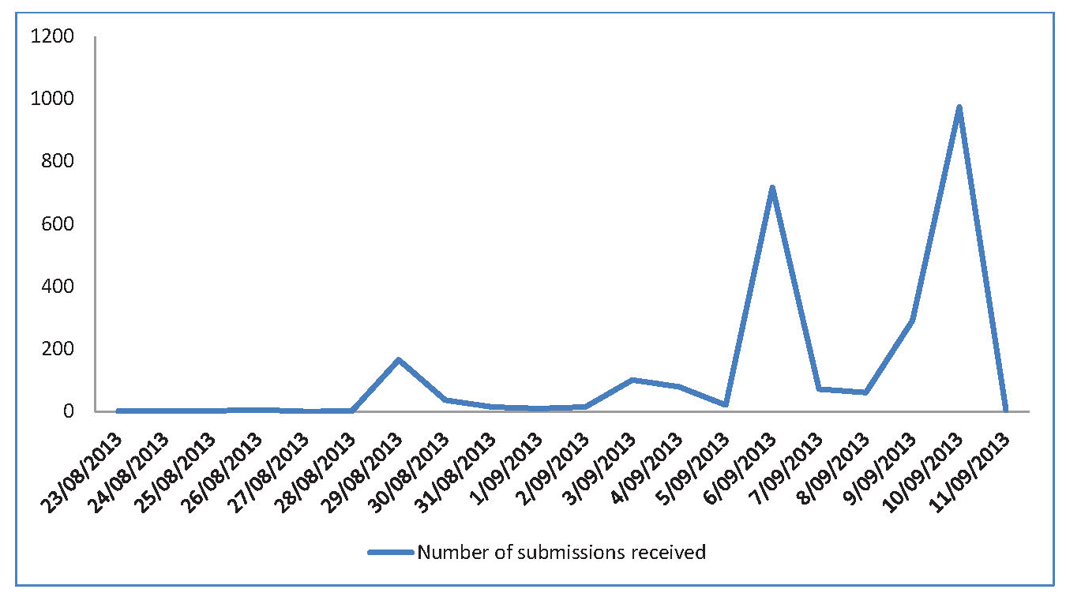
In line with the Tribunal’s principle of transparency, submissions received are available online at www.remunerationtribunal.qld.gov.au. Where the submitter has expressly requested confidentiality the content of these submissions has not been published. Personal information such as names, addresses and information that could be used to constructively identify a person has been removed to maintain the privacy of submitters.
Key themes emerging from the consultation process
An analysis of submissions reveals a number of common key themes, benchmarks and comments. Figure 2.2 provides a snapshot of key words raised in the public submissions.
Figure 2.2 Key words from public submissions
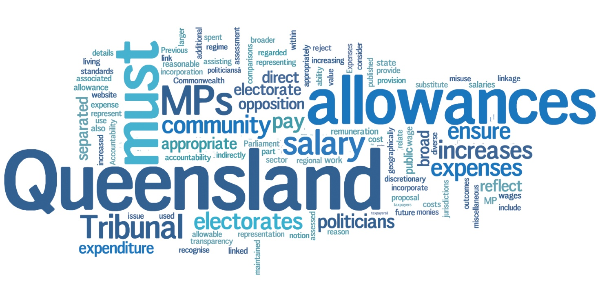Note: Grammatical and spelling errors in Figure 2.2 have not been corrected from the submissions.
Figure 2.3 expands upon the key words by grouping the various issues raised into common themes.
Figure 2.3 Key themes, benchmarks and comments
General principle
Salaries should be separate from allowances
Salary
Opposed to a 41.9% pay rise
Work value assessment of MPs
Performance indicators
Reasonable pay rise for MPs
No pay rise
Allowances
Accountability and transparency for allowances improved
Expense allowances should reflect the MPs local electorate
Allowances should reflect expenses
Former MPs
No entitlements to former MPs
No retrospective changes to former MPs’ entitlements
Entitlements to former MPs should be modified
Decisions made based on superannuation arrangements
Considerations
Economic conditions
MPs are public servants
Privilege of service
MPs should lead by example
Opposed to pay rise given reduction in public servants
Community opposition to link with Commonwealth MPs
Consider community standards rather than MPs in other jurisdictions
Benchmarks
Public sector wage outcomes
A level in the public sector
Average annual earnings
Core public sector enterprise agreement
Cost of living
Inflation
CPI increase
Minimum wage

Discussion
The public submissions confirm that MPs’ remuneration has become an emotive and highly charged issue. Many public submissions expressed disgust, anger, outrage and frustration with MPs and their remuneration.

Many of the submitters were unaware that in mid-August 2013, the 41.9% pay rise awarded in July was rescinded and MPs’ salaries were reduced back to the 30 June 2013 levels.
Many submitters made reference to the importance of having clear separation between the salary of an MP and their allowances, entitlements and expenses. There was a common view that this distinction would provide greater accountability and transparency regarding the whole remuneration package and ensure that allowances are not a substitute for salary.
Approximately 1,900 submissions were received from individual submitters as part of what appeared to be a coordinated campaign. Figure 2.1 above shows significant spikes in submissions received on certain days of the public consultation process.
Approximately 900 submissions were received as an attachment to an email from ‘Working for Queenslanders’. Each of these submissions contained the wording or a variation of the wording included at Figure 2.4. In addition there were approximately 1,000 submissions received from individual submitters which contained the wording or a variation of the wording included at Figure 2.4.
Figure 2.4 Wording used in approximately 1,900 submissions
- The direct salaries for Queensland MPs must be separated from allowances for work within electorates. Previous misuse of electorate and miscellaneous allowances is not a reason to incorporate them into direct salary. Accountability for how allowances are used must be increased to ensure that taxpayers’ monies are spent appropriately. The provision of allowances for reasonable expenses must be separated from the issue of assessment of appropriate remuneration.
- The expense allowances must be maintained to provide the ability to Queensland MPs to represent their electorates. Queensland is a geographically diverse state and allowances should reflect the additional costs associated with representing larger regional electorates. The use of expenses should be discretionary for Queensland MPs, but the details of their expenditure should be published on the Queensland Parliament website. Expenses allowable should include any expenses which relate to assisting the MP in their representation of their electorate.
- The Tribunal must ensure that allowances are not regarded as a substitute for salary by increasing the accountability and transparency regime for allowance expenditure.
- The Tribunal must ensure that the value of Queensland MPs is assessed against Queensland community standards and reject any notion of comparisons with politicians in other jurisdictions. The most appropriate linkage is for Queensland MPs to have future salary increases linked to public sector wages outcomes, which will also indirectly reflect broader wage increases and increases in the cost of living in Queensland.
- The Tribunal must consider the broad community opposition to the proposal to link Queensland politicians’ pay to Commonwealth politicians’ pay. The Tribunal must recognise the broad community opposition to the incorporation of allowances as part of salary.
Base salary of an MP
Submitters provided the Tribunal with a range of benchmarks and comments regarding the setting of the base salary of an MP. A strong, consistent view was that linking the base salary again to that received by Commonwealth MPs, and therefore the 41.9% proposed increase, was inappropriate. However a reasonable pay rise based on specific benchmarks did not appear to be significantly disputed.
Benchmarks provided by submitters for an increase, if any, in the salary of an MP included a wide range as follows:
- the Public Sector with specific reference to current Enterprise Based Agreement negotiations, public sector wages outcomes, police, fire fighters, nurses, and paramedics, school teachers and principals, cleaners, the senior executive service, the administrative stream and the core public service
- the State Government’s wages policy
- the aged pension or disability support pension
- minimum wage
- average annual earnings
- Average Weekly Ordinary Time Earnings
- the Consumer Price Index
- inflation
- Non-Government Organisation managers
- Gross Domestic Product of the state/country
- OECD countries
- cost of living increases.
Other matters suggested for Tribunal consideration in deliberations about the base salary were also put forward by submitters.
The primary consideration raised in these submissions was the current fiscal position and economic conditions of the State. Submitter no. 218 provides a detailed rationale for the Tribunal to consider the State’s financial and budgetary situation as follows:
Since its election in March 2012 the Government’s constant message to the people of Queensland has been that the State is facing a severe financial crisis. In an address to the Queensland Media Press Club on 8 May 2013, for instance, the Premier stated, “There is a reality, frankly, that people need to get used to and we have been saying over and over and over again, just how much trouble the state of Queensland's finances are in and sadly it pains me to say today that still, some people don't understand, and I use the word carefully and soberly, how desperate our situation is.” Over the last 12 months the Government has made wide ranging cuts to services and programs and has terminated the jobs of thousands of Queenslanders on the basis that they could no longer be afforded. Also, in late 2012 the Government introduced legislation to amend the Industrial Relations Act 1999 to require the independent Queensland Industrial Relations Commission to give
consideration to prevailing economic conditions and the State’s financial position when determining public sector wages and employment conditions.
If the State’s financial situation is as dire as what the Government claims it to be, then as a matter of policy it is essential that the Tribunal should similarly consider prevailing economic conditions and the State’s financial position when determining MPs’ salaries and allowances. That the Tribunal is able to do so was confirmed by the Premier in his Introductory Speech to the Queensland Independent Remuneration Tribunal Bill 2013 about it providing the Tribunal with “broad methods of inquiry” and the Attorney-General with his assurance during the parliamentary debate on the Bill regarding the “pretty broad” powers of the Tribunal to inquire into and inform itself of anything in the way it considers under clause 28 (now section 28 of the Queensland Independent Remuneration Tribunal Act 2013 [QIRT Act]).
This view was also expressed by submitter no. 383 in the following way:
The Newman government, through changes to the IR system have required the QIRC to consider the fiscal circumstances of the state in determining wage increases. I believe that should be a guiding principle in awarding MP pay increases also.
Submitter no. 231 expresses the view that many submitters had about the economic conditions of the state:
The LNP Government came to power in 2012 & implemented an austerity program based on the “need” to bring Queensland’s budget back into a surplus. They have been in power for just over 12 months & during that time we have been constantly harangued about the economical state that the previous government had left our state in, a state of “emergency”.
Many submissions also made reference to the government asking the general public to ‘tighten their belts’ because of the state’s economic situation. Consistent with this view were submissions that MPs should be leading by example in this respect.
Submitters also felt strongly about constant references to the state’s economy as government’s justification for the public sector redundancies that have occurred. The following submitters expressed this view as follows:
The Newman government has been responsible for extensive job cuts across Queensland's public service on the premise that these cuts were necessary to improve Queensland's budget situation now and into the future.
I do not support pay rise for Qld elected representatives. The current Qld government has made it very clear throughout his term that budget tightening is required and has made widespread cuts to essential community and health services on this basis. It is not justifiable to then allow pay rises for those in power. Politicians were are [sic] aware of pay levels when then [sic] run for government and should not have an advantage over citizens by not having to comply with cuts and budget tightening.
The LNP came into power talking up Qld’s debt, and subsequently sacked many public servants…
If as a means of fiscal restraint, the LNP had to make massive cuts to public sector jobs, then there are no circumstances that justify excessive increases to MPs remuneration… If the tribunal acts in good faith, then it must hold MPs accountable to the same standards they set for state government employees responsible for providing public services.
I strongly believe consideration for the current economic climate should play as vital a role in determining MP salaries and relevant pay rises as it has reportedly done for other community/public service workers in recent times. MP's may play a valuable role in our community, but the wages and pay rises they receive should not grossly exceed what other government workers in Queensland are being asked to accept at the same time.
I think the Politician pay rise in the midst of cuts to Public servants entitlements and halt to any pay increase is an absolute disgrace and demonstrates the hypocritical policies that allows [sic] this to legitimately occur in parallel to other events.
Other submitters agreed that assessing the value of the role of an MP was essential. References were made to the work of an MP, the relative worth of the role and there were suggestions that MPs be subject to key performance indicators and be paid bonuses upon achieving results.
Submitter no. 366 stated that ‘In my humble opinion, people who choose to work in public service should be paid a fair and decent wage and accordingly on qualifications, skill and experience.’ The Queensland Nurses Union submitted that ‘We accept that MPs should receive a level of remuneration that reflects the duties and responsibilities of the role’.
Submitter no. 1385 made the following observation:
While agreeing that MP’s have a range of skills, experience and qualifications, it is important not to assume that such attributes are – of themselves – somehow in advance of those obtaining [sic] in the general electorate; thus while some members may have considerable experience and expertise, others may have considerably less. It is critically important therefore not to assume – as is often said – that members could earn significantly more in private practice: this is an unproven and unprovable assumption. For example, if a senior Minister chooses to describe his work experience prior to being elected simply as “farm labourer” the public is entitled to take that at face value.
Indeed the 'value' that an MP contributes to the good of society at large is extremely difficult to determine, and care must be taken not to assume that simply being an MP is somehow of more value than, say, a school teacher or an A&E surgeon – both of whom bring specific skill sets and tertiary training to their jobs.
A submitter questioned what politicians do to warrant their pay and another stated that ‘The base salary should be reasonable and reflect the responsibility of an MP as well as attractive enough to secure quality candidates’. Submitter no. 1050 suggested that ‘MPs should be paid a base salary that reflect [sic] the role they play in the community and that the role can be a seven day job.’
A common theme that emerged was that the role of MPs was to serve the community and represent the people. Submission no. 101 summarises this view:
A Queensland MP’s role is to serve the people of their electorate in public office. They chose to go into Politics and serve the state as a senior public servant, voted into this position to serve not to profit.
A number of submissions suggested the use of key performance indicators. In relation to performance indicators, one submission stated that ‘Politicians need to be bench marked and evaluated against KPI's like every one [sic] else.’
Some examples of suggested performance indicators put forward by a number of submitters were:
- productivity increases
- reducing the state’s debt
- keeping unemployment below 5%
- growing the state’s GDP
- improvements in:
  - health care
  - education
  - infrastructure
  - law enforcement
  - emergency services
- delivery of pre-election commitments
- areas of responsibility
- community and volunteer involvement
- no inappropriate dealings.

Expenses, allowances and entitlements
A key theme from the majority of submissions was a call for greater accountability and transparency for expenses, allowances and entitlements. As shown in Figure 2.4, approximately 1,900 submissions raised the importance of ‘increasing the accountability and transparency regime for allowance expenditure’.
Submitter no. 104 states that:
Ultimately, MP's are public servants and subsequently, constituents have high expectations for job performance and service to their local community. Therefore, earnings and expenditure should be allocated in a transparent and fair manner, in accordance with the current economical [sic] climate and community expectations.
In relation to allowances the United Firefighters Union Queensland submitted:
…the Queensland Independent Remuneration Tribunal needs to have at the forefront of its deliberations, the need to … ensure that allowances and expenditure based components are publicly accountable.
Similarly the Queensland Council of Unions submitted that ‘…the support for the allowance is qualified and there is a strong case for the allowance to be subject to far greater scrutiny and accountability.’
To foster greater accountability, one submission suggested ‘Clearly stating what is accepted allowances in a policy specific for MP's and stating what is not considered as claimable expenses.’ A similar view was espoused by the Queensland Council of Unions which proposed that guidelines would provide a useful solution on the appropriate use of allowances and that rather than prescribing every single thing that an allowance is able to be spent on public disclosure would enable voters to assess the expenditure.
The majority of submissions raised the importance of maintaining an allowance such as the current Allowance to Members to enable an MP to represent and service their electorates.
As at Figure 2.4:
The expense allowances must be maintained to provide the ability to Queensland MPs to represent their electorates. Queensland is a geographically diverse state and allowances should reflect the additional costs associated with representing larger regional electorates. The use of expenses should be discretionary for Queensland MPs, but the details of their expenditure should be published on the Queensland Parliament website. Expenses allowable should include any expenses which relate to assisting the MP in their representation of their electorate.
Further to this, submitter no. 54 stated:
Allowances should relate directly to the dollares [sic] spent and amount of work performed, not just size of electorate…only expenses relating directly to the job (travel, phone, away from home, stationary(sic) used to reply to constituents). Disallow: clothing, stationary [sic] for electioneering, raffle tickets, buying cakes, etc and donations as they should not be included as expenses.
Another submitter presented the following view on allowances:
…travel is paid by the government anyway and an additional payment in [sic] not needed, allowances should be submitted through the travel approval system like other public servants. Having said this it is reasonable to consider on top of the base salary a smaller electorate allowance to take into account remote areas and additional costs of regional items and servicing regional areas when working in the electorate. The Miscellanous allowance should be abolished it is just cushioning the salary. If they are serious about saving money this could save quite a bit…
The expenses should cover regional servicing and proof of work completed and reciepts [sic] for out of pocket [sic] should be provided and paid on a montly [sic] basis.
One submission raised the technological advances that have been made and the implications this could have on travel:
There should be a tight cap on the travel expenses allowed by all MP's – alot [sic] of travel to major cities is now not required given the techonology [sic] of video conferencing etc. If the MP has a wider remote location to represent, then the budget for travel expenses should match but not exceed a practical budget allowance. If the MP's are provided with a mobile, home phones should not be reimbursed. The same scruitany [sic] as Government Employees should be applied to MP's when claiming expenses.
As above, some submissions supported abolition of the Miscellaneous Allowance or at least making this allowance more specific and accountable.
The view that allowances should not be provided for party political business was raised by submitter no. 1257 and submitter no. 389 stated that ‘Costs involved in entertainment of clients/allies or advertising for the next election etc should be met by their party funds not the taxpayer.’ The Queensland Council of Unions also raised concern with a postal allowance being used for political purposes rather than for the MPs electorate work.
Many submissions supported a form of reimbursement of expenses. Submitter no. 200 raised that ‘all expenses should be reimbursed through a central body where records of all expenses are required to be kept and produced’. The following statement also provides a view on a reimbursement system and considerations for allowances and unspent funds:
Other Allowances should be paid by a reimbursement system. The money should be budgeted for a maximum amount per each MP according to their region. And any savings / unspent funds returned to the public purse. The allowances are there to cover reasonable costs to run the office, electorate, postage (not advertising) again any increase to be based on CPI increase, although savings should be a consideration given the current economic climate and the budget position.
Submitter no. 106 is of the view that:
All other allowance [sic] for expenses should be submitted to a financial controlling department for approval (as set out in policies and legislation), processing and finally payment. Politicians should not self manage allowances as this could lead to a perception of inappropriate spending regardless of documentation provided.
There is further discussion of allowances in Chapters 5 and 6.
Additional salary for office holders
While the matter of additional salary for office holders is outside the scope of this initial review of MPs remuneration it will be considered as part of the Tribunal’s ongoing scope of work.
The Tribunal notes that there were a range of views put forward regarding additional salary for office holders:
Additional salary for the different roles Premier, Treasurer, Minister, whip, committees is reasonable considering the additional time, responsibility and decisions that are required to be made.
Alternatively:
I am extremely against and would hope the tribunal has the strength and power to abolish the additional salary that a [sic] MPcan claim if they hold office in a formal role...It is a gross misrepresentation of the “public servant” in these roles to accept additional salary such as $8,217 per year (for a Committee Member position) up to $143,499 per year (for the Premier). Also “Additional salary” that some formal office roles are entitled to such as “Expense of Office Allowance”. These additional salaries should be abolished and a base salary agreed to which encompasses a pay increase per year in line with the current CPI that is fair and reasonable comparable to the public servants.
In addition, some submissions suggested that being on Committees was part of any job and that MPs should not receive additional salary for this role viz: ‘All MPs are Committee Members then this role [sic] part of the expectation of being an MP. Hence, an additional salary should not be payable for this role as the annual base salary is more than generous.’ Submitter no. 1650 supports this view stating that ‘Politicians shouldn’t be paid extra to sit on committees as that is part of their jobs as Parliamentarians, just like normal people are allocated jobs at work.

Entitlements for former MPs
There was a firm view from the public submissions that upon leaving office, for whatever reason, MPs should only be entitled to what a standard worker would receive such as standard superannuation arrangements.
Comments included:
As for previously serving MP’s, consideration needs to be given to make it law that MPs do not get both a superannuation and an annual salary. They should not be entitled to both… No other worker is entitled to continue being paid after they leave as well as get access to superannuation
…I would also assert that Politicians seek to remove, reduce entitlements afforded on cessation of public office and reduce their travel allowances. Unlike Politicians, the rest of the public service do not receive ongoing benefits following the cessation of their employment.
While this matter is also outside the scope of this initial review these comments will be considered when entitlements for former MPs are reviewed as part of the Tribunal’s ongoing scope of work.
2.4 MPs and former MPs
The Tribunal wrote to all current MPs and former MPs inviting them to provide a written submission regarding remuneration for serving MPs and entitlements for former MPs. Twenty-five former MPs and two current MPs made submissions to the Tribunal.
Former MPs’ submissions
Many of the former MP’s submissions provided useful information on the role of an MP from their experiences in parliament.
In addition, some former MP submissions made suggestions about matters the Tribunal could consider in determining an appropriate remuneration level for serving MPs:
- The salary should be high enough to attract the most talented of candidates but should not be so high as to attract only those who see it as an easy way to make an easy living. Nor should the salary be such as to encourage a person to make a life-time career of being an MP
- As one experienced MP counselled me shortly after having been elected to the Queensland Parliament: ‘If we got paid nothing, half the electorate would say we’re being over-paid.’
I believe that your Tribunal will be on the safest possible grounds if, in your deliberations, you:-
- apply HR principles which are used community-wide to assess remuneration for a wide variety of occupations
- take into account the specific needs and demands of being a State MP
- take into consideration, and make provision for, the different remuneration regimes which apply to current and former MPs
A primary theme that emerged from submissions received from former MPs was that it would not be considered natural justice for the Tribunal to retrospectively amend entitlements to former MPs. The following statements by submitters aptly show this sentiment.
- … like every MP there was an expectation that despite the potential short term nature of the role that certain benefits would accrue over time. Whilst there is always a financial consideration to these matters there is also the issue of retrospective changes to what is effectively an employment contract.
I have no objection to laws, rules, guidelines and regulations being changed for newly elected MP's but the implementation of retrospective arrangements is always fraught with difficulty.
- I can understand that rules and regulations can be changed for newly elected members but I am concerned that any retrospective changes will further erode the entitlements indicated in the handbook when members were elected.
- … the first one is that any changes in the law, particularly proposals to downgrade any entitlements as they stood at the time of the members retirement is tantamount to retrospective legislation, and as such is not considered either “good” or “fair” legislation.
- On election to the parliament I believe a Member enters a form of Employment Contract with remuneration, including travel or other benefits, as defined under the Member’s Entitlements Handbook at that time. In my opinion any reduction of that remuneration during the term of that Parliament would be a breach of the “employment contract”.
If a decision is taken to change Members’ remuneration, and that of former Members, it should be signalled before an election for the following Parliament so that Members and potential Members are aware of the terms of their “employment contract” if re-elected or elected.
Current MP submissions
The submissions from current MPs provide information on the role and work of an MP but did not comment or make suggestions about the remuneration levels of MPs.
Submission no. 412 provided the following information relating to an MP:
- MPs salaries, additional salaries and allowances for Australian states and territories
- Comparative parliamentary statistics including for instance the total number of enrolled electors
- Historical development of electorate allowances paid to MPs
- Qualification requirements for superannuation for MPs between 1970 and 2007.
Similarly, submission no. 1634 also outlined the work and role of an MP by providing an overview of the member’s work as an MP and other roles. The submission also provides the

MP’s reflections and feedback on the changing work environment of electorate offices over the submitter’s time in parliament; how MPs have adapted to meet these requirements; and the challenges centralised bureaucracies have in getting the balance right between accountability, cost effectiveness and innovation.
The submitter reiterates a view common to the public submissions that accountability in relation to allowances is important. However, this accountability is to be juxtaposed with the need to ensure that the method of remitting for allowances is not overly complicated or costly to implement. This submission goes on to explain how allowances have been spent in fulfilling the MPs various roles.
Tribunal members also attended parliament and held discussions with some current MPs regarding their roles, work load and experiences with allowances.
2.5 The Clerk of the Parliament and QSuper
The Tribunal has engaged in an ongoing process of consultation with the Clerk as required under the Act.
The position of the Clerk is established under the Parliamentary Service Act 1988 (the PS Act). The Clerk is an appointed officer of the Queensland Legislative Assembly. The Clerk is a permanent, non-political officer whose main role is to give advice and guidance to the Speaker and MPs on the Standing Rules and Orders of the Parliament. Other roles include, for example, ensuring all proceedings of the Assembly are accurately recorded in the Record of Proceedings, having custody of all documents tabled and certifying and preparing all legislation passed by the Assembly for Royal Assent by the Governor.
Under the Public Service Act 1988 the Clerk is also the Chief Executive of the Parliamentary Service and, as such, is responsible for the efficient and economical management of the Parliamentary Service. The Clerk is also the employing authority for the Legislative Assembly of Parliamentary Service officers and employees and has control of the parliamentary precinct and accommodation supplied for MPs. The Clerk does not have a specified term of appointment and may only be removed from office for disability, bankruptcy or misconduct.
Advice that the Tribunal sought from the Clerk included detail on the role of an MP, a history of salaries and allowances for MPs in Queensland and detail on the current entitlement framework for MPs in Queensland.
The Tribunal also sought advice from representatives of QSuper in relation to the history of superannuation entitlements and the connection with MP remuneration.
2.6 Summary and conclusions
The Tribunal acknowledges and sincerely thanks those members of the public who showed an interest in and provided submissions for the Tribunal’s consideration about remuneration and entitlements of both serving and former MPs.
In the course of reviewing the public submissions the Tribunal noted a particular misconception. The Tribunal wishes to clarify the following matter concerning the recent 41.9% pay rise.
The Act, which established the Tribunal and the powers given to it to review the remuneration of MPs, also rescinded the 41.9% pay rise for Queensland MPs which took effect on 1 July 2013. Section 63 of the Act in effect overturned the decision to increase MPs salaries by 41.9% and the salary rates that were applicable on 30 June 2013 were reinstated until such time as the first Determination is made by the Tribunal. Any increase to MP salaries determined by the Tribunal will apply from 1 July 2013 and the Clerk is enabled to recover any overpayments since 1 July 2013 as a result of the 41.9% increase. As such, no MP will ultimately have any benefit from the 41.9% pay rise.
In relation to the base salary, references made in submissions examining the role and work value of an MP have been considered by the Tribunal. Further, the Tribunal has holistically examined the role, functions and responsibilities of a Queensland MP taking into account:
- submissions received during the public consultation process elaborating on the work of an MP and observations by the public of the role of an MP to serve the community
- the electorate, parliamentary and party roles of an MP specific to the Queensland context
- work value assessments of MPs undertaken in other jurisdictions
- similar roles within the Queensland public service
- a comparative analysis of the base salary received by MPs in other jurisdictions.
The suggestions made by submitters to develop a set of key performance indicators for determining future salary increases for MPs have been noted by the Tribunal. However, the Tribunal notes that MPs are effectively performance assessed at each election.
In relation to allowances the Tribunal notes that the public submissions conveyed a strong desire for greater accountability and transparency. The Tribunal also notes that submitters commented on the importance of an MP’s role in their electorate and the need for allowances to support those roles.

Chapter 3: Fundamental considerations
Chapter three outlines fundamental considerations the Tribunal examined in undertaking its task of reviewing MP remuneration including:
- an examination of the role of an MP in Queensland
- a comparison of the characteristics of this role with those of an employee
- an examination of the ‘work value’ and ‘work load’ of an MP.
The purpose of this Chapter is to understand and examine the theoretical framework before going on to consider in detail, the issues of MP base salary and the allowance system in later chapters.
3.1 Legislative principles
The Act provides for general principles the Tribunal may consider when making a determination, including:
- the value to the community of an MP carrying out their role, functions and responsibilities
- the importance of an MP being appropriately remunerated for carrying out the MP’s role, functions and responsibilities
- relevant laws applying to MPs (e.g. the Parliament of Queensland Act 2001)
- other matters the Tribunal considers appropriate (e.g. the size of an MP’s electorate).
3.2 Role of a Queensland MP
The Tribunal gave detailed consideration to the role of an MP, consistent with the legislative principle that the Tribunal may have regard to the value to the community of an MP carrying out their role, functions and responsibilities. Unlike jobs in both the private and public sectors, there is no specific position description attached to the role of an MP. It is not like a typical job where a person submits their package of skills, experience and qualifications through an application process to an employer. Rather, there are no formal barriers to entry when seeking to become an MP. Thus, MPs come from a wide variety of backgrounds and have a wide variety of skills, experience and qualifications, evidenced by a review of the occupations of current and former MPs.
Figure 3.1 provides a summary of MPs’ former professions/occupations before their election to the Queensland Parliament over the past four parliaments – the 54th being the current parliament. It is apparent from this information that the composition of the last four parliaments reflects the diversity of backgrounds discussed above.

Figure 3.1 Occupation of MPs prior to election 51st to 54th parliaments
- Occupation prior to election | Number by parliament
- Occupation prior to election | 51st | 52nd | 53rd | 54th
Accountant | 2 | 3 | 2 | 2
Administration | 4 | 4 | 4 | 2
Agriculture | 9 | 9 | 9 | 11
Armed forces | 1 | 1 | 2 | 7
Business | 11 | 12 | 17 | 39
Communications | 4 | 7 | 5 | 10
Education | 19 | 15 | 12 | 3
Electorate officer | 2 | 4 | 4 | 2
Engineer | 2 | 1 | 1 | 1
Fire fighter |  |  | 1
Health professional | 7 | 5 | 7 | 7
Legal professional | 13 | 14 | 13 | 9
Local government | 14 | 10 | 9 | 9
Ministerial advisor | 2 | 4 | 5 | 3
NGO employee | 3 | 2 | 2
Police | 1 | 3 | 1 | 3
Public service | 7 | 7 | 9 | 8
Trade | 4 | 3 | 3 | 5
Union employee | 10 | 10 | 10 | 1
Note: Compiled from information provided by the Queensland Parliamentary Library and Research Service dated 26 July 2013.
The Tribunal’s view, supported by feedback from the public consultation, is that the remuneration of an MP should be commensurate with the responsibilities and duties of the role. However, it is difficult to clearly define the role of an MP. The Tribunal has accepted the
following description of the role of an MP, taken from various sources, including the Egan Report and a recent United Kingdom report into MP remuneration.
In general, an MP has a variety of roles within parliament, their electorate, and their political party (except for independent MPs). The Australian Taxation Office (ATO) also uses these broad categories in its rulings.
An MP’s role within their electorate involves engaging with and representing their constituents in a variety of forums such as community organisations, public committees and parliament itself. MPs also have an electorate office, supported by electorate staff, which is used as a key contact point for all constituents within their electorate. MPs generally receive and are required to respond to correspondence from constituents covering a broad range of issues, and will often use print and social media to communicate directly with their constituents on issues that affect them. They are also often called upon to investigate and to mediate disputes between organisations and members within their electorate and are looked to as a leader within the communities they represent.
In relation to parliament, an MP’s role principally involves debating public policy and legislation that comes before parliament and its committees. Many MPs also undertake other formal roles either within parliament or within the executive (e.g. Committee Member, Whips, Leader of the House, Speaker, Minister or Assistant Minister, Leader of the Opposition and Premier). MPs are expected to attend parliament on all sittings days unless excused from attendance and are often required to work late into the evening, or early morning to debate policy and legislation.
For MPs who are members of a political party, their role also covers involvement in branch meetings, state conferences and parliamentary party meetings to debate and agree upon party policy. The role of an MP may be described as:
- a representative of the people in their electorate who must play an active role in their community; listening and providing advice to; and advocating for their constituents
- providing a direct link between their electorate and parliament
- advocating on behalf of their constituency
- contacting and supporting the communities within their electorate
- performing parliamentary functions as a member of the Legislative Assembly, such as debating legislation, scrutinising the actions of the executive government through asking questions on notice or without notice and making speeches, particularly on topics that affect their constituency
- serving on parliamentary committees, as required, to examine specific issues and legislation that comes before parliament
- participating in internal party processes where applicable.
Other factors that are specific to the role of a Queensland MP also need to be considered. Queensland is the only state in Australia that has a single House of Parliament (i.e. unicameral) where MPs perform the full function of passing legislation in its entirety. Similar to Western Australia, Queensland is a large decentralised state requiring some Queensland MPs to travel great distances to service their electorates.
To fulfill their role, an MP requires the following attributes:
- judgment and initiative
- intelligence
- analytical skills
- leadership skills
- versatility
- ability to work under pressure for sustained periods
- honesty and integrity
- commitment to civic duty
- people and communication skills.
A further consideration is that the responsibilities and duties of an MP vary both by context and time. Changes in the external environment including the economic, political and social climate will impact on the role of an MP. Further, different stages in the electoral cycle place different demands on an MP, thus impacting on an MP’s tenure in their electorate.
It has also been said that ‘the role of the MP is at the heart of our representative democracy’. It is therefore in the interests of all Queenslanders that the level of remuneration of MPs is such that it does not discourage suitable people from seeking election to the role. Further, the level of remuneration should be such that MPs are able to dedicate themselves to the role. Conversely, the level of remuneration should not be such that people are attracted to the role on the basis of financial reward without having due regard to the commitment to civic duty that the role demands.
The base salary for an Queensland MP is currently $137,149 per year, and has remained at that level since August 2011.

3.3 MPs and Ministers
The role of an MP described above must be distinguished from the role of an office holder (e.g. Minister) in carrying out the functions of executive government. Current office holder positions are listed in s. 42 of the Act.
Ministers are drawn from the ranks of MPs whose political party holds the majority of seats in the Queensland Parliament. Ministers are appointed by the Governor on the advice of the Premier (who also holds a ministerial commission). In addition to their role as an MP, Ministers are responsible for government departments, implementing laws relating to their area of responsibility, and are accountable to parliament for the administration of their department. Ministers also collectively make up the Cabinet, which is the principal decision making body of the government. The Premier is the leader of the government, being the Chairperson of Cabinet. Ministers are also Executive Councillors, who provide advice to the Governor when sitting as the ‘Governor in Council’ to give legal effect to certain decisions of the government.
As a result of this significant additional responsibility, MPs who are office holders (e.g. Ministers) receive an additional salary to that of the MP base salary. This additional salary is currently $84,877 for a Minister, $104,287 for the Deputy Premier and $143,499 for the Premier, and these additional salaries have also remained at these levels since August 2011.
3.4 Employee versus MP
Employees and an employee/employer relationship
In terms of assessing the appropriate remuneration for an MP based on their role described above, the Tribunal considered whether an MP can be compared to an employee.
The relationship between an employer and employee is a contractual one (referred to as an Employment Contract). The ATO refers to this relationship as a contract for service. In contrast, an independent contractor is generally a person or entity that enters into a contract or contracts for services. An independent contractor typically contracts to achieve a result whereas an employee contracts to provide their labour (typically to enable the employer to achieve a result).
There is a substantial body of case law on the issue and often many relevant facts and circumstances are taken into account. However, there is no single feature which is determinative of the contractual relationship:
It is the totality of the relationship between the parties that must be considered to determine whether, on balance, the worker is an employee or independent contractor.
Characteristics of an employee compared with an MP
Various indicators identified in judicial decisions indicate that no list of factors defining an employee is exhaustive. Despite this, the taxation office and some academic institutions have provided descriptors for a number of characteristics of an employee. The Tribunal considered each of these descriptors as they are relevant to the role of a Queensland MP.
Ownership of tools and equipment: an employee is generally provided with the equipment needed for their role. An MP is provided with the tools and assistance they need to carry out their role by the Parliamentary Service. This includes an electorate office, electorate staff, allowances, hardware and office fit out, and stationery items.
Method of remuneration: an employee is typically remunerated based on time worked, or regular periodic payment which is indicative of a contract. MPs (similar to some directors and managers) are not paid for specific hours worked and often work in excess of any standard hours, in fact MPs do not have defined standard hours. In that sense the role of an MP is unique. MPs are; however, paid regularly for the duration of their time as an MP which is similar to an employee.
Contracting under a business name: Where the worker undertakes the work as part of their own business and has the ability to enter into a partnership, a Court is unlikely to find an employment relationship. An MP does not undertake to work as part of their own business, cannot enter a partnership and in that respect is similar to an employee.
Ratio of expenses to income: a high ratio of expenses to income is not indicative of an employment relationship. An MP does incur high expenses in relation to their role; however, some large expenses borne by an MP such as travel and communication are compensated for by an allowance or entitlement of some sort. Other significant expenses incurred by MP’s may include donations to charity, raffles, supplying book prizes, sponsoring athletes and assisting those in financial need.
However, these expenses are provided for by an allowance to MPs in recognition of this aspect of their role. Some MPs have submitted that their expenses exceed the allowances and entitlements they receive. Unfortunately there is no data available to verify these claims as
currently several of these allowances do not have an acquittal system in place. That is, MPs are not currently required to show how these allowances are spent. Members may spend well in excess of these amounts in their community and others may choose to retain a portion of these amounts as a defacto salary. The allowance system is discussed in further detail in Chapters 5 and 6.
It appears that MPs are generally compensated for the high expenses they incur through an allowance system. The high expense itself is not indicative of an employee but the compensation for expenses incurred is indicative of an employee relationship. For example, many executives with high expenses and travel requirements are compensated through a reimbursement system.
Duration of service: if the worker is engaged for an indefinite period (rather than a specific task), this indicates an employment contract (note: some employment contracts are for a fixed period and related to a specific task). This again highlights the uniqueness of the role of an MP. On the one hand the role is similar to employees on fixed term contracts. However, in Queensland, parliamentary terms are not fixed and an election may be called prior to completion of the nominal three year parliamentary term.
Hours of work: regular or fixed hours and the ability to take holidays only at prescribed times indicate an employment contract. MPs do not have regular or fixed hours of ‘employment’. There are regular times they are required at parliament and at political party meetings (except for Independents). MPs are usually only able to take holidays at prescribed times (such as during winter or summer recess from parliament). However, the hours outside of this are varied and at the MPs general discretion. In this regard, the characteristics of an MP are quite different from an employee. A number of professions such as medicine, law and the clergy all have varied hours and are often on call, however, the defining difference with an MP is that the hours (aside from parliament and political party meetings) while onerous, are at the MP’s discretion.
Exclusivity of service: where one party has the right to demand exclusive service from the other, this indicates an employment contract. In this respect the role of an MP is similar to an employee. MPs are required to not undertake other paid work whilst holding the position of an MP.
Delegation of duties: an employment contract often includes the right to delegate work so that the work is done but not necessarily done by oneself. In this respect the role of an MP differs to that of an employee, as they are unable to delegate their work.
Deduction of income tax: the deduction of income tax from payments made to a worker indicates an employment contract. In this respect the role of an MP does have employee characteristics as MPs are considered employees for taxation purposes.

Power of summary dismissal: a power of summary dismissal on the part of the person for whom the work is performed indicates an employment contract. An MP may be ‘dismissed’, but the dismissal is at the ballot box, on largely subjective terms and criteria not provided for in a contract of employment. The dismissal is by the ‘public’ and not the party that has been administering their payments and superannuation. This is key to differentiating the role of an MP from that of an employee.
Place of work: the power to control where the work is done indicates an employment contract. This also differentiates the role of an MP from an employee. The place of work at parliament, at the electorate office and at political party meetings is largely controlled. However, there is a significant amount of hours of work undertaken by an MP that may be outside of these three principal work places and at the total discretion of the MP. The ‘control’ in relation to the aforementioned places of work is also exercised by different parties. The political party meetings are ‘controlled’ by the party leader. The other places of work are provided for under Acts of Parliament. Accordingly, in this respect, the role of an MP is quite unique.
Labelling clause: a label will only be effective if it accords with the reality of the relationship between the parties. MPs are not labelled as employees except for taxation purposes.
Worker’s compensation: in Queensland the provision of worker’s compensation insurance by the person for whom the work is performed for the benefit of those performing the work indicates an employment contract. An MP does not have worker’s compensation insurance in the same manner as regular employees. However, there is an insurance scheme provided for MPs which covers them, to some extent, in the event of an illness or accident at work. This scheme provides for the MP to first seek reimbursement through Medicare and private health insurance. If out of pocket expenses remain, MPs may submit an application which will be considered but not automatically approved by the insuring body. This insurance policy is administered through Queensland Treasury and Trade.
Integration/organisation test: if the worker is an integral part of the business and has been integrated into the organisation, this is indicative of an employment contract. An MP would be considered an integral part of running the State of Queensland. After each election and when a new MP enters parliament, the Parliamentary Service conducts a formal induction service to integrate the MP into the Legislative Assembly. In this respect there are similarities to the characteristics of an employee.
Control test: where control is exercised by the party for whom the work is performed over the manner in which the other party performs the work, this indicates an employment contract.
The role of an MP appears unique in that the MP is accountable to a number of ‘stakeholders’ or ‘controls’. These accountabilities at times may come into conflict and require application of skilful judgment in decision making and prioritising of tasks. An MP is responsible to:
- their electorate and its community
- parliament and its committee system
- their political party and its constituents (except Independents).
However, this multiple accountability is not unique to the role of an MP. For example, a lawyer has multiple duties, some of which also may come into conflict and require prioritising and applying a certain level of judgment to decisions. A lawyer has a duty to:
- the client
- the law firm
- the administration of justice (the court and ultimately society).
Accordingly, the control test indicates both similarities and differences with the characteristics of an employee. On balance, the large amount of autonomy with the role of an MP indicates it may be distinguished from that of an employee.
Other factors:
MPs do not have regular employee benefits such as official sick leave, recreation leave or long service leave entitlements. However, MPs do continue to receive their normal salary when they are absent from parliament provided they comply with Standing Orders.
The role of an MP differs from that of many traditional employee roles which have a defined career path. An MP may follow a particular career path’ during their time in parliament including backbench member, Committee member, Assistant Minister, Minister and then Premier. However, this path is not clearly defined, is influenced by many external factors and is arguably partly based on political rather than objective criteria.
Unlike many employees, MPs are in a position of unique privilege with certain prestige and benefits attached to their role. Additionally, MPs are in a position to perform a unique contribution to society. These add to the non-financial benefits associated with the role of an MP. It is arguable that MPs perform a civic duty and the role is more of a vocation rather than a profession. The notion of the role being vocational in nature holds similarities with other roles such as certain roles in the medical profession and religious orders.
Summary
In summary, MPs are not common law employees. None of the usual indicators of an employee/employer relationship, such as express or implied contract of employment, ability to direct activities or exercise control over the employee, strictly apply to MPs. There is clearly no
employer, although in a sense an MP owes duties to the parliament, their constituents and likely, his or her party organisation.
As stated earlier, these characteristics are weighed and balanced in each individual circumstance in order to determine whether an individual is an employee. As there is no single feature, it is a multi-factor approach.
Whilst there is no single feature of the role of an MP that is unique, the Tribunal considers that it is the combination of these features that makes the role of MP unique. When comparing the characteristics of an MP with an employee, there are a number of aspects that are similar and some that are not. It follows that there is no identifiable complete benchmark for the base salary of an MP. Accordingly the Tribunal’s comparison against a range of what are considered imperfect benchmarks is set out in Chapter 4 of this report.
3.5 Work value and work load
In taking a holistic approach to the task of determining remuneration of MPs, the Tribunal considered that the unique nature of the role was an essential element. The traditional method of assessing work value is not (in isolation) ideal because, in the Tribunal’s view, it may introduce the possibility of artificially inflated results which do not account for elements such as civic duty, economic factors and public expectations. Any holistic assessment of work value must also take into account these factors. Nonetheless, the Tribunal considered work value as the principal factor rather than work load as part of the overall assessment.
As evidenced from the previous discussion on the role of an MP, there is great diversity in the skills and qualifications of people who become an MP. The selection process is not necessarily skills based as is the case with traditional employee roles.
‘Work value’ refers to the level of accountability, skill and judgment required to perform the role. In contrast ‘work load’ refers to the number of hours worked and the amount of work an MP is required to perform.
Work value
The traditional method of assessing work value is the approach adopted by many human resources areas within the private and public sector, namely, the job evaluation and classification methodology. This methodology does not readily apply to the role of an MP given its unique characteristics.
As stated previously, the remuneration of an MP should be commensurate with the responsibilities and duties of the role. At this point, it is important to clearly differentiate between the role and work value of a backbench MP receiving a base salary (the focus of this
first Determination) and the role of an MP who also is an officer holder (e.g. Minister) which will be the focus of a future determination. Whilst it is recognised that many MPs undertake an additional role and accordingly contribute greater work value, the base salary is determined upon the role of a backbencher and the value of that role alone. The extra value provided by an MP undertaking an office holder role is currently compensated for in the ‘additional salary’ not the base salary. Accordingly, in considering the work value of an MP, the Tribunal considered the work value of a backbench MP acting purely in that capacity.
In relation to the attributes of an MP outlined previously, there is a view that the intensity of the role of an MP and the consequences of error are greater than other professions. However, the Tribunal considers this argument should be treated with caution. The primary focus of this first Determination is on the remuneration of a backbench MP (i.e. the base salary) where there is a relatively low consequence of error. In considering the benchmark for base salary it is important to not attribute the work value of additional office holder roles such as that of a minister, deputy premier or premier. These tasks add to the intensity of the role of a member and are remunerated by an additional salary. In some cases, for these office holders, the consequences of error may be greater than that of other professions.
In summary, the principal accountability of an MP may be described as:
- represent and promote the interest of their constituents by contributing to public policy and legislation

- further the interests of constituents having regard to the interest of the state and Government policy, as well as the administrative constraints of the bureaucracy.
On the one hand, the unicameral structure of the Queensland Parliament places a higher level of accountability on MPs. This may be due to the absence of an upper house which places an additional burden on MPs to exercise a higher level of scrutiny over legislation. Counter to that view is the argument that the absence of an upper house effectively reduces the accountability of MPs.
In recent times the Queensland Parliamentary Committee system has been overhauled in a bid to increase scrutiny and accountability, particularly in the absence of an upper house. The role of committee chairs and committee members now include the additional accountability to balance the unicameral system in Queensland.
The Mercer report states that:
The backbench member operates in a complex environment where the needs of various constituencies – their electorate, their Party, the national interest, their networks of supporters and their personal careers – must be weighed and balanced. There is a requirement to identify and define emerging issues of community concern, to interpret how national and regional issues may impact their constituency, and to effectively represent these concerns in their engagement in Parliamentary processes.
Backbenchers are engaged in the detailed analysis and review of policy and legislative materials and must engage effectively in the consideration of options, evaluation of alternatives and formulation of solutions. They operate strategically and tactically, balance competing interests, and weigh pragmatic and idealistic considerations.
These considerations (adapted to state context and state interests) apply to backbench MP’s of the Queensland Parliament. To assist in its work value assessment, the Tribunal compared Queensland MP base salary and base salary growth to that of other occupations in the private and public sector. The Tribunal also benchmarked against base salary of backbench MPs in other Australian jurisdictions and compared base salary growth to Brisbane CPI.
What the Tribunal noted in these comparisons was the deterioration in relativities between the remuneration of MPs and that of other occupations and public office holders. In the last three years in particular, there has been deterioration in relativities with comparable Australian states (such as New South Wales, Western Australia and Victoria). Chapter 4 provides a comparative analysis of these benchmarks.
Whilst taking into account these benchmarks and comparisons in relation to work value of a Queensland MP, the Tribunal is conscious that the responsibilities and duties of MPs are unique when considered in combination and conclusions should not be drawn regarding responsibilities of MPs relative to other occupations outside parliament without detailed examination. Accordingly, while the Tribunal examined wage and salary rates of professionals, technical and skilled vocations in the community as part of its work, it maintained a focus on the levels established for MPs in other states in Australia.
The Tribunal also considered the work value assessment undertaken at the Commonwealth level in 2012 and the significant increase subsequently awarded to Commonwealth MPs. The Tribunal noted the recommendation in that report that the assessment was not directly applicable to individual states. After consideration, the Tribunal determined that current Commonwealth MP remuneration is not an appropriate benchmark for Queensland MP base salary.
In considering the work value of a backbench MP, the Tribunal took a holistic and comparative approach. In addition to the comparative data outlined above, the Tribunal also spoke with some current MPs and received submissions from both current and former MPs. The Tribunal also received detailed information from the Queensland Clerk of the Parliament (the Clerk) on the role of a Queensland MP.
In setting an appropriate base salary, reflective of work value, there are a number of competing factors the Tribunal was required to take into consideration. Independent tribunals across all Australian jurisdictions face this challenge. The tribunal in Western Australia appeared to face similar competing factors in determining base salary in its 2011 determination. The Western Australian Salaries and Allowances Tribunal noted:
The salary awarded to a Member is not intended to be an enticement for attracting someone looking for the highest salary possible, however it is intended to be a fair recompense for the considerable
responsibilities and onerous duties required of a Member of Parliament: duties which include advocacy and representation on behalf of constituents, public policy development and analysis, calling government and its instrumentalities to account, law making and participating in both community and political activities. In undertaking these duties, Members make considerable sacrifices to be available to their constituents at all hours and to attend to Parliamentary duties in Perth and their electorates. This places a burden on a Member’s family particularly when the electorate is outside the metropolitan area.
For many Members the commitment to public office carries with it an acceptance of a reduction in income. The level of remuneration should not be so low as to act as a deterrent to taking up public office. The salary should be commensurate with the value of the office to the State, the demands of effective representation and the skills expected of our law makers. It should be sufficient for a fair minded person to consider, given the requirements of a Member, that the level of remuneration is adequate and appropriate when viewed within the context of community wage and salary standards generally. This appreciation recognises that the Member does not have access to general terms and conditions of employment such as long service leave, annual leave, leave loading or redundancy pay. Although after hours availability is not unique to Parliamentary life, there is no additional recognition for being on-call. The expectation of availability and the convenience of communication technology has increased the demands on a Member’s accessibility.
The Tribunal is mindful that the salary of a Member is quite separate from the costs of representing electorates that are properly the subject of allowances and reimbursements determined by the Tribunal.
Work load
There is clear evidence the work load of an MP is high. In the current age of continuous media and communication, an MP is arguably on call constantly. However, it should be noted again that this is not completely unique to the role of an MP. Many professionals are now expected to be available on call. Entry level teachers (who receive lower remuneration compared with an MP) are now able to be contacted by parents through email at any time of day. Partners in law firms and many medical professionals would also be contacted at most times, similarly many senior managers in commercial and not-for-profit organisations and also in the public service. Other occupations such as those in human services, tourism, construction and agriculture also carry a very high workload and irregular hours. This increase in work load, a consequence of the digital age, is equally applicable to all members of society rather than a unique application to MPs alone.
Conversely, the constant media access may assist MPs in carrying out their role effectively and maintaining communication with their electorate. However, this must be balanced with the intense public scrutiny MPs and their families are placed under which appears largely unique to the role of an MP. Whilst other occupations experience similar high workloads, the intense public scrutiny makes the role of an MP unique.
Given that Queensland is the only Australian state with a unicameral parliament, the Tribunal considered the workload of Queensland MPs in relation to the number of sitting days, sitting weeks and sitting hours (per day and total averaged per year). Figure 3.1 compares this aspect of work load with other Australian jurisdictions as well as New Zealand. New Zealand was included as the nation is a good comparator given they also have a unicameral structure and similar system of government, population size and number of electorates.
In 2012, Queensland MPs sat for longer hours per day than any other jurisdiction (upper or lower house), the closest being the Commonwealth House of Representatives with 10:29 hours per sitting day compared to 10:34 hours in Queensland. However, overall the Queensland Parliament sat for less sitting days than any other state or territory except the Australian Capital Territory.
When considering the recent years, Queensland’s total number of sitting hours per year has been consistently at the higher end in comparison with the Australian states and territories. An election was held in March 2009 and early in 2012 with a change of government in March 2012. This may explain the lower average total sitting hours for those years.
Figure 3.2 Comparison of sitting statistics in Australian jurisdictions and New Zealand
 | Qld | Cth |  | NSW |  |  | Vic | SA |  | WA |  | Tas |  | ACT | NT | NZ
 |  | H of Reps | Senate# | Assembly | Council | Assembly | Council | Assembly | Council# | Assembly | Council | Assembly | Council
2008
No. of sitting Days | 43 | 69 |  | 62 | 48 | 49 | 52 | 48 | 50 | 38 | 45 | 54 | 45 | 31 | 31 | N/A
No. of sitting weeks | 14 | 18 |  | 16 | 16 | 17 | 17 | 16 | 17 | 13 | 15 | 18 | 13 | 11 | 10 | N/A
Average sitting hours per day | 11:44 | 9:31 |  | 7:36 | 7:06 | 10:23 | 9:47 | 5:52 | 6:36 | 7:06 | 5:29 | 8:14 | 4:00 | 9:02 | 8:53 | N/A
Total sitting hours | 505 | 657 |  | 471 | 341 | 509 | 509 | 282 | 330 | 270 | 247 | 445 | 180 | 280 | 275
2009
No. of sitting Days | 40 | 68 |  | 59 | 51 | 48 | 48 | 48 | 49 | 56 | 61 | 60 | 49 | 47 | 32 | 64
No. of sitting weeks | 13 | 18 |  | 16 | 17 | 16 | 16 | 16 | 17 | 19 | 21 | 20 | 14 | 17 | 10 | 26
Average sitting hours per day | 12:18 | 12:02 |  | 7:18 | 7:42 | 9:44 | 9:59 | 6:29 | 7:00 | 6:01 | 5:31 | 8:43 | 4:48 | 8:05 | 9:48 | 8:20
Total sitting hours | 492 | 818 |  | 431 | 393 | 467 | 479 | 455 | 343 | 337 | 337 | 523 | 235 | 380 | 314 | 533
2010
No. of sitting Days | 43 | 55 |  | 65 | 51 | 43 | 45 | 32 | 32 | 57 | 60 | 45 | 31 | 42 | 33 | 77
No. of sitting weeks | 14 | 15 |  | 17 | 17 | 15 | 15 | 10 | 10 | 19 | 24 | 15 | 9 | 14 | 10 | 30
Average sitting hours per day | 12:03 | 11:04 |  | 7:03 | 8:06 | 10:00 | 10:28 | 5:53 | 5:33 | 7:33 | 6:19 | 8:13 | 4:06 | 9:07 | 9:35 | 7:30
Total sitting hours | 518 | 609 |  | 458 | 413 | 430 | 471 | 188 | 178 | 430 | 379 | 370 | 127 | 383 | 316 | 578
2011
No. of sitting Days | 43 | 64 |  | 60 | 60 | 51 | 51 | 48 | 51 | 63 | 63 | 54 | 52 | 43 | 30 | 83
No. of sitting weeks | 14 | 18 |  | 15 | 15 | 17 | 17 | 16 | 17 | 21 | 21 | 18 | 15 | 15 | 10 | 31
Average sitting hours per day | 11:11 | 11:33 |  | 8:03 | 7:36 | 9:51 | 9:18 | 6:16 | 6:02 | 7:17 | 5:42 | 8:39 | 4:06 | 8:42 | 9:31 | 6:45
Total sitting hours | 481 | 739 |  | 483 | 456 | 502 | 474 | 301 | 459 | 459 | 359 | 467 | 213 | 374 | 286 | 560
2012
No. of sitting Days | 37 | 63 |  | 63 | 63 | 52 | 52 | 50 | 51 | 54 | 58 | 51 | 50 | 25 | 33 | 69
No. of sitting weeks | 12 | 17 |  | 21 | 21 | 18 | 18 | 17 | 17 | 18 | 19 | 17 | 15 | 9 | 10 | 24
Average sitting hours per day | 10:34 | 10:29 |  | 9:06 | 7:54 | 9:44 | 8:49 | 6:13 | 5:30 | 8:33 | 5:35 | 8:30 | 4:24 | 8:48 | 9:30 | 6:05
Total sitting hours | 391 | 660 |  | 673 | 498 | 506 | 458 | 311 | 281 | 462 | 324 | 434 | 220 | 220 | 214 | 420
2013
No. of sitting Days | 22 | 33 |  | 30 | 36 | 27 | 27 | 27 | 27 | 22 | 16 | 30 | 22 | 25 | 31 | 91
No. of sitting weeks | 7 | 9 |  | 10 | 12 | 9 | 9 | 9 | 9 | 7 | 6 | 10 | 7 | 9 | 10 | 31
Average sitting hours per day | 10:45 | 10:00 |  | 8:53 | 7:00 | 9:51 | 8:23 | 7:20 | 4:09 | 7:26 | 6:18 | 8:58 | 5:06 | 7:17 | N/A | 6:25
Total sitting hours | 237 | 330 |  | 267 | 252 | 266 | 226 | 198 | 112 | 164 | 101 | 269 | 112 | 182 |  | 584
Note: The figures in italics reflect financial years as calendar years not provided or readily sourced.
Having regard to these considerations, the remainder of this Determination is devoted to a detailed examination of base salary for a Queensland MP and the allowances system. In the following discussion the Tribunal is making a clear delineation between the base salary of an MP in fulfilling their role and provision of allowances and entitlements which are necessary expenses incurred in carrying out their electorate responsibilities and parliamentary obligations.
Chapter 4: Base salary – historical and comparative analysis
Chapter four examines the base salary of a Queensland MP and associated matters. The chapter commences with an examination of the history of base salary increases.
A detailed comparison is then conducted between base salary levels and changes with various potential benchmarks. These benchmarks include general wage increases, the salary of other occupations, salary levels in the public sector, and base salaries of MPs in other jurisdictions.
A summary of these comparisons is then provided and a holistic approach is taken, which concludes on an appropriate range of the base salary for a Queensland MP.
4.1 Overview
It follows from the previous discussion in Chapter 3 that there is no direct benchmark role against which to draw a direct comparison of remuneration for a Queensland MP. While some aspects of the role of a Queensland MP, and the type of work, are paralleled in other positions; there is no equivalent position where all of the factors are present. Hence, it is difficult to establish a single benchmark for a comparison. Rather, this chapter explores a range of possible benchmarks and identifies their strengths and weaknesses. Where possible, the benchmarks are quantified such that an overall judgment can be applied to determine the base salary level.
4.2 History of changes in the base salary
Chapter 1 provided an overview of the history of changes to the Queensland MP base salary. Of note, legislation was passed in April 1988 that created a nexus between Queensland and Commonwealth MP base salaries. That nexus provided for Queensland MPs to receive a base salary of $500 less than the Commonwealth MP base salary. This section discusses in detail the history of changes in base salary rates.
Figure 4.1 shows the base salary percentage increase for Queensland MPs since 1988. The largest increases occurred in 1989, 1991 and 1994 (when adding together the percentage increases awarded over a full year). In 1989 and 1991 the cumulative total of percentage increases was 11.96% and 13.42% respectively. In 1994, the cumulative percentage total was 8.40%. Leaving aside the abnormal increase that occurred on 1 July 2013 which has now been rescinded, there have been only modest increases since 2007.
When the data from 1988 to 2007 are averaged, the average annual percentage increase across this period was 5.23%. Data from the 2008–2013 period has been excluded as there were added anomalies and interferences with setting base salary rates over that period.

Figure 4.1 Base salary increases payable to Queensland MPs from July 1988 to July 2013
Date increase was effective from | Percentage increase (rounded to two decimal places) | $ increase | Total base salary
1 July 1988 | 6.52% | - | $48,680
1 January 1989 | 11.96% | $5,820 | $54,500
1 July 1990 | 6.06% | $3,300 | $57,800
1 January 1991 | 6.05% | $3,498 | $61,298
1 July 1991 | 4.85% | $2,970 | $64,268
15 August 1991 | 2.52% | $1,619 | $65,887
17 December 1992 | 2.02% | $1,328 | $67,215
11 March 1993 | 1.41% | $948 | $68,163
10 March 1994 | 1.51% | $1,030 | $69,193
15 December 1994 | 6.89% | $4,767 | $73,960
12 January 1995 | 2.01% | $1,489 | $75,449
6 April 1995 | 1.97% | $1,489 | $76,938
13 July 1995 | 2.01% | $1,549 | $78,487
7 March 1996 | 1.61% | $1,264 | $79,751
17 October 1996 | 2.01% | $1,605 | $81,356
1 July 1997 | 0% | 0 | $81,356
1 July 1998 | 0% | 0 | $81,356
7 December 1999 | 4.48% | $3,644 | $85,000
1 July 2000 | 5.29%  2.23% | $4,500  $2,000 | $89,500  $91,500
1 July 2001 | 3.93% | $3,600 | $95,100
1 July 2002 | 3.36% | $3,200 | $98,300
1 July 2003 | 4.03% | $3,960 | $102,260
1 July 2004 | 3.92% | $4,010 | $106,270
1 July 2005 | 4.12% | $4,380 | $110,650
1 July 2006 | 7.05% | $7,800 | $118,450

1 July 2007 | 6.85% | $8,110 | $126,560
1 July 2008 | 0% | 0 | $126,560
1 July 2009 | 0% | 0 | $126,560
1 January 2010 | 3.14% | $3,980 | $130,540
1 August 2010 | 2.5% | $3,264 | $133,804
1 August 2011 | 2.5% | $3,345 | $137,149
1 July 2012 | 0% | 0 | $137,149
1 July 2013 | 41.9% | $51,481 | $194,630

Notes:
- The 1 July 1988 percentage increase also includes increases granted during the 1987–1988 financial year.
- There were two salary increases with effect from 1 July 2000, one gazetted on 7 July 2000 and the second gazetted on 10 November 2000.
- The increase on 1 July 2013 of 41.9% was later rescinded under the Queensland Independent Remuneration Tribunal Act 2013.
A graphical representation of the base salary changes from 1988 is presented in Figure 4.2 below. The dotted line represents the 41.9% increase on 1 July 2013 and the significance of this outlier is obvious from the graph. Apart from this data point, annual changes have been consistently below 10% since the early 1990s.

Figure 4.2 MP base salary movements from July 1988 to July 2013
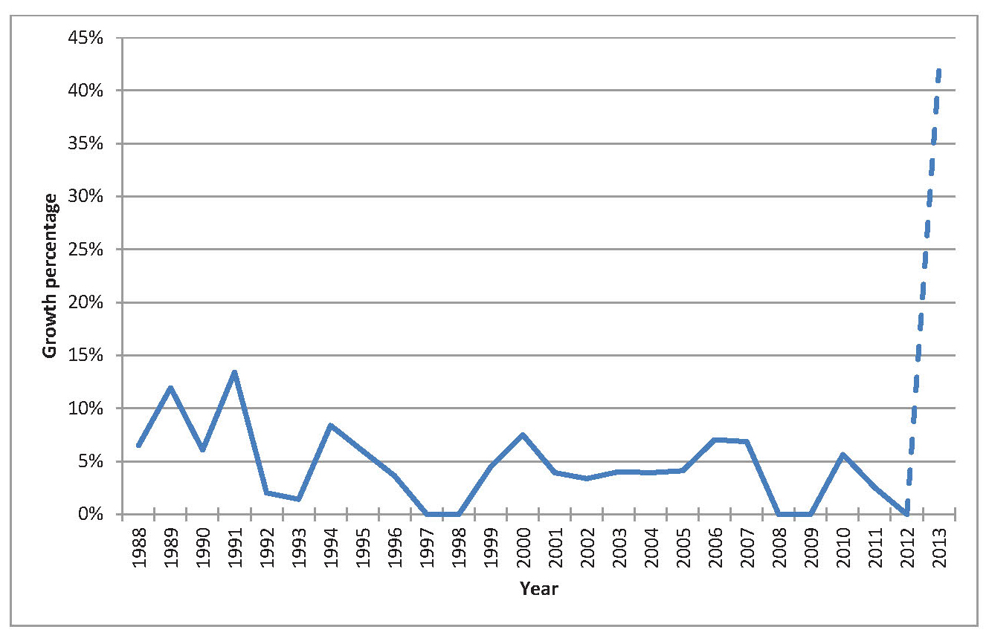
Notes:
- In cases where there was more than one increase in a calendar year, the combined annual effect is plotted.
- The dotted line represents the increase on 1 July 2013 of 41.9% that was later rescinded under the Queensland Independent Remuneration Tribunal Act 2013.

A longer term perspective is provided in Figures 4.3 and 4.4. These figures include data about the base salary back to 1960 and hence these data cover a significant period prior to the introduction of the nexus with Commonwealth member salaries. The dollar value of the base salary of Queensland MP and ministerial salaries from 1960–2013 is presented in Figure 4.3 while the annual changes are presented in Figure 4.4.

Figure 4.3 Salaries of MPs and Ministers of the Queensland Legislative Assembly 1960–2012
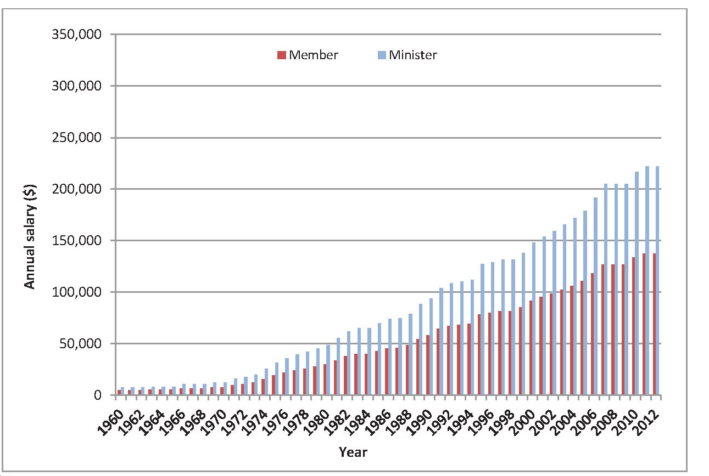
Notes:
- Member salaries provided are backbencher base salaries and exclude additional allowances for participation on Parliamentary Committees or other ancillary roles and responsibilities.
- In years in which more than one salary increase was affected, the figure provided is the salary as at June, or the closest to June.
- Salaries prior to 1963 were converted from pounds as per the then current rate of exchange (approximately $2 to the £1).
- All figures are original, nominal amounts (not adjusted for inflation).

Source: Queensland Parliamentary Library and Research Service (received 15 August 2013).

Figure 4.4 Annual changes in MP and Ministers’ salaries 1960–2012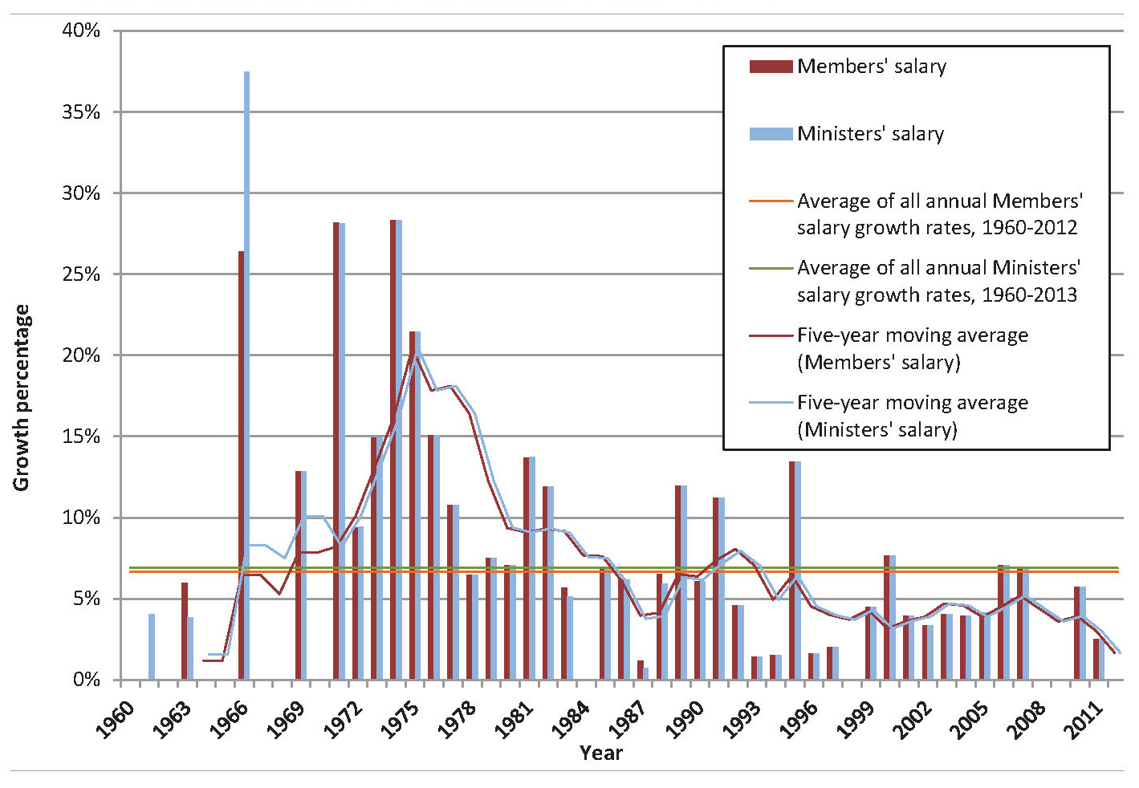
Notes:
- Annual growth calculations based on salaries as at June, or closest to June.
- Percentages are based on nominal figures (not adjusted for inflation).
Source: Queensland Parliamentary Library and Research Service (received 15 August 2013).
Figure 4.4 shows the annual percentage change in base salary. The figure demonstrates that the annual change has been quite volatile over time. The period of the 1960s shows the impact of periodic change. That is, the pattern during the 1960s was for no change over successive years to be followed by a large increase. The most significant increase in percentage terms was in 1966. In addition, the only significant difference in percentage increases between MP base salary and Ministerial salary also occurred in 1966. These 1966 increases followed publication of the Done Report into MP salaries and allowances in November 1965.
The averages in Figure 4.4 reveal the trends over the past 50 years. The long-run average annual growth rate in base salary has been 6.67%. The five-year moving average shows that the annual average growth rate was considerably higher in the 1960s and 1970s before reverting to a trend below the long-run average since the mid-1980s. Further note that the lowest moving average is observed in the most recent time.
The following sections compare the change in base salary with changes in various other wage metrics and benchmarks.
4.3 Comparison to general wage increases
This section provides a comparison of changes in base salary to general wage increases as measured by average weekly earnings. In so doing a relativity is established. Note that the Tribunal does not assert that average weekly earnings is the most appropriate benchmark but rather, it is one relevant benchmark among various alternatives. The measure used to capture average weekly earnings is Average Weekly Ordinary Time Earnings (AWOTE).
Figure 4.5 presents the annual growth in average weekly earnings. It can be seen that there has been significant divergence between the change in base salary and average weekly earnings in certain years (such as 1989, 1991 and 1995) as opposed to a sustained period of divergence between the two rates. Generally, annual changes in base salary were higher than annual changes in average weekly earnings in the early part of the period, with this trend reversed in the later part of the period.
Figure 4.5 Annual changes in MP base salary and average weekly earnings
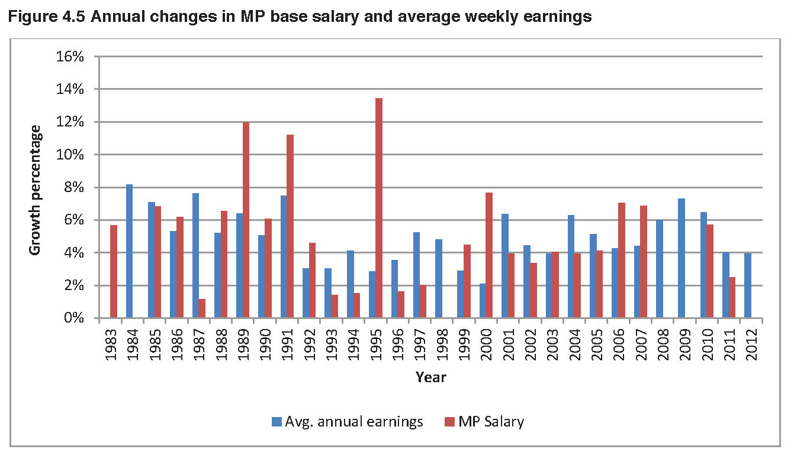
Figure 4.6 presents the cumulative index since 1982 of the base salary with a similarly constructed index derived from changes in average weekly earnings and an index of the Brisbane CPI. The use of a cumulative index allows for a comparison of dollar growth including the effects of compounding.
The cumulative growth in the base salary has been lower than the cumulative growth in average weekly earnings. Since 1983, the average annual growth in average weekly earnings of 5.04% has exceeded the average annual growth in the MP base salary of 4.36%. Further,
the growth in average weekly earnings has significantly exceeded the growth in base salary from 2007–08. Note that growth in both the base salary and average weekly earnings have exceeded the growth in CPI.
Figure 4.6 Cumulative index comparing CPI and average weekly earnings with MP base salary
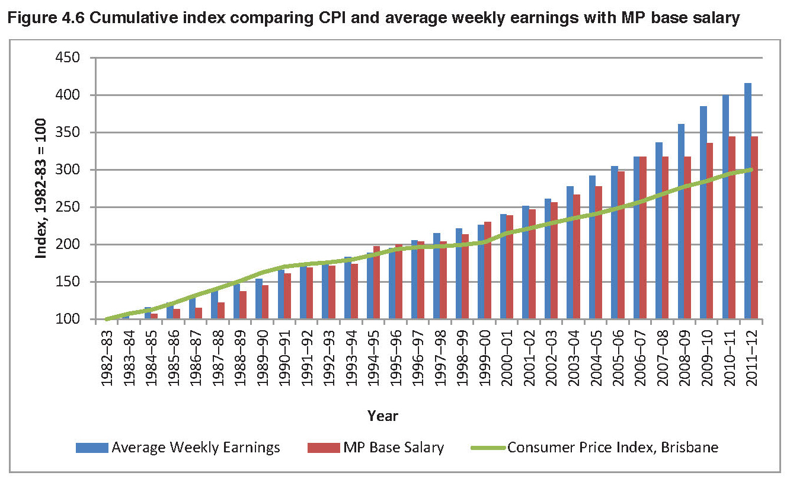
To illustrate the practical impact of the differences in the annual growth rates, one can examine the relative change in value of a notional amount invested at the various growth rates. In recent years the cumulative growth in the base salary has been lower than the cumulative growth in average weekly earnings. For instance, $1,000 in 2005–06 at the average annual growth in average weekly earnings would have a compounded value of $1,438 in 2012–13. In contrast the equivalent amount at the average annual growth rate in base salary would have a compounded value of $1,239.
Figure 4.7 shows the comparative changes in various salary indices. The base salary has been lower than the cumulative growth in the comparison series. This includes comparisons against average weekly earnings and various wage indices relating to the Queensland public service. Of note, is that the cumulative growth in the base salary has fallen behind CPI over this period.

Figure 4.7 Annual changes in MP base salary and other salary indices 2000–13
 |  | Year | MP Salary Increase | Average Weekly Earnings | CPI Increase | Qld Public Service | Qld Core Public Service | SES Remuneration
 |  | 2000-01 | 3.9% | 7.0% | 6.1% |  |  | 3.1%
 |  | 2001-02 | 3.4% | 4.2% | 3.0% |  |  | 3.1%
 |  | 2002-03 | 4.0% | 3.2% | 2.7% |  |  | 4.0%
 |  | 2003-04 | 3.9% | 4.4% | 3.1% | 4.3% | 3.8% | 4.0%
 |  | 2004-05 | 4.1% | 4.6% | 2.5% | 4.2% | 3.8% | 0.0%
 |  | 2005-06 | 7.0% | 5.4% | 4.2% | 6.1% | 4.0% | 4.0%
 |  | 2006-07 | 6.8% | 4.5% | 2.6% | 4.9% | 4.0% | 8.2%
 |  | 2007-08 | 0.0% | 4.0% | 5.1% | 4.0% | 4.0% | 4.0%
 |  | 2008-09 | 0.0% | 5.0% | 2.0% | 4.5% | 4.5% | 2.5%
 |  | 2009-10 | 3.1% | 5.2% | 3.2% | 5.3% | 4.0% | 2.5%
 |  | 2010-11 | 2.5% | 5.1% | 3.9% | 6.1% | 4.0% | 2.5%
 |  | 2011-12 | 2.5% | 4.2% | 0.9% | 2.9% | 0.0% | 2.2%
 |  | 2012-13 | 0.0% | 3.8% | 2.0% | 2.9% | 0.0% | 2.2%
Last | 5 | years (p.a.) | 1.6% | 4.6% | 2.4% | 4.4% | 2.5% | 2.4%
Last | 10 | years (p.a.) | 3.0% | 4.6% | 2.9% | 4.5% | 3.2% | 3.2%
$1,000 indexed since 2005-06 |  |  | $1,239 | $1,438 | $1,264 | $1,433 | $1,271 | $1,315
DATA |  |  | SOURCE
MP Base Salary |  |  | MP Base Salary increase from 1 July in financial year
Average Weekly Earnings |  |  | ABS 6302.0 - Average Weekly Ordinary Time Earnings - Qld ; Persons ; Full Time ; Adult ; Public Sector
CPI |  |  | ABS 6401.0 - Consumer Price Index - All groups CPI; Brisbane
QLD Public Service |  |  | Average Qld Permanent Public Service Salary
QLD Core Public Service |  |  | Wage increases of 'core' government departments and agencies, State Government Departments Certified Agreement (2003, 2006, 2009)
SES Remuneration |  |  | Based on SES Remuneration Scale provided by PSC

4.4 Comparison to selected professions
Chapter 1 previously described the role of an MP and illustrated that in some aspects the role is unique, whilst it also has many attributes similar to other professions. It was concluded that it is the combination of various aspects of the role that makes it unique. Hence, it is difficult to directly compare the work value and salary of an MP to a single occupational benchmark. However, the Tribunal has undertaken a comparison of the salary of an MP to other selected occupations being, Teacher (base), Registered Nurse, Police Constable (first year), District Court Judge and the Auditor-General.
Figure 4.8 compares the annual levels of base salary of an MP with the annual salaries of these occupations from 2001. The figure illustrates that the base salary of an MP has remained in the middle between the salaries of the higher paid District Court Judge and Auditor-General and the salaries of the lower paid professions.
Figure 4.8 Historical salaries of MPs and selected occupations
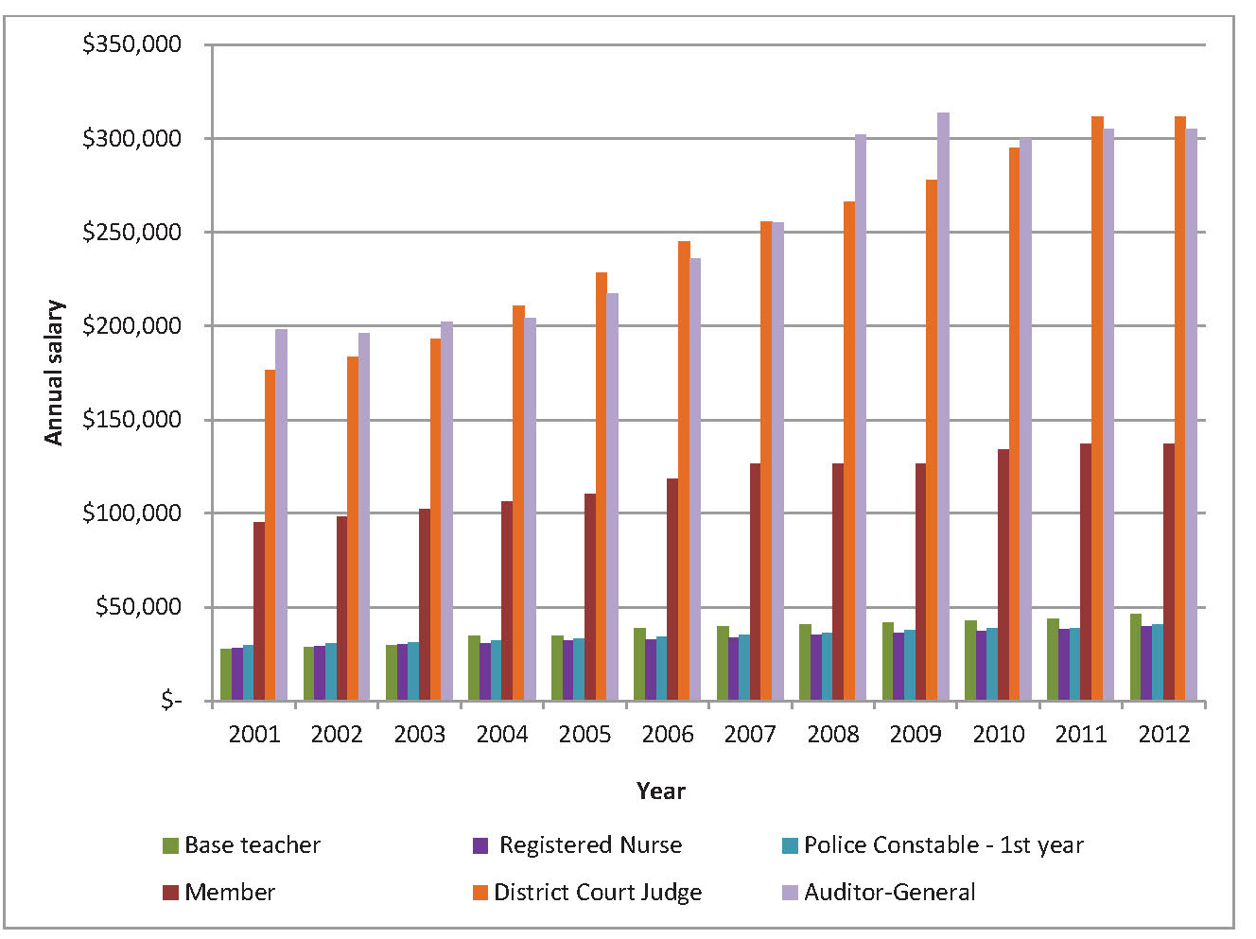Notes:
  - Auditor-General salaries are base salaries as at 30 June only (excluding other allowances, non-monetary benefits, termination payments or additional remuneration). For 2002, 2003, 2005, 2008 and 2009 the Queensland Audit Office Annual Reports identified a base salary range only. Accordingly, figure 4.8 illustrates the average of this broad range provided.
  - District Court judge salaries include all judges other than the Chief Judge of the District Court as at 30 June and are base salaries only (excluding other allowances, non-monetary benefits, termination payments or additional remuneration).
From a visual inspection of Figure 4.8, the relativities between the various salaries appears to have remained fairly constant. However, on closer inspection of individual data points, the relativity of the base salary has generally trended downward. This trend is evident from Figure 4.9 which presents the relative pay multiples of the salaries of the various occupations using the MP base salary as the benchmark. From Table 4.9, the various pay multiples have either remained static or increased over time. Note that an increasing multiple means that the relativity in the salary of the occupation is improving relative to the MP base salary. For instance, the pay multiple for a District Court judge has increased from 1.86 times in 2001 to 2.27 times in 2012. Similarly, the pay multiple for a base teacher has improved from 0.29 times in 2001 to 0.34 times in 2012. The only occupations where the pay multiple has decreased is for a registered nurse and police constable but in these cases the change has been minimal.
Pay multiples (Relative to MP base salary)
 | Base teacher |  | Registered nurse |  | Police constable  (1st year) |  | District Court judge |  | Auditor-General
2001 | 0.29 times |  | 0.30 times |  | 0.31 times |  | 1.86 times |  | 2.08 times
2012 | 0.34 times |  | 0.29 times |  | 0.30 times |  | 2.27 times |  | 2.22 times
Figure 4.9 Pay multiples for MPs and selected occupations
4.5 Comparison to the public sector
As discussed in Chapter 2, many of the public submissions received suggested the public service wages as a benchmark for the base salary. Further, the public service has been suggested as a benchmark in other jurisdictions. For instance, the Egan Associates report into Commonwealth MP remuneration examined a similar benchmark of the senior executive service. Figure 4.10 displays the percentage change each year over the last ten years for the following:
- MP base salary
- Queensland core public service salary
- Average Queensland public service salary
- Public Service salary for SES executives.
The various public service salary indices in Figure 4.10 capture different groups of employees within the Queensland public service. The Average Queensland Public Service salary is the most comprehensive as this index captures total permanent employees across the state. For instance, this index covers employees such as teachers, police officers, nurses and mid-wives, medical officers, health practitioners, ambulance service employees and fire and rescue employees in addition to the core public service. The Queensland Core Public Service salary currently represents around one quarter of the employees represented in the Average Queensland Public Service salary.
Figure 4.10 Comparison of percentage change in MP base salary and public service salaries
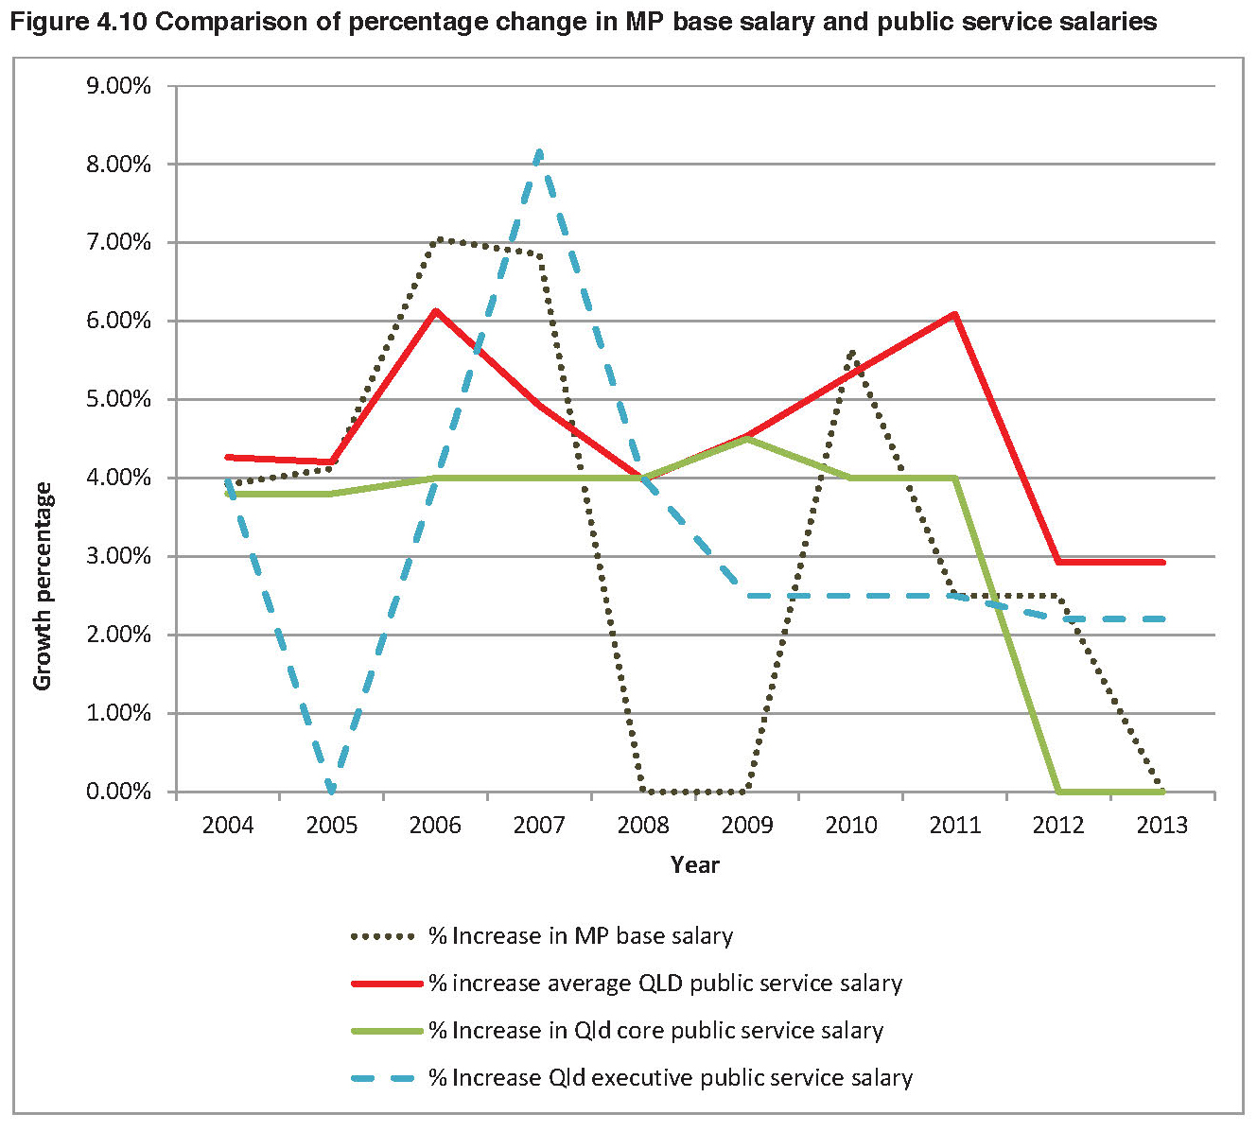
From Figure 4.10 the pattern of changes in MP base salary appear to bear little similarity to changes in any of the public service salary indices. In contrast, the pattern of changes in the various public service salary indices follows a similar trend to each other.
Figure 4.11 presents the information in a different way by showing the cumulative index of changes in MP base salary, public service salaries and the Brisbane CPI. The index covers the previous ten years with 2002–03 being the base year. The inclusion of the CPI provides a benchmark for all the salaries.

Figure 4.11 Cumulative index of changes in MP base salary, public service salaries and Brisbane CPI
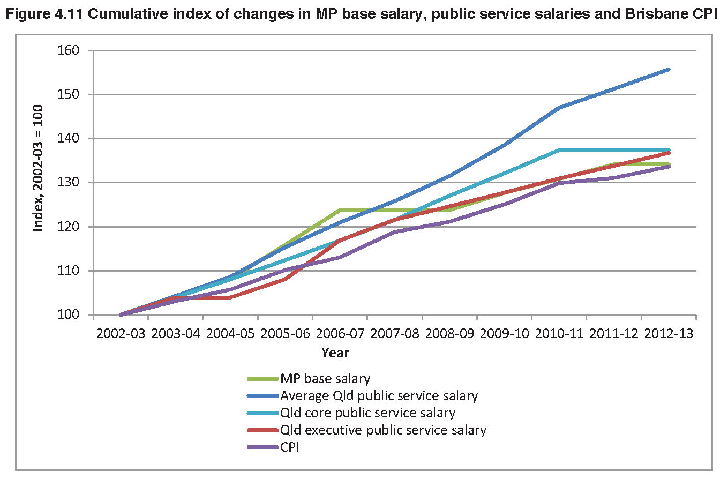
Figure 4.11 illustrates that the growth in MP base salary has been marginally less than the growth in salaries of the executive public service and less than the growth in the core public service salary. Note that these three series largely track to the CPI. However, the major observation from the graph is that the growth in the average public service salary has exceeded the growth in the other indices including MP base salary.
4.6 Comparative salaries from international jurisdictions
Figure 4.12 provides a comparison of Queensland MP base salaries with equivalent base salaries in selected international jurisdictions and the base salary of a Commonwealth MP. The base salaries of MPs in New Zealand and Canada were selected due to similarities with Queensland in relation to their system of government. In particular, New Zealand’s unicameral system is the closest comparison to Queensland’s unicameral structure. New Zealand also has a similar population and number of electorates to Queensland. The amounts in
Figure 4.12 are all in Australian dollars using the exchange rate at 31 July 2013.

The comparison of Queensland with the Commonwealth and the select international jurisdictions is loose because of the lack of equivalence between national policy issues. Egan Associates noted that the roles of a state MP and Commonwealth MP were substantially different and that the two roles should not be directly compared. Specifically, Egan Associates formed the view that state backbench MPs were not an appropriate comparator in work value terms, viz:
…any adjustment to the Commonwealth Parliamentary Backbenchers’ salary should not lead to a direct flow-on to State Parliaments without an equivalent and comprehensive assessment of the role, workload and accountability of Members of State legislatures.
Hence, there should be no large weight placed on the comparison in Figure 4.12, but rather it is a point of note.
Figure 4.12 Salaries of MPs of selected jurisdictions
Jurisdiction | Base annual salary as a backbencher
Queensland (up to 30 June 2013) | $137,149
Commonwealth (from 1 July 2013) | $195,130
New Zealand (from 1 July 2012) | $127,897
Canada (from 1 April 2013) | $172,576

4.7 Comparative salaries from the states and territories
Historically, the Queensland MP base salary has been linked to the Commonwealth MP base salary. In April 1988 legislation was passed to provide that the Queensland MP base salary is $500 less than the base salary of a member of the Australian House of Representatives. Note that the figure of $500 translates to $1,043 in today’s dollar terms. With the passing of the Queensland Independent Remuneration Tribunal Act this year, that nexus between the MP base salary of Queensland and the Commonwealth has now been broken.
For various reasons that relate to differences in roles, the Tribunal concurs with the assessment of Egan Associates and believes that state comparisons are more valid than a comparison with the Commonwealth.
Figure 4.13 provides a comparison of the MP base salary across Australian states and territories. Note that the amounts do not include allowances and entitlements which vary considerably across the states and territories. The base salary levels are those applicable at 1 July 2013 except for Queensland where the base salary at 30 June 2013 is used.

Figure 4.13 Base salary of MPs in Australian states and territories at 1 July 2013
State | Base annual salary of a backbencher
Queensland (at 30 June 2013) | $137,149
New South Wales | $146,251
Victoria | $140,973
Western Australia | $148,638
South Australia | $153,130
Tasmania | $118,466
Australian Capital Territory¹ | $125,259
Northern Territory | $138,953

¹ The ACT Remuneration Tribunal made a determination to not make any changes to base salary from 2012.

The comparison in Figure 4.13 shows that the base salary in South Australia is the highest, although this amount is established with reference to the Commonwealth base salary level. The next highest base salary is Western Australia. The Queensland base salary level is at the lower end of the comparison, exceeded by all the other states except Tasmania.
Given that any singular jurisdiction is subject to its particular circumstances at any one point in time, an alternative is to examine an average across jurisdictions. An average figure mitigates the influence of any one benchmark. Hence, Figure 4.14 compares the base salary of a Queensland MP with the average base salary of the other five states.
An interesting trend emerges from Figure 4.14. Over the past ten years, the relativity between the base salary in Queensland and that of the average of the other states has reversed. In the early part of the period, the base salary in Queensland was higher than the average of the other states, but this difference narrows over time and the relativity is reversed in 2013. Presently, the base salary of a Queensland MP is lower (at 96.9%) than the average base salary of the other states. In dollar terms, this difference translates to $4,342.

Figure 4.14 Queensland MP base salary compared with the average MP base salary of other states
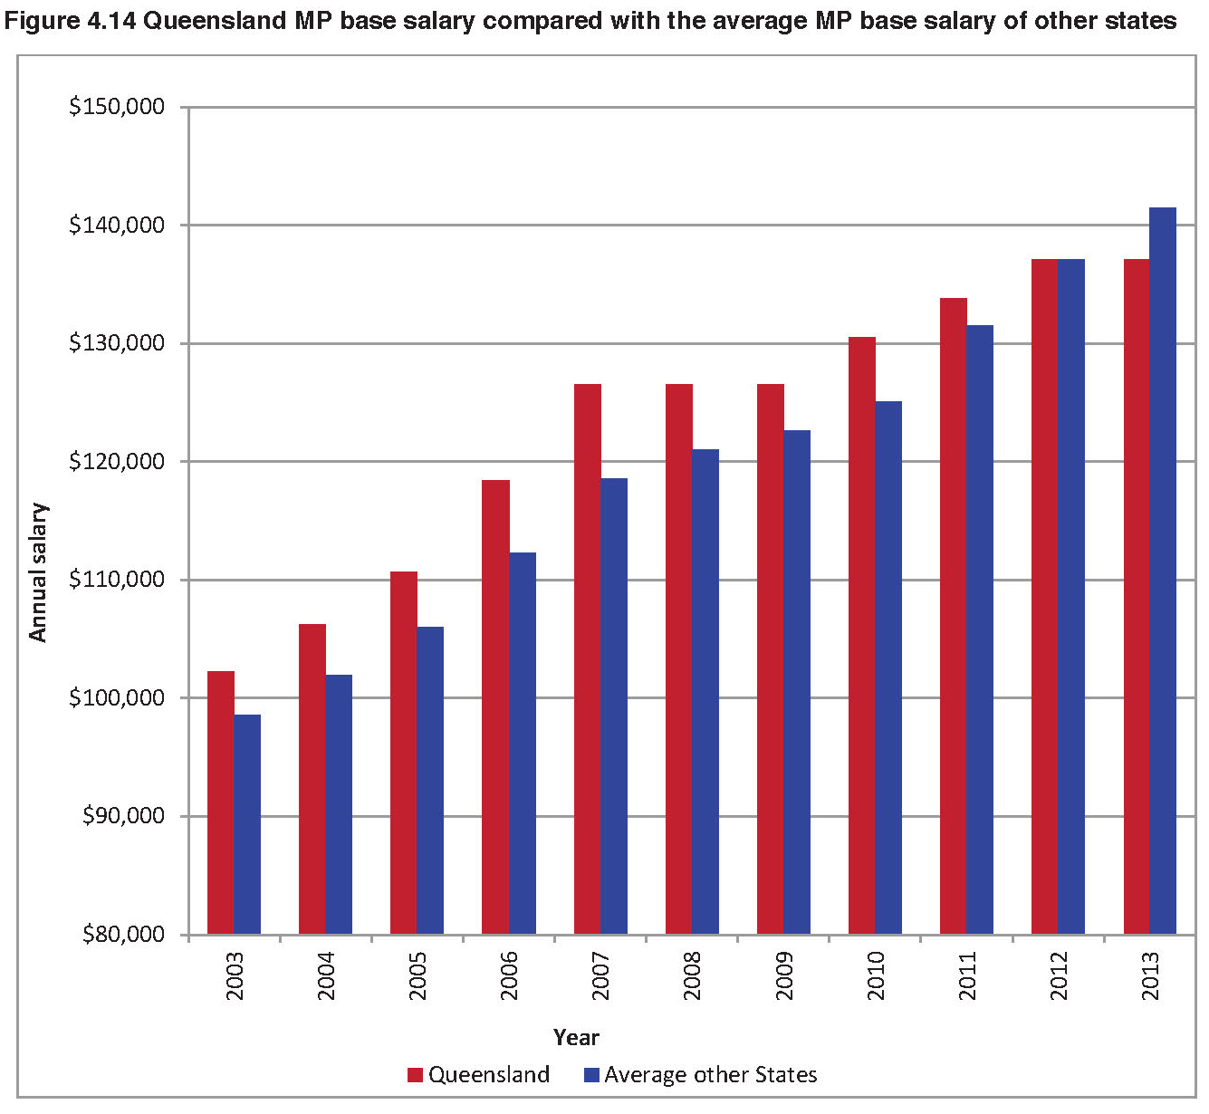
The Tribunal notes that Tasmania has a particularly low base salary rate that presumably reflects the smaller nature of Tasmania, and further notes that South Australia’s base salary is still linked to the base salary of a Commonwealth MP. Hence, these two rates represent the extremes of the other states and as shown in Figure 4.13 South Australia has the highest base salary and Tasmania has the lowest base salary. Accordingly, these two rates are then excluded from the calculation of the average and Figure 4.15 presents the comparison of the base salary in Queensland against the average base salary of New South Wales, Victoria and Western Australia.
Figure 4.15 Queensland MP base salary compared with the average MP base salary of NSW, Vic and WA
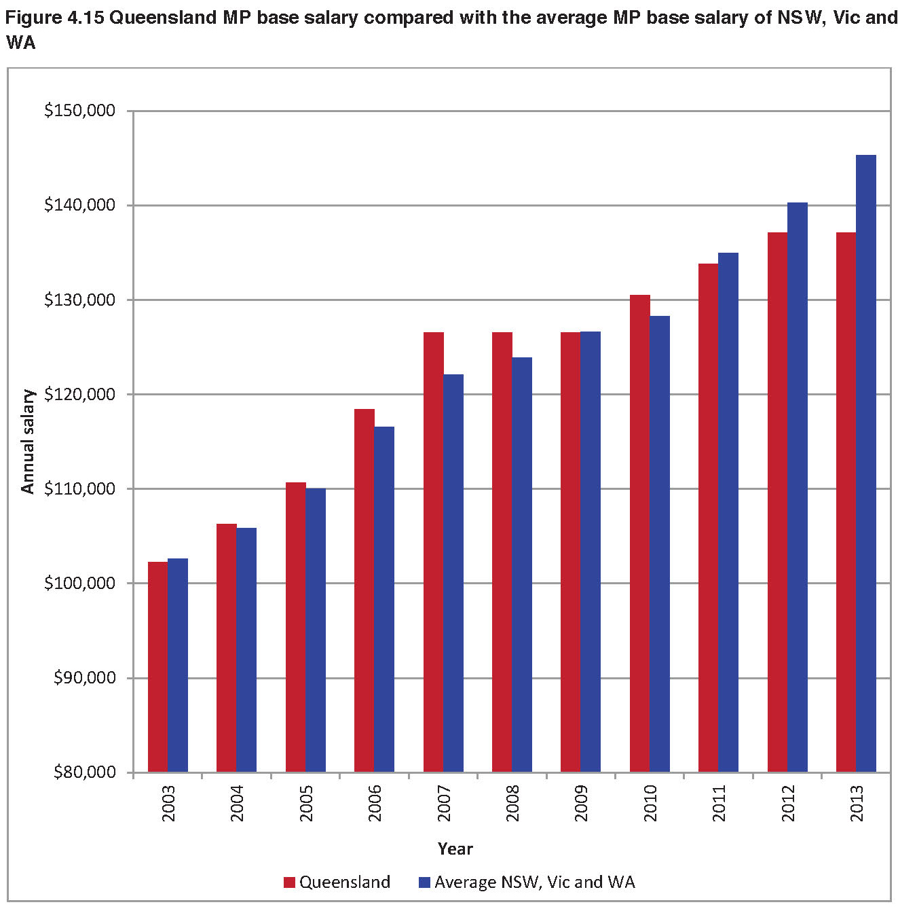
The analysis in Figure 4.15 is consistent with the earlier analysis in Figure 4.14. That is, when South Australia and Tasmania are excluded, the base salary in Queensland exceeded that of the average of the other states in the early part of the period but has fallen below that average by the end of the period. This means that, over the last decade, the base salary in Queensland has decreased in a relative sense compared with the other States. Indeed, the difference becomes larger in the comparison in Figure 4.15 with the base salary in Queensland now falling to 94.4% of the average base salary of New South Wales, Victoria and Western Australia. In dollar terms, this difference is $8,138.

4.8 Summary
The analysis in this chapter extends the discussion in earlier chapters where the Tribunal argued that a holistic examination of the role, functions and responsibilities of a Queensland MP is important. This chapter has provided an historical perspective on changes in the base salary which includes an examination of changes in relativities between the base salary and a range of benchmarks over time. Further, the chapter provided insight on the range of potential quantitative benchmarks.
The historical analysis of changes in base salary reflects a fairly ad hoc pattern over time, perhaps consistent with the lack of a formal framework. The early part of the series is dominated by some spikes especially in the 1960s and 1970s. The long-run average annual growth rate in base salary over the past 50 years, has been 6.67%. The five-year moving average shows that the annual average growth rate was considerably higher in the 1960s and 1970s before reverting to a trend below the long-run average since the mid-1980s. In more recent times since 1983, growth has been moderate and has been quite modest over the past couple of years (excluding the rescinded increase of 1 July 2013).
Chapter 4 has presented a series of comparisons with potential benchmarks. However, in examining the role of an MP, the Tribunal considers that the combination of the individual aspects of an MP’s role, functions and responsibilities is unique compared to other employment roles and professions. Hence, there is no single benchmark that can be applied.
In a general comparison, the cumulative growth in the MP base salary has been lower than the cumulative growth in average weekly earnings. Since 1983, the average annual growth in average weekly earnings of 5.04% has exceeded the average annual growth in MP base salary of 4.36%. Further, the growth in average weekly earnings has significantly exceeded the growth in base salary since 2007–08.
In a specific comparison with select professions, the relativity in the MP base salary has generally trended downward. The various pay multiples of these other professions have either remained static or increased over time.
In relation to public sector benchmarks, the growth in MP base salary has been marginally less than the growth in salaries of the executive public service and less than the core public service salary over the past ten years. However, the growth in the average public service salary has exceeded growth in the MP base salary.
When compared to the equivalent base salary of MPs in other Australian jurisdictions (excluding the Commonwealth system), the base salary level in Queensland is at the lower end of the comparison. At current levels, the base salary in Queensland is exceeded by all the other States apart from Tasmania. Over the past ten years, the relativity between the base salary in Queensland and that of the average of the other states has shifted. In the early part of the period, the base salary in Queensland was higher than the average of the other states, but this difference has reversed over time. Currently, the base salary of a Queensland MP is $8,138 lower than the average base salary of New South Wales, Victoria and Western Australia.
The Tribunal considers that the closest comparator is the base salaries paid to MPs in other states, noting also that many of these salaries are set by independent Tribunals within these jurisdictions, who have no doubt also carefully considered many of the factors that the Queensland Tribunal has had to consider. In addition, the fact that Queensland has a unicameral parliament and the total sitting hours of Queensland MPs within this parliament needs to be taken into account.
Accordingly, the Tribunal concludes that an increase in MP base salary is justified. When the various factors are taken into account, the Tribunal believes a reasonable range for the annual base salary as at 30 June 2013 should have been $140,000 to $150,000. The decision on the exact amount of base salary is provided in the discussion in Chapter 6.

Chapter 5: Allowances and entitlements
Chapter five provides a detailed examination of the current allowances and entitlements system for an MP. What is revealed is an allowance system which has been allowed to develop in ad hoc fashion and which has not been subject to any detailed review for almost 50 years. It is a system in need of modernisation.
5.1 History of allowances and entitlements in Queensland
The current allowance system is largely based on a 1960s and 1970s entitlements framework that could not have contemplated the rapid advances in transport, communications and technology since that time. The system has been subject to ad hoc changes over time reducing its coherence and consistency. Further, there is a wide variation in how entitlements are accounted for, reported upon and administered. The history of allowances and entitlements in Queensland is summarised below.
Under the Constitution Act Amendment Act 1896 travelling allowances were paid to MPs in respect of their journeys from their electorates to sittings of Parliament, being mileage and passage money. However, no MP while receiving an official salary was entitled to receive any payment or allowances under the Act.
In 1951, the Under Secretary of the Chief Secretary’s Department issued a minute stating the position at the time in relation to postage and telephones and deciding to combine the postage and telephone allowances. It was also decided to pay an away from home allowance and a graduated allowance to country MPs required to travel long distances in their electorates.
The Chief Secretary’s Department issued a further minute in December 1952 regarding air travel. The minute approved that MPs representing country electorates would be permitted six return air trips or twelve single air trips per annum. In 1958, Cabinet approved that this be increased to eight return or sixteen single trips each calendar year and in 1961 this was again increased to 24 single air flights for the calendar year.
By 1960 MPs received telephone, postage and additionally, a marginal allowance for metropolitan, provincial cities and country districts based on the electorate area.
A 1961 Committee of Inquiry noted the provision of air warrants for regional members, Gold Rail passes, and allowances for postage and telephone. The Committee recommended that postage, telephone and marginal allowances be combined into one Electorate Allowance based on the size and nature of the electorate. The Electorate Allowance was to be for all expenses ‘properly incurred in the discharge of parliamentary duties’ taking into account postage, telegrams, telephones, transport, a medium priced motor car, accommodation away
from home, and modest entertainment and contributions to charities and other deserving causes. The Committee also noted that MPs could stay in accommodation in the grounds of Parliament House. The recommendations of the 1961 Committee were implemented exactly.
In 1963 a further Committee of Inquiry agreed with the views of the 1961 Committee outlined above. This Committee commented that ‘in assessing allowances, no principle is or can be invoked: the simple question always is, what is the actual expenditure properly incurred in the discharge of parliamentary and electorate duties?’ Subsequently, the Committee recommended an increase in the Electorate Allowance and that country MPs who are unable to secure accommodation at the Lodge (accommodation prior to the Parliamentary Annexe being constructed) receive an allowance per day during parliamentary sessions. These recommendations were also implemented.
Between 1963 and 1965 the number of flights for MPs was increased; the payment of basic rentals on telephones was made; 50% of trunk-line calls and telegraphs on an MP’s private telephone were paid; and the concession to MPs of a certain number of free copies of Hansard was increased.
A subsequent Committee of Inquiry in 1965, the ‘Done Report’ recommended a decrease in electorate allowances of between £45 and £260. Additionally, in relation to allowances to MPs, the Committee recommended that:
- if in the future air warrants were granted for travel between Brisbane and any electorate additional to those electorates entitled to air warrants, a review and reduction of the electorate allowance was to be made
- MP’s for electorates above 2,500 square miles in area were to be allowed air warrants up to a specified limit of between £0 and £300
- each MP would be allowed air warrants for two return flights each financial year to any part of Queensland and while absent from home be allowed a travelling allowance of £5 per day of 24 hours to a maximum of 10 days each financial year
- from the date of issue of the writ until the declaration of the poll when an election was held that no free air travel and travelling allowance be provided
- the Electorate Allowance would be subject to review by Cabinet or an appointed Committee from time to time, rather than being varied automatically.
In 1978 the Auditor-General undertook a Special Report (Audit of the Expenditure of Appropriations to defray the contingencies Air Transport of Members and Allowances to Members (Travelling) in connection with the Legislative Assembly) following allegations of inappropriate claims for MP travel and expenses. The Auditor-General noted in the report that the Legislative Assembly had not adopted legislation setting out the terms and conditions applicable to the expenditure of public funds on air travel and travelling allowances.
Following this report, Cabinet decided to prepare a report recommending that guidelines for MP’s entitlements should be published. A Members’ Entitlements Booklet was first circulated in March 1979. This Booklet provided for certain allowances such as the Electorate Allowance and daily travelling allowance.
Between 1988 and 1992 changes to allowances were decided by Cabinet and authorised by the Governor-in-Council.
In 1998 a Select Committee on Parliamentary Entitlements was appointed to review MPs’ entitlements. No significant changes to entitlements and allowances resulted; however, existing information was clarified and re-organised. It was recommended that The Members’ Salaries, Allowances and Services Handbook be split into a Members’ Entitlements Handbook and a Members’ Office Support Handbook. These two handbooks were gazetted on 18 December 1998.
Between 1998 and 2013 there have been some key changes to the 1998 handbooks, aside from adjustments to the value of allowances and entitlements. The following table summarises these changes.
February 1999 | Change to the ‘purpose and description’ of electorate allowance:  Omitted –  Electorate Allowance is paid to each Member to cover a range of expenses reasonably and necessarily incurred in servicing his/her Electorate.  Inserted –  Electorate Allowance is paid to each Member to cover a range of expenses. It is to be expended at the discretion of the Member. Members are accountable to the Australian Taxation Office for receipt of this income as they are for any other income.
March 2001 | Change to the ‘purpose and description’ of electorate allowance:  Omitted –  Electorate Allowance is paid to each Member to cover a range of expenses. It is to be expended at the discretion of the Member. Members are accountable to the Australian Taxation Office for receipt of this income as they are for any other income.  Inserted –  Electorate allowance is paid to each Member. It is to be expended at the total discretion of the Member. It is treated as part of a Member’s normal income except for superannuation purposes. Members are accountable to the Australian Taxation Office for receipt of this income as they are for any other income.
November 2003 | The name of the Allowance was changed – from Electorate Allowance to Allowance to Members.
2004–05 | The addition of a newsletter/publication ‘allocation’ of $9,000, which was replaced in 2005 with an ‘allowance’ paid directly to Members.  The abolition of postage allowance, newsletter/publication allowance and car allowance.  Removing reference to the provision of mobile telephones to Members, and the introduction of a new ‘Miscellaneous Allowance’ to replace the abovementioned entitlements.
2007 | Introduction of a ‘resettlement allowance’, under certain circumstances, payable to Members not returned or not contesting an election.

The history of allowances and entitlements in Queensland shows the ad hoc development of the current allowance system and reiterates the need for a more comprehensive and holistic framework.
5.2 The allowance system
The current allowance system is outlined in the Members’ Entitlements Handbook (Entitlements Handbook) and the Members’ Office Support Handbook (Support Handbook) currently available at www.parliament.qld.gov.au.
Members’ Entitlements Handbook
The Entitlements Handbook is administered by the Clerk of the Parliament who also has statutory obligations as accountable officer to ensure that financial and administrative activity under the Clerk’s control is in accordance with the law. The Entitlements Handbook is designed to be an informational and operational document detailing benefits and services provided and how these benefits and services are administered by the Parliamentary Service.
The Entitlements Handbook defines a number of key terms for benefits provided which should be considered when discussing the current allowance system (Figure 5.1):
- Salary/Allowances – payments of a dollar value to an MP without substantiation or certification

- Reimbursements – payments of a dollar value to an MP for actual expenses incurred

- Entitlements – a non dollar benefit provided which requires no substantiation or certification by the MP

- Allocations – an amount an MP may draw upon until the amount is extinguished and generally requires some form of certification and/or substantiation.

Figure 5.1 Allowance system
Allowances and Entitlements | - Entitlements take various forms:  - Allowances (payment of pre-set amount without substantiation)  - Reimbursements (payment for personal, substantiated, expense incurred)  - Allocations (limited amounts against which a claim can be made)  - Direct provision (e.g. offices, staff, equipment, consumables).  - Some of these entitlements are like salary, that is  - every MPs receives certain, standard entitlements  - other MPs receive additional entitlements by virtue of their positions.  - There are other entitlements that vary according to other factors for example:  - the size of the MPs electorate  - the location of the MPs electorate (distance from Brisbane).  - Public reporting of expenditure incurred on entitlements is currently limited to just one type of travel (Daily Travelling Allowance).

The current system comprises of allowances and entitlements with administrative arrangements as outlined at Figure 5.2.
Figure 5.2 Summary of the administration of allowances and entitlements
Allowance to Members | The Entitlement’s Handbook provides that the allowance is to be expended at the total discretion of the MP. The allowance is treated as part of an MP’s normal income except for superannuation purposes. MPs are accountable to the Australian Taxation Office for receipt of this income as they are for any other income.
Miscellaneous Allowance | The Entitlement’s Handbook provides that the allowance is to be expended at the total discretion of the MP. The allowance is treated as part of an MP’s normal income except for superannuation purposes. MPs are accountable to the Australian Taxation Office for receipt of this income as they are for any other income.
Special Car Allowance | This allowance is only available to MPs representing 44 of the 89 electorates.  The allowance is provided to cover additional private motor vehicle expenses associated with travel to/from parliament. This allowance is not available to office holders and officials who are supplied with a vehicle by the parliament or the government and that vehicle may be used for travel between parliament and their electorate.
Commercial Air Travel Allocation (Warrants, Connecting Travel and Alternative Travel) | MPs representing 24 regional electorates a large distance from Brisbane, are provided with an allocation of Air Warrants to facilitate air travel from the MP’s electorate to Brisbane and/or return. Each MP who qualifies is issued with 60 air warrants per financial year on 1 July each year. Each air warrant may be exchanged for a one way business class airline ticket, but may not be exchanged for personal credit by the MP.  MPs who receive air warrants may also incur certain connecting travel associated with air warrant travel that is met by the parliament (e.g. taxi travel between Brisbane Airport and Parliament House and vice versa, and commercial transfer service, other than normal taxis, or private motor vehicle usage at public service kilometric rates for direct travel between their electorate and a commercial airport).  MPs who qualify for air warrants may also claim alternative travel. Where an
 | MP wishes to travel between their electorate and Brisbane and scheduled airline services are unsuitable, a claim may be made for use of an MP’s private vehicle (at public service kilometric rates) or a charter flight. One of the MP’s 60 air warrants must be issued by the MP to make an alternative travel claim and if approved the private motor vehicle or air charter travel will only be reimbursed up to the value of the normal business class airfare from the MP’s electorate to Brisbane.
General Travel Allocation | All MPs are able to draw upon an allocation each financial year for travel on parliamentary business within Australia, New Zealand and Papua New Guinea.  The allocation is held on the MP’s behalf by the Clerk of the Parliament and after travel is undertaken as booked through the Parliament House Travel Office the allocation is reduced accordingly.  Any unspent amount of the allocation as at 30 June each year shall be accumulated over the term of the parliament but is not cumulative from one parliamentary term to another.
Daily Travelling Allowance | All MPs are able to claim up to 28 days Daily Travelling Allowance each financial year for travel on parliamentary business.
Flight Within Electorate Allocation | MPs from the 13 electorates which have an area of 6,476 square kilometres or above are able to draw from an allocation each financial year for flights (generally charters) within their electorate on parliamentary business. The amount of the allocation depends on the size of the electorate.  The allocation is held by the Clerk of the Parliament and MP’s claims are reimbursed by the Clerk accordingly.
Home Telephone | Each MP (excluding ministers and the speaker) is reimbursed for the following costs:  • standard base rental on one nominated telephone line; and  • 85% of the cost of all calls on the above telephone line.  Certain parliamentary office holders such as Whips and Political Party Secretaries receive a 100% refund of their home telephone account.  Ministers and the Speaker are entitled to home telephone reimbursement under different provisions (i.e. Queensland Ministerial Handbook and Guidelines for the Financial Management of the Office of the Speaker).
Rail Travel | Each MP is issued with a Gold Pass which entitles the MP to first class rail travel over the railways of Australia. Rail travel may also be undertaken in New Zealand using a pass issued by Railways of Australia.
Optional 4WD vehicle | MPs representing the electorates of Cook, Dalrymple, Gregory, Mount Isa and Warrego have the option of being provided with a four wheel drive vehicle.  The vehicle is fully maintained by the parliament, except for fuel and oil expenses which are to be met by the MP.
Optional motor vehicles | Certain parliamentary office holders (e.g. Deputy Speaker, Government and Opposition Whips, Leader of the House and Leader of a Minor Party) may elect to be provided by the Parliament with a fully maintained motor vehicle. The make and model of the vehicle is determined by the Committee of the Legislative Assembly.
The vehicle is for the use of the office holder at their discretion and may be used by their spouse or electorate office staff. The vehicle is available for private use but must not be used for any commercial or business related purposes, or to display any form of advertising.
If the office holder elects to receive a vehicle then the MP is required to forfeit any special car allowance that may be payable.
Special Postage Allowance | Certain parliamentary office holders (e.g. Government and Opposition Whips, Whips of a Recognised Political Party, the Secretary of the Parliamentary Party in Government, the Secretary of the Official Opposition and the Secretary of a Recognised Political Party) are entitled to a special postage allowance.  The allowance is to cover postage expenses reasonably and necessarily incurred in the conduct of their duties. The financial amount of the allowance varies for each office holder position and is paid at an amount equal to a certain number of basic ordinary letter rate stamps.
Expenses of Office Allowance | Certain office holders (e.g. Premier, Deputy Premier, Ministers, Speaker, Deputy Speaker, Leader of the Opposition, Deputy Leader of the Opposition, Leader of a Recognised Political Party and Leader of a Minor Party) are provided with an Expense of Office Allowance in recognition of the additional duties and responsibilities associated with those positions.  The allowance is varied in accordance with and following any variation to the base salary of a MP. The allowance is paid fortnightly with salary, is subject to PAYE taxation, but is not taken into account for superannuation purposes.
Opposition Spokespersons Allowance | Opposition Spokespersons are provided with an allowance to assist them carry out duties reasonably and necessarily associated with their role as Opposition Spokesperson.  The Leader of the Opposition may nominate up to 16 Opposition Spokespersons, however the Leader of the Opposition and the Deputy Leader of the Opposition may not be nominated.  The amount of the allowance is equal to 7.5% of the annual base salary payable to an MP. The allowance is varied in accordance with and following any variation to the base salary of an MP. The allowance is paid annually in advance on 1 July, it is subject to PAYE taxation, but is not taken into account for superannuation purposes.

Members’ Office Support Handbook
The Support Handbook contains the Electorate and Parliament House Office support provided to MPs. Currently, the administration of the Support Handbook is with the Committee of the Legislative Assembly (CLA) and the Clerk of the Parliament (the Clerk).
The CLA’s role is particularly to set policies to guide the operation of the Parliamentary Service and determine budgets. Similar to the Entitlement’s Handbook the Clerk, as accountable officer, has certain statutory obligations to ensure that financial and administrative activity under his control is in accordance with the law.

Similar to the Entitlement’s Handbook the Support Handbook is designed to be an informational and operational document detailing the benefits and services provided and how these benefits are administered by the Parliamentary Service.
Each MP is provided a single electorate office to support the activities in servicing their electorate. If the electorate is over 100 000 square kilometres another electorate office may be provided if required.
Electorate office equipment, including telephone equipment, is also provided to each MP as outlined in the current Support Handbook. MPs may also order items of stationery and consumables from the Clerk’s store at Parliament House.
In maintaining the electorate office, the Clerk is responsible for the following:
- office leasing/rental
- furnishings
- electricity
- security
- insurance
- signage.
Each MP is responsible for:
- internal office cleaning
- private insurance
- postal boxes.
In relation to staffing, subject to approval from the Clerk, an MP may engage one full time electorate officer and one full time assistant electorate officer to assist the MP in the operation of the electorate office. Where these electorate officers are absent upon approved leave, relieving arrangements are to be made internally within set staffing allocations.
MPs also have access to a range of Hansard publications including receiving one copy of Daily Hansard and electoral roll information. The Support Handbook details the publications MPs are entitled to receive.
The Parliamentary Service also provides services to MPs within the parliamentary precinct such as an office, equipment such as telephones, photocopiers and personal pagers as provided according to policy determined by the CLA, and in some cases overnight accommodation. Currently 80 of the 89 Queensland MPs are provided with overnight accommodation, the number being determined by the existing limited capacity of the Parliamentary Annexe.
5.3 Allowances and entitlements
MPs in Queensland currently receive a number of allowances and entitlements in addition to the electorate office and parliamentary precinct entitlements outlined earlier in this chapter and in the Support Handbook.
Allowance to Members
Depending on the geographical size of the electorate, an MP currently receives between $39,263 and $77,922 as an Allowance to Members, and has discretion in how to expend this allowance. The allowance is varied annually each July in accordance with the variation in the CPI for the previous financial year ending 30 June.
Figure 5.3 Allowance to Members
(taken from Schedule B of the Members’ Entitlements Handbook at 30 June 2013)
Electorate | Allowance
Albert; Algester; Ashgrove; Aspley; Brisbane Central; Broadwater; Buderim; Bulimba; Bundaberg; Bundamba; Burleigh; Cairns; Caloundra; Capalaba; Chatsworth; Clayfield; Cleveland; Coomera; Currumbin; Everton; Ferny Grove; Gaven; Greenslopes; Inala; Indooroopilly; Ipswich; Kallangur; Kawana; Logan; Lytton; Mackay; Mansfield; Maroochydore; Mermaid Beach; Moggill; Morayfield; Mount Coot-tha; Mount Ommaney; Mudgeeraba; Mundingburra; Murrumba; Nudgee; Pine Rivers; Pumicestone; Redcliffe; Redlands; Rockhampton; Sandgate; South Brisbane; Southport; Springwood; Stafford; Stretton; Sunnybank; Surfers Paradise; Thuringowa, Toowoomba North; Toowoomba South; Townsville; Waterford; Woodridge; Yeerongpilly | $39,263
Barron River; Glass House; Hervey Bay; Ipswich West; Mulgrave; Nicklin; Noosa | $43,556
Beaudesert; Burnett; Condamine; Gladstone; Gympie; Hinchinbrook; Keppel; Lockyer; Maryborough; Whitsunday | $47,846
Nanango | $56,443
Burdekin; Callide; Mirani; Southern Downs | $65,032
Cook; Dalrymple; Gregory; Mount Isa; Warrego | $77,922

Home telephone reimbursement
MPs are reimbursed for the cost of certain home telephone expenses. This reimbursement is to help pay the total cost of telephone expenses reasonably and necessarily incurred in servicing the MPs electorate.
MPs, with the exception of Ministers and the Speaker, are reimbursed for standard base rental on one nominated fixed telephone line and 85% of the cost of all calls on the nominated telephone line. Ministers and the Speaker are entitled to home telephone reimbursement under provisions in the Queensland Ministers’ Handbook and the Guidelines for Financial Management of the Office of the Speaker, both of which are outside the scope of the Act.
Miscellaneous allowance
MPs currently receive a miscellaneous allowance of $32,355 and have total discretion in how to expend this allowance. The Miscellaneous Allowance was established in 2005 by amalgamating four allowances (newsletter/publications, car, mobile phone and postage). The allowance is currently varied annually each July in accordance with the variation in the CPI for the previous financial year ending 30 June.
Travel allowances, allocations and entitlements
The intention of the various travel allowances is to enable MPs to facilitate the conduct of Parliamentary business. The travel entitlements (an allocation or dollar amount) are varied annually each July in accordance with the variation in the CPI for the previous financial year ending 30 June.
Where travel includes spouses, the Support Handbook defines a spouse of an MP to include either:
- the married partner of an MP, designated by the MP
- A defacto partner of an MP, designated by the MP
- For an MP that has no partner, a designated relative of the MP.
For domestic travel (within Australia and to and from New Zealand and Papua New Guinea), the travel allowance includes a number of allocations and entitlements.
- General travel allocation – MPs may claim travel on parliamentary business. The travel expenses claimed include, but are not limited to, commercial air travel, charter air travel, short-term car hire, taxis, airline club memberships, airport car parking, and travel insurance. This general travel allocation cannot be used for expenses with the MP’s private motor vehicle. Where a spouse travels with an MP to a community or parliamentary function or is formally invited, their travel can also be met from this allocation.
- Daily travel allocation and allowance – where an MP travels for the primary purpose of conducting Parliamentary business and incurs expenses as a result of overnight absence from the MP’s electorate, a daily travelling allowance may be claimed to meet

expenses such as accommodation, meals, telephone calls (etc. to a maximum allocation of 28 days per annum). If an MP is provided with accommodation in the Parliamentary Annexe they become ineligible to claim this allowance for overnight stays in Brisbane.
- Rail travel entitlement – each MP is issued with a Gold pass entitling them to first class rail travel across Australia. In New Zealand a pass issued by Railways of Australia may also be used. An MP’s spouse is issued with a metal pass entitling the holder to first class rail operated by Queensland Rail and four return or eight single interstate rail trips each financial year.
- Metropolitan MPs’ taxi travel entitlement – MPs representing electorates within the Brisbane metropolitan area receive an additional taxi travel entitlement with costs associated with taxi travel between the Brisbane airport and the MP’s residence met.
- Regional MPs’ travel – MPs of regional electorates are provided with additional compensation for travel expenses associated with travel between their electorate and Brisbane. The regional electorates are divided into four groups with different travel allocations for each group.
- Regional sittings – special arrangements apply if parliament sits outside of Brisbane.
- For overseas travel to conduct parliamentary business, or as a group/delegation representing the Queensland Parliament, MPs are entitled to the following allowances and allocations:
- Daily travel allowance – where an MP has an unexpended balance of the daily travel allocation under domestic travel this may be used for overseas travel to meet overnight expenses such as accommodation, meals and telephone calls.
- Overseas parliamentary trade delegations – MPs may represent the parliament as delegates on overseas parliamentary trade delegations as approved by the Premier. MPs receive a daily allowance to meet the cost of accommodation, meals and incidental expenses.
- Commonwealth Parliamentary Association – annual subscription to the association for MPs is met by the parliament and includes regular newsletters. Attendance at association conferences and seminars are normally attended by a representative of the Queensland Branch of the Association on a rotational basis.
Office holders who are entitled to an additional salary and in some cases an expense of office allowance may also be entitled to additional allowances and entitlements. Refer to the Members’ Entitlements Handbook for more detail on these additional allowances.
A summary of the above allowances and entitlements is provided at Figure 5.4.

Figure 5.4 Allowances and entitlements provided to MPs in dollar terms
(taken from the Members’ Entitlements Handbook at 30 June 2013)
Allowance | Amount per annum
Allowance to MPs | $39,263 – $77,922 (depending on the size of the electorate)
Miscellaneous Allowance | $32,355
Travel Allowances:  General Travel Allocation  Daily Travel Allowance (Domestic)  Daily Travel Allowance (Overseas)  Special car allowance  Flight within electorate allocation | $13,498  $240 – $305 per day (max. 28 days)  $333 per day  $881 – $1,781 as applicable  $1,386 – $18,575 (depending on the size of the electorate)

Figure 5.5 illustrates the CPI adjustments made to relevant MP allowances, based on Brisbane CPI figures from 2002 to 2012. CPI adjustment of MPs’ allowances was delayed approximately six months in 2008 and MPs did not receive a CPI adjustment to allowances at all in 2012. An adjustment has not been made in 2013 pending the Tribunal’s first Determination. Accordingly, MP allowances are not currently in step with CPI as set out in the current Members’ Entitlements Handbook.
Figure 5.5 MP allowances – CPI adjustment compared to Brisbane CPI
Brisbane CPI date | Brisbane CPI  (for preceding 12 months) | Date allowances CPI adjustment was effective from | Percentage of the increase
30 June 2002 | 3.1% | 1 July 2002 | 3.1%
30 June 2003 | 2.7% | 1 July 2003 | 2.7%
30 June 2004 | 3.2% | 1 July 2004 | 3.2%
30 June 2005 | 2.5% | 1 July 2005 | 2.5%
30 June 2006 | 4.1% | 1 July 2006 | 4.1%
30 June 2007 | 2.6% | 1 July 2007 | 2.6%
30 June 2008 | 5.1% | N/A | Nil
30 June 2009 | 2.0% | 1 January 2010 | 2.0%
30 June 2010 | 3.2% | 1 July 2010 | 3.2%
30 June 2011 | 3.8% | 1 July 2011 | 3.8%
30 June 2012 | 0.9% | 1 July 2012 | 0.0%
30 June 2013 | 2.0% | - | -
Note: On 11 December 2008, the Governor in Council approved that the 5.1% CPI increase due on 1 July 2008 not be paid.
Expense of Office Allowance
Certain office holders (e.g. Ministers) are also entitled to an Expense of Office Allowance in recognition of the additional duties and responsibilities associated with the relevant position. Figure 5.6 lists the office holders and the expense of office allowance currently received.
Figure 5.6 Expense of Office Allowance provided to certain office holders
(taken from Schedule F of the Members’ Entitlements Handbook at 30 June 2013)
Office holder | Expense of Office Allowance $
Premier | 19,288
Deputy Premier | 9,085
Other Ministers | 8,701
Speaker | 8,701
Chairperson of Committees | 4,350
Leader of the Opposition | 18,425
Deputy Leader of the Opposition | 6,024
Leader of a Recognised Political Party | 4,350
Leader of a Minor Party | 4,350

5.4 Opposition Spokesperson’s Allowance
The Opposition Spokesperson’s Allowance is provided to Opposition Spokespersons (also referred to as Shadow Ministers) to assist them to carry out their duties. Since 1 January 2010, the amount of the allowance provided is equal to 7.5% of the annual base salary payable to a Queensland MP. Figure 5.7 provides a brief history of this allowance:
Figure 5.7 History of the Opposition Spokesperson’s Allowance
Gazetted | Particulars
26 April 1996 | Allowance first introduced  The old Members’ Salaries, Allowances and Services Handbook was amended to include the following – ‘An Opposition Spokesperson who is nominated is entitled to be paid by the Parliamentary Service an allowance of $5,887 per annum to assist the Member in their duties as an Opposition Spokesperson.’
18 December 1998 | New Members’ Entitlements Handbook was published –administrative arrangements documented  The Purpose and Description and Amount of Allowance stayed the same as in the old Handbook; however, Method of Payment and Administrative Arrangements were outlined to reflect the date annually paid, that PAYE taxation would be withdrawn, and should a Member resign, repayment of unserved portion of the specified period.
5 February 1999 | Clarification inserted in relation to superannuation  Omit – The allowance is paid annually in advance on 1 July.  Insert – The allowance is paid annually in advance on 1 July, it is subject to PAYE Taxation, but is not taken into account for superannuation purposes.
6 October 2006 | Arrangements for election years and repayment in certain circumstances were documented  After ‘The allowance is paid annually in advance on 1 July each year, it is subject to PAYE taxation, but is not taken into account for superannuation purposes’ –  Insert – ‘In the year preceding the date by which a state general election must be held, the allowance will be paid quarterly (in advance)’.  Omit – ‘Where a Member is paid an Opposition Spokesperson Allowance in respect of a specified period and resigns as a Member for the Electoral District before that period elapses, the Member shall be liable to refund such proportion thereof as the unserved portion of the specified period bears to the whole of the specified period’.  Insert – ‘Where a Member is paid an Opposition Spokesperson Allowance in respect of a specified period and ceases to be a Member for the Electoral District before that period elapses, the Member shall be liable to refund the pro rata amount of the allowance from the date the person ceased to be a Member’.
11 December 2009 | The rate changed from a set amount to a % of salary  Omitted – Amount of Allowance $5,887 per annum.  Inserted – Amount of Allowance – With effect on and 1 January 2010, the amount of the Allowance is equal to 7.5% of the annual Salary payable to a Member of the Legislative Assembly.  Inserted – Variation of Allowance – The Allowance is varied in accordance with and following any variation to A Member of the Legislative Assembly’s annual salary rate payable pursuant to the Parliament of Queensland Act 2001.

The Leader of the Opposition may nominate up to 16 Spokespersons, however, the Leader of the Opposition and the Deputy Leader do not receive this allowance as they already receive additional salary attached to their roles. Historically, the Opposition Spokesperson Allowance was compensation for not receiving any additional salary for performing this role.
5.5 Discussion
Legislative requirements
The Tribunal notes that under the Act, the Tribunal is required to ensure that allowances reflect the reasonable expenses incurred by an MP in servicing their electorate and are not a substitute for other remuneration.
The Tribunal notes that the Act does not affect the following entitlements and as such, these have not been considered by the Tribunal:
- accommodation and services in the parliamentary precinct under the Parliamentary Service Act 1988, section 5 (a)
- accommodation and services supplied elsewhere under the Parliamentary Service Act 1988, section 5 (b) for instance, electorate offices, furniture, telephones and staffing support
- entitlements under the Queensland Ministerial Handbook or Queensland Opposition Handbook published by the department in which the Constitution of Queensland 2001 is administered
- entitlements under the Guidelines for the Financial Management of the Office of the Speaker
- entitlements arising out of a national or international arrangement for instance, expenses and travel entitlements for participation in a trade mission.
General comments
Following an examination of the current allowances system and the allowances and entitlements provided to MPs under the Entitlement and Support Handbooks, it is evident that the current system has a number of issues.
The Tribunal notes that there is limited accountability and transparency in relation to allowances, particularly the Members (Electorate) and Miscellaneous Allowances, and that this matter was raised by the majority of public submissions. In developing the new allowance system outlined in section 5.6, the Tribunal has endeavoured to increase the accountability and transparency of allowances and entitlements for Queensland MPs while at the same time ensuring MP’s have flexibility to meet the diverse needs of their electorates.
Currently, for the Members’ Allowance and Miscellaneous Allowance, MPs are not required to report on how these allowances are expended. This lack of reporting has not only resulted in a lack of accountability and transparency, but also in little or data being available to assess what
MPs actually use their allowances for. Following the first year of the operation of the new allowance system the Tribunal will have enhanced data available to accurately assess the expenditure of allowances by MPs.
Many of the allowances and entitlements are outdated. Ad hoc changes have been made to the allowances system with little adjustment made for technological advances and modern day requirements.
In relation to inconsistencies, the Tribunal takes particular note of the Clerk’s advice that:
a) There are inconsistencies in how entitlements are defined (i.e. their purpose):
- Some entitlements are defined quite specifically (i.e. the purpose of the entitlement).
- Other entitlements are not defined at all.
b) There are inconsistencies in how expenditure is accounted for:
Some expenditure against allocations are subject to considerable scrutiny (most travel expenditure) while other expenditure against allowances is not accounted for at all.
  - There is limited flexibility in the use of similar entitlements, particularly in the case of travel entitlements.
c) There are inconsistencies in how expenditure is reported:
- Some expenditure is publicly reported in some detail but most expenditure is not subject to any form of reporting (public or otherwise).
The method by which entitlements and allowances are currently calculated also does not sufficiently take into account the individual circumstances of each electorate or the role of an MP. For instance, a number of allowances are adjusted according to variations in the CPI rather than reflecting the changing needs of individual electorates and their constituents.
The Tribunal is of the view that there are three broad categories of expenses incurred by a Queensland MP in fulfilling their electorate and parliamentary roles being:
- electorate expenses
- information and communication expenses
- travel expenses.
The Tribunal is establishing a new allowance system that aligns with these three categories.
To ensure greater transparency and accountability, any allowances received by MPs should be subject to a level of acquittal and reporting that while accurate and transparent, is not unnecessarily administratively burdensome and is similar to that already required in relation to the Australian Tax Office (ATO).

5.6 A new allowance and entitlement system
The Tribunal have decided to create a new allowance and entitlements system. This system, developed in close consultation with the Clerk and taking into account suggestions received from the public consultation, will provide a contemporary, transparent and accountable framework for MP allowances and entitlements.
Following the Tribunal’s Determination the Members’ Entitlements Handbook and the Members’ Office Support Handbook will cease to exist and will be replaced by a new Members’ Remuneration Handbook, which will reflect the Tribunal’s Determination.
On 1 January 2014 the new system with three new categories of allowances for Queensland MPs will be established. The three categories are:
- Electorate Allowance (i.e. expenditure incurred in supporting their electorate and its constituents)
- Information and Communication Allowance (i.e. expenditure incurred in obtaining and disseminating constituency and legislative information)
- General Travel Entitlement (i.e. expenditure incurred in travelling to conduct electorate and parliamentary business, excluding political party business as currently defined in the Entitlements Handbook, including:
  - Motor Vehicle Allowance
  - General Travel Allocation
  - Commercial Air Travel or Warrant Allocation).
The Tribunal is also establishing new acquittal and reporting requirements for these allowances.
Each of these new allowances, the Electorate Allowance, Information and Communication Allowance and the Motor Vehicle Allowance (contained within the General Travel Entitlement), will be paid in advance on a biannual basis to MPs. MPs will then be required to acquit the allowance to the Clerk within one month of the end of the relevant period.
MPs will be expected to retain all receipts with the exception of any single item under $100. Further, the maximum amount of aggregate un-receipted expenditure that can be incurred in any one biannual period is $1,000.
The Clerk will have responsibility for scrutiny of the individual MP biannual acquittals, reporting this information to the Tribunal as required. The Clerk is also required to table an annual report in parliament.
At the end of each biannual period, up to 10% of the biannual allowance payment that is unexpended for any one allowance may be carried over to the next allowance period, subject to satisfactory acquittal. However, the total amount of carry-over in any given year cannot exceed 10% of the full annual allowance for that year (i.e excluding any carry-over from
previous years). The balance of any unspent allowances remaining on the departure of an MP from Parliament will be dealt with in accordance with the Act.
Figure 5.8 provides an example of the timeline of the new acquittal process for the Electorate Allowance, Information and Communication Allowance and the Motor Vehicle Allowance as part of the General Travel Allocation.
Figure 5.8 New acquittal and reporting system for Electorate Allowance, Information and Communication Allowance and the Motor Vehicle Allowance
Date | Action | Responsible person
1 July  Half Year 1 | The Clerk pays allowance for the following 6 month period | The Clerk
1 January  Half Year 2 | The Clerk pays allowance for the following 6 month period | The Clerk
31 July | MP must provide a certified allowance acquittal to the Clerk for Half Year 1 | MP
1 July  Half Year 3 | The Clerk pays allowance for the following 6 month period less any overpayments of allowances | The Clerk
31 January | MP must provide a certified allowance acquittal to the Clerk for Half Year 2 | MP
30 September | Clerk of the Parliament to table annual report covering the aggregate of Half Years 1 and 2 | The Clerk
Noting the new system to be established, a number of existing allowances and entitlements will be abolished on 1 January 2014. An examination of each of the allowances and entitlements to be abolished shows that these allowances will either be subsumed within one of the three new allowances, or are no longer applicable.
The allowances and entitlements in Figure 5.9 will be abolished on 1 January 2014.

Figure 5.9 Allowances and Entitlements to be abolished on 1 January 2014
Members’ Entitlements Handbook
Handbook section | Allowance/entitlement
2.2.1 | Allowance to Members
2.2.2 | Home Telephone Reimbursement
2.2.3 | Miscellaneous Allowance
2.3.1.2 | Daily Travel Allocation
2.3.1.3 | Rail Travel Entitlement
2.3.1.4 | Metropolitan Members Taxi Travel entitlement
2.3.1.5 GROUP 1 b) | Connecting Taxis and other Travel
2.3.1.5 GROUP 1 c) | Alternative travel reimbursement (for motor vehicles only)
2.3.1.5 GROUP 1 d) | State Functions
2.3.1.5 GROUP 2 a) | Special Car Allowance
2.3.1.5 GROUP 3 a) | Flight Within Electorate Allocation
2.3.1.5 GROUP 4 a) | Conversion of Air Warrants
2.3.1.5 GROUP 4 b) | Optional Four Wheel Drive Vehicle
3.2.3 | Additional travel (for Chairperson of Committees)
Various sections | Optional Motor Vehicle (all abolished)
Various sections | Entertainment expenses (all abolished)
Various sections | Additional Home Telephone Reimbursement (all abolished)
Various sections | Special Postage Allowance (all abolished)
4.2.1 | Alternative travel reimbursement

Members’ Office Support Handbook
Handbook section | Allowance/entitlement
2.3 | Equipment {minor equipment only (Section 55 (b) of the Act 2013 refers}
2.4 | Telephones (for Telecards only)
2.5 | Stationery/consumables
2.6.1 e) | Hansard Publications (‘half electorate speech’ only)
2.6.3 | Acts of Parliament
2.6.4 | Printing of personalised stationery

There are two further allowances that relate to an MP’s role as an office holder that will no longer form part of the new allowance system. The Tribunal intends to review the additional salaries paid to the various office holders as part of its ongoing program of work in 2014. Hence, it would be premature to abolish these allowances without full consideration of the context of additional salaries for office holders. Notwithstanding, the Tribunal gives early notice that these allowances will be abolished on 30 June 2014, at which time it anticipates that a review of officeholders’ additional salaries will be complete and some particular complexities associated with the Opposition Spokespersons’ Allowance will be resolved.
Figure 5.10 Allowances to be abolished on 30 June 2014
Members’ Entitlements Handbook
Handbook section | Allowance/entitlement
3.12 | Oppositions Spokespersons’ Allowance
Various sections | Expense of Office Allowance (all abolished)

5.7 The new Electorate Allowance
The Tribunal notes the importance of an Electorate Allowance to assist each MP to discharge their electorate and constituency responsibilities. As highlighted in public submissions this allowance is considered essential to enable an MP to support their electorate. The majority of submissions took the following view as stated in Chapter 2:
The expense allowances must be maintained to provide the ability to Queensland MPs to represent their electorates. Queensland is a geographically diverse state and allowances should reflect the additional costs associated with representing larger regional electorates. The use of expenses should be discretionary for Queensland MPs, but the details of their expenditure should be published on the Queensland Parliament website. Expenses allowable should include any expenses which relate to assisting the MP in their representation of their electorate.
It is intended that the new Electorate Allowance be used for constituent support including for example, donations, gifts and contributions. The Tribunal, after consultation with the Clerk, considers the following uses of the Electorate Allowance to be appropriate:
- donations (e.g. prizes for school raffles, trophies or prizes for school achievement etc)
- support for constituents (e.g. emergency financial assistance, charitable works)
- support for organisations (e.g. minor financial assistance to schools, clubs, charities, educational institutions)
- patron expenses (e.g. hosting minor hospitality for organisations)
- membership fees (e.g. community groups)
- hosting costs (e.g. providing light refreshments in electorate office or hosting electorate ‘town hall’ meetings)
- gifts (e.g. flowers for funerals or wreaths for ANZAC day).
The Electorate Allowance will be subject to a reporting and acquittal system to foster greater accountability and transparency.
The determination of the rate of the Electorate Allowance has been established using a combination of population and size. It is obvious that a greater population within an electorate will inevitably impose more demands on an MP. In addition large electorates by geographic area are likely to contain decentralised communities resulting in dis-economies of scale. As such there is a need to accommodate differences in both population and geographic size in determining the Electorate Allowance.
The Tribunal has adopted a formula of 60 cents per head of population plus 1.5 cents per square kilometre of electorate to rank all electorates. The 89 electorates have then been grouped into three bands, each of which carries a fixed Electorate Allowance. The assignment of electorates into these bands will be reviewed on a periodic basis as will the appropriateness of the inputs to the formula. It is anticipated that future reviews will be informed by data obtained from the new acquittal and reporting system.
Figure 5.11 outlines the three new Electorate Allowance bands and identifies the band in which each electorate falls.
Figure 5.11 Electorate Allowance amounts and bands
Electorate | ECQ size (km²) | ECQ population
Band 1 – Electorate Allowance of $27,500
Ashgrove | 70 | 44,610
Aspley | 33 | 42,136
Beaudesert | 4,322 | 49,570
Broadwater | 53 | 46,358
Buderim | 85 | 42,048
Bulimba | 31 | 47,605
Bundaberg | 65 | 44,084
Burdekin | 28,344 | 46,195
Burleigh | 32 | 48,338
Burnett | 6,947 | 44,526
Callide | 67,427 | 45,415
Caloundra | 292 | 44,305
Capalaba | 44 | 46,639
Chatsworth | 61 | 48,845
Clayfield | 76 | 46,971
Cleveland | 313 | 47,441
Currumbin | 139 | 46,021
Dalrymple | 105,337 | 47,229
Everton | 37 | 44,705
Ferny Grove | 244 | 44,031
Glass House | 1,582 | 47,219
Greenslopes | 18 | 44,101
Gympie | 3,365 | 45,869
Hervey Bay | 1,813 | 49,058
Hinchinbrook | 8,434 | 45,975
Indooroopilly | 27 | 46,086
Ipswich | 56 | 48,286
Ipswich West | 603 | 49,144
Kallangur | 99 | 47,347
Kawana | 74 | 47,866
Keppel | 3,805 | 49,422
Lockyer | 3,148 | 49,244
Logan | 215 | 47,478
Lytton | 48 | 47,219
Mackay | 63 | 46,612
Mansfield | 78 | 43,214
Maroochydore | 52 | 47,711
Maryborough | 5,869 | 48,587
Moggill | 358 | 45,984
Mount Coot-tha | 29 | 43,807
Mt Ommaney | 30 | 44,517
Mulgrave | 1,664 | 49,871
Mundingburra | 31 | 45,996
Nanango | 13,885 | 48,175
Nicklin | 920 | 44,612
Noosa | 516 | 47,128
Pine Rivers | 411 | 46,756
Redcliffe | 198 | 46,696
Redlands | 206 | 46,465
Rockhampton | 170 | 48,229
Sandgate | 34 | 45,679
South Brisbane | 17 | 49,305
Southern Downs | 30,953 | 47,580
Springwood | 45 | 47,931
Stafford | 19 | 44,427
Sunnybank | 41 | 49,395
Toowoomba North | 112 | 48,818
Toowoomba South | 42 | 48,023
Townsville | 250 | 48,149
Warrego | 279,546 | 41,000
Yeerongpilly | 36 | 47,406
Band 2 – Electorate Allowance of $30,000
Algester | 105 | 51,041
Barron River | 600 | 55,177
Brisbane Central | 18 | 51,355
Cairns | 49 | 56,634
Condamine | 6,054 | 52,320
Cook | 196,805 | 47,665
Gaven | 141 | 55,448
Gladstone | 6,718 | 52,372
Gregory | 327,212 | 44,040
Inala | 58 | 53,018
Mermaid Beach | 29 | 50,624
Mirani | 44,727 | 52,733
Morayfield | 127 | 50,791
Mount Isa | 570,502 | 36,435
Mudgeeraba | 404 | 50,316
Nudgee | 44 | 50,568
Pumicestone | 294 | 51,171
Southport | 34 | 54,409
Stretton | 40 | 53,530
Surfers Paradise | 27 | 51,867
Thuringowa | 374 | 50,376
Whitsunday | 6,073 | 53,461
Band 3 – Electorate Allowance of $34,000
Albert | 235 | 57,635
Bundamba | 178 | 62,109
Coomera | 305 | 58,033
Murrumba | 115 | 56,754
Waterford | 65 | 57,999
Woodridge | 34 | 58,389

5.8 The new Information and Communication Allowance
Obtaining and disseminating information is essential to enable an MP to fulfil their electorate and parliamentary roles. The new Information and Communication Allowance will provide for expenses such as production, publication and distribution, telecommunication, as well as additional staff and equipment costs.
As outlined above, parliament provides MPs with an electorate office, support staff and standard equipment as well as IT networks and computers with basic software for information exchange. This new allowance is in addition to that which is already supplied to MPs under the Parliamentary Service Act 1998.
Figure 5.12 provides a summary of how an MP may use the new Information and Communication Allowance.
Figure 5.12 Information and Communication Allowance
Production, publication and distribution services | e.g. costs such as:  - producing, publishing and distributing hardcopy newsletters and other similar publications  - postage and other delivery costs  - purchasing electronic services including computer software not provided by the Parliamentary Service and costs associated with developing and maintaining websites  - constituency management software
Telecommunications | e.g. home and mobile telephony and data costs
Consumables | e.g. stores and stationery for the electorate office, business cards, personalised stationery expenses
Minor equipment | e.g. minor electorate office equipment costs not provided by the Parliamentary Service
Additional staffing | i.e. additional temporary and casual staffing costs beyond that provided by the Parliamentary Service
Education | e.g. training and development, conference/seminar fees etc
Administrative costs | e.g. book keeping, account keeping, bank charges or other software costs
Incidental office expenses | e.g. office cleaning, confidential document destruction or storage costs
As part of the information provided from current MPs during the public consultation period, the Tribunal noted that one direct mail out via Australian Post to all electorate households’ costs approximately $11,000 in postage and approximately $3,000 in design and printing. Further noting the likely range of other expenses listed in figure 5.12, the Tribunal considers that an annual amount of $34,000 is reasonable for the new Information and Communication Allowance. Future decisions regarding the level of this allowance will be informed by data collected from the new acquittal and reporting system.
5.9 The new General Travel Entitlement
As outlined previously, MPs are currently required to advise the Clerk of all parliamentary travel undertaken. The Clerk, in almost all cases, requires substantiation in the form of a parliamentary business certification that the travel was undertaken for the purposes of parliamentary business.
The new General Travel Entitlement simplifies and streamlines the current arrangements, maintains accountability and brings consistency in the way all travel arrangements are administered.
The new General Travel Entitlement consists of three key allowances/allocations for MPs:
- A Motor Vehicle Allowance (MVA)
- A General Travel Allocation (GTA)
- Commercial Air (Warrant) Travel and Alternative Travel (applicable for MP’s representing certain regional/remote electorates).
The Motor Vehicle Allowance
As discussed earlier an MP is required to service their electorate. The Tribunal recognises that they are expected by the community to attend events and liaise with constituents across their electorate. As such the Tribunal considers it appropriate to standardise the approach in relation to the Motor Vehicle Allowance.
The Tribunal based the new Motor Vehicle Allowance on that currently provided to a Senior Executive Service level two officer in the public service being $25,500 and then increased the Allowance to $32,000 or $40,000 depending on the size of the MP’s electorate.
Figure 5.13 provides the new Motor Vehicle Allowance amounts and bands.
Figure 5.13 Motor Vehicle Allowance amounts and bands
Electorate | ECQ size (km²)
Band 1 – Motor Vehicle Allowance of $25,500
Albert | 235
Algester | 105
Ashgrove | 70
Aspley | 33
Barron River | 600
Brisbane Central | 18
Broadwater | 53
Buderim | 85
Bulimba | 31
Bundaberg | 65
Bundamba | 178
Burleigh | 32
Cairns | 49
Caloundra | 292
Capalaba | 44
Chatsworth | 61
Clayfield | 76
Cleveland | 313
Coomera | 305
Currumbin | 139
Everton | 37
Ferny Grove | 244
Gaven | 141
Greenslopes | 18
Inala | 58
Indooroopilly | 27
Ipswich | 56
Ipswich West | 603
Kallangur | 99
Kawana | 74
Logan | 215
Lytton | 48
Mackay | 63
Mansfield | 78
Maroochydore | 52
Mermaid Beach | 29
Moggill | 358
Morayfield | 127
Mount Coot-tha | 29
Mt Ommaney | 30
Mudgeeraba | 404
Mundingburra | 31
Murrumba | 115
Nicklin | 920
Noosa | 516
Nudgee | 44
Pine Rivers | 411
Pumicestone | 294
Redcliffe | 198
Redlands | 206
Rockhampton | 170
Sandgate | 34
South Brisbane | 17
Southport | 34
Springwood | 45
Stafford | 19
Stretton | 40
Sunnybank | 41
Surfers Paradise | 27
Thuringowa | 374
Toowoomba North | 112
Toowoomba South | 42
Townsville | 250
Waterford | 65
Woodridge | 34
Yeerongpilly | 36
Band 2 – Motor Vehicle Allowance of $32,000
Beaudesert | 4,322
Burnett | 6,947
Condamine | 6,054
Gladstone | 6,718
Glass House | 1,582
Gympie | 3,365
Hervey Bay | 1,813
Hinchinbrook | 8,434
Keppel | 3,805
Lockyer | 3,148
Maryborough | 5,869
Mulgrave | 1,664
Whitsunday | 6,073
Band 3 – Motor Vehicle Allowance of $40,000
Burdekin | 28,344
Callide | 67,427
Cook | 196,805
Dalrymple | 105,337
Gregory | 327,212
Mirani | 44,727
Mount Isa | 570,502
Nanango | 13,885
Southern Downs | 30,953
Warrego | 279,546

The Motor Vehicle Allowance will be subject to acquittal and reporting, in the same manner as the Electorate Allowance and the Information and Communication Allowance.
The General Travel Allocation
The General Travel Allocation will be held by the Clerk to meet the cost of MPs (and spouses, where approved) travelling on parliamentary business within Australia by a range of ground and air transport options. The value of the General Travel Allocation also takes into account the size of the MP’s electorate.
The General Travel Allocation consolidates and incorporates the current Daily Travelling Allowance and Allocation; rail travel; metropolitan taxi travel; connecting taxis and other travel; as well as flight within the electorate. Similar to the Motor Vehicle Allowance the General Travel Allocation also has three bands depending on the size of the MP’s electorate and distance from Brisbane.
In determining the new General Travel Allocation rates, the Tribunal has considered:
- the current use of General Travel Entitlements
- additional compensation that will be needed as a result of incorporating other entitlements into the new General Travel Allocation
- the removal of the current provision for the General Travel Entitlement to be cumulative over the life of the parliament
- the likely impact that remote regional locations have for additional travel requirements.
The Tribunal has decided the General Travel Allocation Bands will commence at $18,360 and then increase to $30,040 or $61,720 depending on the size of the electorate. Figure 5.14 outlines the basis for the new General Travel Allocation, and Figure 5.15 lists electorates in each band.
Figure 5.14 Proposed General Travel Allocation bands
Band | Electorate size | Base GTA amount | Flight within electorate | Daily travel allowance adjustment | Total new GTA
Band 1 | 0 km² – 4,999 km² | $15,000 | Nil | $3,360 | $18,360
Band 2 | 5,000 km² – 99,999 km² | $20,000 | $5,000 | $5,040 | $30,040
Band 3 | 100,000 km² and over | $25,000 | $30,000 | $6,720 | $61,720

Figure 5.15 Electorates in each General Travel Allocation Band
Electorate | ECQ size (km²)
Band 1 – General Travel Allocation of $18,360
Albert | 235
Algester | 105
Ashgrove | 70
Aspley | 33
Barron River | 600
Beaudesert | 4,322
Brisbane Central | 18
Broadwater | 53
Buderim | 85
Bulimba | 31
Bundaberg | 65
Bundamba | 178
Burleigh | 32
Cairns | 49
Caloundra | 292
Capalaba | 44
Chatsworth | 61
Clayfield | 76
Cleveland | 313
Coomera | 305
Currumbin | 139
Everton | 37
Ferny Grove | 244
Gaven | 141
Glass House | 1,582
Greenslopes | 18
Gympie | 3,365
Hervey Bay | 1,813
Inala | 58
Indooroopilly | 27
Ipswich | 56
Ipswich West | 603
Kallangur | 99
Kawana | 74
Keppel | 3,805
Lockyer | 3,148
Logan | 215
Lytton | 48
Mackay | 63
Mansfield | 78
Maroochydore | 52
Mermaid Beach | 29
Moggill | 358
Morayfield | 127
Mount Coot-tha | 29
Mt Ommaney | 30
Mudgeeraba | 404
Mulgrave | 1,664
Mundingburra | 31
Murrumba | 115
Nicklin | 920
Noosa | 516
Nudgee | 44
Pine Rivers | 411
Pumicestone | 294
Redcliffe | 198
Redlands | 206
Rockhampton | 170
Sandgate | 34
South Brisbane | 17
Southport | 34
Springwood | 45
Stafford | 19
Stretton | 40
Sunnybank | 41
Surfers Paradise | 27
Thuringowa | 374
Toowoomba Nth | 112
Toowoomba Sth | 42
Townsville | 250
Waterford | 65
Woodridge | 34
Yeerongpilly | 36
Band 2 – General Travel Allocation of $30,040
Burdekin | 28,344
Burnett | 6,947
Callide | 67,427
Condamine | 6,054
Gladstone | 6,718
Hinchinbrook | 8,434
Maryborough | 5,869
Mirani | 44,727
Nanango | 13,885
Southern Downs | 30,953
Whitsunday | 6,073
Band 3 – General Travel Allocation of $61,720
Cook | 196,805
Dalrymple | 105,337
Gregory | 327,212
Mount Isa | 570,502
Warrego | 279,546

There are currently nine MPs who are not provided with accommodation in the Parliamentary precinct, due to limited capacity. In the interests of equity, MPs who are not provided with overnight accommodation in the Parliamentary Annexe and who make a General Travel Allocation claim for an overnight stay in Brisbane when conducting Parliamentary Business/attending Parliamentary sittings will have such costs met by parliament, but not have that claim charged against their General Travel Allocation.
Commercial Air Travel or Warrant Allocation
For those MPs representing certain regional and remote electorates the current Regional Air Travel (warrant travel) allocations will remain as they are now, and the Alternative Travel arrangements will also largely remain the same apart from the abolition of alternative travel kilometric allowances.

Chapter 6: Discussion
Chapter six brings together the issues discussed in the previous chapters and provides the Tribunal’s rationale for reaching its Determination on the level of MP base salary and the new allowances system.
The chapter also briefly canvasses the issue of additional salaries for office holders and the issue of former MP entitlements, and flags that these matters will be the subject of future review as a part of the Tribunal’s ongoing program of work.
6.1 Base salary
MPs in Queensland currently receive an annual base salary of $137,149 as at 30 June 2013.
Previous chapters have reported on the history of changes in base salary over the past 50 years. There have been no increases in the base salary since August 2011. As such, the Tribunal considers it appropriate to first determine a reasonable base salary level as at 1 July 2013 prior to the determination of any annual increase for 2013–14.
The analysis of the base salary in Chapter 4 concluded that a reasonable range for the base salary for a Queensland MP is $140,000 to $150,000 (at 30 June 2013). In order to determine the exact amount, the Tribunal has considered a number of benchmarks as discussed in Chapter 4. For reasons discussed in that chapter, the Tribunal concluded that no single benchmark is appropriate but rather an holistic approach is required that considers a range of benchmarks. In reaching its decision, the Tribunal has constructed a series of averages and on the basis of this analysis, the Tribunal determines that the base salary as at 1 July 2013 be set at $144,485. The new salary level represents an increase of 5.35% since August 2011.
In relation to the base salary increase for 2013-14, the Tribunal has considered a range of factors and economic indicators. Many of these factors are discussed in Chapter 4. These factors include:
- inflation and price level increases
- average weekly earnings
- Queensland wage indices
- public sector comparisons
- community grant indexation
- projected economic growth
- increases in MP base salary in comparable jurisdictions.
Using these benchmarks, an average series has been constructed for the period 1 July 2013 to 30 June 2014. The applicable rate for this 12 month period is 3.02%. Hence, the Tribunal has decided to apply an increase of 3.02% to the base salary from 1 July 2013.
The net effect of the Tribunal’s Determination of the base salary and percentage increase for
2013–14 results in a total base salary for a Queensland MP of $148,848 applicable from 1 July 2013.
6.2 Additional salaries
As discussed in Chapter 1, many MPs also undertake formal roles within the Queensland Parliament or within the Executive Government. There is formal recognition of several of these roles by the Assembly. Specifically, the Assembly has approved a schedule of ‘office holders and officials: with additional salary payable to those MPs occupying such roles. Further, some of these roles also carry an allowance to cover the expense of the office.
In order to make a determination about the appropriate level of remuneration for office holders and officials, the Tribunal requires a detailed understanding of the nature of such roles. Given the limited time available for this first Determination and in the absence of a detailed consideration of the work value associated with these roles, the Tribunal has deferred the consideration of the relative levels of additional salary.
As such, the Tribunal will review the additional salary payable to office holders and officials as part of its ongoing program of work. In the interim, the Tribunal has determined to maintain the existing salary amounts so not to impose ad hoc changes to the additional salary system. As this work is planned for 2014, the Tribunal has determined to leave the additional salaries at the existing dollar amounts as at 30 June 2013.
Details of the current annual additional salary payable to the office holders and officials are provided in Figure 6.1.
Figure 6.1 Additional salary payable to office holders and officials
Office holder | Annual additional salary $
Member of the:  - Committee of the Legislative Assembly  - Finance and Administration Committee  - State Development, Infrastructure and Industry Committee  - Legal Affairs and Community Safety Committee  - Agriculture, Resources and Environment Committee  - Education and Innovation Committee  - Health and Community Services Committee  - Transport, Housing and Local Government Committee  - Ethics Committee  - Parliamentary Crime and Misconduct Committee | 8,217
Chairperson of the:  - Committee of the Legislative Assembly  - Finance and Administration Committee  - State Development, Infrastructure and Industry Committee  - Legal Affairs and Community Safety Committee  - Agriculture, Resources and Environment Committee | 21,168
- Education and Innovation Committee
- Health and Community services Committee
- Transport, Housing and Local Government Committee
- Ethics Committee
- Parliamentary Crime and Misconduct Committee
Chief Government Whip | 21,168
Senior Government Whip | 16,043
Deputy Government Whip | 8,217
Opposition Whip | 16,043
Assistant Minister | 24,572
Leader of the Opposition | 63,329
Deputy Leader of the Opposition | 32,630
Manager of Opposition Business | 21,168
Leader of a Recognised Political Party | 32,630
Chairperson of Committees | 32,630
Manager of Government Business | 32,630
Assistant Minister and Manager of Government Business | 57,202
Speaker | 63,329
Minister | 84,877
Deputy Premier | 104,287
Premier | 143,499

6.3 The allowances system
As discussed in detail in Chapter 5, allowances provide MPs with the resources necessary to perform their roles, and in doing so, meet community expectations. Allowances have been referred to as ‘tools of trade’ and represent necessary expenses. In contrast, a salary can be thought of as payment for work performed.
In Queensland, an MP is currently entitled to allowances specified in the Members’ Entitlements Handbook and the Members’ Office Support Handbook (the Handbooks). These allowances can be grouped into the following categories:
- Allowance to Members (formerly known as electorate allowance)
- Miscellaneous Allowance
- home telephone reimbursement
- travel allowances, allocations and entitlements.
There are several problems with the current allowances system. The system has developed in an ad hoc manner and has little internal consistency. The changes over time have been incremental and have been embedded in an historical framework. Thus, the current system does not reflect modern society and advances in transport, technology and communication. Further, it system lacks a comprehensive and transparent acquittal process.
The changes to the system outlined in Chapter 5 create three new categories of allowances and entitlements, each with acquittal and reporting requirements. The changes represent a major overhaul of the current system. The Tribunal’s review of the system has identified a large number of current allowances and entitlements that are to be abolished, noting that many of these are incorporated into the new categories of allowances and entitlements.
Given the magnitude of the changes, some time is required to allow the administrative processes to be developed that will support the new system. Further, an education program needs to be developed and rolled out to MPs and electorate staff. These tasks are the responsibility of the Clerk of the Parliament. In consultation with the Clerk, the Tribunal has set the remainder of 2013 as the period of transition, with the new allowances system to be effective from 1 January 2014.
The following allowances and entitlements contained in the Members’ Entitlements Handbook and the Members’ Office Support Handbook will be abolished effective 1 January 2014:
  - Members’ Entitlements Handbook
2.2.1 Allowance to Members
2.2.2 Home Telephone Reimbursement
2.2.3 Miscellaneous Allowance
2.3.1.2 Daily Travel Allocation
2.3.1.3 Rail Travel Entitlement
2.3.1.4 Metropolitan Members Taxi Travel entitlement
2.3.1.5 GROUP 1 b) Connecting Taxis and other Travel
2.3.1.5 GROUP 1 c) Alternative travel reimbursement (for motor vehicles only)
2.3.1.5 GROUP 1 d) State Functions
2.3.1.5 GROUP 2 a) Special Car Allowance
2.3.1.5 GROUP 3 a) Flight Within Electorate Allocation
2.3.1.5 GROUP 4 a) Conversion of Air Warrants
2.3.1.5 GROUP 4 b) Optional Four Wheel Drive Vehicle
3.2.3 Additional travel (for Chairperson of Committees)
Various sections Optional Motor Vehicle (all abolished)
Various sections Entertainment expenses (all abolished)
Various sections Additional Home Telephone Reimbursement (all abolished)
Various sections Special Postage Allowance (all abolished)
4.2.1 Alternative travel reimbursement

  - Members’ Office Support Handbook
2.3 Equipment {minor equipment only (Section 55 (b) of the Act 2013 refers}
2.4 Telephones (for Telecards only)
2.5 Stationery/consumables
2.6.1 e) Hansard Publications (‘half electorate speech’ only)
2.6.3 Acts of Parliament
2.6.4 Printing of personalised stationery
There are two allowances that relate to office holders. These are the Expense of Office and the Opposition Spokespersons Allowance. As noted above, the additional salary payable to office holders will remain at the current dollar value pending a further review by the Tribunal in the first half of 2014. It logically follows that there should not be ad hoc changes to the allowances associated with these positions, rather these allowances should be reviewed in line with the review of the additional salary. Further, there is a practical matter to be resolved that falls outside of the authority of the Tribunal involving the Assembly considering whether it wants to recognise the role of opposition spokesperson as a formal office holder. Hence, these two allowances will remain until 30 June 2014.
The following allowances contained in the Members’ Entitlements Handbook will be abolished effective 30 June 2014:
- 3.12 – Oppositions Spokespersons Allowance
- Various sections – Expense of Office Allowance (all abolished)
The current allowances which are to be abolished will be replaced by a simpler and more transparent system. The new allowances map expenditure with the nature of the activity. The new allowance system involves the creation of three new categories:
    - Electorate Allowance – to be set on the basis of a combination of electorate population and electorate size with electorates allocated into bands. The allocation of electorates into bands will be on the basis of a formula being (60c per head of population) + (1.5c square km of electorate) resulting in an Electorate Allowance of either $27,500, $30,000 or $34,000.
    - Information and Communication Allowance – to be set at $34,000 per MP per year.
    - General Travel Entitlement – which will include:

  - Motor Vehicle Allowance (MVA) based on that currently provided to an SES level 2 officer in the public service ($25,500) to increase to $32,000 or $40,000 depending on the size of an MP’s electorate
  - Commercial Air Travel or Warrant Allocation (and alternate travel options) provided for travel to/from Brisbane by MPs representing certain regional electorates
  - General Travel Allocation (GTA), set at different rates depending on the size of the electorate, to cover the remainder of an MP’s travel requirements as follows:

Band | Electorate size | Total new GTA
Band 1 | 0 km² – 4,999 km² | $18,360
Band 2 | 5,000 km² – 99,999 km² | $30,040
Band 3 | 100,000 km² and over | $61,720
In its review of travel allowances, the Tribunal noted an inequity that relates to overnight accommodation. Many MPs are provided with accommodation in the Parliamentary Annexe when attending Brisbane for Parliamentary sittings and associated business. However a small number of MPs do not have access to accommodation in the Parliamentary Annexe (currently nine MPs) and these MPs are forced to either travel to and from Parliament which in some cases is unreasonable late at night, or pay for their own accommodation within Brisbane. The Tribunal considers that this situation could be rectified at minimal cost.
Effective 15 October 2013, MPs who are not provided with overnight accommodation in the Parliamentary Annexe and make a Daily Travelling Allowance claim for an overnight stay in Brisbane when conducting Parliamentary Business/attending Parliamentary sittings will have such costs met by parliament, but not have that claim charged against their General Travel Allocation.
In relation to acquittals and reporting, the new system provides for a higher level of accountability. The new system requires acquittal and reporting for all items (apart from items below a materiality threshold) across all categories of allowances. This change will require MPs to undertake a greater level of record keeping but one which is no more onerous than that required by the Australian Taxation Office for deductible expense claims or that required by many employers. As the new system will be introduced from 1 January 2014, MPs will be required to implement new record keeping systems from that date.
6.4 Superannuation
From 1948 until December 2004, MPs’ superannuation was provided as a defined benefit through the Parliamentary Contributory Superannuation Fund, which was established under the Parliamentary Contributory Superannuation Act 1970. The superannuation arrangements are currently managed by the QSuper Board of Trustees (QSuper).
Under this fund, MPs were required to contribute 11.5% of their salary to the scheme. These contributions were automatically deducted by the payroll system and remitted to QSuper.
The scheme provided for a lifetime pension upon retirement as an MP provided that the MP was eligible. MPs with over 11 years of service who have left voluntarily, or MPs who have served more than eight years and left involuntarily (e.g. through losing an election or ill health) are eligible for a lifetime pension. Eligible MPs could elect to convert the pension either partially or totally to a lump sum. Annual percentage increases in the pension were linked to the CPI.
In December 2004, the then Parliament closed the defined benefit scheme to new members and a new method of indexation was introduced. Instead of linking increases in the pension to CPI, the pension was linked to the base salary of a sitting MP.
All MPs elected after December 2004 no longer have access to the defined benefit scheme. Rather, these MPs are in a standard public sector arrangement; predominantly an accumulation fund.
The different superannuation arrangements and the numbers within those groups can be summarised as follows:
- There are 60 former MPs in receipt of lifetime pensions with increases linked to the CPI.
- There are 63 former MPs in receipt of lifetime pensions with increases linked to the MP base salary.
- There are 19 sitting MPs elected before 2004 who may be eligible to receive a lifetime pension upon retirement.
- All other sitting MPs (70) are in receipt of superannuation under standard public sector arrangements (through either an accumulation account or lump sum defined benefit account).
It is noted that the changes brought about by the 2004 legislation which affected MPs’ superannuation were not accompanied by any off-setting salary adjustment. The Tribunal also notes that certain former MPs have incurred surcharge tax in the calculation of their pension entitlements. Figure 4.7 in Chapter 4, which compares the growth in value of $1000 over various indices, also shows that since 2005-2006 the pensions of those former members which are linked to the MP base salary have not increased as much as pensions of former members that are linked to the CPI.
The Tribunal notes the effect of changes in the base salary upon the superannuation arrangements of current and former MPs and has decided to make no adjustments in this regard.
6.5 Former MP entitlements
Upon leaving parliament, former MPs may be entitled to ongoing benefits under the Members’ Entitlements Handbook.
Where a former MP meets certain conditions they are entitled to:
- commercial air travel benefits;
- rail travel with a Railways of Australia Gold Pass
- rail travel with a Queensland Rail Gold Pass
- spouse travel for the above.
The Tribunal notes that these entitlements are relatively modest compared to the Commonwealth system and the overall Queensland parliamentary travel budget. For instance,
in 2011–12 the travel claim per eligible former MP was approximately $1,800. Further all these travel claims are subject to public reporting by the Clerk.
Accordingly, given the Tribunal’s other priorities for this review, these entitlements have not formed a part of this review but will be reviewed as part of the Tribunal’s ongoing program of work. However, in order to provide for some certainty and allow for forward planning, any changes to former MP entitlements will not take effect until 1 January 2015.
In addition, where an MP loses their seat a resettlement allowance may be payable if they:
- were elected or returned to the parliament at or since the September 2006 election
- are not able to access a pension or superannuation benefit (related to their service to the parliament) immediately upon ceasing to be an MP (i.e. they are too young)
- have retired involuntarily through defeat at an election or through loss of party preselection for a reason other than misconduct.
For an MP who has served a single term, the resettlement allowance is three months of the base salary. For an MP who has served more than one term, the resettlement allowance is six months of the base salary.
The Tribunal notes that the resettlement allowance will be reviewed together with other former MP entitlements as part of its ongoing program of work.

Determination 1/2013
Preamble
This Determination is issued by the Queensland Independent Remuneration Tribunal (Tribunal) under the Queensland Independent Remuneration Tribunal Act 2013 (the Act).
The Tribunal’s Determination must be read in the context of the entire report, which provides reasons for the Determination as required under the Act. The Determination has been reached after taking a holistic view of MPs’ remuneration that includes a balance between salaries and allowances, consistent with the provisions of the Act. Accordingly, it would not be appropriate to read the specific determinations below without the full context and reference to the reasons for the decisions outlined in the Tribunal’s report.
It is also important to read the Determination as a whole, representing a change to the overall remuneration package of an MP, and not to read each component of the Determination in isolation.
Base Salary
- The base salary for an MP is set at $144,485 effective from 1 July 2013.

- The base salary of an MP is to be increased by 3.02 % of the salary level as stated in paragraph 1 for the 2013–14 financial year, bringing the total base salary to $148,848 effective from 1 July 2013.
Additional Salaries
- The amounts of annual additional salaries shall be maintained at the dollar levels as at 30 June 2013.
Allowances and Entitlements
- The following allowances and entitlements contained in the Members’ Entitlements Handbook and the Members’ Office Support Handbook will be abolished effective
1 January 2014.

  - Members’ Entitlements Handbook
2.2.1 Allowance to Members
2.2.2 Home Telephone Reimbursement
2.2.3 Miscellaneous Allowance
2.3.1.2 Daily Travel Allocation
2.3.1.3 Rail Travel Entitlement
2.3.1.4 Metropolitan Members Taxi Travel entitlement
2.3.1.5 GROUP 1 b) Connecting Taxis and other Travel

2.3.1.5 GROUP 1 c) Alternative travel reimbursement (for motor vehicles only)
2.3.1.5 GROUP 1 d) State Functions
2.3.1.5 GROUP 2 a) Special Car Allowance
2.3.1.5 GROUP 3 a) Flight within Electorate Allocation
2.3.1.5 GROUP 4 a) Conversion of Air Warrants
2.3.1.5 GROUP 4 b) Optional Four Wheel Drive Vehicle
3.2.3 Additional travel (for Chairperson of Committees)
Various sections Optional Motor Vehicle (all abolished)
Various sections Entertainment expenses (all abolished)
Various sections Additional Home Telephone Reimbursement (all
abolished)
Various sections Special Postage Allowance (all abolished)
4.2.1 Alternative travel reimbursement

  - Members Office Support Handbook
2.3 Equipment {minor equipment only (Section 55 (b) of the Act refers}
2.4 Telephones (for Telecards only)
2.5 Stationery/consumables
2.6.1 e) Hansard Publications (‘half electorate speech’ only)
2.6.3 Acts of Parliament
2.6.4 Printing of personalised stationery

All of the above allowances and entitlements will remain until 31 December 2013 (the transitional period).

- The following allowances contained in the Members’ Entitlements Handbook will be abolished effective 30 June 2014:

  - 3.12 Oppositions Spokespersons Allowance
  - Various sections Expense of Office Allowance (all abolished)

The above allowances will remain until 30 June 2014 pending a review of all additional salaries payable to office holders under s. 42 of the Act.

- The following allowances and entitlements are established from 1 January 2014 and are to be subject to an acquittal and reporting system as detailed in the Appendix to the Determination:

  - Electorate Allowance – to be set on the basis of a combination of electorate population and electorate size with electorates allocated into three bands, with an annual allowance ranging from $27,500 to $30,000 to $34,000.

  - Information and Communication Allowance, to be set at $34,000 per MP per year

  - General Travel Entitlement, which shall include:

    - Motor Vehicle Allowance (MVA) based on the size of an MP’s electorate ranging from $25,500 to $32,000 to $40,000;
    - Commercial Air Travel or Warrant Allocation (and alternate travel options) provided for travel to/from Brisbane by Members representing certain regional electorates ; and
    - General Travel Allocation (GTA) set at different rates depending on the size of the electorate, to cover the remainder of an MP’s travel requirements.

- Effective 15 October 2013, MPs who are not provided with overnight accommodation in the Parliamentary Annexe and make a Daily Travelling Allowance claim for an overnight stay in Brisbane when conducting parliamentary business including attending parliamentary sittings will have such costs met by the parliament, but not have that claim charged against their individual General Travel Allocation.

- The Resettlement Allowance will remain. However, this allowance will be reviewed at a later time as a part of the Tribunal’s ongoing program of work.
Former MPs
- The Tribunal notes the effect of changes in the base salary upon the superannuation arrangements of current and former MPs and has decided to make no adjustments in this regard.

- Other entitlements to former MPs are not subject to change at this time but will be reviewed at a later time as part of the Tribunal’s ongoing work program. These entitlements include those that may accrue to current MPs on their departure from their current roles. To provide certainty, any potential changes to former MP entitlements will not take effect until 1 January 2015.

- Existing disqualification provisions regarding former MP entitlements in the Members’ Entitlements Handbook are to remain.
Recommendation
- The Tribunal recommends that the Assembly, by resolution, create another office under section 42 of the Act to provide for additional salary in lieu of the Opposition Spokesperson’s Allowance. The Tribunal recommends that this office commence on 1 July 2014.

Date of Determination: 15 October 2013

_______________________ ___________________ ___________________
Professor Tim Brailsford Ms Joanne Jessop Mr David Harrison
Chair Member Member
Appendix to the Determination
Definition of parliamentary business
For the purposes of the Determination and this Appendix ‘parliamentary business’ may be defined as:
  - Sittings of the Legislative Assembly or direct travel of the Member to or from such sittings
  - A meeting of a parliamentary committee, or attending a meeting, conference or seminar or other business relating to such a parliamentary committee, of which he/she is a member or the member’s direct travel to or from such an event
  - Attendance at a function, conference, meeting or seminar representing a Minister, the Speaker, Leader of the Opposition or Leader of other Party on official business as such office-bearer or direct travel to or from such an event
  - A meeting of the member’s parliamentary or political party or policy formulation body, of its executive or of one of its committees or the member’s direct travel to or from such a meeting
  - Attendance at official government, parliamentary or vice-regal functions
  - Attending to business (including attending conferences, functions, meetings or seminars) outside a member’s electorate, directly relating to a member’s electorate
  - Attending to business directly related to a matter of current parliamentary debate or addressing conferences, meetings and seminars to which a member has been invited in his/her capacity as a Member of Parliament
  - Attending to business directly related to the subject matter of a parliamentary party committee to which the member belongs
  - Attending to business related to the member’s current responsibilities as non-government spokesperson for the Ministerial portfolio
  - Studies, investigations, or inquiries on matters related to duties and responsibilities as a Member of Parliament (including addressing or attending conferences, meetings, functions or seminars) provided that the nature, official purpose, place and other relevant information is stated by the member to identify the parliamentary business involved
  - Travel by Leader of the Opposition, Leader of a Recognised Political Party or Leader of a Minor party in the Legislative Assembly for the purpose of campaigning during an ‘official election campaign period’.

Electorate Allowance
Purpose
The Electorate Allowance is provided to cover a range of expenditure in providing constituent assistance and service in the electorate.
Examples may include:
Donations | e.g. prizes for school raffles, trophies or prizes for school achievement etc.
Support for constituents | e.g. emergency financial assistance, charitable works
Support for organisations | e.g. minor financial assistance to schools, clubs, charities, educational institutions
Patron expenses | e.g. hosting minor hospitality for organisations
Membership fees | e.g. community groups
Hosting costs | e.g. providing light refreshments in electorate office or hosting electorate ‘town hall’ meetings
Gifts | e.g. flowers for funerals or wreaths for ANZAC Day

Timing of payment
Members will receive the allowance on a biannual basis, in advance on 1 July and 1 January each year and acquit expenditure against the allowance on a biannual basis within one month of the end of each six month period (i.e. by 31 July and 31 January).
Responsibility of Members
Members are personally responsible for ensuring that their expenditure and use of the Electorate Allowance is within the parameters of the entitlement. All expenditure must be related to constituent assistance and service in the electorate.
Expenditure related to the following purposes is not permitted:
- Private or commercial purposes
- Political party activity
- Electioneering/campaigning purposes
Members in doubt of the validity of any expense should take proactive steps to clarify the eligibility of the expense prior to its incurrence with the Clerk or their delegate.
Acquittal system
This allowance is an allowance subject to section 57(1) of the Act. That is, it is an allowance paid on condition that the member accounts for the expenditure of the allowance to the Clerk.
The Clerk will develop a proforma schedule template for the acquittal, which will then be completed and certified (signed) by each member and submitted to the Clerk.
Any over-expenditure of the allowance must be borne by the member personally.
Any under-expenditure in excess of the prescribed carry-over (see below) is deemed an overpayment of the original allowance and will be dealt with in accordance with section 57(3) of the Act. To avoid any doubt under-expenditure will be deducted from future allowances.
Carry-over
Up to 10% of the total allowance for each period that is unexpended is able to be carried over to the next allowance period. The total amount of carry-over in any given year cannot exceed 10% of the total Electorate Allowance payment for that year (i.e. excluding any carry-over from previous years).
Audit
Each year, the Clerk will conduct a sample, random audit of acquittals and supporting documentation to test compliance. The audit will require members to substantiate individual expenditure items under each allowance category. Receipts will be required for all expenditure transactions in excess of $100.00. In any given period, transactions unsubstantiated with a receipt (i.e. transactions less than $100.00 with no receipts) must total no more than $1,000.
Reporting system
The Clerk will develop a proforma schedule template for the acquittal, which will then be completed and certified (signed) by each member and submitted to the Clerk. The schedule will be certified by the member (signed) and must include the following particulars:
- the name of the member
- total expenditure incurred during the reporting period under nominated categories
- total allowance provided
- any carry-over from the previous period and any carry forward to the next period
- any variance between the allowance provided and actual expenditure incurred against the allowance
- the amount of the allowance, if any, not carried forward and to be repaid.
The Clerk must provide an annual report to parliament within three months of the end of the second biannual period which contains information on all expenditure incurred by each member against the Electorate Allowance.
A sample report to be tabled in parliament is included below.
SAMPLE OF SUMMARY SCHEDULE FOR EACH MEMBER FOR ANNUAL REPORT
TO BE TABLED IN PARLIAMENT
This sample is presented as an example only. Individual entries are presented to aid in interpretation of the design and amounts are not intended to reflect actual expenditure that may be incurred for such entries.
ANNUAL REPORT OF EXPENDITURE
ELECTORATE ALLOWANCE
Schedule of Electorate Allowance expenditure for the period 1 July 2014 to 30 June 2015
Member name : J. BLOGGS Electorate: Plaza Park
ELECTORATE ALLOWANCE – EXPENDITURE BY CATEGORY
DONATIONS | SUPPORT FOR CONSTITUENTS | SUPPORT FOR ORGANISATIONS | PATRON EXPENSES | MEMBERSHIP FEES |  | HOSTING COSTS | GIFTS | TOTAL EXPENDITURE FOR THE PERIOD
$7,000 | $2,000 | $2,500 | $1,000.00 |  | $500.00 | $200 | $1,600 | $14,800

ELECTORATE ALLOWANCE – RECONCILIATION
TOTAL EXPENDITURE FOR THE PERIOD | CARRY-OVER FROM PREVIOUS PERIOD  (Up to 10% of previous period allowance) | ALLOWANCE FOR THE PERIOD | TOTAL ALLOWANCE FOR THE PERIOD | VARIANCE | CARRY-OVER TO NEXT PERIOD | REDUCTION IN FUTURE PAYMENT
$14,800 | $1,650.00 | $16,500 | $18,150 | $3,350 | $1,650 | $1,700
Notes
- Any over-expenditure of the allowance must be borne by the Member.
- Any under-expenditure in excess of the prescribed carry-over (see below) is deemed an overpayment of the original allowance and will be dealt with in accordance with section 57(3) of the Act.
3. Up to 10% of the total annual allowance if unexpended can be carried over to the next financial year.
I certify that the above summary is a true and correct record of the expenditure of the electorate allowance and that receipts for all expenditures above $100.00 are held by me for audit purposes.

Member of the Legislative Assembly (signature)

Information and support systems
The Clerk will establish information and administrative systems to facilitate the biannual acquittal process and communicate with members regarding their obligations in this regard.
Information and Communication Allowance
Purpose
The Information and Communication Allowance is provided to members for the purpose of obtaining information and disseminating information to constituents and incidental matters relating to operating the electorate office.
Examples of expenditure may include:
Production, publication and distribution services | e.g. costs such as:  - producing, publishing and distributing hardcopy newsletters and other similar publications  - postage and other delivery costs  - purchasing electronic services including computer software not provided by the Parliamentary Service and costs associated with developing and maintaining websites  - constituency management software
Telecommunications | e.g. home and mobile telephony and data costs
Consumables | e.g. stores and stationery for the electorate office, business cards, personalised stationery expenses
Minor equipment | e.g. minor electorate office equipment not provided by the Parliamentary Service
Additional staffing | i.e. additional temporary and casual staffing costs beyond that provided by the Parliamentary Service
Education | e.g. training and development, conference/seminar fees etc.
Administrative costs | e.g. book keeping, account keeping, bank charges or other software costs
Incidental office expenses | e.g. office cleaning, confidential document destruction or storage costs
Timing of payment
Members will receive the allowance on a biannual basis, in advance on 1 July and 1 January each year and acquit expenditure against the allowance on a biannual basis within one month of the end of each six month period (i.e. by 31 July and 31 January).
Responsibility of Members
Members are personally responsible for ensuring that their expenditure and use of the Information and Communication Allowance is within the parameters of the entitlement. All expenditure must be related to parliamentary or constituency purposes.
Expenditure related to the following purposes is not permitted:
- Private or commercial purposes
- Electioneering/campaigning purposes
- Political party activity (the exception being constituency software purchased from the member’s party).
Members in doubt of the validity of any expense should take proactive steps to clarify the eligibility of the expense prior to its incurrence with the Clerk or their delegate.
Acquittal system

This allowance is an allowance subject to section 57(1) of the Act. That is, it is an allowance paid on condition that the member accounts for the expenditure of the allowance to the Clerk.
The Clerk will develop a proforma schedule template for the acquittal, which will then be completed and certified (signed) by each member and submitted to the Clerk.
Any over-expenditure of the allowance must be borne by the member personally.
Any under-expenditure in excess of the prescribed carry-over (see below) is deemed an overpayment of the original allowance and will be dealt with in accordance with section 57(3) of the Act. To avoid any doubt under-expenditure will be deducted from future allowances.
Carry-over

Up to 10% of the total allowance for each period that is unexpended is able to be carried over to the next allowance period. The total amount of carry-over in any given year cannot exceed 10% of the biannual payment for the previous period (i.e. excluding any carry-over from previous periods).
Audit
Each year, the Clerk will conduct a sample, random audit of acquittals and supporting documentation to test compliance.

The audit will require members to substantiate individual expenditure items under each allowance category. Receipts will be required for all expenditure transactions in excess of $100.00. In any given period, transactions unsubstantiated with a receipt (i.e. transactions less than $100.00 with no receipts) must total no more than $1,000.
Reporting system
The Clerk will develop a proforma schedule template for the acquittal, which will then be completed and certified (signed) by each member and submitted to the Clerk.

The schedule will be certified by the member (signed) and must include the following particulars:
- the name of the member
- total expenditure incurred during the reporting period under nominated categories
- total allowance provided
- any carry-over from the previous period and any carry forward to the next period
- any variance between the allowance provided and actual expenditure incurred against the allowance
- the amount of the allowance, if any, not carried forward and to be repaid.
The Clerk of the Parliament must provide an annual report to the parliament within three months of the end of the second biannual period which contains information on all expenditure incurred by each member against the Information and Communication Allowance.
A sample report to be tabled in parliament follows.

SAMPLE OF SUMMARY SCHEDULE FOR EACH MEMBER FOR ANNUAL REPORT TO BE TABLED IN PARLIAMENT
This sample is presented as an example only. Individual entries are presented to aid in interpretation of the design and amounts are not intended to reflect actual expenditure that may be incurred for such entries.
ANNUAL REPORT OF EXPENDITURE
INFORMATION AND COMMUNICATION ALLOWANCE
Schedule of Information and Communication Allowance expenditure for the period 1 July 2014 to 30 June 2015
Member name : J. BLOGGS Electorate: Plaza Park
COSTS
Production/ Publication/ Distribution | Telecommunications | Educational &  informational | Other (e.g. temp staffing, support costs)
$30,300 | $3,000 | $1,000 | $1,700

INFORMATION AND COMMUNICATION ALLOWANCE – RECONCILIATION
TOTAL EXPENDITURE FOR THE PERIOD | CARRY-OVER FROM PREVIOUS PERIOD  (Up to 10% of previous period allowance) | ALLOWANCE FOR THE PERIOD | TOTAL ALLOWANCE FOR THE PERIOD | VARIANCE | CARRY-OVER TO NEXT PERIOD | REDUCTION IN FUTURE PAYMENT
$36,000 | Nil | $34,000 | $34,000 | $2,000 | Nil | $2,000
Notes
      - Any over-expenditure of the allowance must be borne by the Member.
      - Any under-expenditure in excess of the prescribed carry-over (see below) is deemed an overpayment of the original allowance and will be dealt with in accordance with section 57(3) of the Act.
      - Up to 10% of the total annual allowance if unexpended can be carried over to the next financial year.

I certify that the above summary is a true and correct record of the expenditure of the Information and Communication Allowance and that receipts for all expenditures above $100.00 are held by me for audit purposes.

Member of the Legislative Assembly (signature)

Information and support systems
The Clerk will establish information and administrative systems to facilitate the biannual acquittal process and communicate with members regarding their obligations in this regard.
Motor Vehicle Allowance
Purpose
The Motor Vehicle Allowance is provided to cover expenditure incurred in acquiring and maintaining a member’s vehicle or equivalent for electorate work.
Examples may include depreciation or leasing costs as well as operating costs (e.g. fuel, oil, tyres, maintenance, registration, insurance, repairs, cleaning etc).
Ownership and use
A motor vehicle purchased or leased with the assistance of this allowance is not the property of the parliament. Any vehicle acquired or maintained using this allowance may not be used for commercial or business related purposes. Any use for personal purposes may have tax implications and added cost for members. In appropriate circumstances the allowance may be used by electorate office staff acting on behalf of and with the explicit approval of the member.
Acquisition costs
Where a member chooses to purchase a motor vehicle outright, a member may claim depreciation on the vehicle in the same manner as permitted under Australian Taxation Office rules. Any accelerated depreciation available under tax rules may also be claimed. If a member takes out a loan to purchase the motor vehicle, fees and interest costs on that loan may also be claimed. Members should seek independent financial/tax advice as appropriate.
Timing of payment
Members will receive the allowance on a biannual basis, in advance on 1 July and 1 January each financial year and acquit expenditure against the allowance on a biannual basis within one month of the end of each six month period (i.e. by 31 July and 31 January).
Responsibility of Members
Members are personally responsible for ensuring that their expenditure and use of the Motor Vehicle Allowance is within the parameters of the entitlement. All expenditure must be directly related to the Member’s vehicle.
Members in doubt of the validity of any expense should take proactive steps to clarify the eligibility of the expense prior to its incurrence with the Clerk or their delegate.
Acquittal system
This allowance is an allowance subject to section 57(1) of the Act. That is, it is an allowance paid on condition that the member accounts for the expenditure of the allowance to the Clerk.
The Clerk will develop a proforma schedule template for the acquittal, which will then be completed and certified (signed) by each member and submitted to the Clerk.
Any over-expenditure of the allowance must be borne by the member personally.
Any under-expenditure in excess of the prescribed carry-over (see below) is deemed an overpayment of the original allowance and will be dealt with in accordance with section 57(3) of the Act. To avoid any doubt under-expenditure will be deducted from future allowances.
Carry-over
Up to 10% of the total allowance for each period that is unexpended is able to be carried over to the next allowance period. The total amount of carry-over in any given biannual period cannot exceed 10% of the principle allowance payment for that biannual period (i.e excluding any carry-over from previous biannual period).
Audit
Each year, the Clerk will conduct a sample, random audit of acquittals and supporting documentation to test compliance.
The audit will require members to substantiate individual expenditure items under each allowance category. Receipts will be required for all expenditure transactions in excess of $50.00. In any given period, transactions unsubstantiated with a receipt (i.e. transactions less than $50.00 with no receipts) must total no more than $500.
Reporting system
The Clerk will develop a proforma schedule template for the acquittal, which will then be completed and certified (signed) by each member and submitted to the Clerk.
The schedule will be certified by the member (signed) and must include the following particulars:
- the name of the member
- total expenditure incurred during the reporting period under nominated categories
- total allowance provided
- any carry-over from the previous period and any carry forward to the next period
- any variance between the allowance provided and actual expenditure incurred against the allowance
- the amount of the allowance, if any, not carried forward and to be repaid.
The Clerk of the Parliament must provide an annual report to parliament within three months of the end of the second biannual period which contains information on all expenditure incurred by each member against the Motor Vehicle Allowance.
A sample report to be tabled in parliament follows.

SAMPLE OF SUMMARY SCHEDULE FOR EACH MEMBER FOR ANNUAL REPORT
TO BE TABLED IN PARLIAMENT
This sample is presented as an example only. Individual entries are presented to aid in interpretation of the design and amounts are not intended to reflect actual expenditure that may be incurred for such entries.
ANNUAL REPORT OF EXPENDITURE
MOTOR VEHICLE ALLOWANCE
Schedule of Motor Vehicle Allowance expenditure for the period 1 July 2014 to 30 June 2015
Member name : J. BLOGGS Electorate: Plaza Park
MOTOR VEHICLE ALLOWANCE CATEGORY
ACQUISITION (depreciation) | LEASING | FUEL | REPAIRS | INSURANCE | REGISTRATION | OTHER
 | $22,000 | $4,000 | $3,000 | $1,200 | $750 | $2,550

MOTOR VEHICLE ALLOWANCE – RECONCILIATION
TOTAL EXPENDITURE FOR THE PERIOD | CARRY-OVER FROM PREVIOUS PERIOD  (Up to 10% of previous period allowance) | ALLOWANCE FOR THE PERIOD | TOTAL ALLOWANCE FOR THE PERIOD | VARIANCE | CARRY-OVER TO NEXT PERIOD | REDUCTION IN FUTURE PAYMENT
$33,500 | Nil | $35,000 | $35,000 | $1,500 | $1,500 | Nil
Notes
  - Any over-expenditure of the allowance must be borne by the Member.
  - Any under-expenditure in excess of the prescribed carry-over (see below) is deemed an overpayment of the original allowance and will be dealt with in accordance with section 57(3) of the Act.
  - Up to 10% of the total annual allowance if unexpended can be carried over to the next financial year.

I certify that the above summary is a true and correct record of the expenditure of the Motor Vehicle Allowance and that receipts for all expenditures above $50.00 are held by me for audit purposes.

Member of the Legislative Assembly (signature)

Information and support systems
The Clerk will establish information and administrative systems to facilitate the biannual acquittal process and communicate with members regarding their obligations in this regard.
General Travel Allocation and Commercial Air Travel (warrants)
Purpose
The General Travel Allocation and Commercial Air Travel (warrants) are the primary travel entitlements available to members, allowing travel on ‘Parliamentary Business’ within Australia and to/from New Zealand and Papua New Guinea.
Examples of expenditure include:
- commercial and charter air travel costs within and outside the electorate
- reimbursement for actual private air travel costs, up to the value of commercial air travel costs
- airline club memberships, passport/visa fees, travel insurance, airport parking
- public transport expenses (including rail, bus, ferry)
- short term car hire, taxis and connecting services
- Daily Travelling Allowance.
Note: The allocation may not be used to meet expenses associated with a member’s private motor vehicle.
In addition, members representing certain regional electorates are provided with an allocation of ‘Air Warrants’ to facilitate commercial air travel from the member’s electorate to Brisbane and/or return. This allocation supports the longstanding principle that remote/regional members should not be disadvantaged in terms of travelling to and from Brisbane to conduct parliamentary business. members entitled to Warrant Travel are also able to utilise ‘alternate’ travel options when commercial air travel options are unsuitable (e.g. using charter flights or private air travel costs – up to the value of commercial air travel costs). However, members are not able to claim kilometric allowance for use of their private vehicle given that all members are now provided with a separate Motor Vehicle Allowance.
Timing of payment
Unlike the allowances outlined earlier, there is no up-front payment made to members. The annual General Travel Allocation and Commercial Air Travel (Warrants) Allocations are held by the Clerk, with claims against these allocations submitted to the Clerk by MPs as required.

Responsibility of Members
All travel claims against these allocations must be for the primary purpose of Parliamentary Business as defined in the Members’ Remuneration Handbook. Members must certify in writing that the travel undertaken is for this purpose (except in the case of minor taxi and public transport travel) in order for expenditure to be charged against the appropriate Allocation.
‘Minor’ travel
Minor travel is taxi and public transport travel less than $100.
Acquittal system
Because there is no up-front payment made to members, there is no biannual acquittal process, as there is for allowances.
The Parliamentary Service manages the annual General Travel Allocation and Commercial Air Travel Allocation provided to members, and monitors expenditure to prevent these Allocations being exceeded. However in the event of an inadvertent over-expenditure, any over-expenditure of either Allocation must be borne by the member personally.
Carry-over
There is no carry-over system in place for these Allocations. Any unexpended Allocation lapses at the end of each financial year.
Audit
The Parliamentary Service retains all claims and details of substantiation provided by members for travel. These records are subject to periodic audit by the Queensland Audit Office.
Reporting system
The Clerk of the Parliament must provide an Annual Report to the Parliament which contains a schedule of all expenditure incurred by each member against the General Travel Entitlement with the exception of the new Motor Vehicle Allowance which has its own reporting system.
The Clerk will develop a proforma template for the report based on the current Daily Travelling Allowance Claims Annual Report.
Information and support systems
The Clerk will establish information and administrative systems to facilitate the biannual reporting process and communicate with members regarding their obligations in this regard.

While there was a parliamentary committee review of certain MP entitlements in 1998, the last comprehensive independent review of MP salaries, allowances and entitlements was the Committee of Inquiry, Parliament of Queensland, Report of Committee of Inquiry appointed to inquire into and report upon the Salaries and Allowances of Members of Parliament, Officials in Parliament, and Ministers of the Crown of the State of Queensland (1965) (the Done Report).
Committee of Inquiry, above n 1.
Based on the ABS inflation calculator, $500 in 1988 is worth $1,043 as at 30 June 2013.
Queensland Independent Remuneration Tribunal Act 2013 (Qld) s. 28.
Note that this figure does not include identical duplicates received based on the name, content of the submission and contact details of the submitter and submissions received without any content or attachments.
Note that one former MP provided two submissions.
Note that the Queensland Independent Remuneration Tribunal Act 2013 broke the legislative link between the base salary of Queensland MPs and Commonwealth MPs.
Queensland Council of Unions, Submission No 1619 and Queensland Nurses’ Union, Submission No 1640 to the Queensland Independent Remuneration Tribunal, 10 September 2013.
United Firefighters Union Queensland, Submission No 1058 to the Queensland Independent Remuneration Tribunal, 6 September 2013.
Submission No 218 to the Queensland Independent Remuneration Tribunal, 31 August 2013.
Ibid, Source: <http://www.brisbanetimes.com.au/queensland/premiers-speech-to-the-queensland-media-press-club-20130507-2j5sw.html?rand=1367920507786>
Above n 10, Premier’s Introductory Speech, Queensland Independent Remuneration Tribunal Bill 2013, Queensland Parliamentary Hansard 6 August 2013, p. 2291; Attorney-General’s response to an amendment moved by the Opposition to clause 30 of the Bill, Queensland Parliamentary Hansard 8 August 2013, p. 2552
Submission No 383 to the Queensland Independent Remuneration Tribunal, 4 September 2013.
Submission No 231 to the Queensland Independent Remuneration Tribunal, 1 September 2013.
Submission No 867 to the Queensland Independent Remuneration Tribunal, 6 September 2013.
Submission No 240 to the Queensland Independent Remuneration Tribunal, 2 September 2013.
Submission No 350 to the Queensland Independent Remuneration Tribunal, 4 September 2013.
Queensland Nurses’ Union, above n 8.
Submission No 393 and 400 to the Queensland Independent Remuneration Tribunal, 4 September 2013.
Submission No 1916 to the Queensland Independent Remuneration Tribunal, 10 September 2013.
Submission No 366 to the Queensland Independent Remuneration Tribunal, 4 September 2013.
Queensland Nurses’ Union, above n 8.
Submission No 1385 to the Queensland Independent Remuneration Tribunal, 9 September 2013.
Submission No 379 to the Queensland Independent Remuneration Tribunal, 4 September 2013.
Submission No 389 to the Queensland Independent Remuneration Tribunal, 4 September 2013.
Submission No 1050 to the Queensland Independent Remuneration Tribunal, 6 September 2013.
Submission No 101 to the Queensland Independent Remuneration Tribunal, 29 August 2013.
Submission No 435 to the Queensland Independent Remuneration Tribunal, 5 September 2013.
Submission No 1630 to the Queensland Independent Remuneration Tribunal, 10 September 2013.
Submission No 933 to the Queensland Independent Remuneration Tribunal, 6 September 2013.
Submission No 1526 to the Queensland Independent Remuneration Tribunal, 9 September 2013.
Ibid.
Submission No 1141 to the Queensland Independent Remuneration Tribunal, 6 September 2013.
Submission No 81 to the Queensland Independent Remuneration Tribunal, 29 August 2013.
Ibid.
Ibid.
Ibid.
Submission No 104 to the Queensland Independent Remuneration Tribunal, 29 August 2013.
United Firefighters Union Queensland, above n 9.
Queensland Council of Unions, above n 8.
Submission No 34 to the Queensland Independent Remuneration Tribunal, 29 August 2013.
Queensland Council of Unions, above n 8.
Submission No 54 to the Queensland Independent Remuneration Tribunal, 29 August 2013.
Submission No 59 to the Queensland Independent Remuneration Tribunal, 29 August 2013.
Submission No 34, above n 41.
Submission No 59, above n 44.
Submission No 1469 to the Queensland Independent Remuneration Tribunal, 9 September 2013.
Submission No 1257 to the Queensland Independent Remuneration Tribunal, 8 September 2013.
Submission No 389, above n 25.
Queensland Council of Unions, above n 8.
Submission No 200 to the Queensland Independent Remuneration Tribunal, 30 August 2013.
Submission No 1050, above n 26.
Submission No 106 to the Queensland Independent Remuneration Tribunal, 29 August 2013.
Submission No 1050 above n 26.
Submission No 101, above n 27.
Submission No 1645 to the Queensland Independent Remuneration Tribunal, 10 September 2013.
Submission No 1650 to the Queensland Independent Remuneration Tribunal, 10 September 2013.
Submission No 81, above n 34.
Submission No 38 to the Queensland Independent Remuneration Tribunal, 29 August 2013.
Please note that approximately 10% of letters were returned to sender.
Submission No 250 to the Queensland Independent Remuneration Tribunal, 3 September 2013.
Submission No 1601 to the Queensland Independent Remuneration Tribunal, 10 September 2013.
Submission No 8 to the Queensland Independent Remuneration Tribunal, 26 August 2013.
Submission No 9 to the Queensland Independent Remuneration Tribunal, 26 August 2013.
Submission No 1447 to the Queensland Independent Remuneration Tribunal, 9 September 2013.
Submission No 203 to the Queensland Independent Remuneration Tribunal, 30 August 2013.
Submission No 412 to the Queensland Independent Remuneration Tribunal, 4 September 2013.
Submission no. 1634 to the Queensland Independent Remuneration Tribunal, 10 September 2013.
Ibid, 2.
Ibid, 1.
Further information is available at www.parliament.qld.gov.au
Parliamentary Service Act 1988 (Qld), Part 3.
Queensland Independent Remuneration Tribunal Act 2013 (Qld), s 64.
‘Business’ category includes owner, employee and manager.
John Egan of Egan Associates, The Attributes, Role and Reward of a Backbencher in the Federal Parliament (November 2011) Egan Associates <http://www.eganassociates.com.au/wp-content/uploads/2011/12/1212-PARLIAMENTARY-REPORT-web.pdf>.
Independent Parliamentary Standards Authority, Reviewing MPs’ Pay and Pensions: A First Report – January 2013 (January 2013) Independent Parliamentary Standards Authority <http://parliamentarystandards.org.uk/payandpensions/Documents/1.%20Reviewing%20MPs'%20Pay%20and%20Pensions%20-%20A%20First%20Report.pdf>
The list of attributes has been compiled with reference to the Egan report (John Egan of Egan Associates, above n 75) and the 1965 Queensland Parliamentary report into MP salaries (Committee of Inquiry, above n 1).
Independent Parliamentary Standards Authority, above n 76, 9.
See the Queensland Cabinet Handbook (2013) www.premiers.qld.gov.au/publications/categories/policies-and-codes/handbooks/cabinet-handbook/ sections 1 and 2.
Taxation Ruling, TR 2005/16 <http://law.ato.gov.au/atolaw/view.htm?DocID=TXR/TR200516/NAT/ATO/00001> 4.
Ibid.
Ibid.
Stevens v Brodribb Sawmilling Company Pty Ltd (1986) 160 CLR 16; (1986) 63 ALR 513 (Stevens v Brodribb) at CLR 29; ALR 521, per Mason J. The principle that the ‘totality of the relationship between the parties’ be considered to determine the nature of the contractual relationship at common law was adopted with approval by the majority of the High Court in Hollis v Vabu (2001) 207 CLR 21 (Hollis . Vabu); cited in Taxation Ruling, TR 2005/16, above n 80.
B Marshall, ‘Working it out – Employee or independent contractor?’ (2006) 12, 2, The National Legal Eagle.
Parliament of Queensland Act 2001 (Qld), Chapter 4 “Candidates and Members”, specifically, part 2 about paid public employment and part 3 “Restrictions on dealings with the State”.
Queensland Parliamentary Service, Insurance Information for Members of Parliament and Parliamentary Service Staff (2006).
Marshall, B, “Working it out – Employee or independent contractor?”, The National Legal Eagle, Volume 12, Issue 2, Spring 2006.
Standing Order 263B, 12 Consecutive sitting days and leave of absence; Automatic vacation of seat if absent for more than 12 consecutive sitting days without leave, Parliament of Queensland Act 2001 (Qld) (passed 12 September 2013, effective upon Assent on 23 September 2013) s 72(1)(m).
Taxation ruling, TR 1999/10 <http://law.ato.gov.au/atolaw/view.htm?Docid=TXR/TR199910/NAT/ATO/00001&PiT=99991231235958> [36].
John Egan of Egan Associates, above n 75.
For example, the Queensland Government uses the Job Evaluation Methodology (JEM) process to evaluate and classify roles within the public service.
As adapted from John Egan of Egan Associates, above n 75, 18.
Mercer Remuneration Research in John Egan of Egan Associates, above n 75, 43.
John Egan of Egan Associates, above n 75.
Western Australian Government Gazette Monday 22 August 2011 No 159 Special, p 3376-7.
Committee for the Review of Parliamentary Entitlements, Australian Government, Review of Parliamentary Entitlements (April 2010) 32 (the Belcher report).
Rounded to the nearest hour.
This figure is calculated as a compound growth rate from 1987 to 2007. It is calculated upon the percentage increase each year (rounded to two decimal places) extracted from figure 4.1.
Committee of Inquiry, above n 1.
Data provided by the State Actuary, State Actuary’s Office.
John Egan of Egan Associates, above n 75, 6, 47and 48.
Queensland core public service is defined as those government departments and agencies set out in the State Government Departments Certified Agreement (2003, 2006, 2009). As at July 2010 this agreement covered approximately 62,000 public sector workers.
The series for the average Queensland public service salary is constructed by using the total salaries divided by the total number of permanent Queensland public servants, and these data have been provided by the State Actuary.
Committee for the Review of Parliamentary Entitlements, above n 96, 32.
John Egan of Egan Associates, above n 75, 51.
Exchange rate as at 31 July 2013.
Based on the ABS inflation calculator as at 30 June 2013.
Constitution Act Amendment Act 1896 (Qld) 4.
Constitution Act Amendment Act 1896 (Qld) 7.
Committee of Inquiry, Parliament of Queensland, Report of Committee of Inquiry Appointed to Inquire into and Report upon the Salaries of Members of Parliament, Officials in Parliament, and Ministers of the Crown of the State of Queensland (1961) 8.
Ibid.
Committee of Inquiry, Parliament of Queensland, Report of Committee of Inquiry Appointed to Inquire into and Report upon the Salaries of Members of Parliament, Officials in Parliament, and Ministers of the Crown of the State of Queensland (1963).
Ibid, 12.
Committee of Inquiry, above n 1, 24.
Committee of Inquiry, above n 1.
Ibid, 49
Ibid, 51.
Ibid.
Ibid.
Ibid.
Ibid, 52.
Note that with the approval of the Clerk, in lieu of receiving an assistant electorate officer, an MP may be provided with an annual allocation to fund the engagement of additional part-time/casual staff.
Queensland Independent Remuneration Tribunal Act 2013 (Qld), 30.
Queensland Independent Remuneration Tribunal Act 2013 (Qld), 55.
Queensland Independent Remuneration Tribunal Act 2013 (Qld), 60.
Using data from the Electoral Commission Queensland, Statistical Profiles 2013: Queensland State Electoral Districts (Research Report 1/2013, 18 January 2013) Electoral Commission of Queensland <www.ecq.qld.gov.au/>.
Other than the increase on 1 July 2013 which has since been rescinded by the Queensland Independent Remuneration Tribunal Act 2013 (Qld).
Committee for the Review of Parliamentary Entitlements, above n 96, 9.

