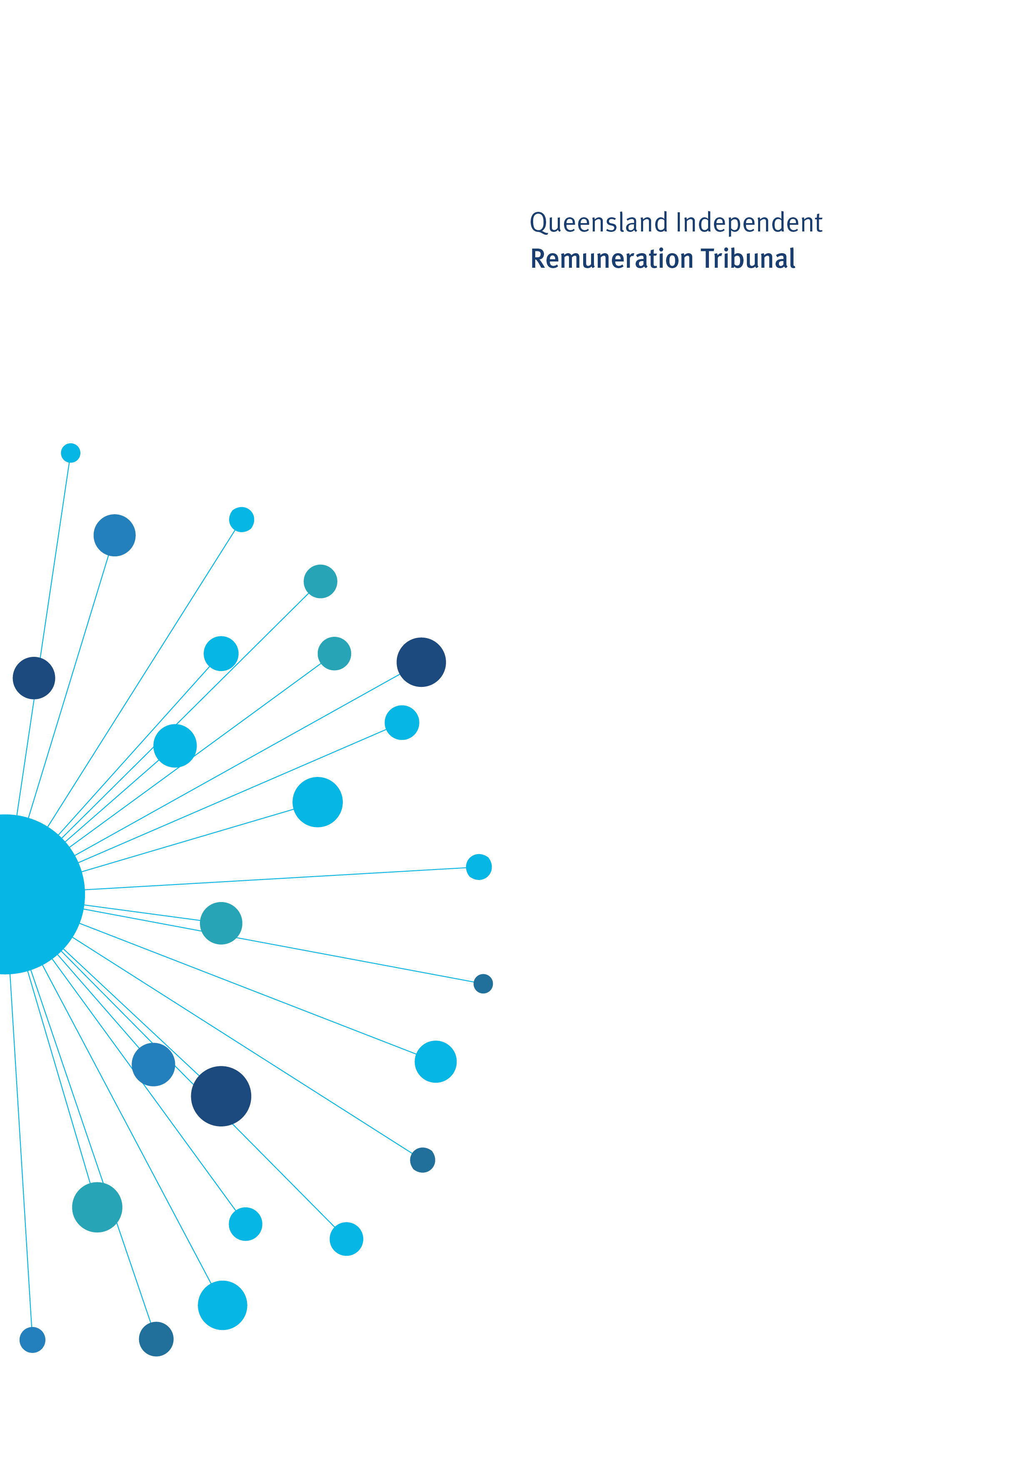

Remuneration Determination

Electorate and Communication Allowance Band Adjustment 2023

Determination 28/2023

5 October 2023

Determination 28/2023

Background and Reasons

Tribunal roles and responsibilities
The Queensland Independent Remuneration Tribunal Act 2013 (the Act) provides for the Queensland Independent Remuneration Tribunal (the Tribunal) to:
- review and determine remuneration (annual and additional salaries, allowances and entitlements) in connection with members and former members of the Queensland Legislative Assembly (Remuneration Determination), and
- review and determine entitlements of cross bench members to additional staff members (Additional Staff Member Determination).
For a Remuneration Determination the Tribunal may have regard to the value to the community of a member of the Legislative Assembly (member) carrying out their role, functions and responsibilities and the importance of a member being appropriately remunerated for carrying out their role. The Tribunal may also consider relevant laws and any other matters the Tribunal considers appropriate including, for example, the size of an electorate (section 29 of the Act). Before making a Determination, the Tribunal must consult with and consider the views of the Clerk of the Parliament (the Clerk).
The Tribunal must ensure any allowances paid to a member reflect the amount of reasonable expenses incurred by a member in servicing their electorate; ensure these allowances are not a substitute for other remuneration; and ensure accommodation services or other entitlements provided for in section 55 of the Act are not taken into account, such as electorate offices, staffing support and major items of office equipment (section 30 of the Act).

Electorate and Communication Allowance
Electorate and Communication Allowance
The Electorate and Communication Allowance (ECA) is provided to cover a range of expenditure associated with:
- providing constituent assistance and service for the electorate
- obtaining and disseminating information to constituents that is relevant to fulfilling parliamentary and constituency responsibilities
- meeting incidental costs relating to the operation of a member’s electorate office.

The ECA may not be used to meet expenditure for:
- private or commercial purposes or to purchase goods and services where the member, or a connected party is the provider of the goods and services
- political party activity
- electioneering and campaigning purposes.

ECA bands and electoral roll data
Electorates are grouped into four bands based on the following formula which recognises the impact of both the number of electors and land area on usage of the ECA:

Band = (60 cents per person registered on the electoral roll) + (1.5 cents per square kilometre of electorate area (land only)).

The quantum of ECA for each band (set in Determination 21/2020) is shown in Table 1.

Table 1: Quantum of ECA per ECA Band
Band | Quantum of ECA for each band
1 | $89,200
2 | $90,900
3 | $93,400
4 | $95,200

Electoral roll data
Previously, the Tribunal has committed to reviewing electoral roll data and making any necessary adjustments to the allocation of electorates to bands. The electoral roll data as at 30 June 2023 indicates that there has been an increase in voter registrations. An additional 157,944 voters have been added to the State electoral roll since adjustments were last made to the ECA in Determination 21/2020.
The Tribunal notes that electoral roll data fluctuates across a financial year. Accordingly, the Tribunal has decided to use an average of quarterly electoral roll data for the preceding financial year to allocate electorates to bands. Using average quarterly electoral roll data for the 2022-23 financial year 41 electorates move up ECA bands as shown in Table 2.
Table 2: Shift in electorates across ECA bands
Band | Quantum of ECA | No. of electorates at 29 October 2021 | No. of electorates at 30 June 2023
1 | $89,200 | 8 | 4
2 | $90,900 | 26 | 10
3 | $93,400 | 29 | 30
4 | $95,200 | 30 | 49
The Tribunal remains of the view that ECA bands should be differentiated based on both electoral roll figures and area of electorate (km²); that is, electorates with a larger number of electors and larger land area should be in higher bands with higher ECA amounts and electorates with smaller population and smaller land area should be in lower bands with smaller ECA amounts.
The Tribunal notes that it is likely that the number of voters registered on the Queensland electoral roll will continue to increase in the lead up to the 2024 State General Election. The increase in the number of voters on the State electoral roll is expected to result in electorates continuing to move up ECA bands resulting in the majority of electorates falling within Bands 3 and 4. As a result the impact of the electoral roll numbers as a discriminator in the ECA formula has reduced.
Accordingly, the Tribunal has decided to re-set the ECA bands and associated ECA band amounts to recognise the increases in voter registration across electorates and continue to maintain the differentiation between the bands on both electoral roll figures and area of electorate. To achieve this, the lower bands have been merged and new ECA amounts set for each band. As a result of re-setting the bands no electorate receives less ECA.
With effect from 1 July 2023, the ECA bands will be set as follows:
Band | Amount | Electorates in each Band | Number of electorates
1 | $93,400 | Broadwater, Bundaberg, Burdekin, Burleigh, Callide, Capalaba, Chatsworth, Currumbin, Ferny Grove, Gaven, Gladstone, Glass House, Hinchinbrook, Ipswich, Lockyer, Mansfield, Miller, Mirani, Moggill, Mount Ommaney, Mundingburra, Nicklin, Oodgeroo, Southport, Springwood, Stretton, Toohey, Townsville, Waterford, Whitsunday. | 30
2 | $95,200 | Algester, Aspley, Bancroft, Bonney, Buderim, Burnett, Cairns, Cooper, Everton, Greenslopes, Inala, Ipswich West, Kawana, Keppel, Kurwongbah, Lytton, Macalister, Mackay, Maroochydore, Mermaid Beach, Mudgeeraba, Mulgrave, Nanango, Noosa, Nudgee, Pine Rivers, Rockhampton, Sandgate, Southern Downs, Stafford, Surfers Paradise, Theodore, Thuringowa, Toowoomba North, Toowoomba South, Woodridge. | 36
3 | $97,700 | Barron River, Bulimba, Bundamba, Caloundra, Clayfield, Condamine, Cook, Gympie, Hervey Bay, Hill, Jordan, Logan, Maiwar, Maryborough, McConnel, Morayfield, Murrumba, Ninderry, Pumicestone, Redcliffe, Redlands, Scenic Rim, South Brisbane. | 23
4 | $100,200 | Coomera, Gregory, Traeger, Warrego. | 4
The current acquittal and reporting requirements for the ECA remain unchanged.
Quantum of ECA bands
The Tribunal will further consider the quantum of the ECA bands as part of its Annual Review of Allowances. This will be undertaken following the tabling of expense reports by the Clerk of the Parliament.

High Enrolment Supplement
In Determination 26/2022 the Tribunal established a ‘high enrolment supplement’. Members are eligible for the high enrolment supplement if:
- the electorate is in ECA Band 4; and
- the number of electors is 25% of more above the quota, over a period of 6 consecutive months, determined in accordance with the ECQ monthly enrolment data.
In Determination 27/2023, the Tribunal set the amount of the high enrolment supplement at $5,000 per financial year.
In re-setting the bands, the Tribunal retained the current high enrolment supplement. This is consistent with Determination 27/2023 where the Tribunal decided no further consideration of changes to the quantum of the High Enrolment Supplement would occur until the next State Electoral Redistribution takes effect.

Determination 28/2023
Any inconsistencies between earlier Tribunal Determinations and Determination 28/2023 are resolved in favour of Determination 28/2023. Matters in earlier Determinations not addressed in this Determination are confirmed by the Tribunal and not amended.
Electorate and Communication Allowance
- The Tribunal determines that the Electorate and Communication Allowance bands, band amounts and allocation of electorates in each band, as set out in the table below, will apply with effect from 1 July 2023

Band | ECA Amount | Electorates in each Band
1 | $93,400 | Broadwater, Bundaberg, Burdekin, Burleigh, Callide, Capalaba, Chatsworth, Currumbin, Ferny Grove, Gaven, Gladstone, Glass House, Hinchinbrook, Ipswich, Lockyer, Mansfield, Miller, Mirani, Moggill, Mount Ommaney, Mundingburra, Nicklin, Oodgeroo, Southport, Springwood, Stretton, Toohey, Townsville, Waterford, Whitsunday.
2 | $95,200 | Algester, Aspley, Bancroft, Bonney, Buderim, Burnett, Cairns, Cooper, Everton, Greenslopes, Inala, Ipswich West, Kawana, Keppel, Kurwongbah, Lytton, Macalister, Mackay, Maroochydore, Mermaid Beach, Mudgeeraba, Mulgrave, Nanango, Noosa, Nudgee, Pine Rivers, Rockhampton, Sandgate, Southern Downs, Stafford, Surfers Paradise, Theodore, Thuringowa, Toowoomba North, Toowoomba South, Woodridge.
3 | $97,700 | Barron River, Bulimba, Bundamba, Caloundra, Clayfield, Condamine, Cook, Gympie, Hervey Bay, Hill, Jordan, Logan, Maiwar, Maryborough, McConnel, Morayfield, Murrumba, Ninderry, Pumicestone, Redcliffe, Redlands, Scenic Rim, South Brisbane.
4 | $100,200 | Coomera, Gregory, Traeger, Warrego.

Date of Determination: 5 October 2023
Effective Date: 1 July 2023

_______________________ __________________ ___________________
Keitha Dunstan Jim Varghese Patrick Weller
Chairperson Member Member

