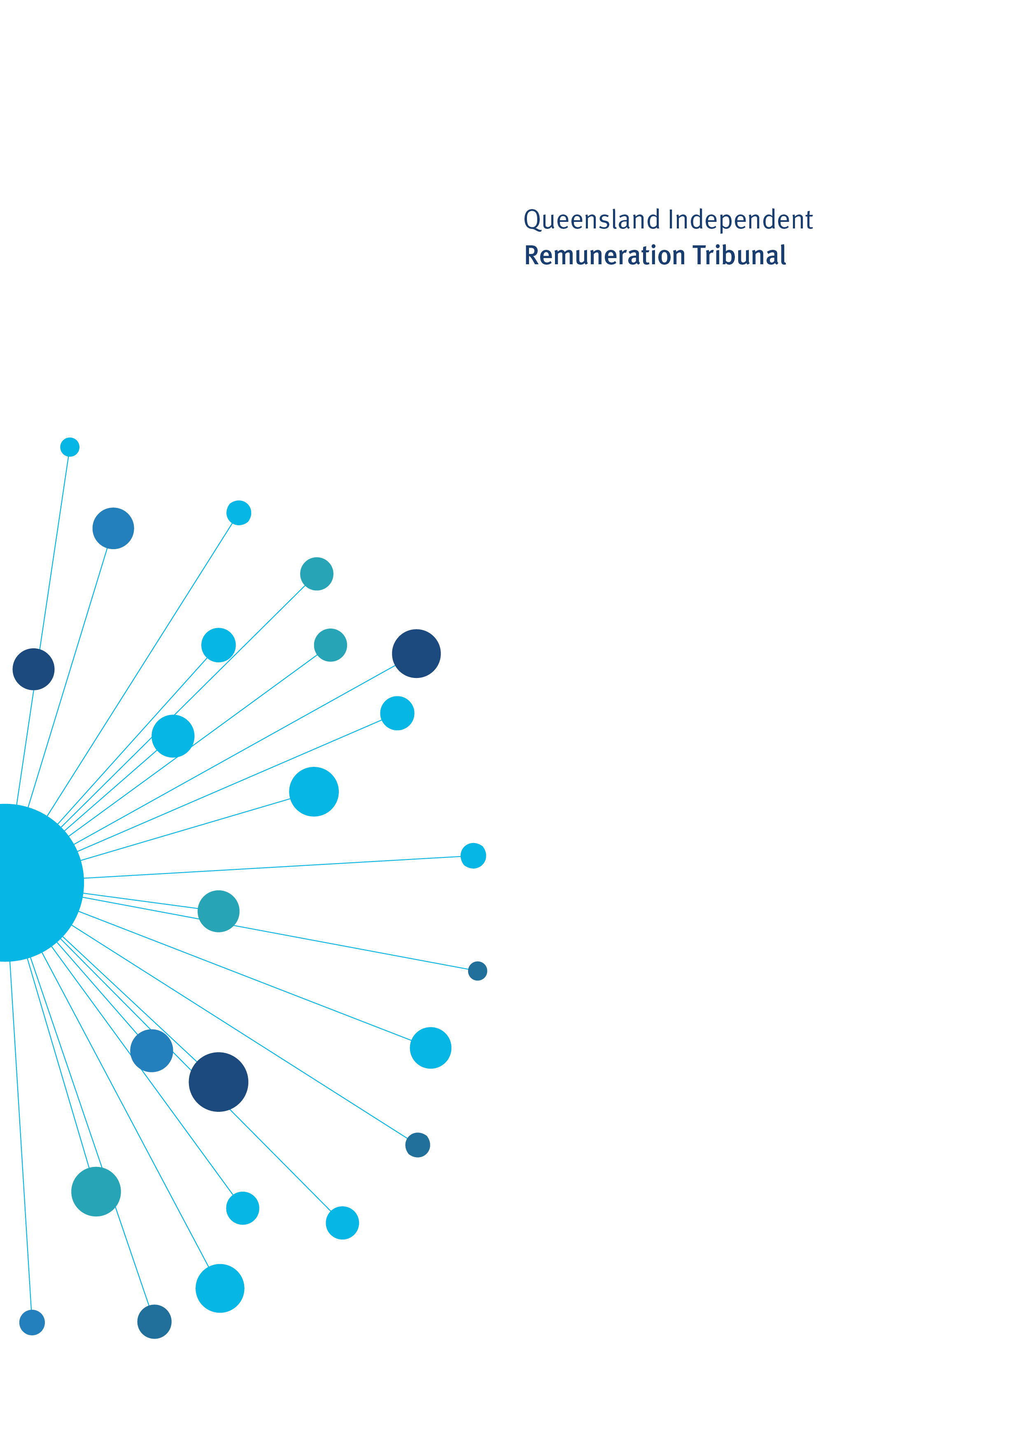

Determination 20/2020

21 April 2020

Minor amendment to the Allowances System 2020

Determination 20/2020

Background and Reasons
  - Tribunal roles and responsibilities
The Queensland Independent Remuneration Tribunal Act 2013 (Act) provides for the Queensland Independent Remuneration Tribunal (Tribunal) to review and determine remuneration (annual and additional salaries, allowances and entitlements) in connection with members and former members of the Queensland Legislative Assembly (section 7).
Under the Act, the Tribunal may have regard to the value to the community of a member carrying out their role, functions and responsibilities and the importance of a member being appropriately remunerated for carrying out their role. The Tribunal may also consider relevant laws and any other matters the Tribunal considers appropriate including, for example, the size of an electorate (section 29).
Before making a Determination, the Tribunal must consult with and consider the views of the Clerk of the Queensland Parliament (the Clerk). In making a Determination, the Tribunal must ensure any allowances paid to a member reflect the amount of reasonable expenses incurred by a member in servicing their electorate; ensure these allowances are not a substitute for other remuneration; and ensure accommodation services or other entitlements provided for in section 55 of the Act are not taken into account - for example, electorate offices, staffing support and major items of office equipment (section 30).
  - Background
In December 2019 and January 2020, a new coronavirus, now known as COVID-19, emerged in Wuhan City, in the Hubei Province of China. On 29 January 2020, the Minister for Health and Minister for Ambulance Services declared a public health emergency under section 319 of the Public Health Act 2005.
On 11 March 2020, the Director-General of the World Health Organization (WHO) declared COVID-19 a global pandemic.
On 13 March 2020, the Commonwealth Government endorsed social distancing measures as set out by the Australian Health Protection Principal Committee.
On 15 March 2020, the National Cabinet, comprising the Prime Minister, State Premiers and Territory Chief Ministers, asked all States and Territories to ensure they had appropriate legislative provisions in place to implement and monitor social distancing measures.
On 18 March 2020, the Prime Minister advised of further restrictions, including advice to not travel overseas at this time, restrictions on non-essential indoor gatherings of more than 100 people, and restrictions on entry into aged care facilities.
On 22 March 2020, the Prime Minister advised of further enhanced measures to slow the virus, including that all non-essential indoor gatherings of less than 100 people must have no more than one person per 4sqm.
On 29 March the National Cabinet agreed to further limit most indoor and outdoor non-essential gatherings to 2 people.
On 2 April 2020 the Queensland Chief Health Officer issued the Home Confinement, Movement and Gathering Direction to outline requirements for home confinement, outdoor gathering, receiving visitors at a residence and gatherings in non-residences.
COVID-19 represents a significant risk to the health and wellbeing of many Queenslanders.
In recognition of this risk, the Clerk of the Parliament has introduced a number of preventative health measures, both within the parliamentary precinct and across Members’ electorate offices. These measures include moving to work from home arrangements for electorate staff and ceasing public access to electorate offices, restricting public access to the parliamentary precinct, and suspension of all catered events held in the precinct. The Legislative Assembly has also made changes to Sessional Orders that have amended the parliamentary sitting program, with Parliament currently scheduled to reconvene on 22 April 2020.
Members will continue to comply with evolving Queensland and Federal Government health directives and guidance regarding COVID-19.
  - Electorate and Communication Allowance
The Electorate and Communication Allowance (ECA) is provided to cover a range of expenditure associated with:
- providing constituent assistance and service for the electorate
- obtaining and disseminating information to constituents that is relevant to fulfilling parliamentary and constituency responsibilities, and
- meeting incidental costs relating to the operation of a member’s electorate office.
The ECA may not be used to meet expenditure for:
- private or commercial purposes or to purchase goods and services where the member, or a connected party is the provider of the goods and services
- political party activity, or
- electioneering and campaigning purposes.
The Member’s Remuneration Handbook establishes that up to ten per cent of the total ECA paid for each financial year (excluding any reductions or carry-overs from previous years) that is unexpended at 30 June is able to be retained by the Member and carried over for use in the next financial year.
The current and emerging restrictions associated with the COVID-19 situation limit Members ability to undertake functions and activities generally funded via the ECA.
In recognition of these limitations, the Clerk has suggested Members be allowed to retain a higher proportion of their total ECA for the 2019−2020 financial year that is unexpended at 30 June 2020, for carry-over and use prior to the 2020 State Election.
The Tribunal has decided to support changes to allow Members to retain up to 40 per cent of the total ECA paid for the 2019−20 financial year (excluding any reductions or carry-overs from previous years) that is unexpended at 30 June 2020. This unexpended allowance is to be carried over for use by Members in the period 1 July to 30 October 2020.

Determination 20/2020
Any inconsistencies between earlier Tribunal Determinations and Determination 20/2020 are resolved in favour of Determination 20/2020. Matters in earlier Determinations not addressed in this Determination are confirmed by the Tribunal and not amended.
  - Electorate and Communication Allowance
- The Tribunal supports changes to allow Members to retain up to 40 per cent of the total Electorate and Communication Allowance paid for the 2019−20 financial year (excluding any reductions or carry-overs from previous years) that is unexpended at 30 June 2020. This unexpended allowance is to be carried over for use by Members in the period 1 July to 30 October 2020.

Date of Determination: 21 April 2020
Effective Date: 21 April 2020

_______________________ ___________________ ___________________
Mr Walter Tutt Ms Jill Lang Professor Patrick Weller
Chairperson Member Member

