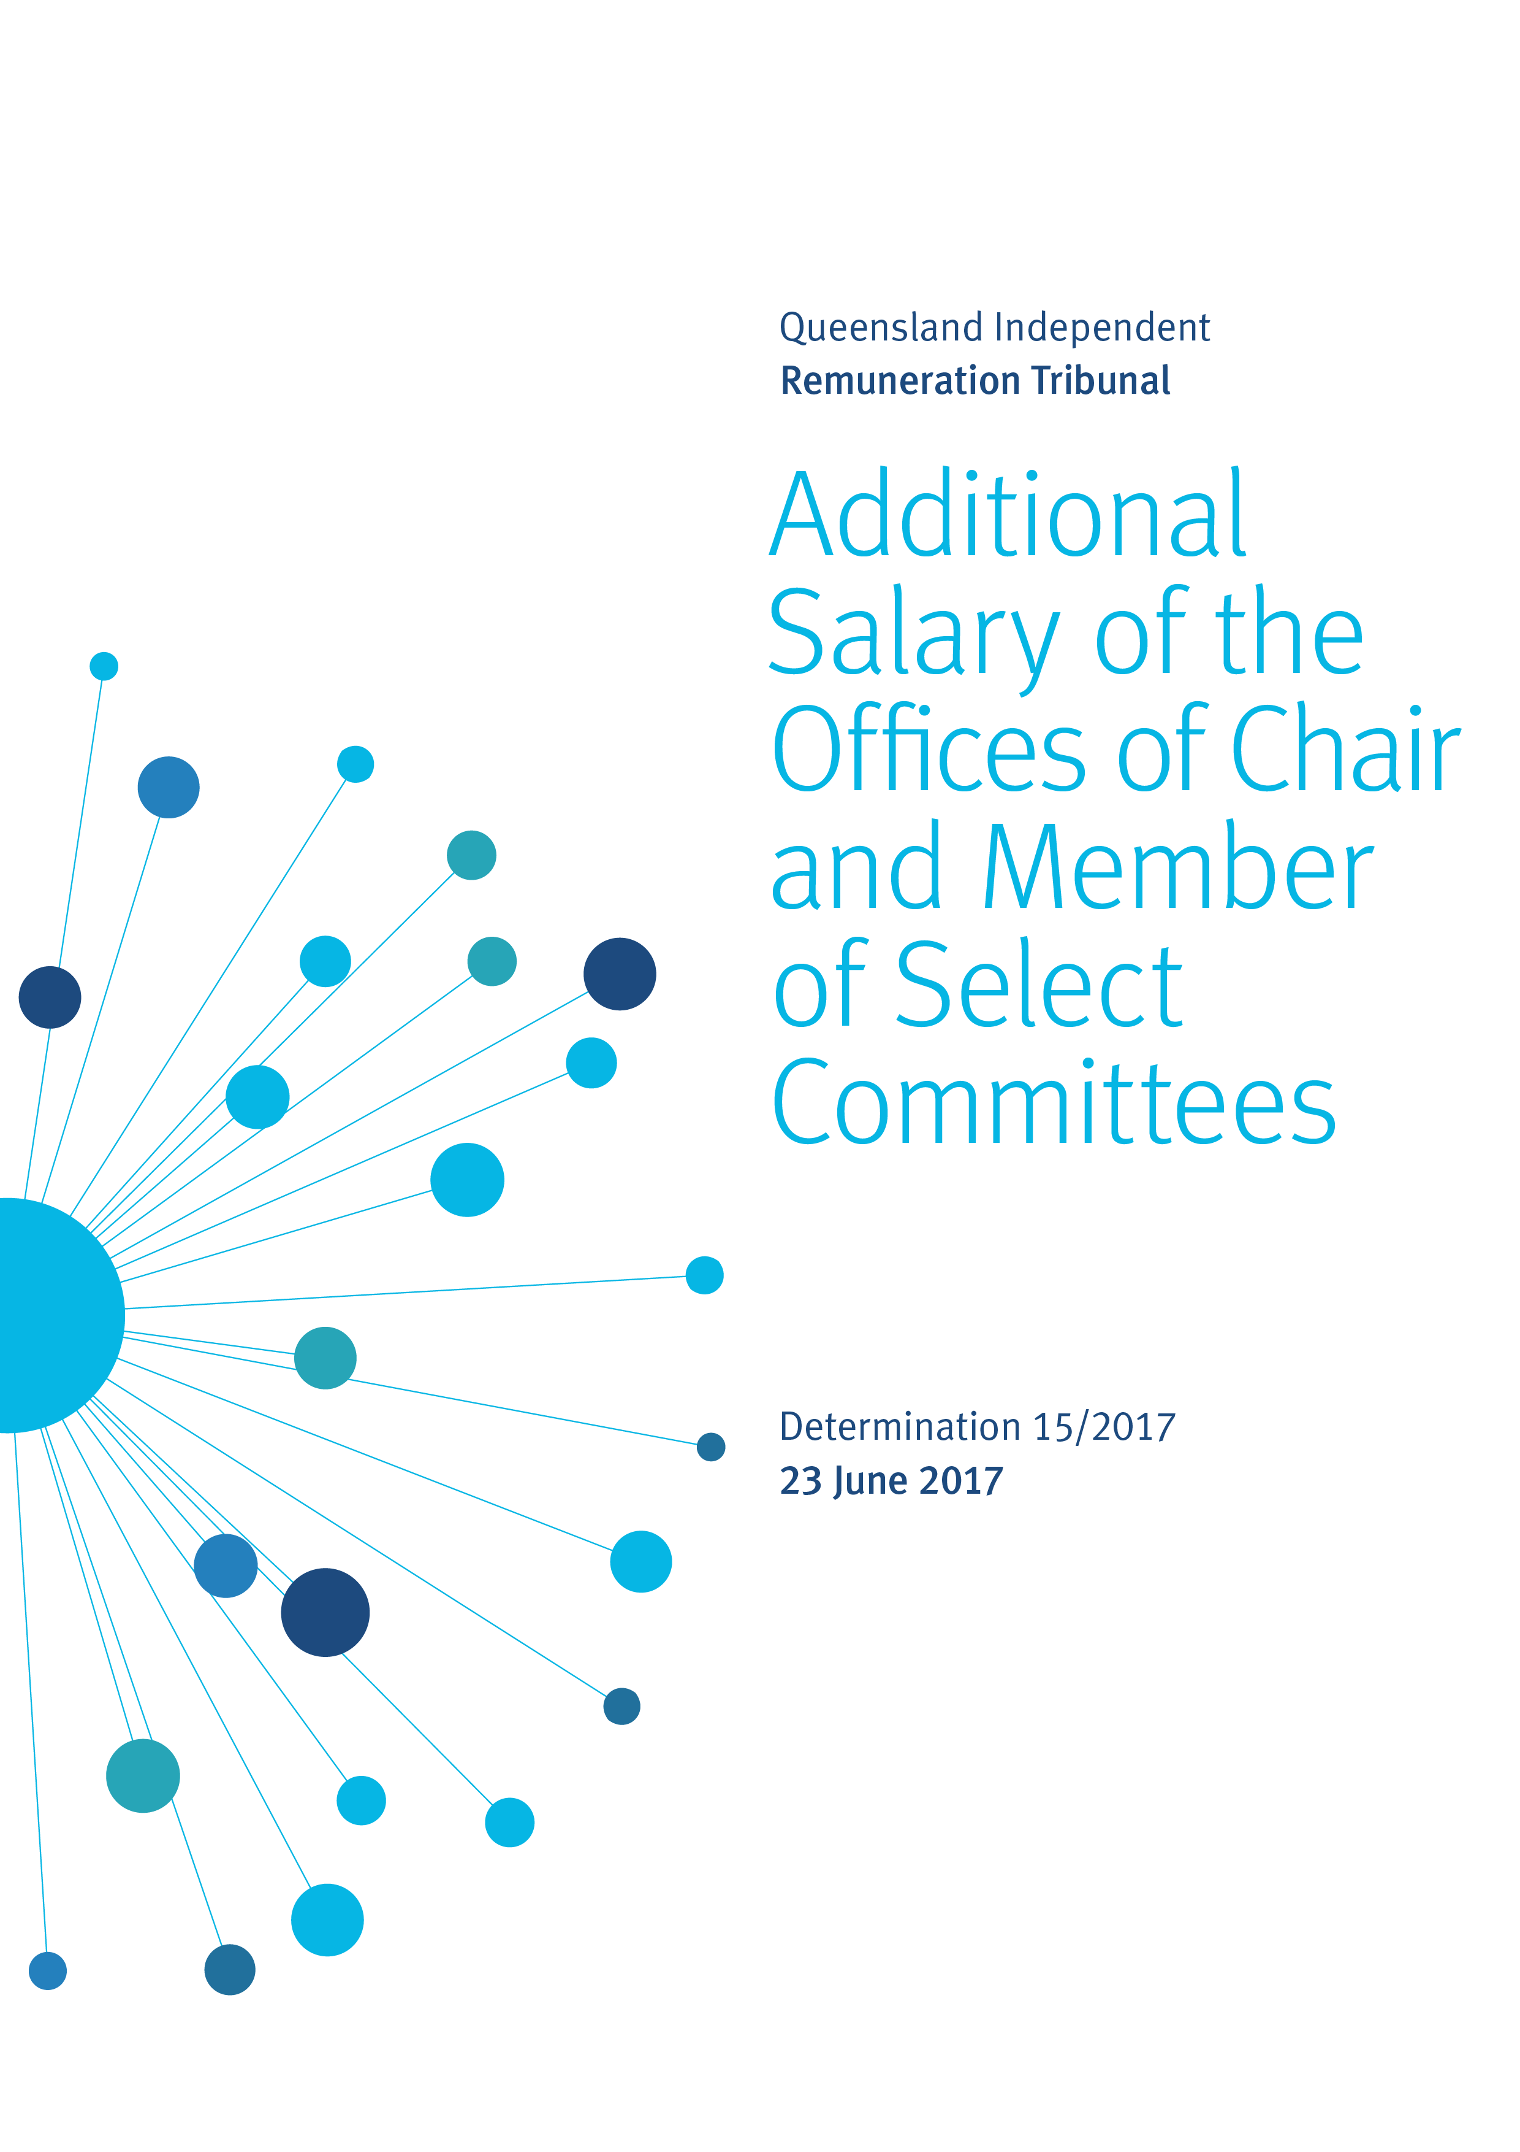

Reasons

Background
The Queensland Independent Remuneration Tribunal (the Tribunal) is an independent statutory authority established by the Queensland Independent Remuneration Tribunal Act 2013 (the Act).

The Tribunal has the power to make determinations in accordance with section 27 of the Act which provides for ‘…the power to make determinations about remuneration in connection with members [MPs] and former members of the [Queensland Legislative] Assembly’.

The definition of ‘remuneration’ under the Act includes the annual salary (s41), the additional salary (s42) and associated allowances (s54) payable to an MP for performing roles as an office holder in addition to that of an MP in the Queensland Legislative Assembly.

Introduction
On 14 June 2017, the Legislative Assembly passed a resolution to establish the offices of chair and member of select committees as offices entitled to be paid an additional salary under section 42 of the Act. The Tribunal has not previously considered the additional salary payable to these offices and therefore a determination may be made in accordance with section 31B of the Act.

Role of Select Committees
The role of parliamentary committees is to investigate specific issues and report back to the Legislative Assembly. There has been one select committee in the 55th Queensland Parliament, the Coal Workers’ Pneumoconiosis (CWP) select committee. The CWP select committee was established on 15 September 2016 to conduct an inquiry and report on the re-emergence of CWP amongst coal mine workers in Queensland and was required to report to the Legislative Assembly by 12 April 2017.

On 23 March 2017, the committee’s terms of reference was extended to include other occupational respirable dust issues. The CWP select committee is now required to report to the Legislative Assembly by 29 September 2017.

The Standing Rules and Orders of the Legislative Assembly provide that members are appointed by motion (Standing Order 196). The order of appointment motion for the CWP select committee was agreed to on 15 September 2016.

The CWP select committee is comprised of six members, as provided in the appointment motion of 15 September 2016.

Standing Order 195 states if a statute, Standing Order or order of appointment does not set a number of members, the committee shall consist of seven members.

Analysis
The Tribunal has previously grouped offices entitled to an additional salary into 12 bands relative to the additional salary payable to the highest office holder, the Premier.

To determine the appropriate additional salary band for the offices of chair and member of select committees, the Tribunal has:
- considered the role, function and responsibilities of the chair and members of a select committee;
- considered the relativity of the role and responsibilities of each office holder in the Legislative Assembly against that of the offices of chair and member of select committees; and
- consulted with the Clerk of the Parliament.

The Tribunal notes the Clerk of the Parliament’s advice that the role and responsibilities of the chair and members of a select committee are generally equal to those of other committees.

In Determination 3/2014, the Tribunal determined the additional salary for the office of chair of a committee would sit at 25% relative to the additional salary payable to the office of the Premier. Determination 3/2014 also set the relativity of the office of member of a committee to 10% of that payable to the office of the Premier. The relativities of committee chairs and members has not changed since that time.

The Tribunal has determined to align the additional salary payable to the offices of chair and member of select committees with that payable to portfolio committees.

As there is currently only one select committee in the Queensland Parliament which was established on 15 September 2016, the Tribunal considers it appropriate for its Determination to take effect from the date of the establishment of the CWP select committee.

Figure 1 - New relativity of additional salaries between offices

Band | Office | Relativity between offices  %
1 | Premier | 100.00
2 | Deputy Premier | 80.0
3 | Minister and Leader of the House | 72.5
4 | - Minister  - Leader of the Opposition | 70.0
5 | - Speaker  - Assistant Minister and Leader of the House | 60.0
6 | Leader of the House | 50.0
7 | Deputy Leader of the Opposition | 40.0
8 | - Chief government whip  - Deputy Speaker  - Manager of Opposition Business  - Assistant Minister | 35.0
9 | - Opposition Spokesperson  - Leader in the Assembly of a recognised political party, other than the Leader or Deputy Leader of the Opposition  - Chairperson of a committee (including a select committee) | 25.0
10 | - Senior government whip  - Opposition whip | 15.0
11 | - Government deputy whip  - Deputy Opposition whip | 12.5
12 | Member of a committee (including a select committee) | 10.0

Determination
Any inconsistencies between earlier Tribunal Determinations and Determination 15/2017 are resolved in favour of Determination 15/2017. Matters in earlier Determinations not addressed in this Determination are confirmed by the Tribunal and not amended.

Additional salary of the Offices of Chair and Member of Select Committees
The Tribunal determines that the additional salary payable to the office of chair of a select committee falls within band 9 of the existing relativities and will be set at 25% of the additional salary payable to the office of the Premier, effective from 15 September 2016.
The Tribunal further determines that the additional salary payable to the office of member of a select committee falls within band 12 of the existing relativities and will be set at 10% of the additional salary payable to the office of the Premier, effective from 15 September 2016.
Professor Anne Tiernan
Chairperson
Mr Michael Noud
Member
Ms Karyn Walsh
Member

Date of Determination: 23 June 2017

